**React Introduction**

**ReactJS**, also known as **React**, is a popular JavaScript library for building user interfaces.

It is also referred to as a front-end JavaScript library.

It was developed by **Facebook** and is widely used for creating dynamic and interactive web applications.

**‍What is React?**

**React** is a **JavaScript library** for building **user interfaces** (UIs) on the web.

React is a declarative, component based library that allows developers to build reusable UI components and it follows the Virtual DOM (Document Object Model) approach, which optimizes rendering performance by minimizing DOM updates.

React is **fast** and works well with other tools and libraries.

***Prerequisite of React***

*For learning React first you have a clear understanding of HTML, CSS and JavaScript.*

*As React is a JavaScript library and uses most of its concept so you really have to understand the major concepts of it.*

**History of React**

* React was invented by **Facebook** developers who found the traditional DOM slow.
* By implementing a virtual DOM, React addressed this issue and gained popularity rapidly.
* It was first deployed in Facebook’s News Feed in 2011, and later in Instagram in 2012.
* The official open-source release happened in **May 2013** on GitHub after the JSConf presentation in March.
* The current stable version, **React 19**, was officially released on **December 5, 2024**.
* The library continues to evolve, introducing new features with each update.

**How does React work?**

React operates by creating an in-memory virtual DOM rather than directly manipulating the browser’s DOM.

It performs necessary manipulations within this virtual representation before applying changes to the actual browser DOM.

React is efficient, altering only what requires modification.

**Features of React**

React is one of the most demanding JavaScript library because it is equipped with a ton of features which makes it faster and production-ready.

Below are the few features of React.

**1. Component-Based Architecture**

React provides the feature to break down the UI into smaller, self-contained components.

Each component can have its own **state and props**.

**2. JSX (JavaScript Syntax Extension)**

JSX is a syntax extension for JavaScript that allows developers to write HTML-like code within their JavaScript files.

It makes React components more readable and expressive.

const name="Ramesh";

const ele = <h1>Welcome to {name}</h1>;

**3. Virtual DOM**

React maintains a lightweight representation of the actual DOM in memory.

When changes occur, React efficiently updates only the necessary parts of the DOM.

**4. One-way Data Binding**

One-way data binding, the name itself says that it is a one-direction flow.

The data in react flows only in one direction i.e. the data is transferred from top to bottom i.e. from parent components to child components.

The properties (props) in the child component cannot return the data to its parent component but it can have communication with the parent components to modify the states according to the provided inputs.

**5. Performance**

As we discussed earlier, react uses virtual DOM and updates only the modified parts.

So, this makes the DOM to run faster.

DOM executes in memory so we can create separate components which makes the DOM run faster.

**6. Components**

React divides the web page into multiple components as it is component-based.

Each component is a part of the UI design which has its own logic and design as shown in the below image.

So the component logic which is written in JavaScript makes it easy and run faster and can be reusable.

**7. Single-Page Applications (SPAs)**

React is recommended in creating SPAs, allowing smooth content updates without page reloads.

Its focus on reusable components makes it ideal for real-time applications.

**ReactJS Lifecycle**

Every React Component has a lifecycle of its own, lifecycle of a component can be defined as the series of methods that are invoked in different stages of the component’s existence.

React automatically calls these methods at different points in a component’s life cycle.

Understanding these phases helps manage state, perform side effects, and optimize components effectively.

**1. Initialization**

This is the stage where the component is constructed with the given Props and default state.

This is done in the constructor of a Component Class.

**2. Mounting Phase**

* **Constructor**:

The constructor method initializes the component.

It’s where you set up initial state and bind event handlers.

* **render():**

This method returns the JSX representation of the component.

It’s called during initial rendering and subsequent updates.

* **componentDidMount():**

After the component is inserted into the DOM, this method is invoked.

Use it for side effects like data fetching or setting timers.

**3. Updating Phase**

* **componentDidUpdate(prevProps, prevState)**:

Called after the component updates due to new props or state changes.

Handle side effects here.

* **shouldComponentUpdate(nextProps, nextState):** Determines if the component should re-render. Optimize performance by customizing this method.
* **render():** Again, the render() method reflects changes in state or props during updates.

**4. Unmounting Phase**

* **componentWillUnmount()**: Invoked just before the component is removed from the DOM. Clean up resources (e.g., event listeners, timers).

**FAQs on React**

**Is React a framework or library?**

*It is very confusing to a lot of people that if React is a framework of a library.*

*React is considered as a library rather than a framework.*

*While in the framework there is a controlled way of structure to write the code whether in library you are free to write without any structural restriction.*

**How do I Start Learning React?**

*React has a large community that keeps updating all the concepts of React.*

*You just need to follow proper step by step roadmap to learn React and keep hands on practice on it.*

**What is JSX?**

*JSX, which stands for JavaScript XML, is a syntax extension for JavaScript.*

*ReactJS uses an XML or HTML-like syntax, which is then transformed into React Framework JavaScript calls.*

*Essentially, JSX expands ES6 to allow HTML-like text to coexist with JavaScript   
React code.*

*Although it is not mandatory to use JSX in ReactJS, it is highly recommended.*

***Syntax:***

*const example = “JSX”*

*const ele = <div>This component uses {example} </div>*

**Is React Beginner Friendly?**

*Yes, React is very simple and beginner friendly.*

*It just uses JavaScript and JSX to create the Single page Application.*

*If you have the basic knowledge of HTML, CSS and JavaScript you are good to go to dive deep into the React world.*

**Topics in React**

To learn React, it's best to approach the topics in a logical sequence, building from foundational concepts to more complex patterns and best practices. Here's a suggested sequence for learning React, from beginner to advanced:

1. **JavaScript Fundamentals**:
   * Ensure you have a strong grasp of JavaScript, including ES6+ features like arrow functions, destructuring, template literals, and the spread/rest operators.
2. **Basic React Concepts**:
   * **Introduction to React**: Understand what React is and why it's used for building user interfaces.
   * **JSX**: Learn how JSX allows you to write React components in a syntax resembling HTML, but with JavaScript functionality.
   * **Components**: Understand functional and class-based components, the building blocks of React applications.
   * **Props and State**: Learn about props (data passed to components) and state (data within a component).
3. **Advanced React Concepts**:
   * **Event Handling**: Learn how to handle events in React components, such as clicks and form submissions.
   * **Conditional Rendering**: Understand how to render components based on conditions.
   * **Lists and Keys**: Learn how to render lists of items and why keys are important.
   * **Lifecycle Methods**: If learning class components, explore lifecycle methods like **componentDidMount**.
   * **Hooks**: Dive into hooks like **useState**, **useEffect**, **useContext**, and **useReducer** for state management and lifecycle control.
4. **Component Composition and Reusability**:
   * **Higher-Order Components (HOCs)**: Learn about this older pattern for reusing component logic (though less commonly used with modern hooks).
   * **Custom Hooks**: Create your own reusable hooks to encapsulate logic.
   * **Context API**: Explore how React's context system allows you to share data across components without prop drilling.
5. **State Management**:
   * **Local State Management**: Understand how state is managed within individual components.
   * **Global State Management**: Learn about solutions like Redux, MobX, or the Context API for managing state across an application.
   * **Reducers**: Learn how to use reducers for complex state management with **useReducer** or Redux.
6. **Routing and Navigation**:
   * **React Router**: Learn how to navigate between pages and manage complex routing.
   * **Dynamic Routing**: Explore how to create routes with parameters and nested routes.
7. **Styling and UI Components**:
   * **Styling Approaches**: Learn about CSS, CSS-in-JS, Styled Components, and other styling methods in React.
   * **UI Component Libraries**: Explore libraries like Material-UI, Ant Design, or Tailwind CSS for building consistent UIs.
8. **Advanced React Techniques**:
   * **Performance Optimization**: Learn about memoization with **React.memo** and **useMemo**, as well as **useCallback**.
   * **Server-Side Rendering (SSR) and Static Site Generation (SSG)**: Explore frameworks like Next.js for server-side rendering and static site generation.
   * **Code Splitting and Lazy Loading**: Understand how to improve performance by splitting code and loading components asynchronously.
9. **Testing and Debugging**:
   * **Testing Frameworks**: Learn about testing libraries like Jest and React Testing Library.
   * **Debugging Tools**: Explore tools like React DevTools and how to debug React applications.
10. **Deployment and Production**:
    * **Build Tools**: Understand tools like Webpack, Babel, and Create React App.
    * **Deployment**: Learn how to deploy React applications to platforms like Netlify, Vercel, or AWS.
    * **Continuous Integration/Continuous Deployment (CI/CD)**: Explore automated deployment and integration workflows.

This sequence provides a comprehensive roadmap for learning React, from the basics to advanced concepts, including state management, routing, and testing. Depending on your specific interests and project needs, you can adjust the focus and depth of your learning in each area.

**Installing React**

To install React, you’ll need Node.js and npm (Node Package Manager) installed on your system.

Once you have those set up, you can create a new React application using Create React App, which is an officially supported way to create single-page React applications.

Here’s a step-by-step guide to get you started:

1. **Install Node.js and npm**:
   * Visit the [Node.js website](https://nodejs.org/) to download and install the latest version of Node.js, which includes npm. Or
   * Type the command as shown below in VSCode terminal

**npm install node.js**

* use the following command to give permission to the npm

**>Set-ExecutionPolicy -Scope CurrentUser -ExecutionPolicy RemoteSigned**

1. **Installing create-react-app application**:
   * Open your terminal or command prompt.
   * Run the following command to install Create React App globally (if you haven’t already):

**npm install -g create-react-app**

**Introduction to Create React App**

The most common way to get started with React is to use a node package called **Create React App**.

**Create React App** is an officially supported tool that installs a toolchain for React development and configures a boilerplate React application that you can use as a starting point for your applications.

To install and run **Create React App**, you can use a command that comes as part of the npm package manager called npx.

**npx is a package runner.**

To create a new React app using Create React App, use the npx command, followed by **create-react-app**, followed by a name that you want to give your new React app.

**For example:**

**> npx create-react-app** **my-new-app**

> cd my-new-app

> npm start

**Naming Your React App**

The name you choose for your new app is up to you, as long as it conforms to the rules of Node.js package names.

These rules are:

➤ It must be less than 214 characters long.

➤ The name can’t start with a dot or underscore.

➤ The name can’t have uppercase letters.

➤ It can’t contain any characters that aren’t allowed in URLs (such as ampersands and dollar signs) and that are “unsafe” in URLs (such as the percent symbol and spaces).

In addition to these rules, there are several common conventions for how Node.js packages, and therefore apps created using Create React App, are named:

➤ Keep it simple and as short as possible.

➤ Use only lowercase letters.

➤ Use dashes in place of spaces.

➤ Don’t use the same name as a common Node.js package.

**First React App**

Follow these steps to use Create React App to make your first React application

1. Make or open a new folder in Visual Studio Code

2. Open the Terminal and make your new folder the working directory.

3. Use npx to run create-react-app and give your new application a name.

For example**: npx create-react-app** my-test-app

4. Press Enter to start the installation of **create-react-app** and the configuration of your new app.

5. You’ll see a series of messages and progress bars in the Terminal.

6. You may also see some errors and warnings, but often these aren’t anything to be concerned about.

7. When the installation and configuration of your new React app finishes, change to the directory containing your new app by typing cd followed by the name you gave to your app: **cd my-test-app**

8. Start up your app by using the **npm start** command.

**Note: npm start is actually shorthand for npm run start.**

9. What you’re doing when you run npm start is that you’re causing a script called start to run its commands.

10. Wait and watch as your generated React app starts up and then opens in a browser to reveal the React logo and a message.

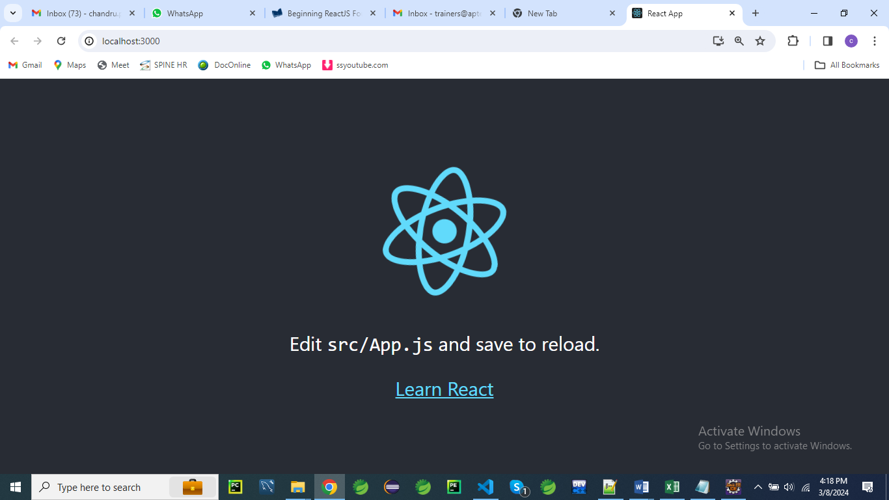

Now that you’ve created a React app, you can try making some changes to it by following these steps:

1. Leave the integrated Terminal in Visual Studio Code open and open src/App.js, which is located inside your application’s folder.

2. Find the part of App.js that contains the code shown below

<div className="App">

      <header className="App-header">

        <img src={logo} className="App-logo" alt="logo" />

        <p>

          Edit <code>src/App.js</code> and save to reload.

        </p>

        <a

          className="App-link"

          href="https://reactjs.org"

          target="_blank"

          rel="noopener noreferrer"

        >

          Learn React

        </a>

      </header>

 </div>

NOTE: The HTML-like syntax you see here is JSX, which is a special feature of React projects.

3. Change the text between the <p> and </p> tags and then save App.js as shown below

<p>

Welcome to react learning....

</p>

The whole code should look like this

<div className="App">

      <header className="App-header">

        <img src={logo} className="App-logo" alt="logo" />

**<p>**

**Welcome to react learning....**

**</p>**

        <a

          className="App-link"

          href="https://reactjs.org"

          target="_blank"

          rel="noopener noreferrer"

        >

          Learn React

        </a>

      </header>

    </div>

The output should be look like below

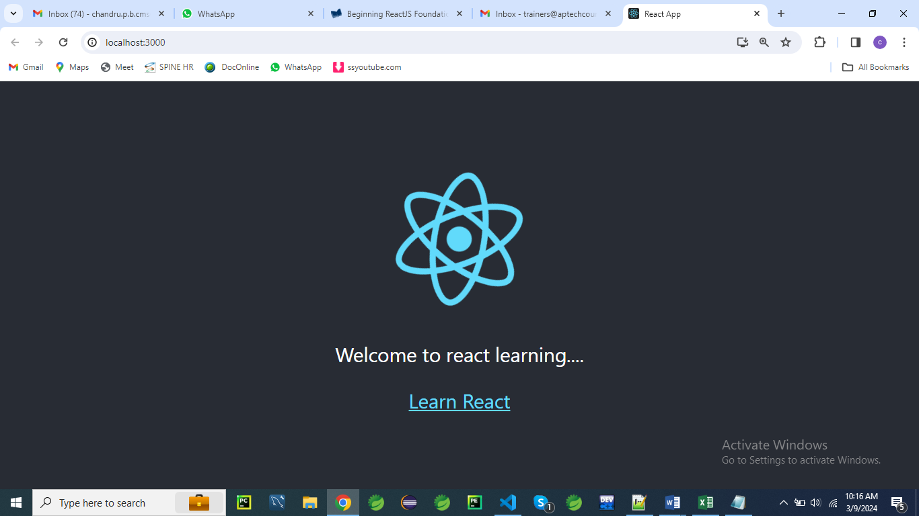

**Creating a Calculator application**

Here is a simple React program that allows you to perform mathematical operations like addition, subtraction, multiplication, and division:

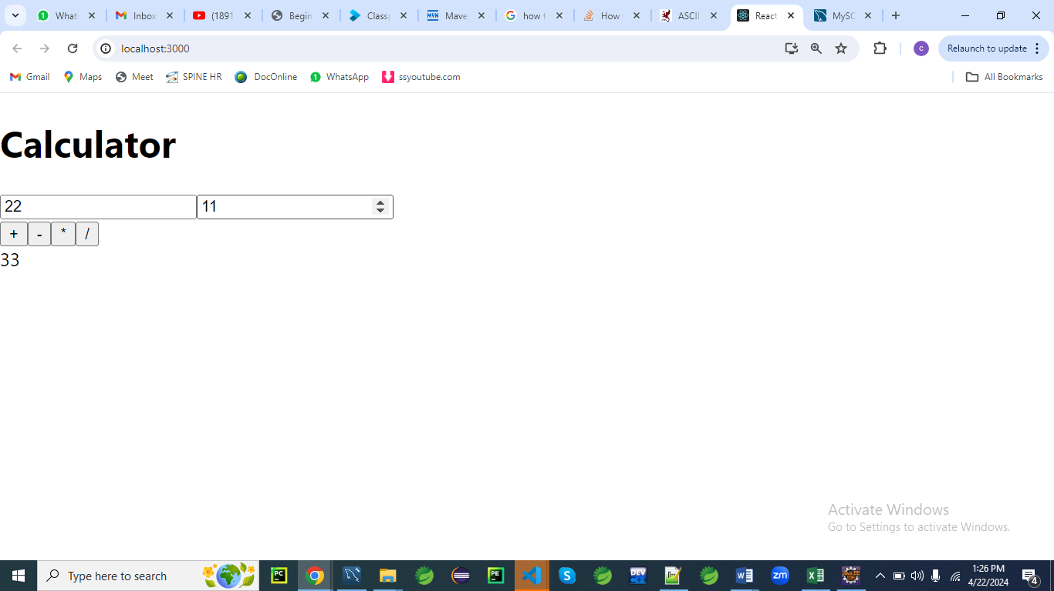

**Calculator.js**

import React, { useState } from 'react';

function Calculator() {

const [num1, setNum1] = useState('');

const [num2, setNum2] = useState('');

const [result, setResult] = useState('');

const handleNum1Change = (e) => {

setNum1(e.target.value);

};

const handleNum2Change = (e) => {

setNum2(e.target.value);

};

const handleAdd = () => {

setResult(parseFloat(num1) + parseFloat(num2));

};

const handleSubtract = () => {

setResult(parseFloat(num1) - parseFloat(num2));

};

const handleMultiply = () => {

setResult(parseFloat(num1) * parseFloat(num2));

};

const handleDivide = () => {

setResult(parseFloat(num1) / parseFloat(num2));

};

return (

<div>

<h2>Simple Calculator</h2>

<input type="number" value={num1} onChange={handleNum1Change} />

<input type="number" value={num2} onChange={handleNum2Change} />

<button onClick={handleAdd}>+</button>

<button onClick={handleSubtract}>-</button>

<button onClick={handleMultiply}>*</button>

<button onClick={handleDivide}>/</button>

<p>Result: {result}</p>

</div>

);

}

export default Calculator;

**Explanation:**

**1. What is a hook in React?**

In React, a **hook** is a special function that allows you to "hook into" React state and lifecycle features from functional components.

Before the introduction of hooks, state and lifecycle methods were only available in class components.

With hooks, functional components can have state and utilize other React features.

Hooks provide a way to reuse stateful logic across components without changing the component hierarchy.

They also allow developers to write more modular and cleaner code.

React provides several built-in hooks such as **useState**, **useEffect**, **useContext**, and **useReducer**.

Developers can also create custom hooks to encapsulate reusable logic.

Here's a brief overview of some commonly used React hooks:

1. **useState**: Allows functional components to manage state.
2. **useEffect**: Performs side effects in functional components, such as data fetching, DOM manipulation, and subscriptions.
3. **useContext**: Accesses the React context within a functional component.
4. **useReducer**: Alternative to **useState** for managing more complex state logic.
5. **useRef**: Returns a mutable ref object whose **.current** property can hold a value. It's often used for accessing the DOM or storing mutable values.
6. **useCallback** and **useMemo**: Memoizes values or functions to optimize performance by preventing unnecessary re-renders.

Hooks have greatly simplified the process of building React applications, enabling developers to write more concise and expressive code while maintaining the benefits of functional components.

**2. What do you mean by array destructuring in React?**

**Array destructuring** in React, or in JavaScript in general, is a convenient way to extract multiple values from an array and assign them to variables in a single statement.

This feature allows you to unpack values from arrays or other iterable objects into distinct variables.

In the context of React, array destructuring is commonly used with hooks like **useState** and **useEffect** to extract state variables and their corresponding update functions.

Here's an example using **useState**:

**const [count, setCount] = useState(0);**

In this code:

* **useState(0)** initializes a state variable named **count** with an initial value of **0**.
* **[count, setCount]** uses array destructuring to assign the first value returned by **useState(0)** (the state variable) to the variable **count**, and the second value (the update function) to the variable **setCount**.

After this line executes, you can use **count** to access the current state value and **setCount** to update it.

Array **destructuring** is not limited to hooks; it's a general feature of JavaScript.

You can use it to extract values from arrays returned by functions, received as function parameters, or stored in variables.

It provides a concise and readable way to work with arrays and iterable objects.

Top of Form

3. **What is the meaning of this line const [num1, setNum1] = useState('');?**

This line of code is from React, specifically using the **useState** hook.

Let's break it down:

* **useState('')**: This is a hook in React that allows functional components to manage state. It initializes a state variable with an initial value of **''**, which is an empty string.
* **const [num1, setNum1]**: This line uses array destructuring to declare two variables (**num1** and **setNum1**) and assign them values returned by **useState('')**.
  + **num1** is the state variable itself. In this case, it's initialized with an empty string.
  + **setNum1** is a function that can be used to update the value of **num1**. When you call **setNum1(newValue)**, React will re-render the component, and **num1** will have the new value **newValue**.

So, essentially, this line sets up a state variable **num1** initialized with an empty string, and a function **setNum1** to update the value of **num1**.

To use this calculator, create a new React component file (e.g., **Calculator.js**) and paste the code above into it.

Then, you can import and render the **Calculator** component in your main **App.js** or wherever you want to use it:

import React from 'react';

import Calculator from './Calculator';

function App() {

return (

<div>

<Calculator />

</div>

);

}

export default App;

This code creates a simple calculator with two input fields for numbers (**num1** and **num2**) and buttons for addition, subtraction, multiplication, and division.

The result of the operation is displayed below the buttons.

**Calculator with CSS**

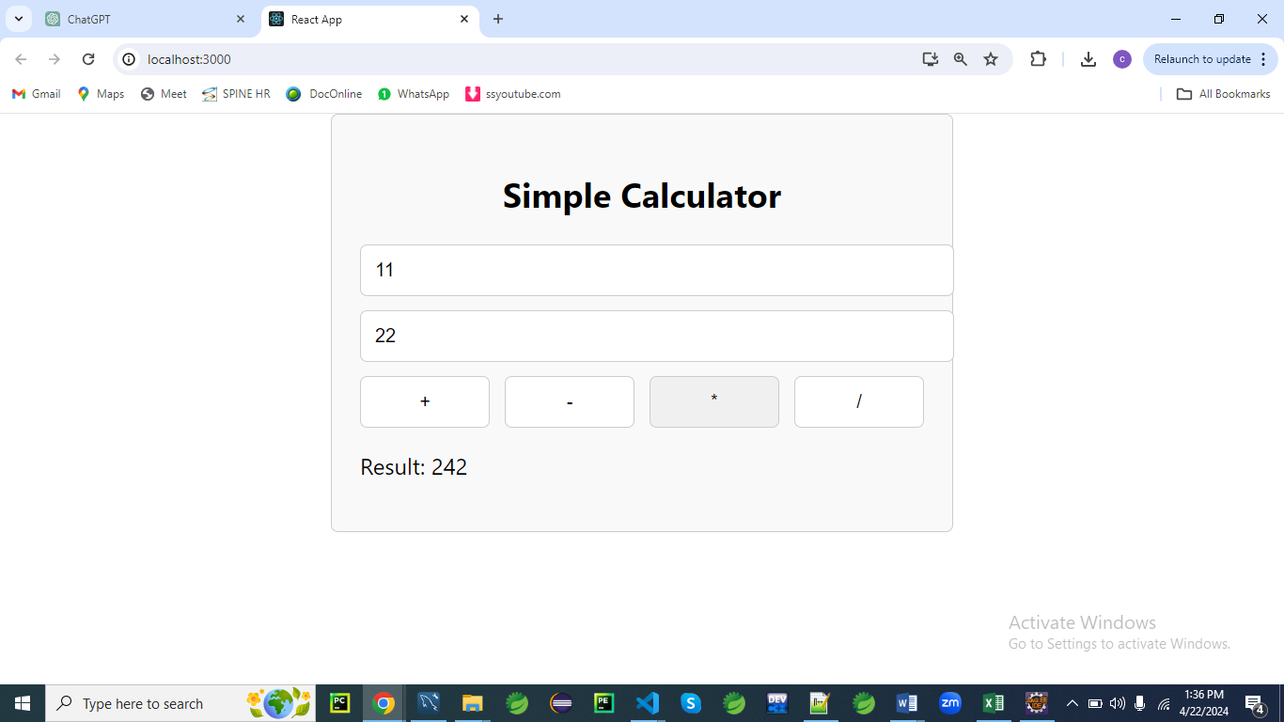

**Calculator.js**

import React, { useState } from 'react';

**import './Calculator.css'; // Import the CSS file**

function Calculator() {

const [num1, setNum1] = useState('');

const [num2, setNum2] = useState('');

const [result, setResult] = useState('');

const handleNum1Change = (e) => {

setNum1(e.target.value);

};

const handleNum2Change = (e) => {

setNum2(e.target.value);

};

const handleAdd = () => {

setResult(parseFloat(num1) + parseFloat(num2));

};

const handleSubtract = () => {

setResult(parseFloat(num1) - parseFloat(num2));

};

const handleMultiply = () => {

setResult(parseFloat(num1) * parseFloat(num2));

};

const handleDivide = () => {

setResult(parseFloat(num1) / parseFloat(num2));

};

return (

**<div className="calculator">**

<h2>Simple Calculator</h2>

<input type="number" value={num1} onChange={handleNum1Change} />

<input type="number" value={num2} onChange={handleNum2Change} />

**<div className="button-group">**

<button onClick={handleAdd}>+</button>

<button onClick={handleSubtract}>-</button>

<button onClick={handleMultiply}>*</button>

<button onClick={handleDivide}>/</button>

</div>

**<p className="result">Result: {result}</p>**

</div>

);

}

export default Calculator;

**Calculator.css**

.calculator {

max-width: 400px;

margin: 0 auto;

padding: 20px;

border: 1px solid #ccc;

border-radius: 5px;

background-color: #f9f9f9;

}

.calculator h2 {

text-align: center;

}

.calculator input {

width: 100%;

margin-bottom: 10px;

padding: 10px;

border: 1px solid #ccc;

border-radius: 5px;

}

.button-group {

display: flex;

justify-content: space-between;

}

.button-group button {

width: 23%;

padding: 10px;

border: 1px solid #ccc;

border-radius: 5px;

background-color: #fff;

cursor: pointer;

}

.button-group button:hover {

background-color: #f0f0f0;

}

.result {

font-size: 18px;

font-weight: bold;

text-align: center;

margin-top: 20px;

}

**App.js**

import React from 'react';

import Calculator from './Calculator';

function App() {

return (

<div>

<Calculator />

</div>

);

}

export default App;

**What is JSX in react?**

JSX, or JavaScript XML, is a syntax extension for JavaScript used in React.

It allows you to write HTML-like code within JavaScript files.

JSX makes it easier to create and visualize the structure of user interfaces in React by providing a more intuitive way to define components and their structure.

Here’s a quick breakdown of how JSX works:

1. **HTML-like Syntax**: JSX looks similar to HTML.

**For example:**

const element = <h1>Hello, world!</h1>;

<div>

        {element}

</div>

1. **Embedding Expressions**: You can embed JavaScript expressions within JSX using curly braces {}:

const name = 'John';

const element = <h1>Hello, {name}!</h1>;

1. **Attributes**: JSX allows you to use attributes similar to HTML attributes, but in camelCase:

const element = <img src="logo.png" alt="Logo" />;

1. **Children**: JSX can include children, making it possible to nest components:

const element = (

<div>

<h1>Hello, world!</h1>

<p>Welcome to React.</p>

</div>

);

1. **Expressions in JSX**: Any valid JavaScript expression can be embedded within curly braces:

const number = 5;

const element = <p>{number * 2}</p>; // Displays "10"

1. **JavaScript Functions**: You can define and use functions within JSX to create dynamic content:

function formatDate(date) {

return date.toLocaleDateString();

}

const element = <p>{formatDate(new Date())}</p>;

Under the hood, JSX is transformed into regular JavaScript function calls by tools like Babel.

For instance, the JSX above might be transformed into:

const element = React.createElement('h1', null, 'Hello, world!');

This makes JSX a powerful tool for creating user interfaces in React by combining the declarative nature of HTML with the power of JavaScript.

Here are a few simple programs to demonstrate JSX in React.

**1. Basic JSX Example**

This example shows how you can use JSX to create a simple element.

// App.js

import React from 'react';

function App() {

return <h1>Hello, world!</h1>;

}

export default App;

**Explanation**:

Here, App is a React component that returns a JSX element <h1>Hello, world!</h1>.

This will render a heading with the text "Hello, world!".

**2. Using JSX with JavaScript Expressions**

This example demonstrates embedding JavaScript expressions within JSX.

// App.js

import React from 'react';

function App() {

const name = 'John';

return <h1>Hello, {name}!</h1>;

}

export default App;

**Explanation**:

The **{name}** inside the JSX will be replaced by the value of the name variable, resulting in "Hello, John!" being displayed.

**3. JSX with Attributes**

This example shows how to use attributes in JSX.

// App.js

import React from 'react';

function App() {

return <img src="logo.png" alt="Logo" />;

}

export default App;

**Explanation**:

This JSX code creates an img element with the src and alt attributes.

logo.png will be used as the image source, and "Logo" will be the alternate text.

**4. JSX with Nested Elements**

This example illustrates how to nest JSX elements.

// App.js

import React from 'react';

function App() {

return (

<div>

<h1>Welcome to React!</h1>

<p>This is a simple example of JSX.</p>

</div>

);

}

export default App;

**Explanation**:

The div element contains two children: an h1 and a p.

This shows how JSX can be used to create a nested structure of elements.

**5. JSX with JavaScript Functions**

This example demonstrates using a JavaScript function within JSX.

// App.js

import React from 'react';

function formatDate(date) {

return date.toLocaleDateString();

}

function App() {

return <p>Today's date is {formatDate(new Date())}</p>;

}

export default App;

**Explanation**:

The formatDate function is called within JSX to format and display the current date.

{formatDate(new Date())} will be replaced with the formatted date.

These examples cover basic use cases for JSX in React.

They illustrate how JSX can make it easier to work with the structure and content of your UI components.

**6. Conditional Rendering in JSX**

This example shows how to conditionally render elements in JSX.

// App.js

import React from 'react';

function App() {

const isLoggedIn = true;

return (

<div>

<h1>Welcome to React!</h1>

{isLoggedIn ? <p>You are logged in.</p> : <p>Please log in.</p>}

</div>

);

}

export default App;

**Explanation**:

The {isLoggedIn ? <p>You are logged in.</p> : <p>Please log in.</p>} part conditionally renders one of the two paragraphs based on the value of isLoggedIn.

**7. Mapping an Array to JSX Elements**

This example demonstrates how to use the map function to create a list of JSX elements.

// App.js

import React from 'react';

function App() {

const items = ['Apple', 'Banana', 'Cherry'];

return (

<ul>

{items.map(item => <li key={item}>{item}</li>)}

</ul>

);

}

export default App;

**Explanation**:

The map function iterates over the items array, creating an li element for each item.

The key attribute is used to uniquely identify each list item.

**8. Event Handling in JSX**

This example shows how to handle events in JSX.

// App.js

import React from 'react';

function App() {

function handleClick() {

alert('Button clicked!');

}

return (

<button onClick={handleClick}>Click Me</button>

);

}

export default App;

**Explanation**:

The onClick attribute is used to handle the click event on the button.

When the button is clicked, the handleClick function is called, displaying an alert.

**9. Inline Styles in JSX**

This example demonstrates how to apply inline styles in JSX.

// App.js

import React from 'react';

function App() {

const divStyle = {

color: 'blue',

backgroundColor: 'lightgray',

padding: '10px',

borderRadius: '5px'

};

return (

<div style={divStyle}>

This is a styled div.

</div>

);

}

export default App;

**Explanation**:

The style attribute is used to apply inline styles to the div element.

The divStyle object contains the CSS properties in camelCase.

**10. Using Props in JSX**

This example shows how to pass and use props in a React component.

// App.js

import React from 'react';

function Greeting(props) {

return <h1>Hello, {props.name}!</h1>;

}

function App() {

return <Greeting name="Alice" />;

}

export default App;

**Explanation**:

The Greeting component takes a name prop and uses it within the JSX.

The App component passes the prop value "Alice" to Greeting.

**11. Fragments in JSX**

This example demonstrates using fragments to group multiple elements without adding extra nodes to the DOM.

// App.js

import React from 'react';

function App() {

return (

<>

<h1>Fragment Example</h1>

<p>This is a paragraph.</p>

</>

);

}

export default App;

**Explanation**:

The <> and </> syntax is used to create a fragment that groups the h1 and p elements without adding an extra div or other wrapper element to the DOM.

These additional examples illustrate various features and techniques in JSX, showcasing its flexibility and power in building React applications.

**Components in React**

In React, a "component" is a fundamental building block used to create user interfaces.

Components are reusable, encapsulated units that can represent a specific part of the UI, such as a button, a form, or an entire page layout.

They encapsulate logic, styles, and state, allowing developers to create modular and maintainable applications.

Here's an overview of what components in React are and why they are essential:

**What are Components?**

* **Encapsulation**: Components encapsulate both the logic and the presentation of a specific part of a user interface. This encapsulation promotes reusability and modularity.
* **Reusable Building Blocks**: Components can be used and reused throughout an application or even across different projects. This reusability leads to more consistent code and faster development.
* **Composition**: Components can contain other components, allowing for complex UIs to be built from smaller, simpler components.

**Types of Components**

* **Functional Components**: These are stateless by default but can use React Hooks to manage state and lifecycle events. They are lightweight and the preferred way to write components in modern React.

**Greeting.js**

const Greeting = ({ name }) => {

return <div>Hello, {name}!</div>;

};

export default Greeting;

**App.js**

function App() {

  return (

    <div>

     <Greeting name='Chandru'/>

    </div>

  );

}

* **Class Components**: These components use ES6 classes and are more heavyweight. They were the primary way to create components before the introduction of hooks. Class components use lifecycle methods and **this.state** for state management.

**Greeting.js**

class **Greeting** extends React.Component {

render() {

return <div>Hello, {this.props.name}!</div>;

}

}

export default Greeting;

**App.js**

import Greeting from './Greeting';

function **App**() {

  return (

    <div>

     <Greeting name='Chandru'/>

    </div>

  );

}

**Component Communication**

* **Props**:
  + Props (short for "properties") are the way data is passed from parent components to child components.
  + Props are read-only, meaning that a component can't change the props it receives from its parent.

**Child.js**

const **Child** = (props) => {

return (

<div>{props.message}</div>

);

};

export default Child;

**Parent.js**

import Child from './Child'

const **Parent** = () => {

return <Child message="Hello, World!" />;

};

export default Parent;

**App.js**

import Parent from './Parent';

// props

const **App** = () => {

  return(

    <Parent/>

  );

}

* **State**:
  + State represents mutable data within a component.
  + Functional components use the **useState** hook to manage state, while class components use **this.state** and **this.setState**.
  + State changes trigger re-renders, allowing components to respond dynamically to changes in data

import React, {useState} from 'react';

const Counter = () => {

    const [count, setCount] = useState(0);

    const increment = () => setCount(count + 1);

    return (

      <div>

        <p>Count: {count}</p>

        <button onClick={increment}>Increment</button>

      </div>

    );

  };

  export default Counter;

**Component Lifecycle**

* **Lifecycle**: Components have lifecycles, from mounting (when they first appear) to updating (when state or props change) to unmounting (when they are removed). In functional components, you manage lifecycles with the **useEffect** hook.

const Timer = () => {

useEffect(() => {

const timer = setInterval(() => console.log("Tick"), 1000);

return () => clearInterval(timer); // Cleanup on unmount

}, []);

return <div>Timer is running...</div>;

};

**Component Best Practices**

* **Single Responsibility**: Components should have a single responsibility, making them easier to understand and maintain.
* **Modular Design**: Build applications by composing smaller components. This approach leads to more maintainable and scalable code.
* **Reusability**: Design components to be reusable and flexible. Pass data through props and avoid hardcoding specific logic or styles.

**Conclusion**

Components in React are the basic building blocks of any React application.

They allow developers to create complex user interfaces by composing and reusing smaller units.

By mastering the use of components, you can create scalable, maintainable, and modular React applications.

**Example of Component**

Creating a simple React component involves setting up a basic component structure, defining its appearance and behavior, and integrating it into a larger React application.

Here's a simple example of a functional component in React, which is the preferred method for creating components since React 16.8, when React Hooks were introduced.

**Simple Functional Component**

Let's create a simple component that displays a greeting message.

We'll pass the name to be greeted as a prop.

**Greeting.js**

import React from 'react';

// Define the Greeting component

const Greeting = ({ name }) => {

return <h1>Hello, {name}!</h1>;

};

export default Greeting;

**Explanation:**

* **Functional Component**: The **Greeting** component is a functional component, meaning it is defined as a JavaScript function. Functional components are simple and typically use React Hooks for state and lifecycle management.
* **Props**: The **name** prop is passed to the component, allowing it to dynamically display different greetings depending on the input.
* **JSX**: JSX is a syntax extension for JavaScript that looks similar to HTML but allows for embedding JavaScript expressions. The **Greeting** component returns a JSX element—a heading with a greeting message.

**Integrating the Component into a React Application**

To use this component in a larger React application, you would import it into a parent component and pass the required props.

Here's an example where the **Greeting** component is used within another component:

import React from 'react';

import Greeting from './Greeting'; // Import the Greeting component

const App = () => {

return (

<div>

<Greeting name="Alice" /> {/* Use the Greeting component with the name prop */}

</div>

);

};

export default App;

**Explanation**

* **Parent Component**: The **App** component serves as the parent component where we import and use the **Greeting** component.
* **Using Props**: The **Greeting** component is used with the **name** prop set to "Alice". This allows the component to display the appropriate greeting message.

**Running the Example**

To run this example in a React application, you would need a development environment set up with Node.js and a tool like Create React App.

If you're using Create React App, you can add the **Greeting** component to the **src** folder and update the **App.js** file to include it, as shown above.

Afterward, start the development server, and you should see the greeting message in your browser.

This simple example demonstrates the basic structure of a React component, how to pass props to it, and how to integrate it into a larger application.

You can build upon this foundation to create more complex components and applications in React.

**Class Component**

A class component in React is a component defined using an ES6 class that extends the **React.Component** base class.

Class components were the primary way to define components in React before the introduction of functional components with hooks.

They support features like local state management and lifecycle methods, allowing you to define complex behavior within the component.

Here is an overview of what a class component is and an example program to illustrate its use:

**What is a Class Component?**

* **Inheritance**: Class components inherit from **React.Component**, giving them access to various features like state management and lifecycle methods.
* **State Management**: Class components can have internal state, defined using **this.state**, and can update this state with **this.setState**.
* **Lifecycle Methods**: Class components support various lifecycle methods, like **componentDidMount**, **componentDidUpdate**, and **componentWillUnmount**, which control what happens at different stages in the component's life cycle.

**Example Program for a Class Component**

Here's a simple example of a class component that manages a counter state and provides a button to increment the counter.

**Counter.js**

import React from 'react';

class Counter extends React.Component {

constructor(props) {

super(props);

// Initialize the state with a count of 0

this.state = {

count: 0,

};

}

// Method to increment the count

increment = () => {

this.setState((prevState) => ({

count: prevState.count + 1,

}));

};

render() {

// Use this.state to access the current state

return (

<div>

<p>Current count: {this.state.count}</p>

<button onClick={this.increment}>Increment</button> {/* Button to increment */}

</div>

);

}

}

export default Counter;

**Explanation**

* **Constructor**: The **Counter** component's constructor initializes the state. It also calls **super(props)** to ensure the base class is initialized correctly.
* **State**: The **count** state is initialized to 0 in the constructor. Class components use **this.state** to manage internal state.
* **Method Definition**: The **increment** method updates the state using **this.setState**. The **setState** method schedules a re-render with the updated state.
* **Rendering**: The **render** method returns the JSX for the component. It displays the current count and a button that, when clicked, increments the count.
* **Event Handling**: The button uses the **onClick** event to call the **increment** method when clicked.

**Using the Class Component**

To use this class component in a React application, you would import it into another component or a main application file, like **App.js**, and include it in the JSX:

import React from 'react';

import Counter from './Counter'; // Import the Counter class component

const App = () => {

return (

<div>

<Counter /> {/* Use the Counter class component */}

</div>

);

};

export default App;

**Key Points**

While class components offer robust functionality with state and lifecycle management, functional components with hooks are now the preferred approach in modern React development.

Class components are still used in existing codebases and in some specific scenarios, but for new development, most developers opt for functional components due to their simplicity and React Hooks' flexibility.

**Props and State**:

In React, **props** and **state** are two fundamental concepts used to manage data and control the behaviour of components.

Here’s an overview of each:

**Props**

**Props** (short for "properties") are a mechanism for passing data from a parent component to a child component.

Props are read-only, meaning that a child component cannot modify the props it receives.

They are used to configure or customize a component.

**Key Characteristics:**

* **Immutable**: Props are immutable. The child component receives the props but cannot change them.
* **Passed Down**: Props are passed from parent components to child components.
* **Read-Only**: Components that receive props can only read them; they cannot modify them.

**Example**

Here’s an example of using props in React:

**Parent Component:**

import React from 'react';

import Greeting from './Greeting';

function App() {

return (

<div>

<Greeting name="Alice" />

<Greeting name="Bob" />

</div>

);

}

export default App;

**Child Component (Greeting.js):**

import React from 'react';

function Greeting(props) {

return <h1>Hello, {props.name}!</h1>;

}

export default Greeting;

**In this example:**

* The **App** component is passing different names as props to the **Greeting** component.
* The **Greeting** component receives the name prop and uses it to render a personalized message.

**State**

**State** is a mechanism for managing data that can change over time within a component.

Unlike props, state is managed within the component and can be modified by the component itself, typically through user interactions or other events.

**Key Characteristics:**

* **Mutable**: State is mutable. Components can modify their own state.
* **Local**: State is specific to a component. Changes to state in one component do not affect other components unless explicitly shared.
* **Managed Internally**: State is managed internally within a component and can change based on user interactions or lifecycle events.

**Example**

Here’s an example of using state in a React function component:

**Counter Component:**

import React, { useState } from 'react';

function Counter() {

const [count, setCount] = useState(0);

const increment = () => {

setCount(count + 1);

};

const decrement = () => {

setCount(count - 1);

};

return (

<div>

<h1>Count: {count}</h1>

<button onClick={increment}>Increment</button>

<button onClick={decrement}>Decrement</button>

</div>

);

}

export default Counter;

In this example:

* The **Counter** component uses the **useState** hook to manage the **count state**.
* The **increment** and **decrement** functions modify the **count state.**
* The component re-renders whenever the state changes, reflecting the updated count in the UI.

**Summary**

* **Props**: Used to pass data from parent to child components. They are read-only and immutable.
* **State**: Used to manage data that can change over time within a component. It is mutable and managed internally by the component.

By understanding and leveraging both props and state, you can effectively manage data and interactions within your React applications.

**Example 01**

Let's create a larger example of a React application that includes a form.

This example will demonstrate both **props** and **state**:

**Overview**

The application will include:

1. **Parent Component**:
   * Manages the form data and passes props to child components.
2. **Child Components**:
   * **Form Component**: A large form that takes user input.
   * **FormField Component**: Represents individual input fields within the form.
   * **Summary Component**: Displays the submitted form data.

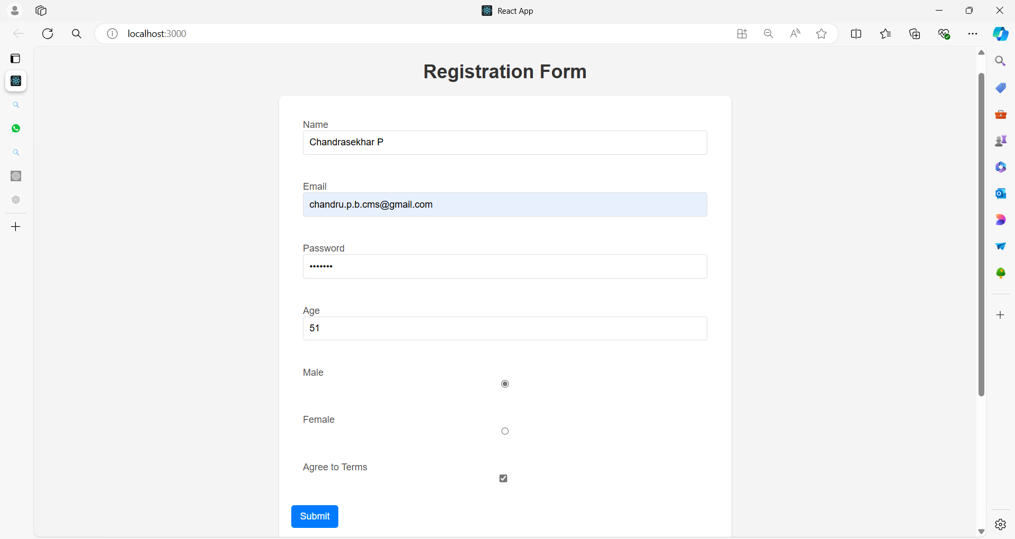

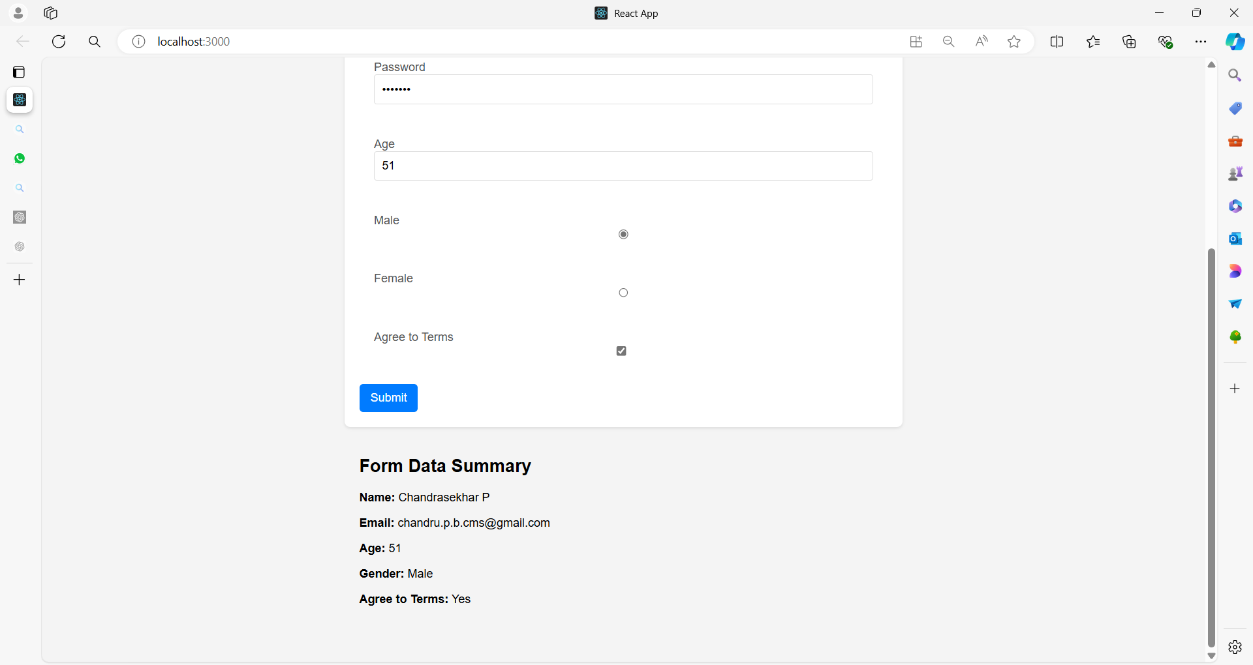

**Full Example**

**1. App Component (Parent)**

The App component will manage the form state and handle the form submission.

**App.js**

import React, { useState } from 'react';

import Form from './Form';

import Summary from './Summary';

import './App.css'

function App() {

const [formData, setFormData] = useState({

name: '',

email: '',

password: '',

age: '',

gender: '',

agreeToTerms: false,

});

const handleInputChange = (event) => {

const { name, value, type, checked } = event.target;

setFormData({

...formData,

[name]: type === 'checkbox' ? checked : value,

});

};

const handleSubmit = (event) => {

event.preventDefault();

// Handle form submission, e.g., send data to a server

console.log('Form submitted:', formData);

};

return (

<div>

<h1>Registration Form</h1>

<Form formData={formData} onInputChange={handleInputChange} onSubmit={handleSubmit} />

<Summary data={formData} />

</div>

);

}

export default App;

**Explanation**

Here's a line-by-line explanation of the App component code:

**1. Importing React and useState Hook**

**import React, { useState } from 'react';**

* **Purpose:** This line imports React and the useState hook from the react library.
* **React:** Required to create React components and manage the component lifecycle.
* **useState:** A hook that allows functional components to have state.

**2. Importing Other Components**

**import Form from './Form';**

**import Summary from './Summary';**

* **Purpose:** This line imports two custom components, Form and Summary, from their respective files.
* **Form Component:** Likely handles rendering and managing the input fields of the form.
* **Summary Component:** Displays a summary of the form data or any other relevant information.

**3. Defining the App Component**

**function App() {**

* **Purpose:** This line defines a functional component named App.
* **Functional Component:** This is a basic React component that returns JSX to render UI elements.

**4. Setting Up State with useState**

**const [formData, setFormData] = useState({**

**name: '',**

**email: '',**

**password: '',**

**age: '',**

**gender: '',**

**agreeToTerms: false,**

**});**

* **Purpose:** This line initializes the state of the component with an object formData.
* **useState:** Returns an array with two elements: the current state (formData) and a function to update it (setFormData).
* **Initial State:** The state object has properties for various form fields with default values (empty strings or false).

**{**

**name: '',**

**email: '',**

**password: '',**

**age: '',**

**gender: '',**

**agreeToTerms: false,**

**}**

**Purpose:** This is a JavaScript object that represents the initial state of the form data.

**Fields and Their Initial Values**

* **name: ''**
  + **Field:** Represents the name of the user.
  + **Initial Value:** An empty string (''). Indicates that the name field starts empty.
* **email: ''**
  + **Field:** Represents the email address of the user.
  + **Initial Value:** An empty string (''). Indicates that the email field starts empty.
* **password: ''**
  + **Field:** Represents the password of the user.
  + **Initial Value:** An empty string (''). Indicates that the password field starts empty.
* **age: ''**
  + **Field:** Represents the age of the user.
  + **Initial Value:** An empty string (''). Indicates that the age field starts empty.
* **gender: ''**
  + **Field:** Represents the gender of the user.
  + **Initial Value:** An empty string (''). Indicates that the gender field starts empty.
* **agreeToTerms: false**
  + **Field:** Represents whether the user agrees to the terms and conditions.
  + **Initial Value:** false. Indicates that the checkbox for agreeing to terms is initially unchecked.

**Usage in State Management**

* **Purpose:** This object serves as the initial state for a form in a React component.
* **State Management:** The useState hook initializes the state with this object. As users interact with the form, the values in this object will be updated accordingly.

**Updating State**

* **Dynamic Updates:** When a user inputs data into the form fields, the state object will be updated. For instance, when a user types their name into the name field, the name property in the state object will be updated with the new value.

**5. Form Handling**

* **Data Handling:** This initial state structure helps to manage form data in a centralized manner, making it easier to handle form submissions, validations, and other interactions.

**5. Handling Input Changes**

**const handleInputChange = (event) => {**

**const { name, value, type, checked } = event.target;**

**setFormData({**

**...formData,**

**[name]: type === 'checkbox' ? checked : value,**

**});**

**};**

* **Purpose:** This function updates the state whenever an input field changes.
* **Destructuring:** Extracts name, value, type, and checked from the event target.
* **Conditional Update:** **If the input type is 'checkbox', it updates the state with checked; otherwise, it uses value.**

**setFormData({**

**...formData,**

**[name]: type === 'checkbox' ? checked : value,**

**});**

**1. Function Call**

**setFormData({**

**// State update logic here**

**});**

* **Purpose:** Calls the setFormData function to update the formData state with a new value.
* **setFormData:** A state updater function provided by the useState hook.

**2. Spread Operator (...formData)**

**...formData**

* **Purpose:** This is the JavaScript spread operator.
* **Function:** It copies all the existing properties and values from the formData object into the new object being created.
* **Benefit:** Ensures that all existing form data is preserved while updating only the specific field that changed.

**3. Dynamic Property Name**

**[name]: type === 'checkbox' ? checked : value**

* **Purpose:** Updates a specific property in the formData object.
* **Dynamic Property:** [name] uses the value of the name variable as the key for the property to be updated.
* **Conditional Value:**
  + **type === 'checkbox' ? checked : value:** A ternary operator that determines the new value for the property based on the input type.
  + **checked:** The value for checkbox inputs. It’s either true or false, reflecting whether the checkbox is checked or not.
  + **value:** The value for other input types (text, email, etc.). It reflects the current value of the input field.

**4. Overall Function**

Combining the above elements, the line does the following:

* **Preserve Existing Data:** The spread operator (...formData) copies the existing state into the new object.
* **Update Specific Field:** The property identified by name is updated with a new value, which is determined based on the input type.
* **Handle Different Input Types:** For checkboxes, it uses the checked property. For other input types, it uses the value property.

**6. Handling Form Submission**

**const handleSubmit = (event) => {**

**event.preventDefault();**

**// Handle form submission, e.g., send data to a server**

**console.log('Form submitted:', formData);**

**};**

* **Purpose:** This function handles the form submission event.
* **event.preventDefault():** Prevents the default form submission behavior (page reload).
* **Logging Data:** Prints the form data to the console (could be replaced with actual submission logic).

**7. Rendering the Component**

**return (**

**<div>**

**<h1>Registration Form</h1>**

**<Form**

**formData={formData}**

**onInputChange={handleInputChange}**

**onSubmit={handleSubmit} />**

**<Summary data={formData} />**

**</div>**

**);**

* **Purpose:** This section defines what the component will render.
* **<h1>:** Displays a heading for the form.
* **<Form />:** Renders the Form component, passing formData, handleInputChange, and handleSubmit as props.
* **<Summary />:** Renders the Summary component, passing formData as a prop.

**8. Exporting the Component**

**export default App;**

* **Purpose:** This line exports the App component as the default export of the file.
* **Export:** Allows other files to import and use the App component.

**Summary**

1. **Imports:** Bring in React, hooks, and other components.
2. **State Setup:** Initializes form data state and its updater function.
3. **Input Handling:** Updates state based on user input, handling different input types.
4. **Form Submission:** Prevents default submission and logs form data.
5. **Rendering:** Renders the UI with Form and Summary components, passing necessary props.

**2. Form Component (Child)**

The Form component renders the form and individual fields, and it receives form data and change handlers as props.

**Form.js**

import React from 'react';

import FormField from './FormField';

function Form({ formData, onInputChange, onSubmit }) {

return (

<form onSubmit={onSubmit}>

<FormField

label="Name"

name="name"

value={formData.name}

onChange={onInputChange}

/>

<FormField

label="Email"

name="email"

value={formData.email}

onChange={onInputChange}

/>

<FormField

label="Password"

name="password"

type="password"

value={formData.password}

onChange={onInputChange}

/>

<FormField

label="Age"

name="age"

type="number"

value={formData.age}

onChange={onInputChange}

/>

<FormField

label="Male"

name="gender"

type="radio"

value="Male"

checked={formData.gender === 'Male'}

onChange={onInputChange}

/>

<FormField

label="Female"

name="gender"

type="radio"

value="Female"

checked={formData.gender === 'Female'}

onChange={onInputChange}

/>

<FormField

label="Agree to Terms"

name="agreeToTerms"

type="checkbox"

checked={formData.agreeToTerms}

onChange={onInputChange}

/>

<button type="submit">Submit</button>

</form>

);

}

export default Form;

Let's explain each line in detail.

**1. Importing React**

**import React from 'react';**

1. **import React**: Imports the React object from the react library.
2. **from 'react'**: Specifies the source module, which is react.
3. **React**: The default export from the react library, required to use JSX and create React components.
4. **Required for JSX**: JSX (JavaScript XML) syntax is used to describe what the UI should look like. React must be in scope to transform this syntax into JavaScript.
5. **No JSX Without It**: Even if you don’t directly use React in your code, it’s needed for JSX compilation.

**2. Importing FormField**

**import FormField from './FormField';**

1. **import FormField**: Imports the FormField component.
2. **from './FormField'**: Specifies the local file from which to import FormField, assumed to be FormField.js.
3. **Component Reusability**: Allows the Form component to use FormField, promoting code reuse.
4. **Local Import**: The ./ indicates that FormField is in the same directory as the current file.
5. **File Resolution**: The imported file should export FormField as default or named export.

**3. Function Declaration**

**function Form({ formData, onInputChange, onSubmit }) {**

1. **function Form**: Declares a functional component named Form.
2. **Destructuring Props**: { formData, onInputChange, onSubmit } destructures props directly in the function parameters for easier access.
3. **Component Purpose**: Form is a React component used to render a form.
4. **Props**: This component expects three props: formData, onInputChange, and onSubmit.
5. **Function Scope**: The component function defines the scope where local logic and rendering logic reside.

**4. Form Element**

**return (**

**<form onSubmit={onSubmit}>**

1. **return**: Specifies what the Form component should render.
2. **<form>**: HTML element that defines the form.
3. **onSubmit={onSubmit}**: Sets the form's onSubmit event handler to the onSubmit function passed as a prop.
4. **Event Handling**: The onSubmit handler will be triggered when the form is submitted.
5. **Form Behavior**: This setup allows custom behavior for form submission through the handler.

**5. Name Field**

**<FormField**

**label="Name"**

**name="name"**

**value={formData.name}**

**onChange={onInputChange}**

**/>**

1. **<FormField>**: Uses the FormField component to render a form field.
2. **label="Name"**: Sets the label for the input field.
3. **name="name"**: Defines the name attribute for the input element, identifying it in the form data.
4. **value={formData.name}**: Binds the input’s value to formData.name from the parent component's state.
5. **onChange={onInputChange}**: Passes the onInputChange handler to manage updates to this field's value.

**6. Email Field**

**<FormField**

**label="Email"**

**name="email"**

**value={formData.email}**

**onChange={onInputChange}**

**/>**

1. **<FormField>**: Another instance of the FormField component.
2. **label="Email"**: Sets the label for this input field to "Email".
3. **name="email"**: Sets the name attribute for this input element.
4. **value={formData.email}**: Binds the input’s value to formData.email.
5. **onChange={onInputChange}**: Uses the same onInputChange handler for this field.

**7. Password Field**

**<FormField**

**label="Password"**

**name="password"**

**type="password"**

**value={formData.password}**

**onChange={onInputChange}**

**/>**

1. **<FormField>**: Another FormField instance, this time for a password input.
2. **label="Password"**: Sets the label for the field to "Password".
3. **name="password"**: Defines the name attribute for the password field.
4. **type="password"**: Sets the input type to "password" to obscure the input characters.
5. **value={formData.password}**: Binds the input value to formData.password.

**8. Age Field**

**<FormField**

**label="Age"**

**name="age"**

**type="number"**

**value={formData.age}**

**onChange={onInputChange}**

**/>**

1. **<FormField>**: Used to render an input field for age.
2. **label="Age"**: Sets the label to "Age".
3. **name="age"**: Defines the name attribute.
4. **type="number"**: Sets the input type to "number" to restrict input to numeric values.
5. **value={formData.age}**: Binds the value to formData.age.

**9. Male Radio Button**

**<FormField**

**label="Male"**

**name="gender"**

**type="radio"**

**value="Male"**

**checked={formData.gender === 'Male'}**

**onChange={onInputChange}**

**/>**

1. **<FormField>**: Renders a radio button for "Male".
2. **label="Male"**: Sets the label for this radio button.
3. **name="gender"**: Defines the name attribute to group radio buttons.
4. **type="radio"**: Specifies that this input is a radio button.
5. **checked={formData.gender === 'Male'}**: Conditionally checks this radio button if formData.gender is "Male".

**10. Female Radio Button**

**<FormField**

**label="Female"**

**name="gender"**

**type="radio"**

**value="Female"**

**checked={formData.gender === 'Female'}**

**onChange={onInputChange}**

**/>**

1. **<FormField>**: Renders a radio button for "Female".
2. **label="Female"**: Sets the label for this radio button.
3. **name="gender"**: Uses the same name as the "Male" radio button to group them.
4. **type="radio"**: Indicates that this is a radio button.
5. **checked={formData.gender === 'Female'}**: Checks this radio button if formData.gender is "Female".

**11. Agree to Terms Checkbox**

**<FormField**

**label="Agree to Terms"**

**name="agreeToTerms"**

**type="checkbox"**

**checked={formData.agreeToTerms}**

**onChange={onInputChange}**

**/>**

1. **<FormField>**: Renders a checkbox input.
2. **label="Agree to Terms"**: Sets the label for this checkbox.
3. **name="agreeToTerms"**: Defines the name attribute for this input.
4. **type="checkbox"**: Specifies that this input is a checkbox.
5. **checked={formData.agreeToTerms}**: Binds the checked state to formData.agreeToTerms.

**12. Submit Button**

**<button type="submit">Submit</button>**

1. **<button>**: Defines a button element.
2. **type="submit"**: Sets the button type to "submit", which triggers form submission when clicked.
3. **Submit**: The text displayed on the button.
4. **button Element**: Represents a clickable button in the form.
5. **Form Submission**: Clicking this button will trigger the onSubmit event handler specified in the form.

**13. Closing Form Tag**

**</form>**

**);**

1. **</form>**: Closes the form element.
2. **</form>**: Ensures the form is properly closed after all fields and the submit button.
3. **Form Scope**: Defines the end of the form section.
4. **return Statement Ends**: Completes the return statement of the Form component.
5. **Form Layout**: Properly closing tags ensures correct rendering of form elements.

**14. Exporting Form Component**

**export default Form;**

1. **export default Form;**: Exports the Form component as the default export from this module.
2. **Default Export**: Allows importing this component in other files without curly braces.
3. **Component Availability**: Makes Form available for use in other parts of the application.
4. **Module System**: Part of ES6 module system for managing imports and exports.
5. **Usage**: Simplifies importing Form elsewhere in your codebase.

Each line is designed to define, configure, and manage different aspects of a form within a React component.

**3. FormField Component (Child)**

The FormField component is a reusable component for rendering individual form fields.

**FormField.js**

import React from 'react';

function FormField({ label, name, type = 'text', value, checked, onChange }) {

return (

<div>

<label>

{label}

{type === 'checkbox' ? (

<input

type={type}

name={name}

checked={checked}

onChange={onChange}

/>

) : (

<input

type={type}

name={name}

value={value}

onChange={onChange}

/>

)}

</label>

</div>

);

}

export default FormField;

Let's break down this FormField component line by line, providing five points for each section:

**1. Importing React**

**import React from 'react';**

1. **import React**: Imports the React object from the react library.
2. **from 'react'**: Specifies the source module for the import.
3. **React**: The default export from react, needed to use JSX syntax.
4. **JSX Compilation**: React must be in scope to compile JSX into JavaScript.
5. **React Dependency**: Essential for defining and rendering React components.

**2. Function Declaration**

**function FormField({ label, name, type = 'text', value, checked, onChange }) {**

1. **function FormField**: Declares a functional React component named FormField.
2. **Destructuring Props**: { label, name, type = 'text', value, checked, onChange } destructures the props directly in the function parameters.
3. **Default Prop Value**: type = 'text' sets a default value for the type prop if it is not provided.
4. **Component Purpose**: FormField is used to render various types of form inputs with a label.
5. **Function Scope**: This function will define the rendering and behavior of the FormField component.

**3. Returning JSX**

**return (**

**<div>**

1. **return**: Specifies the JSX to be rendered by the FormField component.
2. **<div>**: Starts a div element to contain the form field and label.
3. **Container Element**: div serves as a container for the label and input.
4. **Wrapper**: Provides a wrapper for styling and layout purposes.
5. **Enclosing JSX**: All JSX elements within the return statement must be enclosed in a single parent element.

**4. Label Element**

**<label>**

**{label}**

1. **<label>**: HTML element used to label form controls.
2. **{label}**: Inserts the value of the label prop into the label element.
3. **Text Content**: The label text is displayed to the user.
4. **Accessibility**: Labels are important for accessibility, linking form inputs with their descriptions.
5. **Dynamic Content**: The label text can be dynamically set based on the label prop.

**5. Conditional Rendering for Checkbox**

**{type === 'checkbox' ? (**

**<input**

**type={type}**

**name={name}**

**checked={checked}**

**onChange={onChange}**

**/>**

**) : (**

1. **{type === 'checkbox' ? ( ... )**: Uses a ternary operator to conditionally render different input types based on the type prop.
2. **Checkbox Input**: If type is 'checkbox', an input element of type checkbox is rendered.
3. **type={type}**: Sets the type attribute to 'checkbox'.
4. **name={name}**: Sets the name attribute for form submission.
5. **checked={checked}**: Binds the checked state to the checked prop.

**6. Conditional Rendering for Other Inputs**

**<input**

**type={type}**

**name={name}**

**value={value}**

**onChange={onChange}**

**/>**

**)}**

1. **<input>**: Renders an input element for non-checkbox types.
2. **type={type}**: Sets the type attribute (e.g., text, password, number).
3. **name={name}**: Sets the name attribute for the input.
4. **value={value}**: Binds the value of the input to the value prop.
5. **onChange={onChange}**: Passes the onChange handler to manage input changes.

**7. Closing Tags**

**</label>**

**</div>**

**);**

**}**

1. **</label>**: Closes the label element.
2. **</div>**: Closes the div element.
3. **);**: Ends the return statement of the FormField component.
4. **Component Layout**: Properly closes all opened HTML elements.
5. **Render Completion**: Completes the JSX structure for the component.

**8. Exporting Component**

**export default FormField;**

1. **export default FormField;**: Exports the FormField component as the default export from this module.
2. **Default Export**: Allows importing FormField without curly braces.
3. **Component Availability**: Makes the FormField component available for use in other parts of the application.
4. **Module System**: Utilizes ES6 module syntax for exporting components.
5. **Ease of Use**: Simplifies importing and using the FormField component in other files.

This FormField component is a versatile component used for rendering form fields with labels, handling various input types (e.g., text, checkbox), and managing state changes.

**4. Summary Component (Child)**

The Summary component displays the submitted form data.

**Summary.js**

import React from 'react';

function Summary({ data }) {

return (

<div>

<h2>Form Data Summary</h2>

<p><strong>Name:</strong> {data.name}</p>

<p><strong>Email:</strong> {data.email}</p>

<p><strong>Age:</strong> {data.age}</p>

<p><strong>Gender:</strong> {data.gender}</p>

<p><strong>Agree to Terms:</strong> {data.agreeToTerms ? 'Yes' : 'No'}</p>

</div>

);

}

export default Summary;

Let's break down this Summary component line by line, providing five points for each section:

**1. Importing React**

**import React from 'react';**

1. **import React**: Imports the React object from the react library.
2. **from 'react'**: Specifies the module from which to import React.
3. **React**: Required for JSX syntax and to define React components.
4. **JSX Compilation**: React must be in scope to transform JSX into JavaScript.
5. **Essential for Components**: Necessary for any React component that uses JSX.

**2. Function Declaration**

**function Summary({ data }) {**

1. **function Summary**: Declares a functional React component named Summary.
2. **Destructuring Props**: { data } destructures the data prop directly in the function parameters.
3. **Component Purpose**: Summary is used to display a summary of form data.
4. **Prop Handling**: Expects a single prop named data, which contains the form data.
5. **Functional Component**: Defines a component using a function, making it stateless.

**3. Returning JSX**

**return (**

**<div>**

1. **return**: Specifies what the Summary component should render.
2. **<div>**: Starts a div element to contain the summary information.
3. **Container Element**: div is used as a container for the summary content.
4. **Wrapper**: Provides a structural wrapper for styling and layout.
5. **Enclosing JSX**: All JSX elements within the return statement are enclosed in a single parent element.

**4. Title Element**

**<h2>Form Data Summary</h2>**

1. **<h2>**: HTML heading element for the title of the summary.
2. **Title Text**: The text "Form Data Summary" provides a clear heading for the summary section.
3. **Semantic HTML**: <h2> helps with document structure and SEO.
4. **Visual Hierarchy**: Displays the title prominently on the page.
5. **Content Separation**: Distinguishes the summary section from other content.

**5. Name Display**

**<p><strong>Name:</strong> {data.name}</p>**

1. **<p>**: HTML paragraph element to display a piece of information.
2. **<strong>**: HTML element to bold the label "Name:".
3. **{data.name}**: Inserts the value of data.name from the data prop.
4. **Dynamic Content**: Displays the name dynamically based on the data prop.
5. **Text Formatting**: Provides clear and readable formatting for the summary data.

**6. Email Display**

**<p><strong>Email:</strong> {data.email}</p>**

1. **<p>**: HTML paragraph element for displaying email information.
2. **<strong>**: Bolds the label "Email:" for emphasis.
3. **{data.email}**: Inserts the value of data.email from the data prop.
4. **Dynamic Content**: Displays the email address dynamically.
5. **Consistent Formatting**: Maintains the same formatting style as other data points.

**7. Age Display**

**<p><strong>Age:</strong> {data.age}</p>**

1. **<p>**: HTML paragraph element for displaying the age.
2. **<strong>**: Bolds the label "Age:".
3. **{data.age}**: Inserts the value of data.age from the data prop.
4. **Dynamic Content**: Shows the age based on the provided data.
5. **Uniform Style**: Follows the same formatting as the other pieces of information.

**8. Gender Display**

**<p><strong>Gender:</strong> {data.gender}</p>**

1. **<p>**: HTML paragraph element for displaying gender information.
2. **<strong>**: Bolds the label "Gender:".
3. **{data.gender}**: Inserts the value of data.gender from the data prop.
4. **Dynamic Content**: Displays the gender dynamically.
5. **Consistent Formatting**: Maintains formatting consistency with other data points.

**9. Agree to Terms Display**

**<p><strong>Agree to Terms:</strong> {data.agreeToTerms ? 'Yes' : 'No'}</p>**

1. **<p>**: HTML paragraph element for displaying the agreement status.
2. **<strong>**: Bolds the label "Agree to Terms:".
3. **Conditional Rendering**: Uses a ternary operator to display 'Yes' if data.agreeToTerms is true, otherwise 'No'.
4. **Dynamic Content**: Shows the agreement status based on the data prop.
5. **Readability**: Provides a clear and readable summary of whether the terms were agreed to.

**10. Closing Tags**

**</div>**

**);**

**}**

1. **</div>**: Closes the div element.
2. **Component Closure**: Ends the container element for the summary content.
3. **);**: Ends the return statement of the Summary component.
4. **Component Layout**: Properly closes all opened HTML elements.
5. **Completion**: Marks the end of the JSX structure and component function.

**11. Exporting Component**

**export default Summary;**

1. **export default Summary;**: Exports the Summary component as the default export from this module.
2. **Default Export**: Allows importing Summary without curly braces.
3. **Component Availability**: Makes the Summary component available for use in other parts of the application.
4. **Module System**: Uses ES6 module syntax for exporting components.
5. **Simplified Import**: Simplifies the import process in other files.

The Summary component is designed to present a summary of the form data in a readable and organized manner, leveraging dynamic content insertion and conditional rendering for clear and effective display

**CSS**

Here’s a set of CSS styles for each component in your React application. The styles aim to make the form and summary components look clean and user-friendly.

**1. App.css**

/* App.css */

body {

font-family: Arial, sans-serif;

margin: 0;

padding: 0;

background-color: #f4f4f4;

}

div {

padding: 20px;

max-width: 800px;

margin: 0 auto;

}

h1 {

text-align: center;

color: #333;

}

**2. Form.css**

/* Form.css */

form {

background-color: #fff;

padding: 20px;

border-radius: 8px;

box-shadow: 0 2px 4px rgba(0, 0, 0, 0.1);

}

button {

background-color: #007bff;

color: #fff;

border: none;

padding: 10px 15px;

font-size: 16px;

border-radius: 5px;

cursor: pointer;

margin-top: 10px;

}

button:hover {

background-color: #0056b3;

}

**3. FormField.css**

/* FormField.css */

div {

margin-bottom: 15px;

}

label {

display: flex;

flex-direction: column;

margin-bottom: 5px;

color: #555;

}

input {

padding: 10px;

font-size: 16px;

border: 1px solid #ddd;

border-radius: 4px;

}

input[type="checkbox"] {

width: auto;

margin-right: 10px;

}

input[type="radio"] {

margin-right: 5px;

}

**4. Summary.css**

/* Summary.css */

div {

background-color: #fff;

padding: 20px;

border-radius: 8px;

box-shadow: 0 2px 4px rgba(0, 0, 0, 0.1);

margin-top: 20px;

}

h2 {

text-align: center;

color: #333;

}

p {

margin: 5px 0;

font-size: 16px;

}

strong {

color: #333;

}

**Component Imports in Each File**

Make sure to import the corresponding CSS file in each React component file:

**App.js**

import './App.css';

**Form.js**

import './Form.css';

**FormField.js**

import './FormField.css';

**Summary.js**

import './Summary.css';

**Summary of CSS Styles**

1. **App.css:**
   * Sets global styles including font, margin, and background color.
   * Centers the content and applies padding.
2. **Form.css:**
   * Styles the form with padding, background color, and a box shadow.
   * Styles the submit button with a blue background and hover effect.
3. **FormField.css:**
   * Provides styling for individual form fields.
   * Ensures consistent margin, padding, and border styling.
   * Adjusts styling for checkboxes and radio buttons.
4. **Summary.css:**
   * Styles the summary section with padding, background color, and box shadow.
   * Centers the title and adjusts spacing for summary items.

These styles should make your form and summary components visually appealing and user-friendly. Adjust the colors, fonts, and spacing as needed to match your design preferences.

**Explanation**

1. **App Component**:
   * Manages the formData state and handles changes to form inputs and form submission.
   * Passes the formData and handleInputChange function as props to the Form component.
   * Passes the formData to the Summary component for displaying the submitted data.
2. **Form Component**:
   * Receives formData, onInputChange, and onSubmit as props.
   * Renders individual FormField components for different types of input fields.
3. **FormField Component**:
   * A reusable component for rendering different types of form fields.
   * Handles different input types like text, password, number, radio, and checkbox.
4. **Summary Component**:
   * Receives the form data and displays it in a summary format.

**Running the Example**

1. **Setup**:
   * Ensure you have create-react-app installed. Create a new React application if you haven’t already:

**npx create-react-app large-form**

**cd large-form**

1. **Add Components**:
   * Create new files Form.js, FormField.js, Summary.js, and App.js in the src directory with the code provided.
2. **Start the Application**:
   * Run the application using:

**npm start**

* + This will open the application in your default web browser.

This example demonstrates how to use props and state effectively in a React application with a complex form. It shows how to manage form data, pass props to child components, and handle user input and form submission.

**Example 02**

**Example Overview**

1. **Parent Component (MainFormApp)**: Manages the form state and handles form submission.
2. **Child Components**:
   * **UserForm**: Represents the large form with user input fields.
   * **InputField**: Represents individual input fields within the form.
   * **FormSummary**: Displays the submitted form data.

**Project Structure**

src/

|-- App.js

|-- MainFormApp.js

|-- UserForm.js

|-- InputField.js

|-- FormSummary.js

|-- App.css

|-- MainFormApp.css

|-- UserForm.css

|-- FormSummary.css

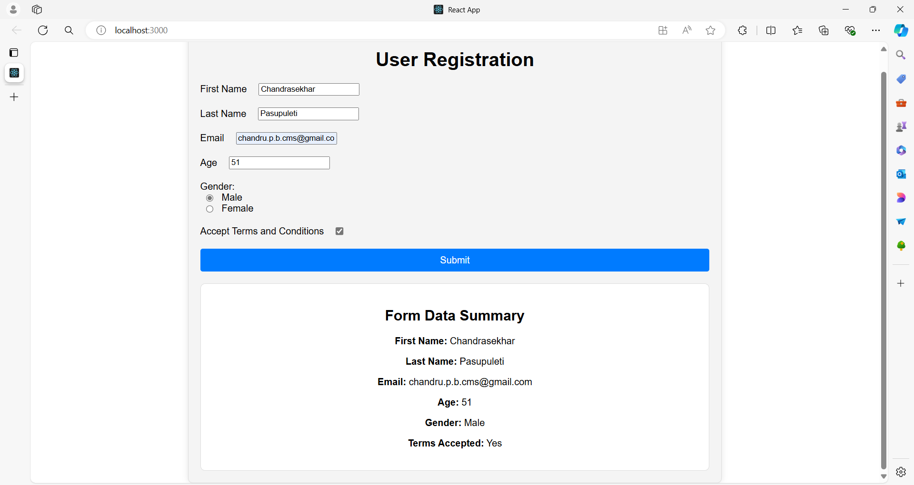

**1. App.js**

You will import the MainFormApp component and render it inside the App component.

**App.js**

import React from 'react';

import './App.css';

import MainFormApp from './MainFormApp';

function App() {

return (

<div className="App">

<MainFormApp />

</div>

);

}

export default App;

Ensure the CSS files are correctly placed and referenced:

**App.css**

.App {

font-family: Arial, sans-serif;

text-align: center;

}

**2. MainFormApp Component**

Ensure the MainFormApp component is defined.

**MainFormApp.js**

import React, { useState } from 'react';

import './MainFormApp.css';

import UserForm from './UserForm';

import FormSummary from './FormSummary';

function MainFormApp() {

const [userData, setUserData] = useState({

firstName: '',

lastName: '',

email: '',

age: '',

gender: '',

termsAccepted: false,

});

const handleInputChange = (event) => {

const { name, value, type, checked } = event.target;

setUserData({

...userData,

[name]: type === 'checkbox' ? checked : value,

});

};

const handleSubmit = (event) => {

event.preventDefault();

console.log('Form submitted:', userData);

};

return (

<div className="container">

<h1>User Registration</h1>

<UserForm userData={userData} onInputChange={handleInputChange} onSubmit={handleSubmit} />

<FormSummary data={userData} />

</div>

);

}

export default MainFormApp;

**MainFormApp.css**

.container {

width: 60%;

margin: 0 auto;

padding: 20px;

border: 1px solid #ddd;

border-radius: 8px;

box-shadow: 0 0 10px rgba(0, 0, 0, 0.1);

background-color: #f4f4f4;

}

h1 {

text-align: center;

}

**3. Ensure Child Components are Properly Defined**

**UserForm.js**

import React from 'react';

import InputField from './InputField';

import './UserForm.css';

function UserForm({ userData, onInputChange, onSubmit }) {

return (

<form className="form" onSubmit={onSubmit}>

<InputField

label="First Name"

name="firstName"

value={userData.firstName}

onChange={onInputChange}

/>

<InputField

label="Last Name"

name="lastName"

value={userData.lastName}

onChange={onInputChange}

/>

<InputField

label="Email"

name="email"

type="email"

value={userData.email}

onChange={onInputChange}

/>

<InputField

label="Age"

name="age"

type="number"

value={userData.age}

onChange={onInputChange}

/>

<div className="form-group">

<label>Gender:</label>

<InputField

name="gender"

type="radio"

value="Male"

checked={userData.gender === 'Male'}

onChange={onInputChange}

labelText="Male"

/>

<InputField

name="gender"

type="radio"

value="Female"

checked={userData.gender === 'Female'}

onChange={onInputChange}

labelText="Female"

/>

</div>

<InputField

label="Accept Terms and Conditions"

name="termsAccepted"

type="checkbox"

checked={userData.termsAccepted}

onChange={onInputChange}

/>

<button type="submit">Submit</button>

</form>

);

}

export default UserForm;

**UserForm.css**

.form {

display: grid;

gap: 20px;

}

.form-group {

display: flex;

flex-direction: column;

}

label {

display: flex;

align-items: center;

gap: 10px;

}

input {

margin-left: 10px;

}

button {

width: 100%;

padding: 10px;

border: none;

border-radius: 4px;

background-color: #007bff;

color: white;

font-size: 16px;

cursor: pointer;

transition: background-color 0.3s;

}

button:hover {

background-color: #0056b3;

}

**InputField.js**

import React from 'react';

function InputField({ label, name, type = 'text', value, checked, onChange, labelText }) {

return (

<div className="form-group">

<label>

{label}

{type === 'checkbox' || type === 'radio' ? (

<input

type={type}

name={name}

value={value}

checked={checked}

onChange={onChange}

/>

) : (

<input

type={type}

name={name}

value={value}

onChange={onChange}

/>

)}

{type === 'radio' && labelText && <span>{labelText}</span>}

</label>

</div>

);

}

export default InputField;

**FormSummary.js**

import React from 'react';

import './FormSummary.css';

function FormSummary({ data }) {

return (

<div className="summary">

<h2>Form Data Summary</h2>

<p><strong>First Name:</strong> {data.firstName}</p>

<p><strong>Last Name:</strong> {data.lastName}</p>

<p><strong>Email:</strong> {data.email}</p>

<p><strong>Age:</strong> {data.age}</p>

<p><strong>Gender:</strong> {data.gender}</p>

<p><strong>Terms Accepted:</strong> {data.termsAccepted ? 'Yes' : 'No'}</p>

</div>

);

}

export default FormSummary;

**4. CSS Files**

Ensure the CSS files are correctly placed and referenced:

**App.css**

.App {

font-family: Arial, sans-serif;

text-align: center;

}

**MainFormApp.css**

.container {

width: 60%;

margin: 0 auto;

padding: 20px;

border: 1px solid #ddd;

border-radius: 8px;

box-shadow: 0 0 10px rgba(0, 0, 0, 0.1);

background-color: #f4f4f4;

}

h1 {

text-align: center;

}

**UserForm.css**

.form {

display: grid;

gap: 20px;

}

.form-group {

display: flex;

flex-direction: column;

}

label {

display: flex;

align-items: center;

gap: 10px;

}

input {

margin-left: 10px;

}

button {

width: 100%;

padding: 10px;

border: none;

border-radius: 4px;

background-color: #007bff;

color: white;

font-size: 16px;

cursor: pointer;

transition: background-color 0.3s;

}

button:hover {

background-color: #0056b3;

}

**FormSummary.css**

.summary {

margin-top: 20px;

padding: 20px;

border: 1px solid #ddd;

border-radius: 8px;

background-color: #fff;

}

h2 {

margin-bottom: 20px;

}

**Running the Example**

1. **Setup**:
   * Create a new React application if you haven’t already:

**npx create-react-app user-form-example**

**cd user-form-example**

1. **Add Components**:
   * Replace the contents of src/App.js with the updated App.js code.
   * Create new files MainFormApp.js, UserForm.js, InputField.js, FormSummary.js in the src directory with the provided code.
   * Add the corresponding CSS files to the src directory.
2. **Start the Application**:
   * Run the application using:

**npm start**

* + This will open the application in your default web browser.

This setup ensures that the MainFormApp component is used as the main component within the App.js, making it easy to manage and understand the structure of your application.

**Example 03**

Creating a more complex example for an **e-commerce website** will involve multiple components and interactions.

Here’s a basic but comprehensive example of an e-commerce application with the following features:

1. **Product List**: Displays a list of products.
2. **Product Item**: Represents individual product cards.
3. **Cart**: Displays items added to the cart.
4. **Cart Item**: Represents individual items in the cart.
5. **Checkout**: A form to handle the checkout process.

**Overview**

1. **App Component**: The main component that integrates the ProductList and Cart components.
2. **ProductList Component**: Manages the list of products.
3. **ProductItem Component**: Represents each product.
4. **Cart Component**: Manages the cart state and displays cart items.
5. **CartItem Component**: Represents each item in the cart.
6. **Checkout Component**: Handles the checkout process.

**ecommerce-app/**

|-- public/

| |-- index.html

|-- src/

| |-- App.js

| |-- ProductList.js

| |-- ProductItem.js

| |-- Cart.js

| |-- CartItem.js

| |-- Checkout.js

| |-- App.css

| |-- ProductList.css

| |-- ProductItem.css

| |-- Cart.css

| |-- CartItem.css

| |-- Checkout.css

|-- package.json

|-- README.md

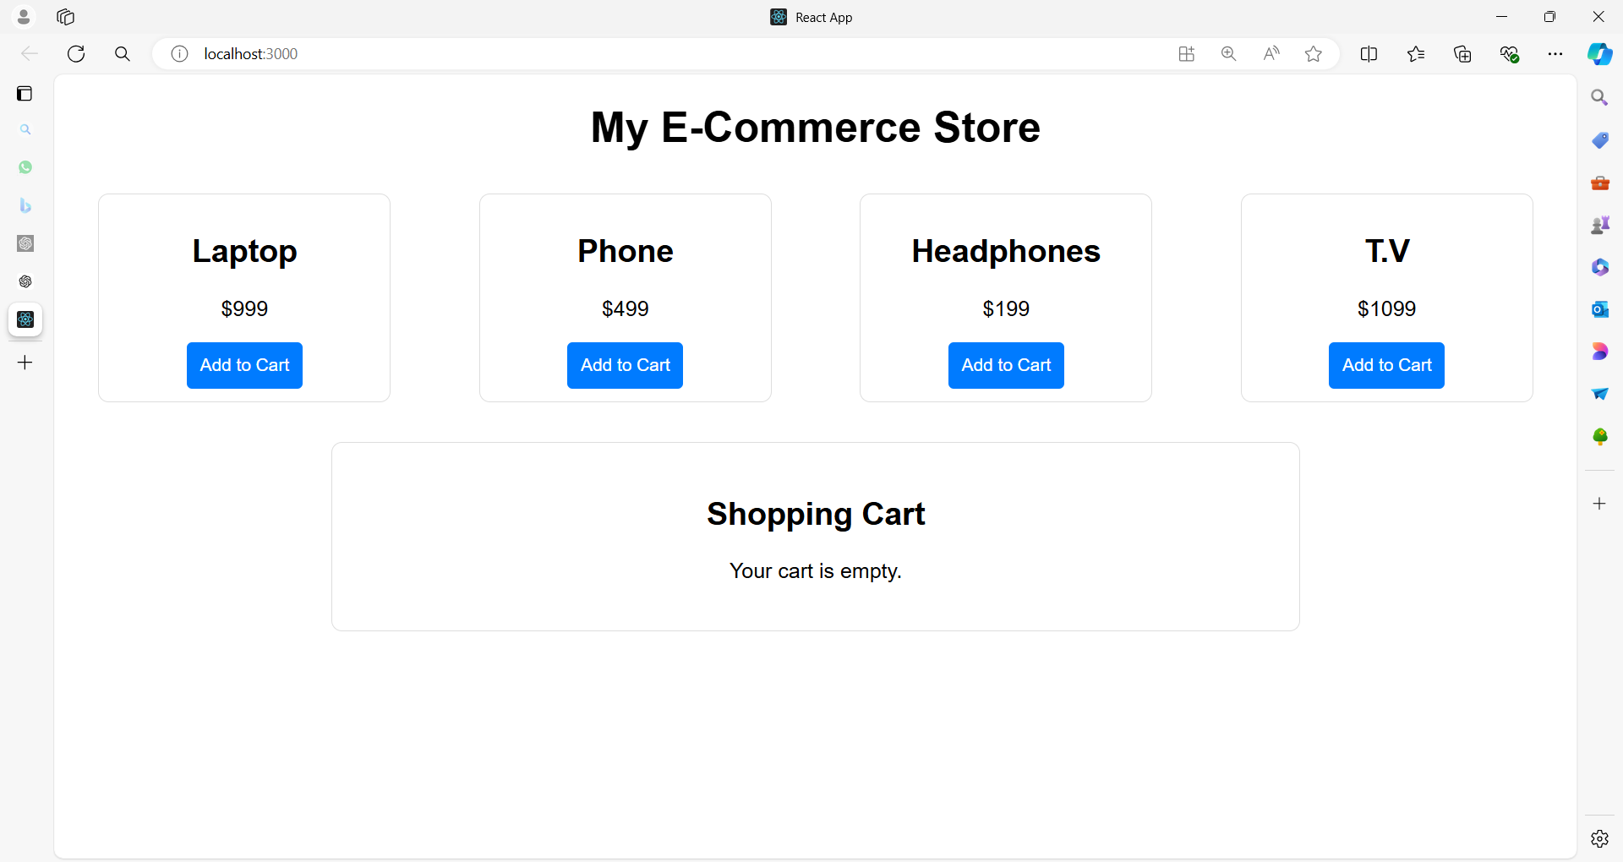

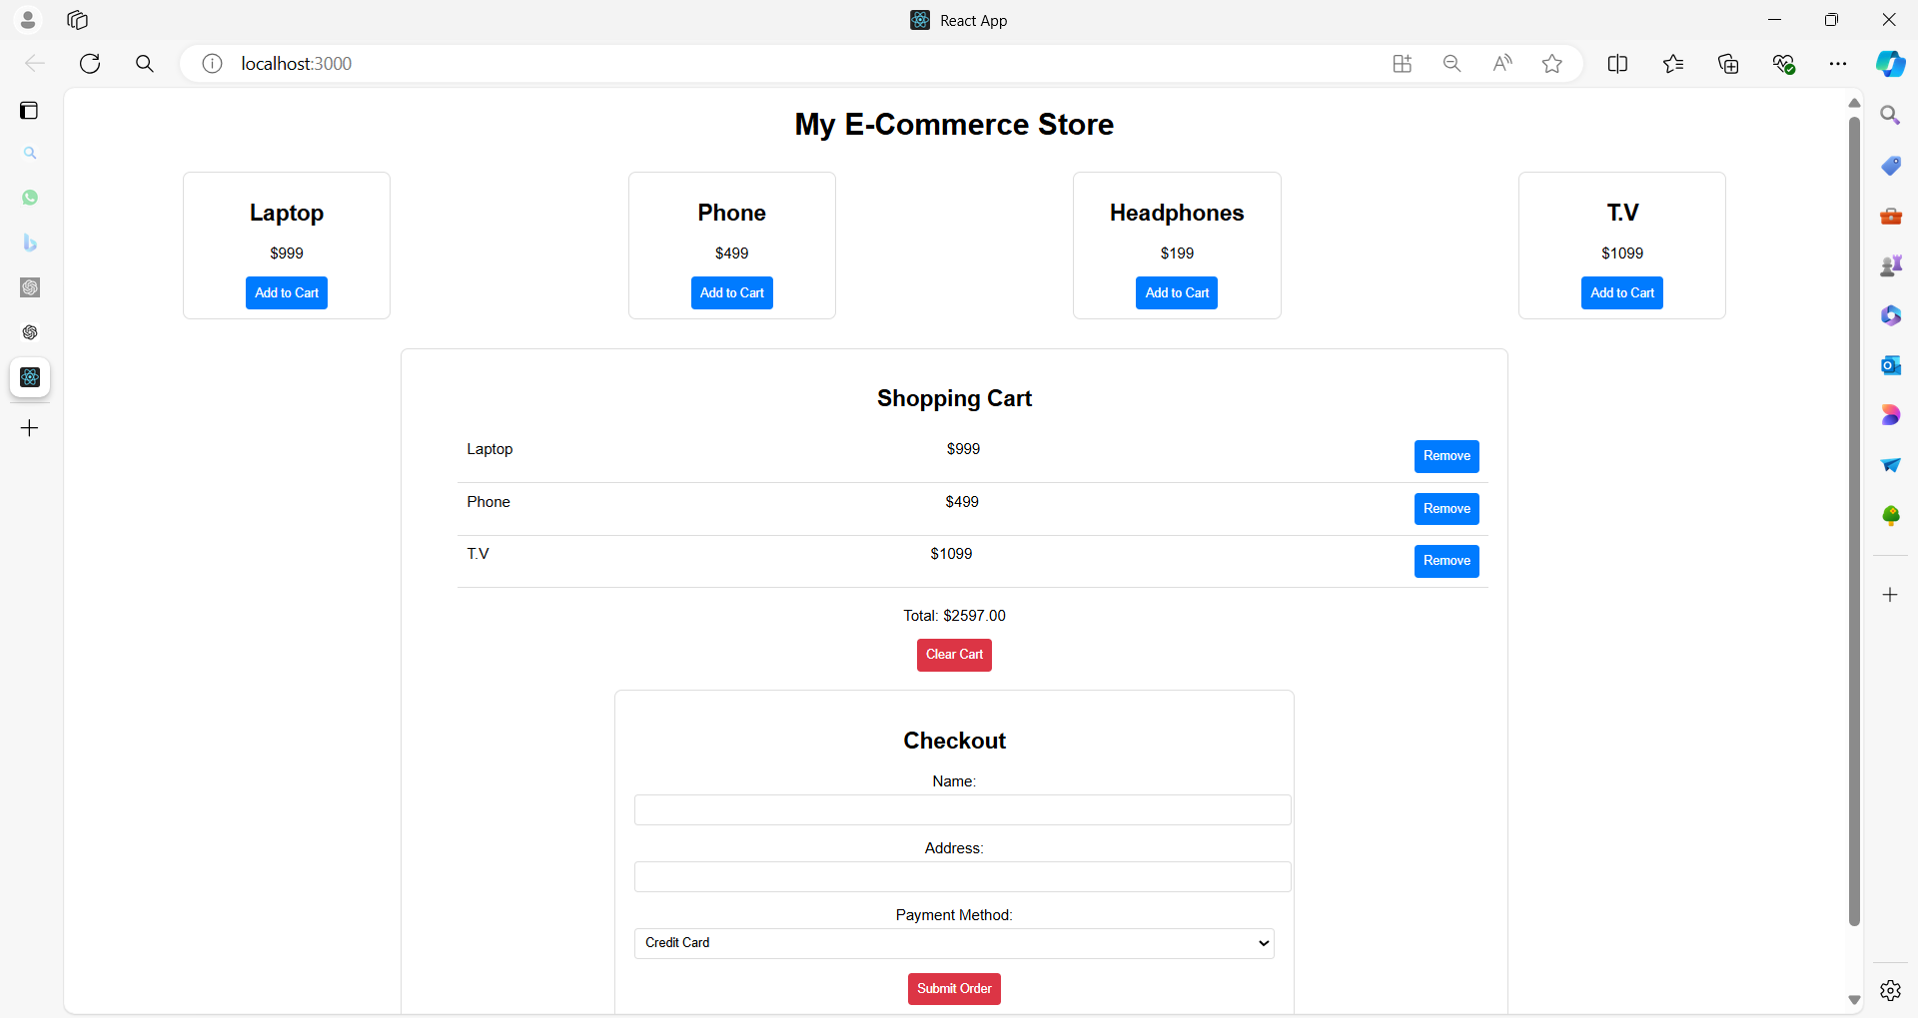

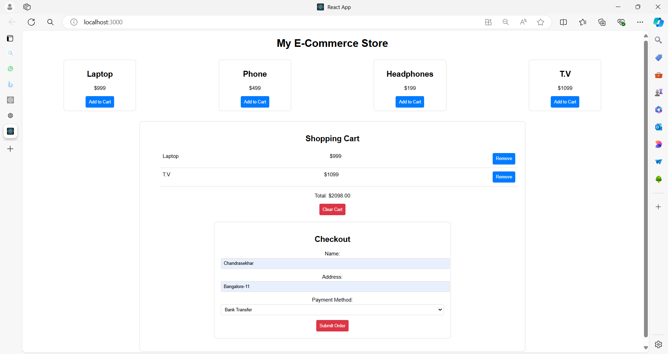

**Full Example**

**1. App Component**

**App.js**

import React, { useState } from 'react';

import './App.css';

import ProductList from './ProductList';

import Cart from './Cart';

function App() {

const [cartItems, setCartItems] = useState([]);

const addToCart = (product) => {

setCartItems((prevItems) => [...prevItems, product]);

};

const removeFromCart = (productId) => {

setCartItems((prevItems) => prevItems.filter(item => item.id !== productId));

};

const clearCart = () => {

setCartItems([]);

};

return (

<div className="App">

<h1>My E-Commerce Store</h1>

<ProductList addToCart={addToCart} />

<Cart items={cartItems} removeFromCart={removeFromCart} clearCart={clearCart} />

</div>

);

}

export default App;

**2. ProductList Component**

**ProductList.js**

import React from 'react';

import ProductItem from './ProductItem';

import './ProductList.css';

const products = [

{ id: 1, name: 'Laptop', price: 999 },

{ id: 2, name: 'Phone', price: 499 },

{ id: 3, name: 'Headphones', price: 199 },

];

function ProductList({ addToCart }) {

return (

<div className="product-list">

{products.map(product => (

<ProductItem key={product.id} product={product} addToCart={addToCart} />

))}

</div>

);

}

export default ProductList;

**3. ProductItem Component**

**ProductItem.js**

import React from 'react';

import './ProductItem.css';

function ProductItem({ product, addToCart }) {

return (

<div className="product-item">

<h2>{product.name}</h2>

<p>${product.price}</p>

<button onClick={() => addToCart(product)}>Add to Cart</button>

</div>

);

}

export default ProductItem;

**4. Cart Component**

**Cart.js**

import React from 'react';

import CartItem from './CartItem';

import Checkout from './Checkout';

import './Cart.css';

function Cart({ items, removeFromCart, clearCart }) {

const total = items.reduce((sum, item) => sum + item.price, 0);

return (

<div className="cart">

<h2>Shopping Cart</h2>

{items.length === 0 ? (

<p>Your cart is empty.</p>

) : (

<>

<ul>

{items.map(item => (

<CartItem key={item.id} item={item} removeFromCart={removeFromCart} />

))}

</ul>

<div className="cart-summary">

<p>Total: ${total.toFixed(2)}</p>

<button onClick={clearCart}>Clear Cart</button>

<Checkout />

</div>

</>

)}

</div>

);

}

export default Cart;

**5. CartItem Component**

**CartItem.js**

import React from 'react';

import './CartItem.css';

function CartItem({ item, removeFromCart }) {

return (

<li className="cart-item">

<span>{item.name}</span>

<span>${item.price}</span>

<button onClick={() => removeFromCart(item.id)}>Remove</button>

</li>

);

}

export default CartItem;

**6. Checkout Component**

**Checkout.js**

import React, { useState } from 'react';

import './Checkout.css';

function Checkout() {

const [formData, setFormData] = useState({

name: '',

address: '',

paymentMethod: 'Credit Card'

});

const handleChange = (e) => {

const { name, value } = e.target;

setFormData({ ...formData, [name]: value });

};

const handleSubmit = (e) => {

e.preventDefault();

console.log('Checkout form submitted:', formData);

};

return (

<div className="checkout">

<h2>Checkout</h2>

<form onSubmit={handleSubmit}>

<div className="form-group">

<label>Name:</label>

<input

type="text"

name="name"

value={formData.name}

onChange={handleChange}

required

/>

</div>

<div className="form-group">

<label>Address:</label>

<input

type="text"

name="address"

value={formData.address}

onChange={handleChange}

required

/>

</div>

<div className="form-group">

<label>Payment Method:</label>

<select

name="paymentMethod"

value={formData.paymentMethod}

onChange={handleChange}

>

<option value="Credit Card">Credit Card</option>

<option value="PayPal">PayPal</option>

<option value="Bank Transfer">Bank Transfer</option>

</select>

</div>

<button type="submit">Submit Order</button>

</form>

</div>

);

}

export default Checkout;

**CSS Files**

**App.css**

.App {

font-family: Arial, sans-serif;

text-align: center;

}

**ProductList.css**

.product-list {

display: flex;

justify-content: space-around;

flex-wrap: wrap;

}

**ProductItem.css**

.product-item {

border: 1px solid #ddd;

border-radius: 8px;

padding: 10px;

width: 200px;

margin: 10px;

text-align: center;

}

.product-item button {

background-color: #007bff;

color: white;

border: none;

padding: 10px;

border-radius: 4px;

cursor: pointer;

}

.product-item button:hover {

background-color: #0056b3;

}

**Cart.css**

.cart {

border: 1px solid #ddd;

border-radius: 8px;

padding: 20px;

margin: 20px auto;

width: 60%;

}

.cart-summary {

margin-top: 20px;

}

.cart-summary button {

background-color: #dc3545;

color: white;

border: none;

padding: 10px;

border-radius: 4px;

cursor: pointer;

}

.cart-summary button:hover {

background-color: #c82333;

}

**CartItem.css**

.cart-item {

display: flex;

justify-content: space-between;

padding: 10px;

border-bottom: 1px solid #ddd;

}

**Checkout.css**

.checkout {

border: 1px solid #ddd;

border-radius: 8px;

padding: 20px;

margin: 20px auto;

width: 60%;

}

.form-group {

margin-bottom: 15px;

}

form input,

form select {

width: 100%;

padding: 8px;

margin-top: 5px;

border-radius: 4px;

border: 1px solid #ddd;

}

button {

background-color: #007bff;

color: white;

border: none;

padding: 10px;

border-radius: 4px;

cursor: pointer;

}

button:hover {

background-color: #0056b3;

}

**Explanation**

1. **App Component**:
   * Manages the cart state and handles adding/removing items and clearing the cart.
   * Integrates ProductList and Cart components.
2. **ProductList Component**:
   * Displays a list of products by mapping over a predefined array.
   * Passes addToCart function to ProductItem components.
3. **ProductItem Component**:
   * Displays individual product information and a button to add the product to the cart.
4. **Cart Component**:
   * Displays items in the cart and provides options to clear the cart and view the checkout form.
5. **CartItem Component**:
   * Represents individual items in the cart with an option to remove them.
6. **Checkout Component**:
   * A form to handle user input for completing the purchase.

This example provides a complete basic structure for an e-commerce website with meaningful components, demonstrating the use of props and state in React.

**Spread Operator**

The spread operator (...) allows you to unpack elements from an array or properties from an object.

In the context of arrays, it can be used to create a new array by copying the elements of an existing array and optionally adding new elements.

**Explanation of [...prevItems, product]**

1. **prevItems**: This is the current array of items in the cart. It’s the previous state of the cart before the new item is added.
2. **...prevItems**: The spread operator takes each element from the prevItems array and includes it in the new array. It essentially creates a **shallow copy** of the prevItems array.
3. **product**: This is the new item that you want to add to the cart. It is placed at the end of the new array.
4. **[...prevItems, product]**: This creates a new array that contains all the elements of prevItems, followed by the new product. This approach is used to add an item to the existing list while maintaining immutability.

**Example**

Suppose prevItems is [ { id: 1, name: 'Laptop', price: 999 } ], and product is { id: 2, name: 'Phone', price: 499 }.

Using [...prevItems, product] will result in a new array:

const prevItems = [{ id: 1, name: 'Laptop', price: 999 }];

const product = { id: 2, name: 'Phone', price: 499 };

const newItems = [...prevItems, product];

console.log(newItems);

// Output: [{ id: 1, name: 'Laptop', price: 999 }, { id: 2, name: 'Phone', price: 499 }]

**Why Use It?**

1. **Immutability**: This approach helps in maintaining immutability. Instead of modifying the existing prevItems array, it creates a new array with the added item. This is crucial in React because it allows the framework to detect changes and re-render components effectively.
2. **Conciseness**: Using the spread operator makes it easy to copy and append elements in a concise and readable way.

This pattern is commonly used in React state updates when you need to add or remove items from an array without mutating the existing state.

**Reduce method**

The line const total = items.reduce((sum, item) => sum + item.price, 0); uses the reduce method to compute the total price of items in an array.

Here’s a detailed explanation:

**reduce Method**

The reduce method in JavaScript is used to apply a function against an accumulator and each element in an array (from left to right) to reduce it to a single value.

It’s a powerful and versatile method often used to perform calculations or transformations on arrays.

**Syntax**

array.reduce((accumulator, currentValue) => {

// return updated accumulator

}, initialValue);

* **accumulator**: The accumulated value returned by the last execution of the callback function. It is initialized to initialValue on the first call.
* **currentValue**: The current element being processed in the array.
* **initialValue**: A value to start the accumulation with. If not provided, the first element in the array is used as the initial value, and the iteration starts from the second element.

**Explanation of const total = items.reduce((sum, item) => sum + item.price, 0);**

1. **items**: This is the array of objects where each object represents an item in the cart. Each object has a price property.
2. **.reduce((sum, item) => sum + item.price, 0)**:
   * **(sum, item) => sum + item.price**: This is the callback function that reduce uses to accumulate values.
     + **sum**: This is the accumulator, which starts with the value of 0 (provided by initialValue). In each iteration, it holds the cumulative total of prices.
     + **item**: This represents the current item being processed in the array.
     + **sum + item.price**: In each iteration, the price of the current item is added to the sum, updating the accumulator.
   * **0**: This is the initialValue for the accumulator. It initializes sum to 0 before any iteration starts.
3. **const total**: This stores the final result after all iterations. It will be the total sum of all price values from the items array.

**Example**

Consider the following array of items:

const items = [

{ id: 1, name: 'Laptop', price: 999 },

{ id: 2, name: 'Phone', price: 499 },

{ id: 3, name: 'Headphones', price: 199 }

];

Using the reduce method:

const total = items.reduce((sum, item) => sum + item.price, 0);

console.log(total); // Output: 1697

* **Initial State**: sum starts at 0.
* **First Iteration**: sum = 0 + 999 (price of the first item), so sum becomes 999.
* **Second Iteration**: sum = 999 + 499 (price of the second item), so sum becomes 1498.
* **Third Iteration**: sum = 1498 + 199 (price of the third item), so sum becomes 1697.

The final value of total is 1697, which is the sum of all item prices.

**Summary**

The reduce method iterates over each element in the array and applies the provided function to accumulate a result.

In this case, it calculates the total sum of item prices, starting from 0 and adding each item's price to the cumulative total.

**Event Handling**

In React, **event handling** refers to the way you respond to user interactions and other events (like clicks, form submissions, and keyboard inputs) within your components.

React provides a declarative way to manage these interactions by defining event handlers that are triggered in response to specific events.

**Key Concepts of Event Handling in React**

1. **Event Handlers**: Functions that are called in response to events, such as user actions (clicking a button) or browser events (loading a page).
2. **Event Binding**: Attaching event handlers to React components or elements.
3. **Synthetic Events**: React wraps native DOM events in its own SyntheticEvent wrapper. This wrapper ensures that events work consistently across different browsers and is part of React’s event delegation system.
4. **Event Propagation**: React’s event handling system uses event delegation to handle events at a higher level in the DOM tree, which improves performance by reducing the number of event listeners attached to individual elements.

**Common Event Types**

* **Click Events**: onClick
* **Form Events**: onChange, onSubmit
* **Keyboard Events**: onKeyDown, onKeyUp
* **Mouse Events**: onMouseEnter, onMouseLeave
* **Focus Events**: onFocus, onBlur

**Example of Event Handling in React**

Here’s a simple example demonstrating how to handle a button click event and form submission in React:

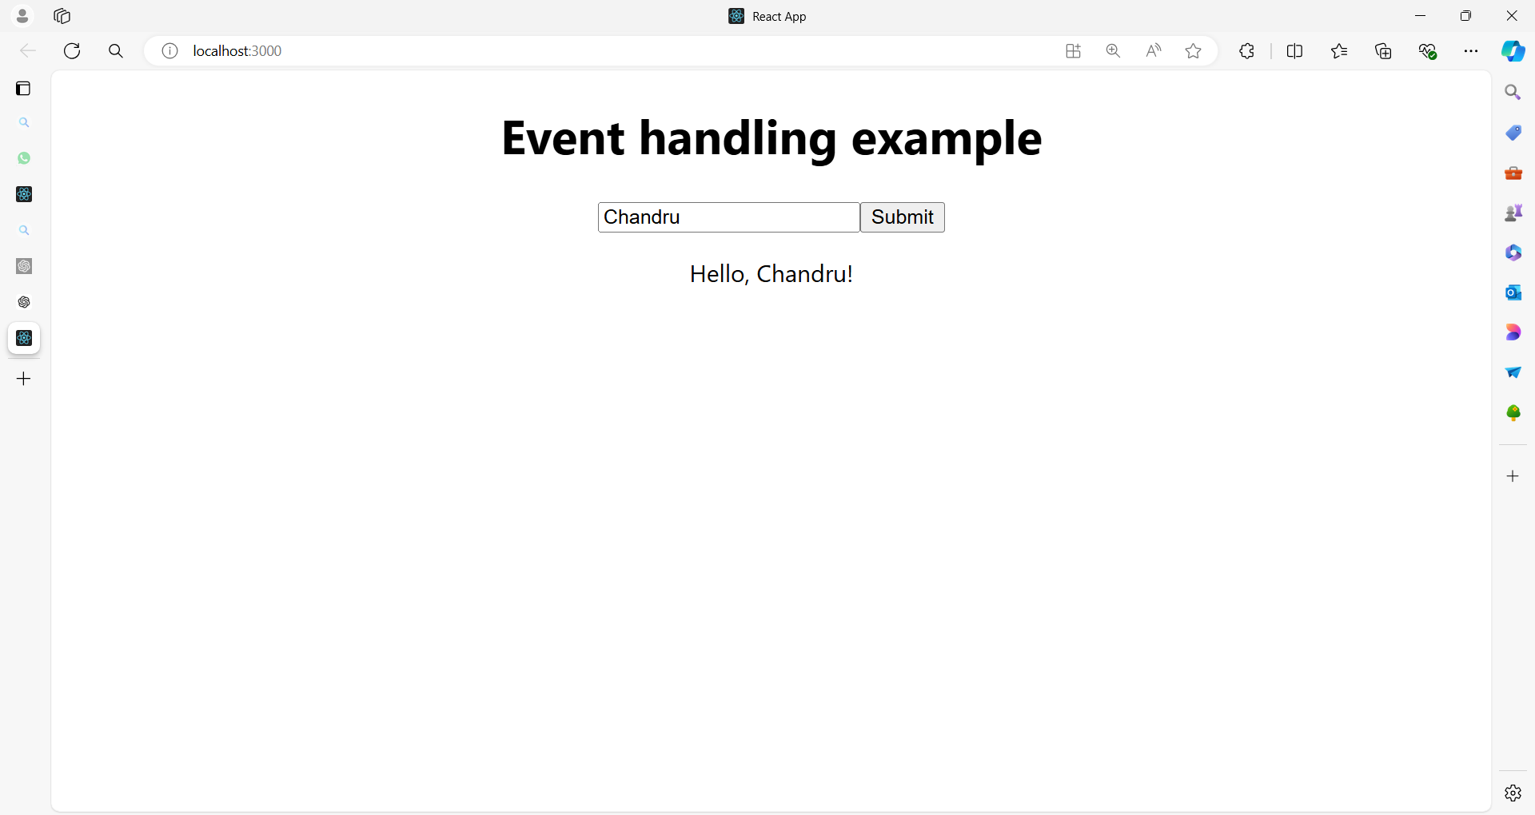

**src/App.js**

import React, { useState } from 'react';

import './App.css';

function App() {

// State to manage the input value

const [inputValue, setInputValue] = useState('');

// State to manage the message displayed

const [message, setMessage] = useState('');

// Event handler for button click

const handleClick = () => {

setMessage(`Hello, ${inputValue}!`);

};

// Event handler for form submission

const handleSubmit = (e) => {

e.preventDefault(); // Prevent the default form submission behavior

handleClick();

};

// Event handler for input change

const handleChange = (e) => {

setInputValue(e.target.value);

};

return (

<div className="App">

<h1>Event Handling Example</h1>

<form onSubmit={handleSubmit}>

<input

type="text"

value={inputValue}

onChange={handleChange}

placeholder="Enter your name"

/>

<button type="submit">Submit</button>

</form>

<p>{message}</p>

</div>

);

}

export default App;

**Breakdown of the Example**

1. **State Management**:
   * inputValue: Manages the value of the text input.
   * message: Stores the greeting message to be displayed.
2. **Event Handlers**:
   * **handleClick**: Updates the message state with a greeting message that includes the inputValue.
   * **handleSubmit**: Prevents the default form submission action (which would reload the page) and calls handleClick to update the message.
   * **handleChange**: Updates the inputValue state whenever the user types in the input field.
3. **Event Binding**:
   * **onSubmit**: Binds to the form's submit event to trigger handleSubmit.
   * **onChange**: Binds to the input field’s change event to trigger handleChange.

**Summary**

Event handling in React involves defining functions to respond to user actions or browser events and binding these functions to the appropriate events on React elements.

React’s synthetic event system and event delegation enhance performance and ensure consistent behavior across different browsers.

**Example 01**

Here's a comprehensive example of a React application that demonstrates various types of events, including click events, form events, mouse events, keyboard events, and more.

The program will include different components to illustrate how these events can be handled in a React application.

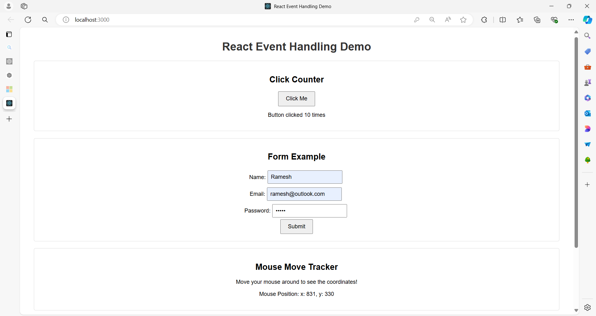

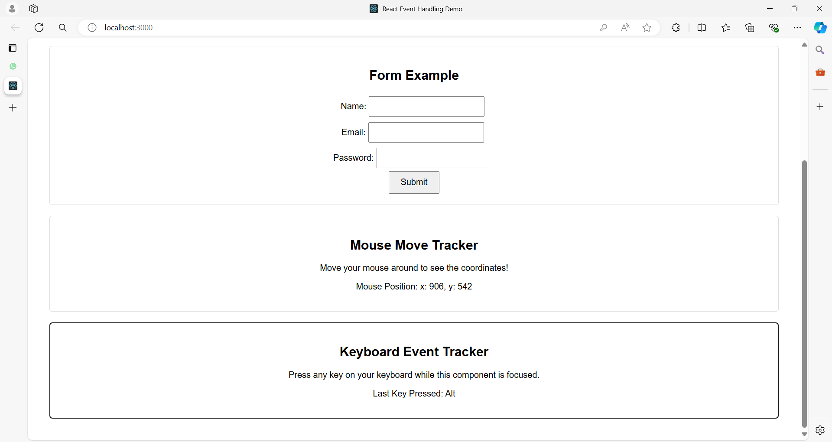

**Project Structure**

**event-demo-app/**

|-- public/

| |-- index.html

|-- src/

| |-- App.js

| |-- ButtonComponent.js

| |-- FormComponent.js

| |-- MouseEventComponent.js

| |-- KeyboardEventComponent.js

| |-- App.css

|-- package.json

|-- README.md

**Code for Each File**

**src/App.css**

.App {

font-family: Arial, sans-serif;

text-align: center;

padding: 20px;

}

.button-component, .form-component, .mouse-event-component, .keyboard-event-component {

margin: 20px;

padding: 20px;

border: 1px solid #ddd;

border-radius: 5px;

}

button {

padding: 10px 20px;

font-size: 16px;

cursor: pointer;

}

input {

padding: 8px;

font-size: 16px;

margin: 5px;

}

form {

display: flex;

flex-direction: column;

align-items: center;

}

h1 {

color: #333;

}

**public/index.html**

<!DOCTYPE html>

<html lang="en">

<head>

<meta charset="UTF-8">

<meta name="viewport" content="width=device-width, initial-scale=1.0">

<title>React Event Handling Demo</title>

</head>

<body>

<div id="root"></div>

</body>

</html>

**src/App.js**

import React from 'react';

import './App.css';

import ButtonComponent from './ButtonComponent';

import FormComponent from './FormComponent';

import MouseEventComponent from './MouseEventComponent';

import KeyboardEventComponent from './KeyboardEventComponent';

function App() {

return (

<div className="App">

<h1>React Event Handling Demo</h1>

<ButtonComponent />

<FormComponent />

<MouseEventComponent />

<KeyboardEventComponent />

</div>

);

}

export default App;

**src/ButtonComponent.js**

import React, { useState } from 'react';

import './App.css';

function ButtonComponent() {

const [count, setCount] = useState(0);

const handleClick = () => {

setCount(count + 1);

};

return (

<div className="button-component">

<h2>Click Counter</h2>

<button onClick={handleClick}>Click Me</button>

<p>Button clicked {count} times</p>

</div>

);

}

export default ButtonComponent;

**src/FormComponent.js**

import React, { useState } from 'react';

import './App.css';

function FormComponent() {

const [formData, setFormData] = useState({

name: '',

email: '',

password: ''

});

const handleChange = (e) => {

const { name, value } = e.target;

setFormData({ ...formData, [name]: value });

};

const handleSubmit = (e) => {

e.preventDefault();

alert(`Submitted! \nName: ${formData.name} \nEmail: ${formData.email}`);

};

return (

<div className="form-component">

<h2>Form Example</h2>

<form onSubmit={handleSubmit}>

<div>

<label>Name:</label>

<input

type="text"

name="name"

value={formData.name}

onChange={handleChange}

required

/>

</div>

<div>

<label>Email:</label>

<input

type="email"

name="email"

value={formData.email}

onChange={handleChange}

required

/>

</div>

<div>

<label>Password:</label>

<input

type="password"

name="password"

value={formData.password}

onChange={handleChange}

required

/>

</div>

<button type="submit">Submit</button>

</form>

</div>

);

}

export default FormComponent;

**src/MouseEventComponent.js**

import React, { useState } from 'react';

import './App.css';

function MouseEventComponent() {

const [position, setPosition] = useState({ x: 0, y: 0 });

const handleMouseMove = (e) => {

setPosition({ x: e.clientX, y: e.clientY });

};

return (

<div className="mouse-event-component" onMouseMove={handleMouseMove}>

<h2>Mouse Move Tracker</h2>

<p>Move your mouse around to see the coordinates!</p>

<p>Mouse Position: {`x: ${position.x}, y: ${position.y}`}</p>

</div>

);

}

export default MouseEventComponent;

**src/KeyboardEventComponent.js**

import React, { useState } from 'react';

import './App.css';

function KeyboardEventComponent() {

const [key, setKey] = useState('');

const handleKeyDown = (e) => {

setKey(e.key);

};

return (

<div className="keyboard-event-component" tabIndex="0" onKeyDown={handleKeyDown}>

<h2>Keyboard Event Tracker</h2>

<p>Press any key on your keyboard while this component is focused.</p>

<p>Last Key Pressed: {key}</p>

</div>

);

}

export default KeyboardEventComponent;

**Summary**

* **ButtonComponent**: Demonstrates handling a click event. The button click increments a counter.
* **FormComponent**: Shows handling form events including input changes and form submission.
* **MouseEventComponent**: Illustrates handling mouse movement events to track the mouse position.
* **KeyboardEventComponent**: Captures keyboard events to display the last key pressed.

This example provides a comprehensive overview of handling various types of events in React, demonstrating how to use event handlers to manage user interactions effectively.

**Example 02**

Here's an example of a more complex React application for an e-commerce website.

This application demonstrates various event handling techniques, including adding items to the cart, updating quantities, and removing items.

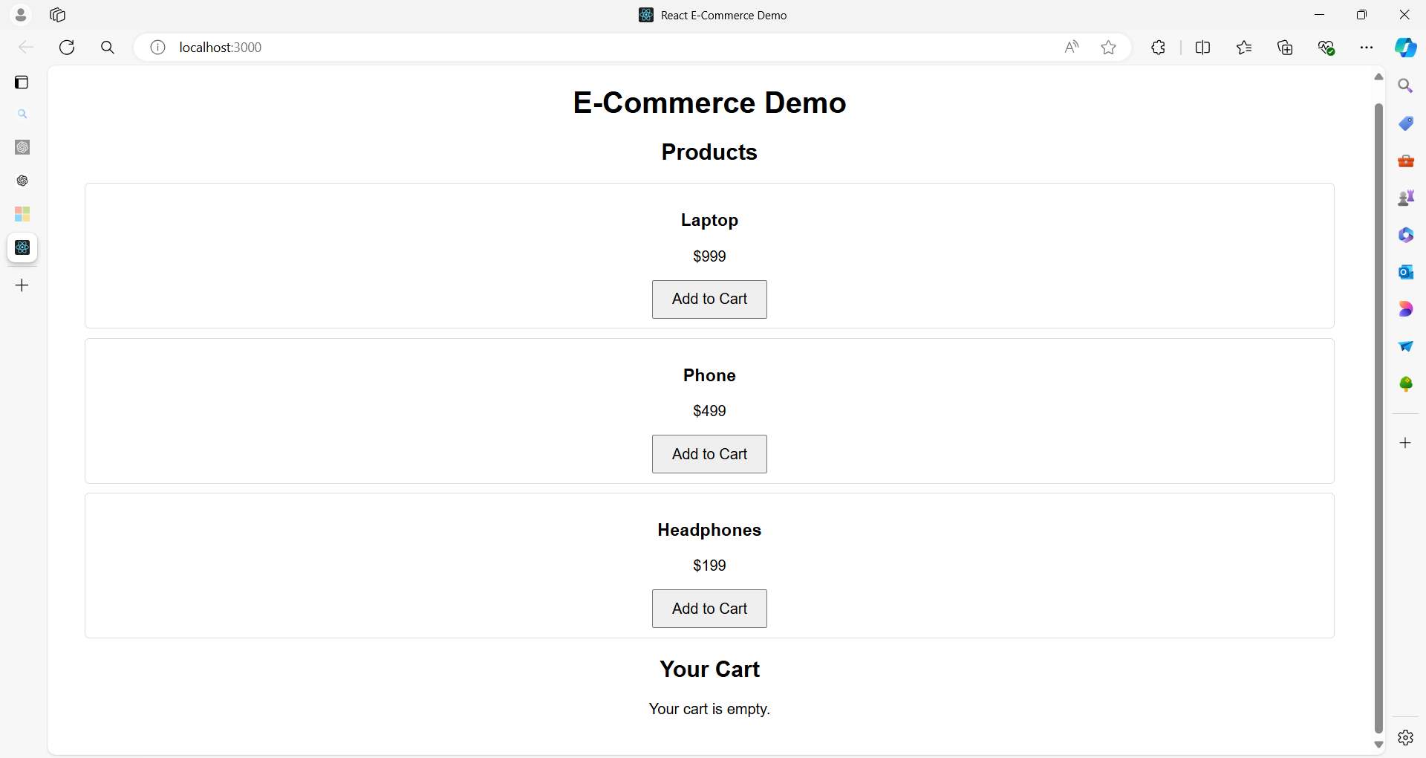

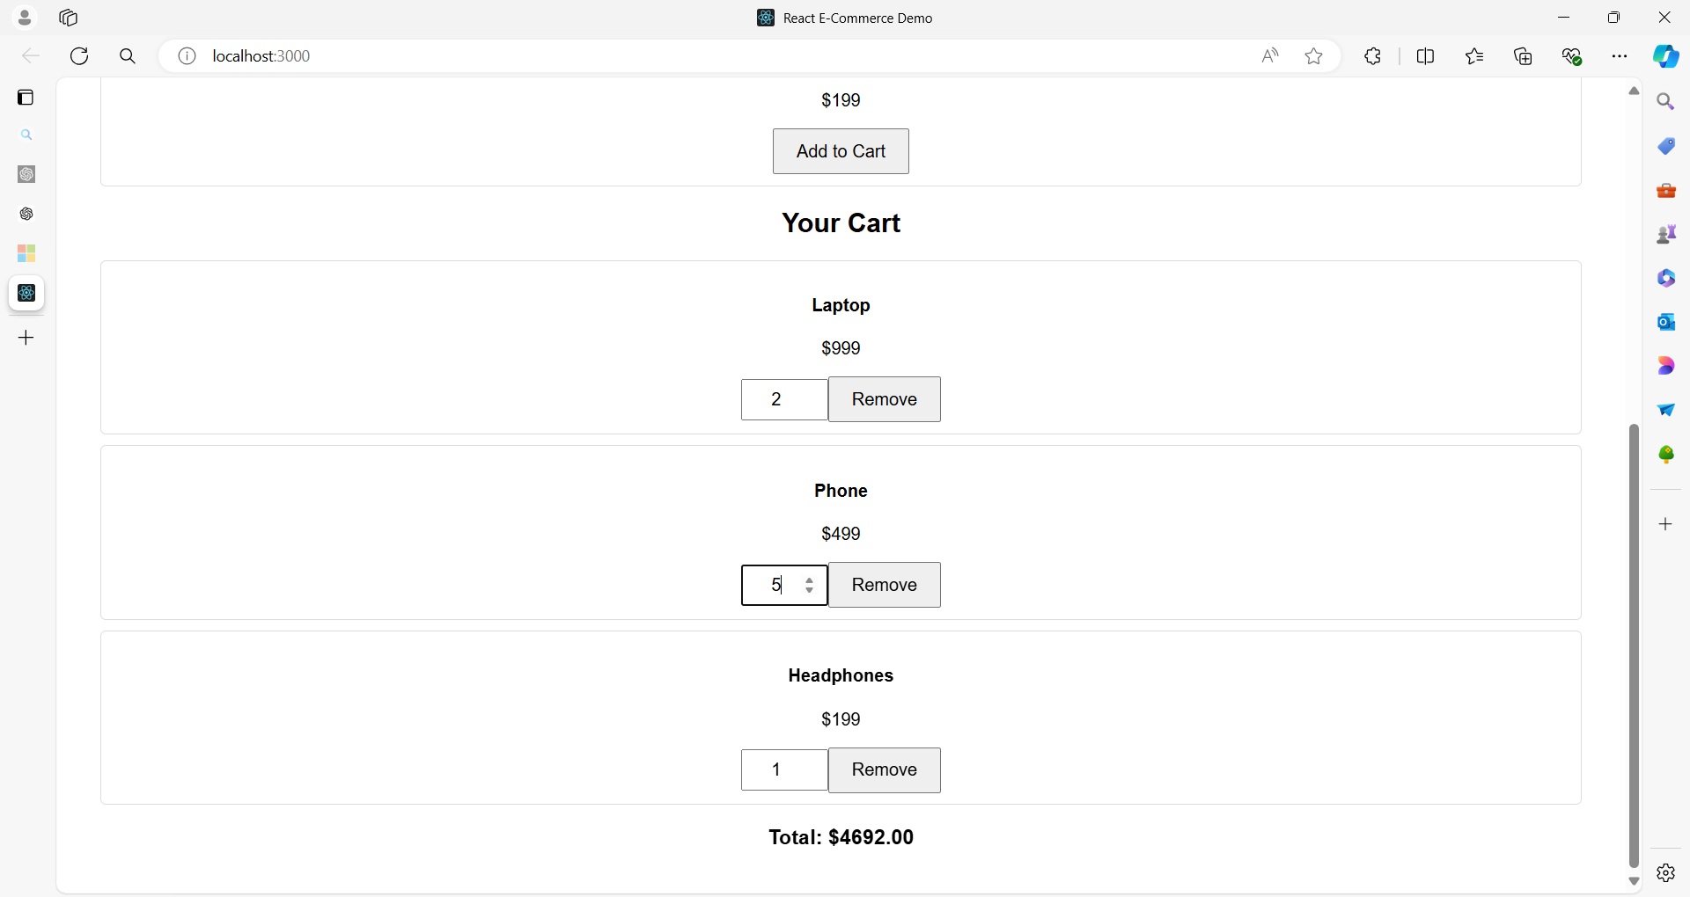

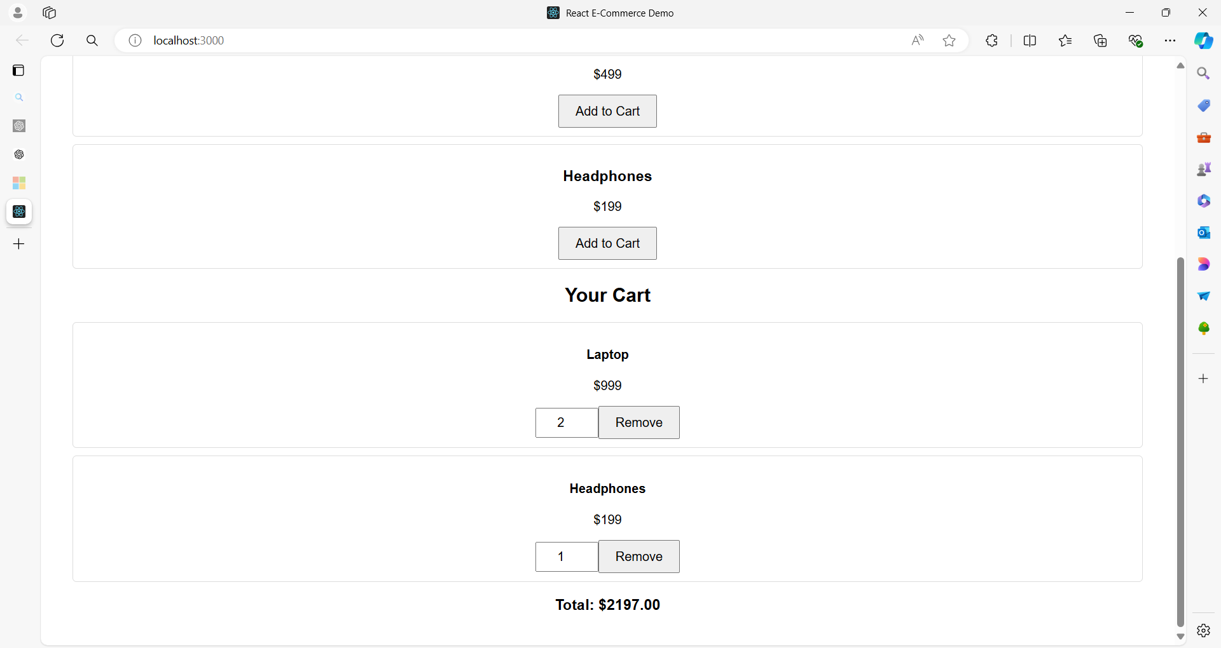

**Project Structure**

**ecommerce-demo/**

|-- public/

| |-- index.html

|-- src/

| |-- App.js

| |-- ProductList.js

| |-- Cart.js

| |-- ProductItem.js

| |-- CartItem.js

| |-- App.css

|-- package.json

|-- README.md

**Code for Each File**

**src/App.css**

.App {

font-family: Arial, sans-serif;

text-align: center;

padding: 20px;

}

.product-list, .cart {

margin: 20px;

}

.product-item, .cart-item {

margin: 10px 0;

padding: 10px;

border: 1px solid #ddd;

border-radius: 5px;

}

button {

padding: 10px 20px;

font-size: 16px;

cursor: pointer;

}

input {

padding: 8px;

font-size: 16px;

width: 60px;

text-align: center;

}

**public/index.html**

<!DOCTYPE html>

<html lang="en">

<head>

<meta charset="UTF-8">

<meta name="viewport" content="width=device-width, initial-scale=1.0">

<title>React E-Commerce Demo</title>

</head>

<body>

<div id="root"></div>

</body>

</html>

**src/App.js**

import React, { useState } from 'react';

import './App.css';

import ProductList from './ProductList';

import Cart from './Cart';

const initialProducts = [

{ id: 1, name: 'Laptop', price: 999 },

{ id: 2, name: 'Phone', price: 499 },

{ id: 3, name: 'Headphones', price: 199 }

];

function App() {

const [cart, setCart] = useState([]);

const addToCart = (product) => {

setCart((prevCart) => {

const existingProduct = prevCart.find(item => item.id === product.id);

if (existingProduct) {

return prevCart.map(item =>

item.id === product.id ? { ...item, quantity: item.quantity + 1 } : item

);

}

return [...prevCart, { ...product, quantity: 1 }];

});

};

const updateQuantity = (id, quantity) => {

setCart((prevCart) =>

prevCart.map(item =>

item.id === id ? { ...item, quantity: Math.max(1, quantity) } : item

)

);

};

const removeFromCart = (id) => {

setCart((prevCart) => prevCart.filter(item => item.id !== id));

};

return (

<div className="App">

<h1>E-Commerce Demo</h1>

<ProductList products={initialProducts} onAddToCart={addToCart} />

<Cart

cartItems={cart}

onUpdateQuantity={updateQuantity}

onRemoveFromCart={removeFromCart}

/>

</div>

);

}

export default App;

**src/ProductList.js**

import React from 'react';

import ProductItem from './ProductItem';

function ProductList({ products, onAddToCart }) {

return (

<div className="product-list">

<h2>Products</h2>

{products.map(product => (

<ProductItem key={product.id} product={product} onAddToCart={onAddToCart} />

))}

</div>

);

}

export default ProductList;

**src/ProductItem.js**

import React from 'react';

function ProductItem({ product, onAddToCart }) {

return (

<div className="product-item">

<h3>{product.name}</h3>

<p>${product.price}</p>

<button onClick={() => onAddToCart(product)}>Add to Cart</button>

</div>

);

}

export default ProductItem;

**src/Cart.js**

import React from 'react';

import CartItem from './CartItem';

function Cart({ cartItems, onUpdateQuantity, onRemoveFromCart }) {

const total = cartItems.reduce((sum, item) => sum + item.price * item.quantity, 0);

return (

<div className="cart">

<h2>Your Cart</h2>

{cartItems.length === 0 ? (

<p>Your cart is empty.</p>

) : (

<div>

{cartItems.map(item => (

<CartItem

key={item.id}

item={item}

onUpdateQuantity={onUpdateQuantity}

onRemoveFromCart={onRemoveFromCart}

/>

))}

<h3>Total: ${total.toFixed(2)}</h3>

</div>

)}

</div>

);

}

export default Cart;

**src/CartItem.js**

import React from 'react';

function CartItem({ item, onUpdateQuantity, onRemoveFromCart }) {

const handleQuantityChange = (e) => {

onUpdateQuantity(item.id, parseInt(e.target.value, 10));

};

return (

<div className="cart-item">

<h4>{item.name}</h4>

<p>${item.price}</p>

<input

type="number"

value={item.quantity}

onChange={handleQuantityChange}

min="1"

/>

<button onClick={() => onRemoveFromCart(item.id)}>Remove</button>

</div>

);

}

export default CartItem;

**Summary**

This e-commerce demo application consists of:

* **App.js**: The main component that holds the application state for the cart and provides functions to add, update, and remove items.
* **ProductList.js**: Displays a list of products with buttons to add items to the cart.
* **ProductItem.js**: Represents an individual product with a button to add it to the cart.
* **Cart.js**: Displays the items in the cart with the ability to update quantities or remove items.
* **CartItem.js**: Represents an individual cart item with quantity control and a remove button.
* **App.css**: Basic styling for the components.

This setup demonstrates various event handling scenarios including:

* **Button Clicks**: Adding items to the cart.
* **Input Changes**: Updating item quantities.
* **Button Clicks**: Removing items from the cart.

The application maintains a clear separation of concerns between different components and demonstrates how to manage state and events in a React application.

**Example 03**

Here's a comprehensive example of a React application for a Human Resource Management System (HRMS).

This example demonstrates various event handling techniques, including managing employee records, adding new employees, editing existing records, and deleting records.

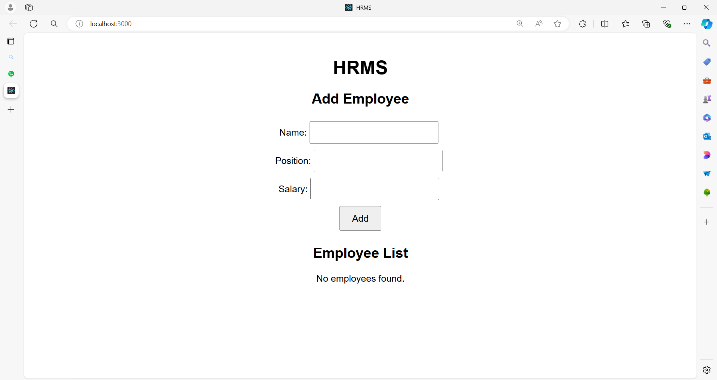

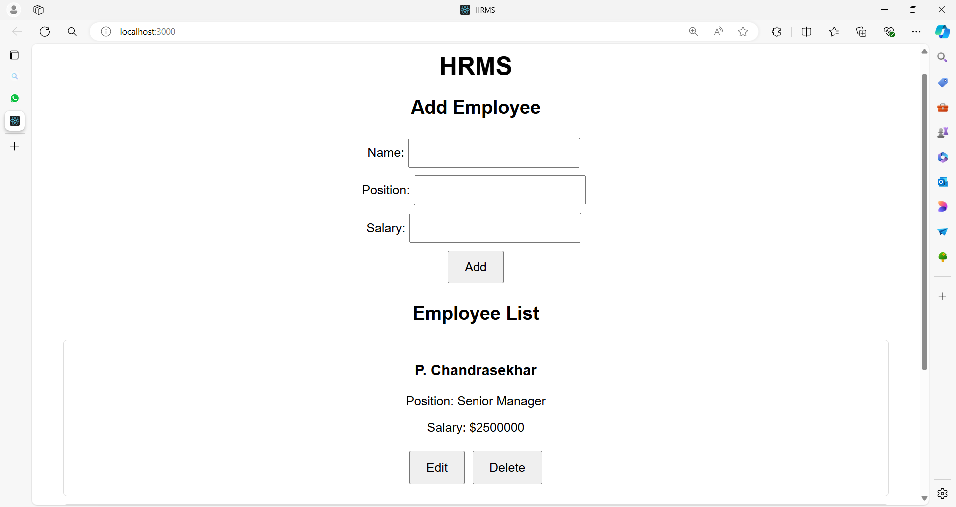

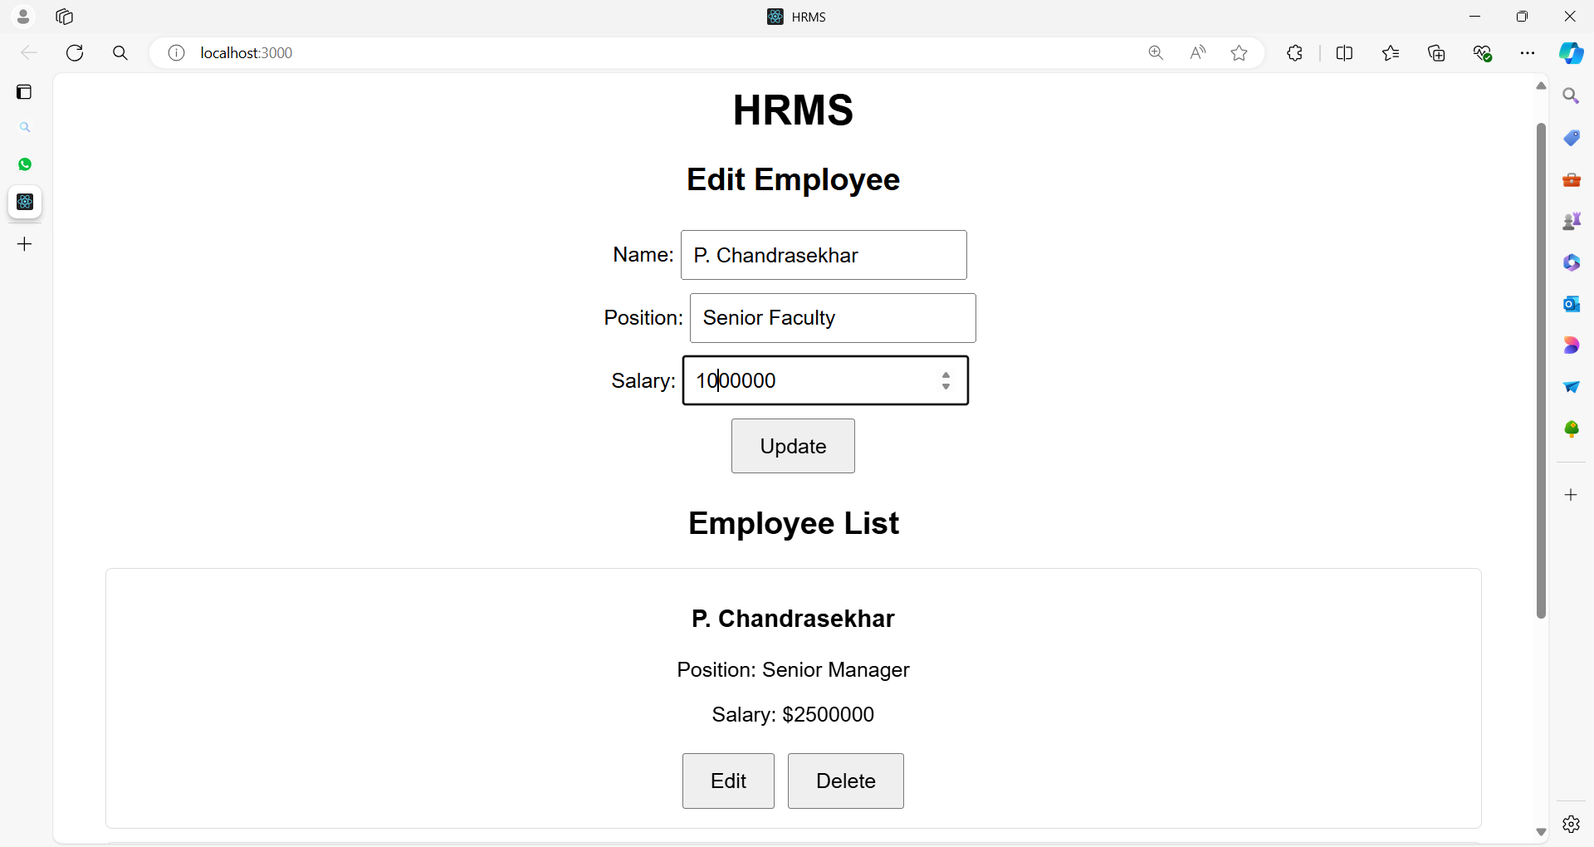

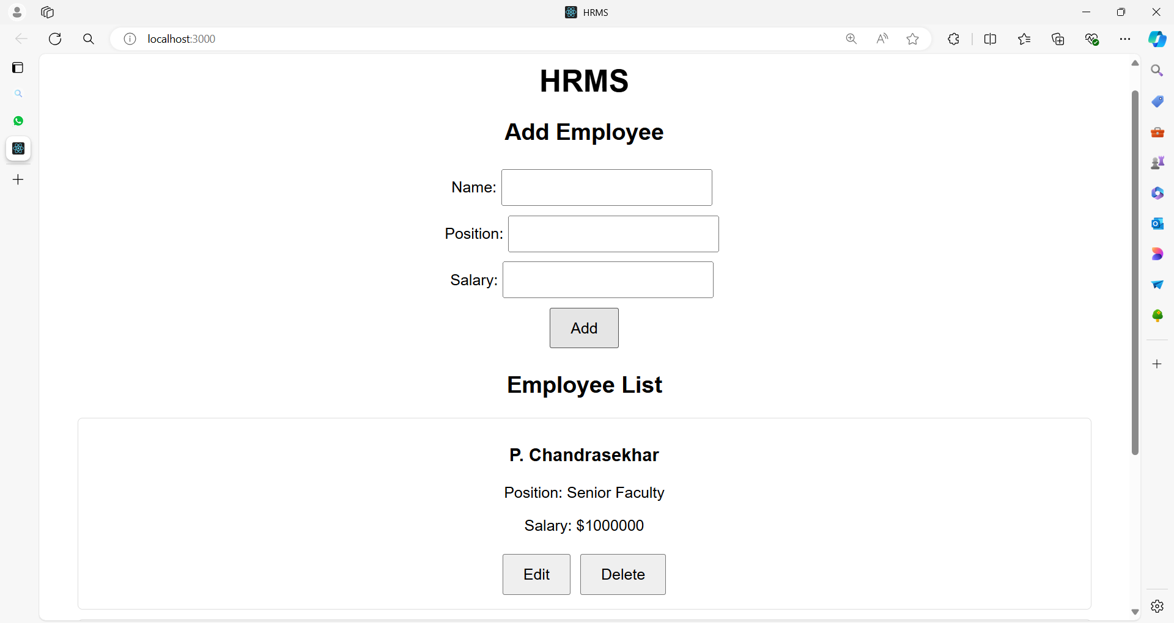

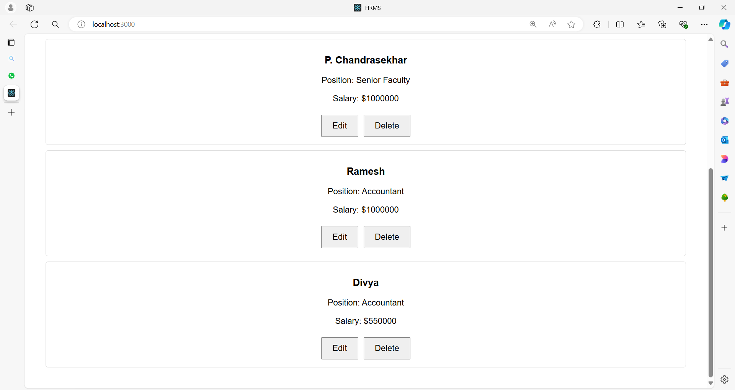

After updating the Ramesh details

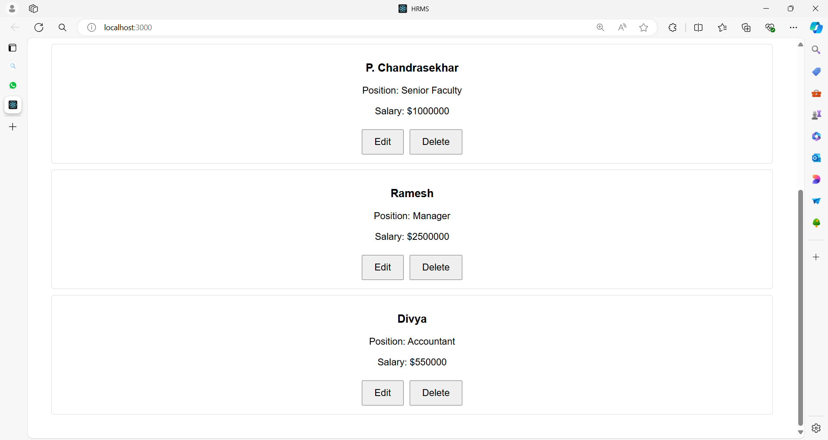

After deleting Divya

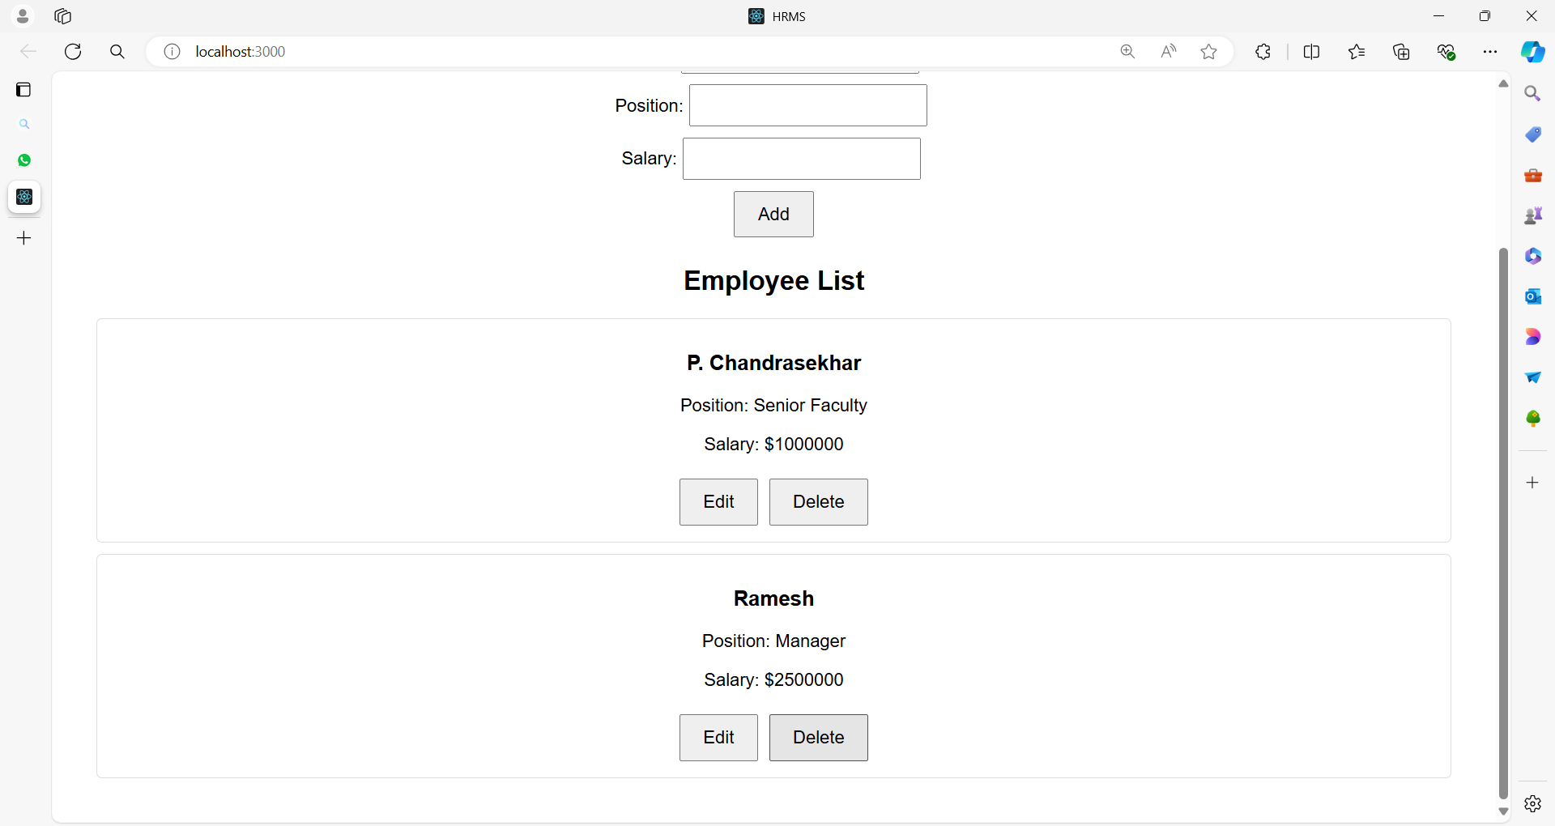

**Project Structure**

**hrms-demo/**

|-- public/

| |-- index.html

|-- src/

| |-- App.js

| |-- EmployeeList.js

| |-- EmployeeForm.js

| |-- EmployeeItem.js

| |-- App.css

|-- package.json

|-- README.md

**Code for Each File**

**public/index.html**

<!DOCTYPE html>

<html lang="en">

<head>

<meta charset="UTF-8">

<meta name="viewport" content="width=device-width, initial-scale=1.0">

<title>HRMS</title>

</head>

<body>

<div id="root"></div>

</body>

</html>

**src/App.js**

import React, { useState } from 'react';

import './App.css';

import EmployeeList from './EmployeeList';

import EmployeeForm from './EmployeeForm';

function App() {

const [employees, setEmployees] = useState([]);

const [editingEmployee, setEditingEmployee] = useState(null);

const addEmployee = (employee) => {

setEmployees((prevEmployees) => [...prevEmployees, { ...employee, id: Date.now() }]);

setEditingEmployee(null);

};

const updateEmployee = (updatedEmployee) => {

setEmployees((prevEmployees) =>

prevEmployees.map((emp) =>

emp.id === updatedEmployee.id ? updatedEmployee : emp

)

);

setEditingEmployee(null);

};

const deleteEmployee = (id) => {

setEmployees((prevEmployees) => prevEmployees.filter((emp) => emp.id !== id));

};

const startEditEmployee = (employee) => {

setEditingEmployee(employee);

};

return (

<div className="App">

<h1>HRMS</h1>

<EmployeeForm

onAddEmployee={addEmployee}

onUpdateEmployee={updateEmployee}

editingEmployee={editingEmployee}

/>

<EmployeeList

employees={employees}

onDeleteEmployee={deleteEmployee}

onEditEmployee={startEditEmployee}

/>

</div>

);

}

export default App;

**src/EmployeeList.js**

import React from 'react';

import EmployeeItem from './EmployeeItem';

function EmployeeList({ employees, onDeleteEmployee, onEditEmployee }) {

return (

<div className="employee-list">

<h2>Employee List</h2>

{employees.length === 0 ? (

<p>No employees found.</p>

) : (

employees.map((employee) => (

<EmployeeItem

key={employee.id}

employee={employee}

onDeleteEmployee={onDeleteEmployee}

onEditEmployee={onEditEmployee}

/>

))

)}

</div>

);

}

export default EmployeeList;

**src/EmployeeForm.js**

import React, { useState, useEffect } from 'react';

function EmployeeForm({ onAddEmployee, onUpdateEmployee, editingEmployee }) {

const [formData, setFormData] = useState({

name: '',

position: '',

salary: ''

});

useEffect(() => {

if (editingEmployee) {

setFormData({

name: editingEmployee.name,

position: editingEmployee.position,

salary: editingEmployee.salary

});

}

}, [editingEmployee]);

const handleChange = (e) => {

const { name, value } = e.target;

setFormData({ ...formData, [name]: value });

};

const handleSubmit = (e) => {

e.preventDefault();

if (editingEmployee) {

onUpdateEmployee({ ...editingEmployee, ...formData });

} else {

onAddEmployee(formData);

}

setFormData({ name: '', position: '', salary: '' });

};

return (

<div className="employee-form">

<h2>{editingEmployee ? 'Edit Employee' : 'Add Employee'}</h2>

<form onSubmit={handleSubmit}>

<div>

<label>Name:</label>

<input

type="text"

name="name"

value={formData.name}

onChange={handleChange}

required

/>

</div>

<div>

<label>Position:</label>

<input

type="text"

name="position"

value={formData.position}

onChange={handleChange}

required

/>

</div>

<div>

<label>Salary:</label>

<input

type="number"

name="salary"

value={formData.salary}

onChange={handleChange}

required

/>

</div>

<button type="submit">{editingEmployee ? 'Update' : 'Add'}</button>

</form>

</div>

);

}

export default EmployeeForm;

**src/EmployeeItem.js**

import React from 'react';

function EmployeeItem({ employee, onDeleteEmployee, onEditEmployee }) {

return (

<div className="employee-item">

<h3>{employee.name}</h3>

<p>Position: {employee.position}</p>

<p>Salary: ${employee.salary}</p>

<button onClick={() => onEditEmployee(employee)}>Edit</button>

<button onClick={() => onDeleteEmployee(employee.id)}>Delete</button>

</div>

);

}

export default EmployeeItem;

**src/App.css**

.App {

font-family: Arial, sans-serif;

text-align: center;

padding: 20px;

}

.employee-list, .employee-form {

margin: 20px;

}

.employee-item {

margin: 10px 0;

padding: 10px;

border: 1px solid #ddd;

border-radius: 5px;

}

button {

padding: 10px 20px;

font-size: 16px;

cursor: pointer;

margin: 5px;

}

input {

padding: 8px;

font-size: 16px;

margin: 5px;

}

form {

display: flex;

flex-direction: column;

align-items: center;

}

**Summary**

This HRMS demo application consists of:

* **App.js**: The main component managing the application state for employees and providing functions to add, update, and delete employees.
* **EmployeeList.js**: Displays the list of employees and provides options to edit or delete them.
* **EmployeeItem.js**: Represents an individual employee with options to edit or delete.
* **EmployeeForm.js**: Handles the form for adding and updating employee records.
* **App.css**: Basic styling for the components.

**Key Event Handling Demonstrations:**

1. **Form Handling**:
   * **Add Employee**: Handle form submission to add new employees.
   * **Update Employee**: Handle form submission to update existing employee details.
2. **Button Clicks**:
   * **Edit**: Pre-fill the form with the selected employee’s details for editing.
   * **Delete**: Remove the employee from the list.
3. **Form Inputs**:
   * **Change Events**: Update form state when user types into input fields.

This setup provides a robust example of handling various types of events in a React application, demonstrating how to manage a more complex state and user interactions effectively.

**Example 04:**

The same HRMS example with additional components to make it more comprehensive.

We'll include:

1. **Search Component**: To filter the employee list based on the search query.
2. **Employee Detail Component**: To display detailed information about an employee when clicked.
3. **Pagination Component**: To manage pagination for large employee lists.
4. **Confirmation Dialog**: For confirming deletion of employee records.

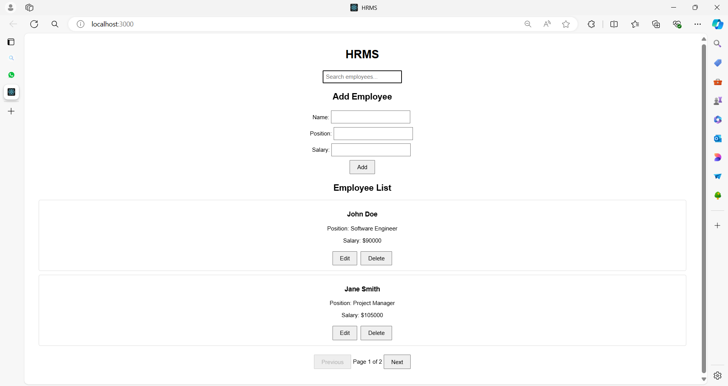

**Expanded Project Structure**

**hrms-demo/**

|-- public/

| |-- index.html

|-- src/

| |-- App.js

| |-- EmployeeList.js

| |-- EmployeeForm.js

| |-- EmployeeItem.js

| |-- EmployeeDetail.js

| |-- Search.js

| |-- Pagination.js

| |-- ConfirmationDialog.js

| |-- App.css

|-- package.json

|-- README.md

**Code for Each File**

**src/App.js**

import React, { useState } from 'react';

import './App.css';

import EmployeeList from './EmployeeList';

import EmployeeForm from './EmployeeForm';

import Search from './Search';

import ConfirmationDialog from './ConfirmationDialog';

import Pagination from './Pagination';

const initialEmployees = [

{ id: 1, name: 'John Doe', position: 'Software Engineer', salary: 90000 },

{ id: 2, name: 'Jane Smith', position: 'Project Manager', salary: 105000 },

{ id: 3, name: 'Alice Johnson', position: 'UX Designer', salary: 75000 }

];

function App() {

const [employees, setEmployees] = useState(initialEmployees);

const [editingEmployee, setEditingEmployee] = useState(null);

const [searchQuery, setSearchQuery] = useState('');

const [currentPage, setCurrentPage] = useState(1);

const [itemsPerPage] = useState(2);

const [showConfirmDialog, setShowConfirmDialog] = useState(false);

const [employeeToDelete, setEmployeeToDelete] = useState(null);

const addEmployee = (employee) => {

setEmployees((prevEmployees) => [

...prevEmployees,

{ ...employee, id: Date.now() }

]);

setEditingEmployee(null);

};

const updateEmployee = (updatedEmployee) => {

setEmployees((prevEmployees) =>

prevEmployees.map((emp) =>

emp.id === updatedEmployee.id ? updatedEmployee : emp

)

);

setEditingEmployee(null);

};

const deleteEmployee = (id) => {

setEmployees((prevEmployees) => prevEmployees.filter((emp) => emp.id !== id));

setShowConfirmDialog(false);

};

const startEditEmployee = (employee) => {

setEditingEmployee(employee);

};

const handleSearchChange = (query) => {

setSearchQuery(query);

setCurrentPage(1); // Reset to the first page on search

};

const handlePageChange = (page) => {

setCurrentPage(page);

};

const handleDeleteClick = (employee) => {

setEmployeeToDelete(employee);

setShowConfirmDialog(true);

};

const filteredEmployees = employees.filter((employee) =>

employee.name.toLowerCase().includes(searchQuery.toLowerCase())

);

const paginatedEmployees = filteredEmployees.slice(

(currentPage - 1) * itemsPerPage,

currentPage * itemsPerPage

);

return (

<div className="App">

<h1>HRMS</h1>

<Search onSearchChange={handleSearchChange} />

<EmployeeForm

onAddEmployee={addEmployee}

onUpdateEmployee={updateEmployee}

editingEmployee={editingEmployee}

/>

<EmployeeList

employees={paginatedEmployees}

onDeleteEmployee={handleDeleteClick}

onEditEmployee={startEditEmployee}

/>

<Pagination

currentPage={currentPage}

totalItems={filteredEmployees.length}

itemsPerPage={itemsPerPage}

onPageChange={handlePageChange}

/>

{showConfirmDialog && (

<ConfirmationDialog

message={`Are you sure you want to delete ${employeeToDelete?.name}?`}

onConfirm={() => deleteEmployee(employeeToDelete.id)}

onCancel={() => setShowConfirmDialog(false)}

/>

)}

</div>

);

}

export default App;

**src/EmployeeList.js**

import React from 'react';

import EmployeeItem from './EmployeeItem';

function EmployeeList({ employees, onDeleteEmployee, onEditEmployee }) {

return (

<div className="employee-list">

<h2>Employee List</h2>

{employees.length === 0 ? (

<p>No employees found.</p>

) : (

employees.map((employee) => (

<EmployeeItem

key={employee.id}

employee={employee}

onDeleteEmployee={onDeleteEmployee}

onEditEmployee={onEditEmployee}

/>

))

)}

</div>

);

}

export default EmployeeList;

**src/EmployeeForm.js**

import React, { useState, useEffect } from 'react';

function EmployeeForm({ onAddEmployee, onUpdateEmployee, editingEmployee }) {

const [formData, setFormData] = useState({

name: '',

position: '',

salary: ''

});

useEffect(() => {

if (editingEmployee) {

setFormData({

name: editingEmployee.name,

position: editingEmployee.position,

salary: editingEmployee.salary

});

}

}, [editingEmployee]);

const handleChange = (e) => {

const { name, value } = e.target;

setFormData({ ...formData, [name]: value });

};

const handleSubmit = (e) => {

e.preventDefault();

if (editingEmployee) {

onUpdateEmployee({ ...editingEmployee, ...formData });

}

else {

onAddEmployee(formData);

}

setFormData({ name: '', position: '', salary: '' });

};

return (

<div className="employee-form">

<h2>{editingEmployee ? 'Edit Employee' : 'Add Employee'}</h2>

<form onSubmit={handleSubmit}>

<div>

<label>Name:</label>

<input

type="text"

name="name"

value={formData.name}

onChange={handleChange}

required

/>

</div>

<div>

<label>Position:</label>

<input

type="text"

name="position"

value={formData.position}

onChange={handleChange}

required

/>

</div>

<div>

<label>Salary:</label>

<input

type="number"

name="salary"

value={formData.salary}

onChange={handleChange}

required

/>

</div>

<button type="submit">{editingEmployee ? 'Update' : 'Add'}</button>

</form>

</div>

);

}

export default EmployeeForm;

**src/EmployeeItem.js**

import React from 'react';

function EmployeeItem({ employee, onDeleteEmployee, onEditEmployee }) {

return (

<div className="employee-item">

<h3>{employee.name}</h3>

<p>Position: {employee.position}</p>

<p>Salary: ${employee.salary}</p>

<button onClick={() => onEditEmployee(employee)}>Edit</button>

<button onClick={() => onDeleteEmployee(employee)}>Delete</button>

</div>

);

}

export default EmployeeItem;

**src/EmployeeDetail.js**

import React from 'react';

function EmployeeDetail({ employee, onClose }) {

if (!employee) return null;

return (

<div className="employee-detail">

<h2>Employee Details</h2>

<p><strong>Name:</strong> {employee.name}</p>

<p><strong>Position:</strong> {employee.position}</p>

<p><strong>Salary:</strong> ${employee.salary}</p>

<button onClick={onClose}>Close</button>

</div>

);

}

export default EmployeeDetail;

**src/Search.js**

import React from 'react';

function Search({ onSearchChange }) {

const handleChange = (e) => {

onSearchChange(e.target.value);

};

return (

<div className="search">

<input

type="text"

placeholder="Search employees..."

onChange={handleChange}

/>

</div>

);

}

export default Search;

**src/Pagination.js**

import React from 'react';

function Pagination({ currentPage, totalItems, itemsPerPage, onPageChange }) {

const totalPages = Math.ceil(totalItems / itemsPerPage);

const handlePageClick = (page) => {

if (page >= 1 && page <= totalPages) {

onPageChange(page);

}

};

return (

<div className="pagination">

<button onClick={() => handlePageClick(currentPage - 1)} disabled={currentPage === 1}>

Previous

</button>

<span>Page {currentPage} of {totalPages}</span>

<button onClick={() => handlePageClick(currentPage + 1)} disabled={currentPage === totalPages}>

Next

</button>

</div>

);

}

export default Pagination;

**src/ConfirmationDialog.js**

import React from 'react';

function ConfirmationDialog({ message, onConfirm, onCancel }) {

return (

<div className="confirmation-dialog">

<p>{message}</p>

<button onClick={onConfirm}>Confirm</button>

<button onClick={onCancel}>Cancel</button>

</div>

);

}

export default ConfirmationDialog;

**src/App.css**

.App {

font-family: Arial, sans-serif;

text-align: center;

padding: 20px;

}

.employee-list, .employee-form {

margin: 20px;

}

.employee-item {

margin: 10px 0;

padding: 10px;

border: 1px solid #ddd;

border-radius: 5px;

}

button {

padding: 10px 20px;

font-size: 16px;

cursor: pointer;

margin: 5px;

}

input {

padding: 8px;

font-size: 16px;

margin: 5px;

}

form {

display: flex;

flex-direction: column;

align-items: center;

}

.employee-detail {

padding: 20px;

border: 1px solid #ddd;

border-radius: 5px;

}

.search {

margin: 20px;

}

.pagination {

margin: 20px;

}

**Summary**

This expanded HRMS application includes:

* **Search Component**: Allows users to search for employees.
* **Pagination Component**: Manages pagination for the employee list.
* **Confirmation Dialog**: Confirms deletion of an employee.
* **Employee Detail Component**: Displays detailed information about an employee.

The App.js component orchestrates the application by managing the state for employees, handling form submissions, managing pagination, and handling search queries. The new components are integrated into this system to provide additional functionality and improve the overall user experience.

**Example 05**

Let's create a blog website with a robust structure and multiple components.

The blog will include features like displaying posts, creating new posts, editing posts, deleting posts, user comments, user profiles, a search bar, pagination, and an about page.

**Project Structure**

**blog-website/**

|-- public/

| |-- index.html

|-- src/

| |-- components/

| | |-- PostList.js

| | |-- PostItem.js

| | |-- PostForm.js

| | |-- PostDetail.js

| | |-- CommentSection.js

| | |-- SearchBar.js

| | |-- Pagination.js

| | |-- UserProfile.js

| | |-- About.js

| | |-- Header.js

| | |-- Footer.js

| |-- styles/

| | |-- App.css

| | |-- PostList.css

| | |-- PostItem.css

| | |-- PostForm.css

| | |-- PostDetail.css

| | |-- CommentSection.css

| | |-- SearchBar.css

| | |-- Pagination.css

| | |-- UserProfile.css

| | |-- About.css

| | |-- Header.css

| | |-- Footer.css

|-- App.js

|-- package.json

|-- README.md

**Code for Each File**

**public/index.html**

<!DOCTYPE html>

<html lang="en">

<head>

<meta charset="UTF-8">

<meta name="viewport" content="width=device-width, initial-scale=1.0">

<title>Blog Website</title>

</head>

<body>

<div id="root"></div>

</body>

</html>

**src/App.js**

import React, { useState } from 'react';

import Header from './Header';

import Footer from './Footer';

import PostList from './PostList';

import PostForm from './PostForm';

import About from './About';

import { BrowserRouter as Router, Route, Switch } from 'react-router-dom';

import './App.css';

function App() {

const [posts, setPosts] = useState([]);

const [currentPost, setCurrentPost] = useState(null);

const addPost = (post) => {

setPosts((prevPosts) => [...prevPosts, { ...post, id: Date.now() }]);

};

const updatePost = (updatedPost) => {

setPosts((prevPosts) =>

prevPosts.map((post) =>

post.id === updatedPost.id ? updatedPost : post

)

);

};

const deletePost = (id) => {

setPosts((prevPosts) => prevPosts.filter((post) => post.id !== id));

};

return (

<Router>

<div className="App">

<Header />

<Switch>

<Route path="/about" component={About} />

<Route path="/create">

<PostForm onAddPost={addPost} />

</Route>

<Route path="/edit/:id">

<PostForm

onAddPost={updatePost}

postToEdit={currentPost}

setPostToEdit={setCurrentPost}

/>

</Route>

<Route path="/" exact>

<PostList

posts={posts}

onDeletePost={deletePost}

setPostToEdit={setCurrentPost}

/>

</Route>

</Switch>

<Footer />

</div>

</Router>

);

}

export default App;

**src/components/Header.js**

import React from 'react';

import { Link } from 'react-router-dom';

import './Header.css';

function Header() {

return (

<header className="Header">

<h1>My Blog</h1>

<nav>

<Link to="/">Home</Link>

<Link to="/create">Create Post</Link>

<Link to="/about">About</Link>

</nav>

</header>

);

}

export default Header;

**src/components/Footer.js**

import React from 'react';

import './Footer.css';

function Footer() {

return (

<footer className="Footer">

<p>&copy; 2024 My Blog. All rights reserved.</p>

</footer>

);

}

export default Footer;

**src/components/PostList.js**

import React from 'react';

import PostItem from './PostItem';

import './PostList.css';

function PostList({ posts, onDeletePost, setPostToEdit }) {

return (

<div className="PostList">

<h2>All Posts</h2>

{posts.length === 0 ? (

<p>No posts available.</p>

) : (

posts.map((post) => (

<PostItem

key={post.id}

post={post}

onDeletePost={onDeletePost}

onEditPost={setPostToEdit}

/>

))

)}

</div>

);

}

export default PostList;

**src/components/PostItem.js**

import React from 'react';

import { Link } from 'react-router-dom';

import './PostItem.css';

function PostItem({ post, onDeletePost, onEditPost }) {

return (

<div className="PostItem">

<h3>{post.title}</h3>

<p>{post.body}</p>

<div className="PostItem-actions">

<Link to={`/edit/${post.id}`}>

<button onClick={() => onEditPost(post)}>Edit</button>

</Link>

<button onClick={() => onDeletePost(post.id)}>Delete</button>

</div>

</div>

);

}

export default PostItem;

**src/components/PostForm.js**

import React, { useState, useEffect } from 'react';

import { useParams, useHistory } from 'react-router-dom';

import './PostForm.css';

function PostForm({ onAddPost, postToEdit, setPostToEdit }) {

const { id } = useParams();

const history = useHistory();

const [formData, setFormData] = useState({

title: '',

body: ''

});

useEffect(() => {

if (postToEdit) {

setFormData({

title: postToEdit.title,

body: postToEdit.body

});

}

}, [postToEdit]);

const handleChange = (e) => {

const { name, value } = e.target;

setFormData({ ...formData, [name]: value });

};

const handleSubmit = (e) => {

e.preventDefault();

if (postToEdit) {

onAddPost({ ...postToEdit, ...formData });

setPostToEdit(null);

} else {

onAddPost(formData);

}

history.push('/');

};

return (

<div className="PostForm">

<h2>{postToEdit ? 'Edit Post' : 'Create Post'}</h2>

<form onSubmit={handleSubmit}>

<div>

<label>Title:</label>

<input

type="text"

name="title"

value={formData.title}

onChange={handleChange}

required

/>

</div>

<div>

<label>Body:</label>

<textarea

name="body"

value={formData.body}

onChange={handleChange}

required

/>

</div>

<button type="submit">{postToEdit ? 'Update' : 'Create'}</button>

</form>

</div>

);

}

export default PostForm;

**src/components/PostDetail.js**

import React from 'react';

import './PostDetail.css';

function PostDetail({ post }) {

if (!post) return null;

return (

<div className="PostDetail">

<h2>{post.title}</h2>

<p>{post.body}</p>

</div>

);

}

export default PostDetail;

**src/components/CommentSection.js**

import React, { useState } from 'react';

import './CommentSection.css';

function CommentSection({ postId }) {

const [comments, setComments] = useState([]);

const [comment, setComment] = useState('');

const handleAddComment = () => {

setComments((prevComments) => [...prevComments, { id: Date.now(), text: comment }]);

setComment('');

};

return (

<div className="CommentSection">

<h3>Comments</h3>

<div>

<textarea

value={comment}

onChange={(e) => setComment(e.target.value)}

/>

<button onClick={handleAddComment}>Add Comment</button>

</div>

<div>

{comments.map((c) => (

<div key={c.id} className="Comment">

<p>{c.text}</p>

</div>

))}

</div>

</div>

);

}

export default CommentSection;

**src/components/SearchBar.js**

import React from 'react';

import './SearchBar.css';

function SearchBar({ onSearch }) {

const handleChange = (e) => {

onSearch(e.target.value);

};

return (

<div className="SearchBar">

<input

type="text"

placeholder="Search posts..."

onChange={handleChange}

/>

</div>

);

}

export default SearchBar;

**src/components/Pagination.js**

import React from 'react';

import './Pagination.css';

function Pagination({ currentPage, totalPages, onPageChange }) {

const handlePageChange = (newPage) => {

if (newPage > 0 && newPage <= totalPages) {

onPageChange(newPage);

}

};

return (

<div className="Pagination">

<button

disabled={currentPage === 1}

onClick={() => handlePageChange(currentPage - 1)}

>

Previous

</button>

<span>Page {currentPage} of {totalPages}</span>

<button

disabled={currentPage === totalPages}

onClick={() => handlePageChange(currentPage + 1)}

>

Next

</button>

</div>

);

}

export default Pagination;

**src/components/UserProfile.js**

import React from 'react';

import './UserProfile.css';

function UserProfile({ user }) {

return (

<div className="UserProfile">

<h2>{user.name}</h2>

<p>Email: {user.email}</p>

<p>Bio: {user.bio}</p>

</div>

);

}

export default UserProfile;

**src/components/About.js**

import React from 'react';

import './About.css';

function About() {

return (

<div className="About">

<h2>About Us</h2>

<p>This blog is created to share knowledge and experiences on various topics.</p>

</div>

);

}

export default About;

**src/styles/App.css**

.App {

font-family: Arial, sans-serif;

text-align: center;

padding: 20px;

}

**src/styles/Header.css**

.Header {

background-color: #f8f9fa;

padding: 20px;

border-bottom: 1px solid #ddd;

}

.Header h1 {

margin: 0;

}

.Header nav {

margin-top: 10px;

}

.Header nav a {

margin: 0 10px;

text-decoration: none;

color: #007bff;

}

**src/styles/Footer.css**

.Footer {

background-color: #f8f9fa;

padding: 10px;

border-top: 1px solid #ddd;

}

**src/styles/PostList.css**

.PostList {

padding: 20px;

}

.PostList h2 {

margin-bottom: 20px;

}

**src/styles/PostItem.css**

.PostItem {

border: 1px solid #ddd;

padding: 10px;

margin-bottom: 10px;

border-radius: 5px;

}

.PostItem-actions {

margin-top: 10px;

}

.PostItem-actions button {

margin-right: 10px;

}

**src/styles/PostForm.css**

.PostForm {

padding: 20px;

}

.PostForm form {

max-width: 600px;

margin: 0 auto;

}

.PostForm label {

display: block;

margin-bottom: 5px;

}

.PostForm input, .PostForm textarea {

width: 100%;

padding: 8px;

margin-bottom: 10px;

}

.PostForm button {

padding: 10px;

}

**src/styles/PostDetail.css**

.PostDetail {

padding: 20px;

}

**src/styles/CommentSection.css**

.CommentSection {

margin-top: 20px;

}

.CommentSection textarea {

width: 100%;

padding: 10px;

}

.CommentSection .Comment {

border-top: 1px solid #ddd;

padding: 10px 0;

}

**src/styles/SearchBar.css**

.SearchBar {

margin-bottom: 20px;

}

.SearchBar input {

padding: 10px;

width: 100%;

}

**src/styles/Pagination.css**

.Pagination {

display: flex;

justify-content: center;

align-items: center;

margin: 20px 0;

}

.Pagination button {

padding: 10px;

margin: 0 5px;

}

**src/styles/UserProfile.css**

.UserProfile {

padding: 20px;

}

**src/styles/About.css**

.About {

padding: 20px;

}

**Summary**

This structure and code outline a basic blog website with essential features.

Each component has its own CSS file to ensure separation of concerns and maintainability.

The blog includes functionalities for managing posts, handling user interactions, and displaying additional information.

**Conditional Rendering**

Conditional rendering in React refers to the practice of rendering different elements or components based on certain conditions or states.

It allows you to control what is displayed in the UI based on conditions such as user input, application state, or props.

Here’s a detailed explanation of conditional rendering in React:

**1. Basic Conditional Rendering**

In React, you can use JavaScript expressions inside JSX to conditionally render elements.

Here are some common patterns:

**1.1. Using If-Else Statements**

You can use traditional if-else statements within your component to determine what to render.

function Greeting({ isLoggedIn }) {

if (isLoggedIn) {

return <h1>Welcome back!</h1>;

} else {

return <h1>Please sign up.</h1>;

}

}

**1.2. Using Conditional (Ternary) Operator**

The ternary operator is a compact way to conditionally render elements.

function Greeting({ isLoggedIn }) {

return (

<h1>{isLoggedIn ? 'Welcome back!' : 'Please sign up.'}</h1>

);

}

**1.3. Using Logical AND (&&) Operator**

The logical AND (&&) operator can be used to conditionally render elements. This is useful when you want to render something only if a condition is true.

function Notification({ message }) {

return (

<div>

{message && <p>{message}</p>}

</div>

);

}

**2. Conditional Rendering with Elements**

You can also use conditionals to render different components or elements based on state or props.

**2.1. Rendering Different Components**

function Page({ pageType }) {

return (

<div>

{pageType === 'home' && <HomePage />}

{pageType === 'about' && <AboutPage />}

{pageType === 'contact' && <ContactPage />}

</div>

);

}

**2.2. Rendering Based on State**

import React, { useState } from 'react';

function ToggleButton() {

const [isOn, setIsOn] = useState(false);

return (

<div>

<button onClick={() => setIsOn(!isOn)}>

{isOn ? 'Turn Off' : 'Turn On'}

</button>

{isOn && <p>The light is on!</p>}

</div>

);

}

**3. Conditional Rendering with Higher-Order Components**

You can create higher-order components (HOCs) to handle conditional rendering.

function withAuth(Component) {

return function AuthComponent(props) {

const isAuthenticated = /* logic to check authentication */;

return isAuthenticated ? <Component {...props} /> : <p>Please log in.</p>;

};

}

**Summary**

Conditional rendering in React allows you to dynamically adjust what is displayed based on the conditions.

This can be achieved using various techniques such as if-else statements, ternary operators, logical AND operators, and more complex patterns like higher-order components.

By leveraging these methods, you can create dynamic and interactive user interfaces.

**Lists and Keys**

In React, "lists" and "keys" are essential concepts when rendering collections of elements.

Here’s an overview of both:

**Lists**

**Lists** in React refer to rendering multiple elements based on an array of data.

React allows you to create a list of components by mapping over an array and generating a set of components from it.

**Key Points about Lists:**

1. **Dynamic Rendering**: Lists are used to render multiple components or elements dynamically based on data.

const numbers = [1, 2, 3, 4, 5];

const listItems = numbers.map(number =>

<li key={number.toString()}>{number}</li>

);

1. **Array Mapping**: You typically use the map() method to iterate over an array and return a new array of JSX elements.

const items = ['Apple', 'Banana', 'Cherry'];

const list = items.map(item =>

<li key={item}>{item}</li>

);

1. **Component Lists**: You can also create lists of components:

const users = [{ id: 1, name: 'John' }, { id: 2, name: 'Jane' }];

const userList = users.map(user =>

<UserProfile key={user.id} name={user.name} />

);

1. **Flexibility**: Lists can be used to render anything from a list of numbers, strings, objects, or even other React components.
2. **Dynamic Content**: Lists are particularly useful for rendering data from an API or state.

**Keys**

**Keys** are a special attribute you should include when rendering lists of elements.

They help React identify which items have changed, been added, or been removed, which improves performance and helps React manage the list efficiently.

**Key Points about Keys:**

1. **Uniqueness**: Each element in a list must have a **unique key**. This helps React identify and track changes in the list.

const items = ['Apple', 'Banana', 'Cherry'];

const list = items.map((item, index) =>

<li key={index}>{item}</li>

);

1. **Stable Identifier**: Ideally, use a stable and unique identifier, like an ID from your data, rather than the array index, to avoid potential issues with reordering or filtering lists.

const users = [{ id: 1, name: 'John' }, { id: 2, name: 'Jane' }];

const userList = users.map(user =>

<UserProfile key={user.id} name={user.name} />

);

1. **Performance**: Properly using keys allows React to efficiently update the user interface. Without keys or with duplicate keys, React may not correctly manage element updates, leading to performance issues and rendering bugs.
2. **Key Prop**: Keys should be provided directly on the elements that are being generated in the list.

<ul>

{list.map(item => (

<li key={item.id}>{item.text}</li>

))}

</ul>

1. **Not Visible**: The key prop is used internally by React and does not get rendered to the DOM. It's solely for React’s use to track and manage elements.

**Summary**

* **Lists**: Used to render multiple elements or components based on an array of data. Achieved with array methods like map().
* **Keys**: Unique identifiers used to help React efficiently manage and update lists. Should be stable and unique for each element in the list.

Using lists and keys effectively ensures smooth and efficient rendering of dynamic content in your React applications.

**Example 01**

Let's create a comprehensive example that demonstrates the use of lists and keys in React.

We'll build a simple application that renders a list of users, each with some details and the ability to filter the list based on user input.

**User Management System**

In this example, we'll create:

1. **A user list** with dynamic rendering.
2. **Keys** for each list item.
3. **A filter** to show users based on a search input.

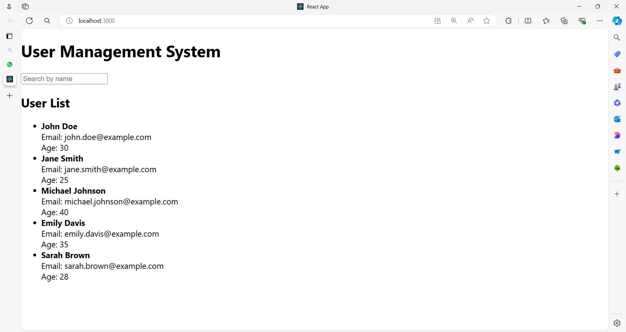

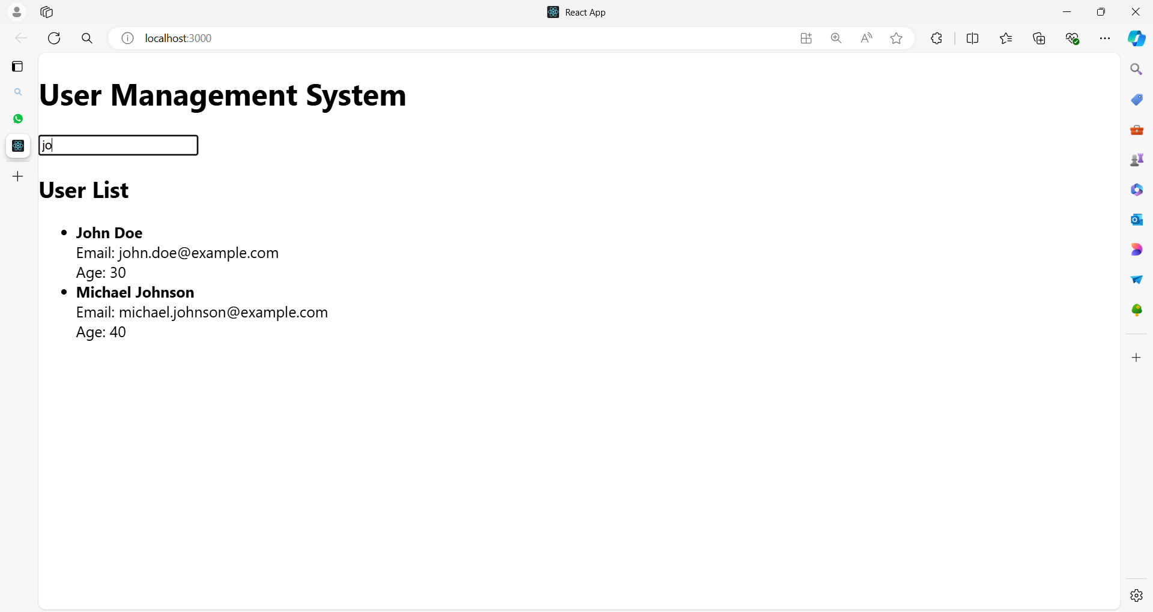

Here's the complete code:

**App.js**

import React, { useState } from 'react';

// Sample user data

const initialUsers = [

{ id: 1, name: 'John Doe', email: 'john.doe@example.com', age: 30 },

{ id: 2, name: 'Jane Smith', email: 'jane.smith@example.com', age: 25 },

{ id: 3, name: 'Michael Johnson', email: 'michael.johnson@example.com', age: 40 },

{ id: 4, name: 'Emily Davis', email: 'emily.davis@example.com', age: 35 },

{ id: 5, name: 'Sarah Brown', email: 'sarah.brown@example.com', age: 28 },

];

// UserList component to display list of users

function UserList({ users }) {

return (

<ul>

{users.map(user => (

<li key={user.id}>

<strong>{user.name}</strong><br />

Email: {user.email}<br />

Age: {user.age}

</li>

))}

</ul>

);

}

// FilterForm component to handle search input

function FilterForm({ filter, setFilter }) {

return (

<input

type="text"

value={filter}

onChange={(e) => setFilter(e.target.value)}

placeholder="Search by name"

/>

);

}

// Main App component

function App() {

const [users, setUsers] = useState(initialUsers);

const [filter, setFilter] = useState('');

// Filter users based on the search input

const filteredUsers = users.filter(user =>

user.name.toLowerCase().includes(filter.toLowerCase())

);

return (

<div>

<h1>User Management System</h1>

<FilterForm filter={filter} setFilter={setFilter} />

<h2>User List</h2>

<UserList users={filteredUsers} />

</div>

);

}

export default App;

**Explanation**

**1. Sample Data**

**const initialUsers = [**

**// User objects with id, name, email, and age**

**];**

* **Purpose**: Provides initial data for the list of users.
* **Keys**: Each user object has a unique id which will be used as a key.

**2. UserList Component**

**function UserList({ users }) {**

**return (**

**<ul>**

**{users.map(user => (**

**<li key={user.id}>**

**<strong>{user.name}</strong><br />**

**Email: {user.email}<br />**

**Age: {user.age}**

**</li>**

**))}**

**</ul>**

**);**

**}**

* **Rendering List**: Maps over the users array and returns a list item (<li>) for each user.
* **Keys**: Uses user.id as the unique key for each list item to help React identify each item uniquely.

**users.map(user => (**

**<li key={user.id}>**

**<strong>{user.name}</strong><br />**

**Email: {user.email}<br />**

**Age: {user.age}**

**</li>**

**))**

Let’s break it down line by line:

1. **users.map(user => (**
   * This line uses the map function on the users array.
   * **map** is an array method that creates a new array with the results of calling a provided function on every element in the array.
   * user is a parameter for the callback function, representing each individual item in the users array as it is processed by map.
2. **<li key={user.id}>**
   * This line returns an <li> element (a list item in HTML) for each user.
   * The key attribute is set to user.id. In React, key helps identify which items have changed, are added, or are removed. It should be unique for each item in the list to help React efficiently update the UI.
3. **<strong>{user.name}</strong><br />**
   * This line renders the user's name inside a <strong> tag, which makes the text bold.
   * {user.name} is a JavaScript expression that outputs the name of the user from the user object.
   * <br /> is an HTML line break element that moves the following content to a new line.
4. **Email: {user.email}<br />**
   * This line displays the label Email: followed by the user’s email address, extracted from the user.email property.
   * {user.email} outputs the email value for the current user.
   * <br /> again creates a line break to ensure that the following content starts on a new line.
5. **Age: {user.age}**
   * This line displays the label Age: followed by the user’s age, obtained from user.age.
   * {user.age} is a JavaScript expression that outputs the age of the user.
6. **))**
   * This closes the JSX expression opened by the map function. The map function will iterate over each user in the users array, returning an array of <li> elements, each populated with the corresponding user data.

**Summary**

This code snippet is rendering a list of users in HTML <li> elements.

Each list item displays the user's name (in bold), email, and age.

The key attribute ensures that each list item can be uniquely identified by React for efficient rendering and updating.

**3. FilterForm Component**

**function FilterForm({ filter, setFilter }) {**

**return (**

**<input**

**type="text"**

**value={filter}**

**onChange={(e) => setFilter(e.target.value)}**

**placeholder="Search by name"**

**/>**

**);**

**}**

* **Search Input**: Handles user input to filter the list of users.
* **Props**: Receives filter (search text) and setFilter (function to update the filter state).

**4. App Component**

**function App() {**

**const [users, setUsers] = useState(initialUsers);**

**const [filter, setFilter] = useState('');**

**const filteredUsers = users.filter(user =>**

**user.name.toLowerCase().includes(filter.toLowerCase())**

**);**

**return (**

**<div>**

**<h1>User Management System</h1>**

**<FilterForm filter={filter} setFilter={setFilter} />**

**<h2>User List</h2>**

**<UserList users={filteredUsers} />**

**</div>**

**);**

**}**

* **State Management**: Uses useState to manage users and filter.
* **Filtering**: Filters the users array based on the search input before passing it to the UserList component.
* **Rendering**: Renders the FilterForm and UserList components, passing necessary props.

**Summary**

* **Lists**: Rendered using the map() function and displayed dynamically based on data.
* **Keys**: Ensure each list item is uniquely identified using the key prop, which improves performance and helps React manage updates.
* **Filtering**: Demonstrates how to handle user input to filter and display a subset of data.

This example illustrates how to effectively use lists and keys in React, along with managing state and user input to create a dynamic and interactive UI.

**Example 02**

Here's a comprehensive example of a Travel Booking application that demonstrates the use of lists and keys.

The application will consist of several components and separate CSS files for each component.

**Travel Booking Application**

**Components:**

1. **App**: Main component.
2. **Header**: Displays the header of the application.
3. **DestinationList**: Renders a list of travel destinations.
4. **DestinationCard**: Displays details of a single destination.
5. **BookingForm**: Allows users to book a destination.

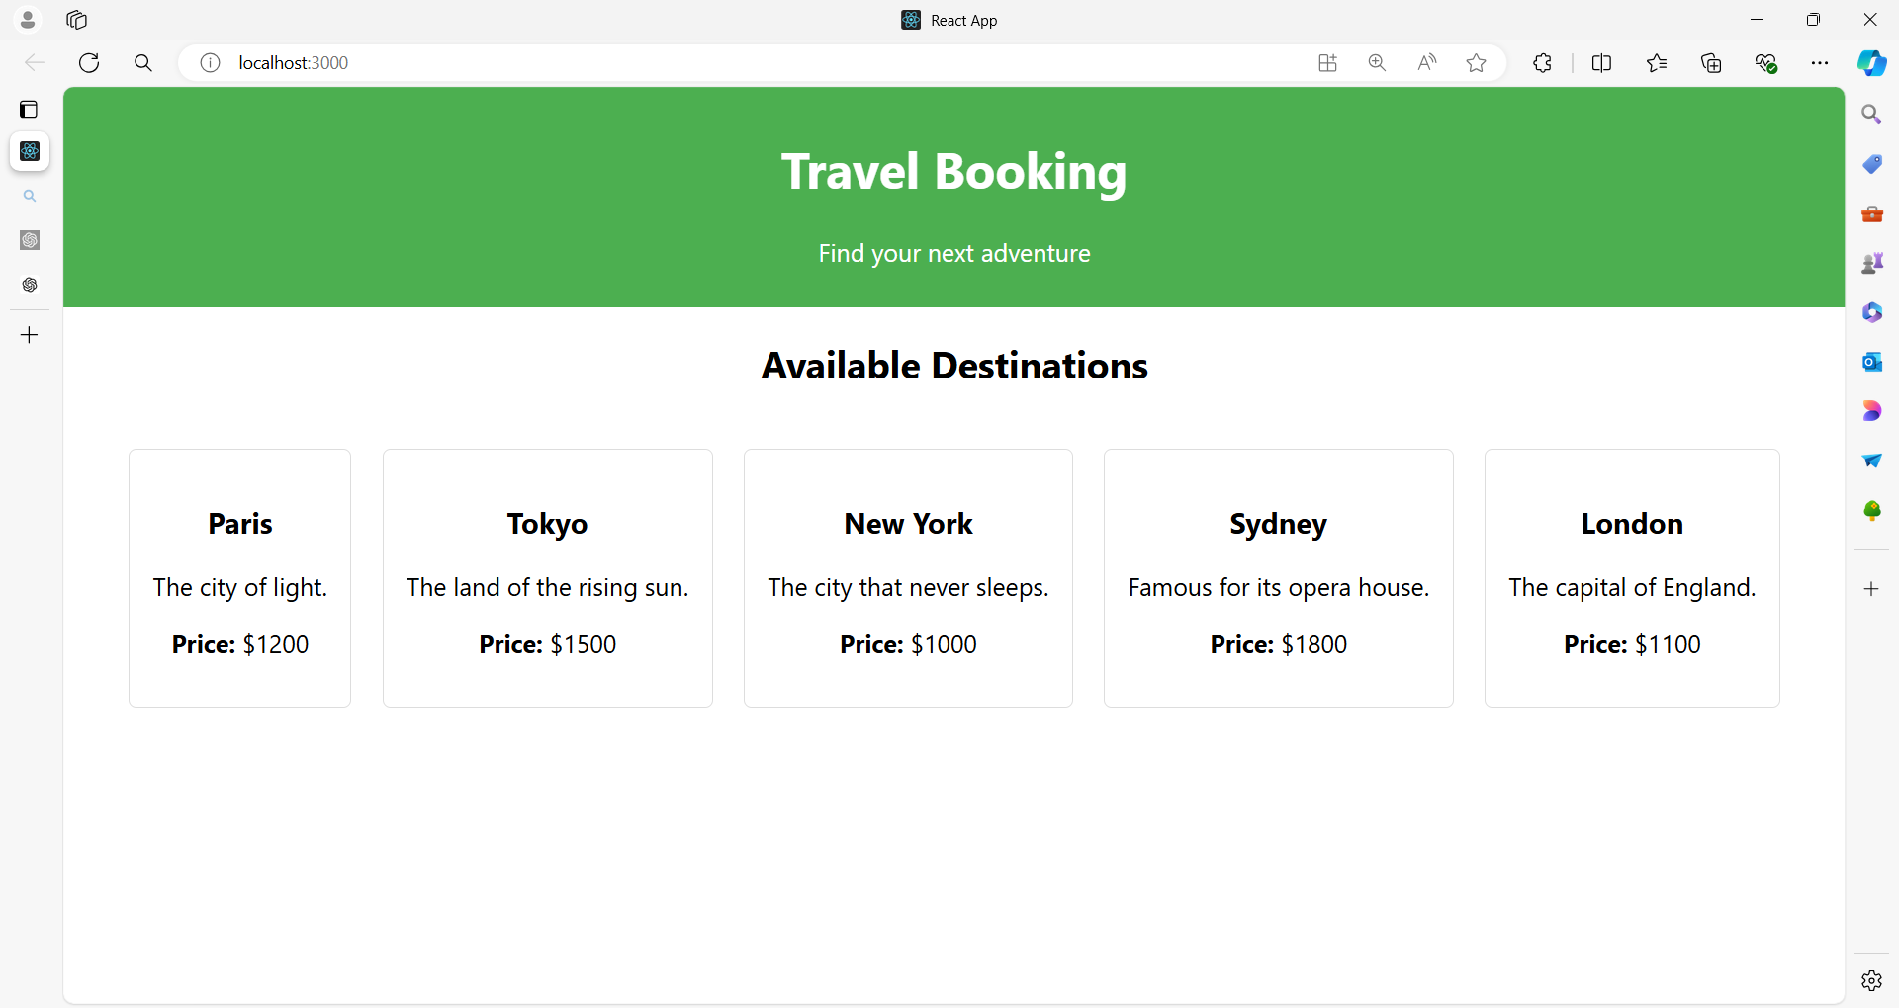

**After clicking Any City**

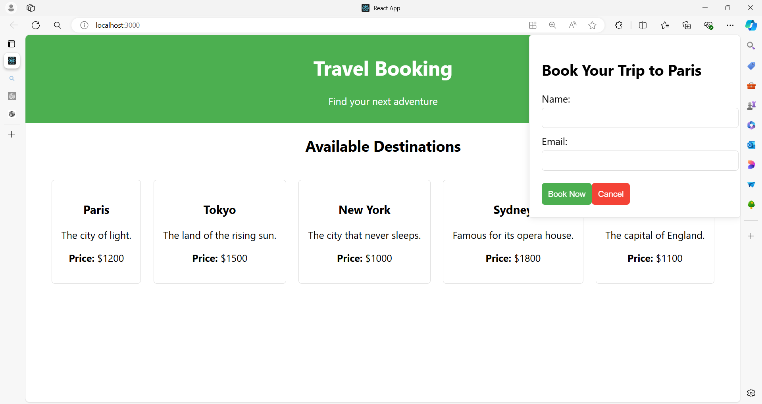

**Fill the form as shown below**

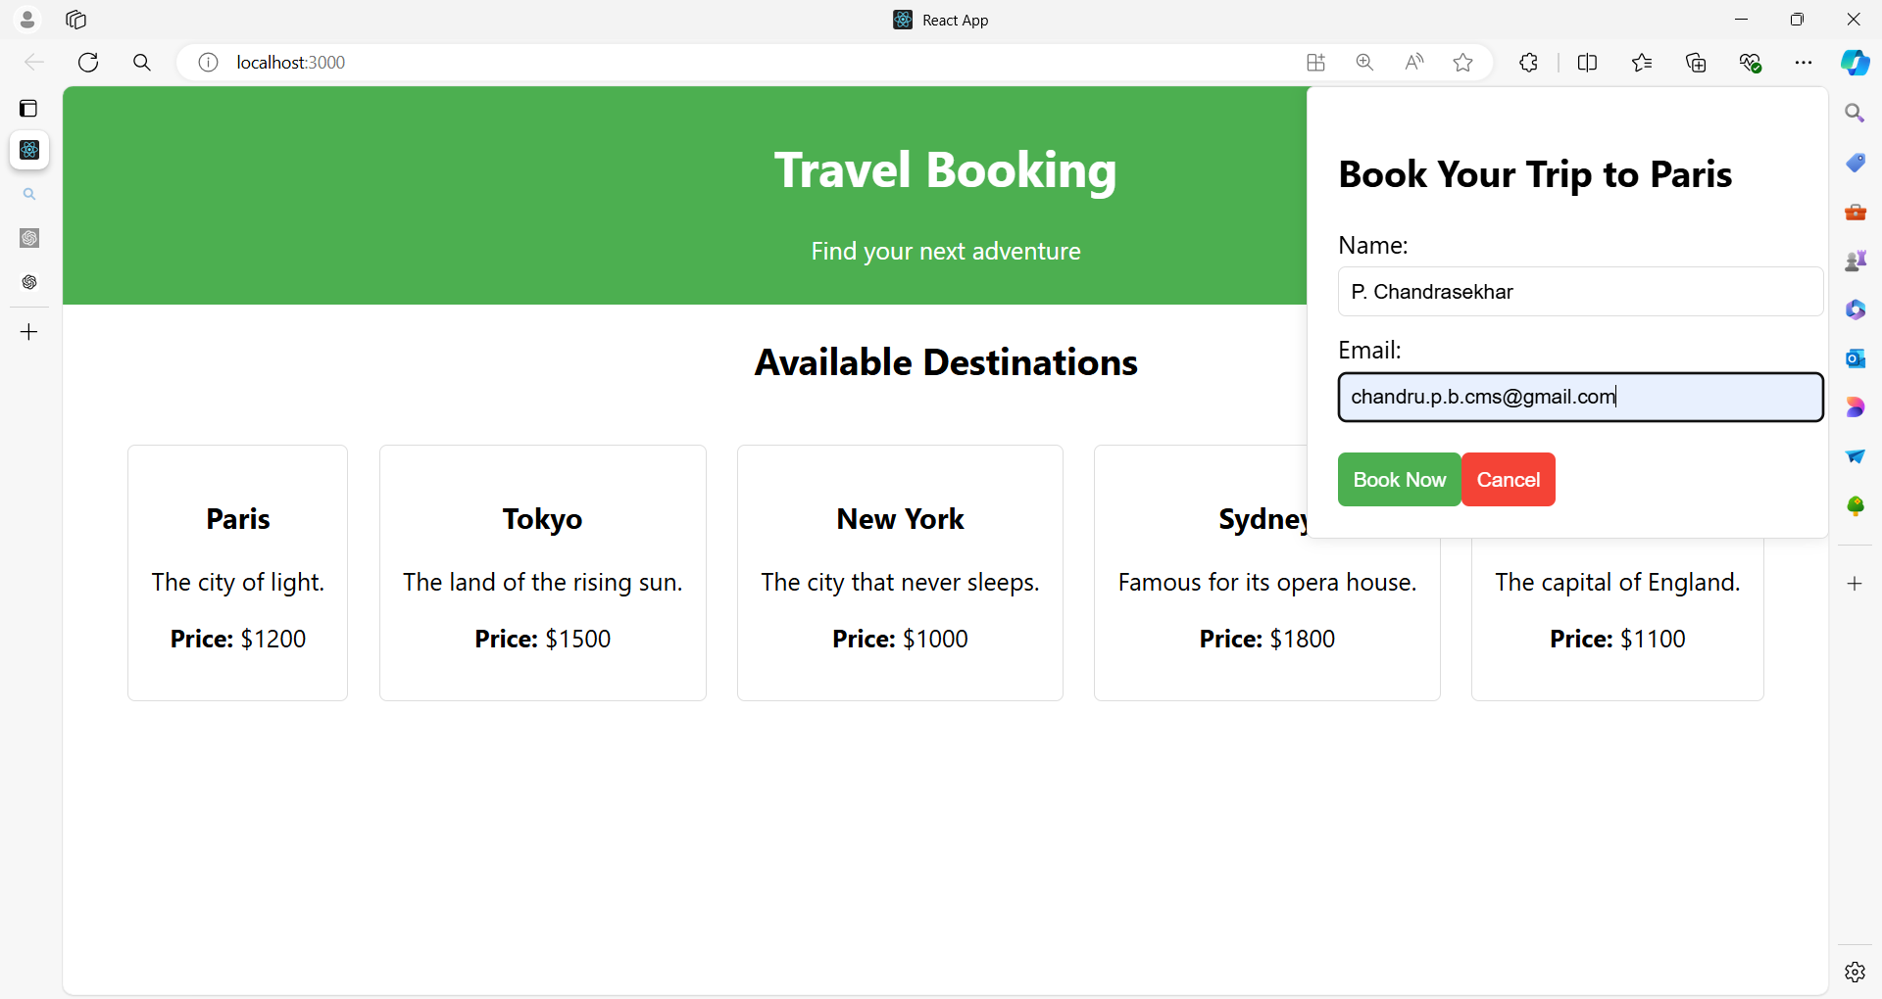

**After clicking Book Now button**

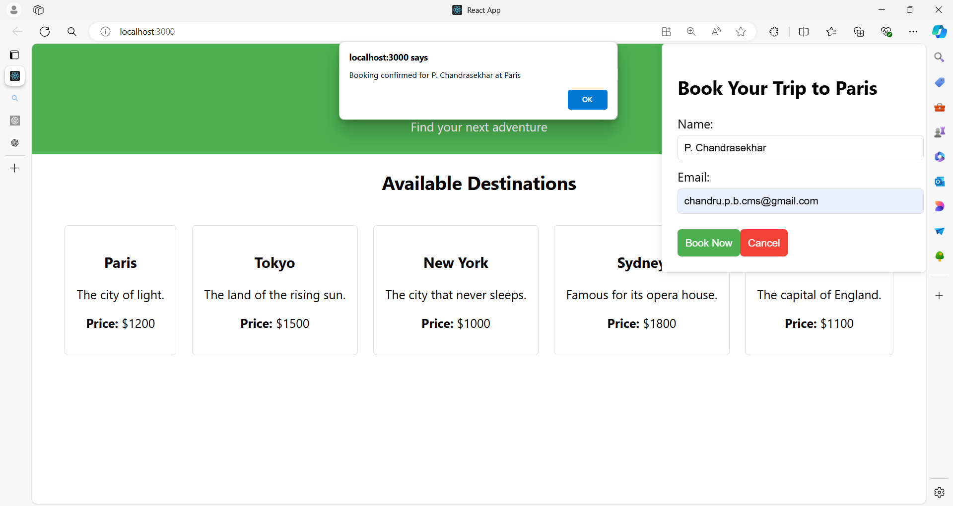

**Project Structure**

/travel-booking

/components

Header.js

DestinationList.js

DestinationCard.js

BookingForm.js

/styles

App.css

Header.css

DestinationList.css

DestinationCard.css

BookingForm.css

App.js

index.js

**1. App.js**

import React, { useState } from 'react';

import Header from './components/Header';

import DestinationList from './components/DestinationList';

import BookingForm from './components/BookingForm';

import './styles/App.css'; // Global styles

const destinations = [

{ id: 1, name: 'Paris', description: 'The city of light.', price: 1200 },

{ id: 2, name: 'Tokyo', description: 'The land of the rising sun.', price: 1500 },

{ id: 3, name: 'New York', description: 'The city that never sleeps.', price: 1000 },

{ id: 4, name: 'Sydney', description: 'Famous for its opera house.', price: 1800 },

{ id: 5, name: 'London', description: 'The capital of England.', price: 1100 },

{ id: 6, name: 'Rome', description: 'The eternal city with rich history.', price: 1300 },

{ id: 7, name: 'Barcelona', description: 'Famous for its architecture and beaches.', price: 1400 },

{ id: 8, name: 'Dubai', description: 'A modern city with luxurious experiences.', price: 2000 },

{ id: 9, name: 'Istanbul', description: 'Where East meets West with vibrant culture.', price: 1100 },

{ id: 10, name: 'Rio de Janeiro', description: 'Known for its carnival and beautiful beaches.', price: 1600 }

];

function App() {

  const [selectedDestination, setSelectedDestination] = useState(null);

  return (

    <div className="app">

      <Header />

      <DestinationList

        destinations={destinations}

        setSelectedDestination={setSelectedDestination}

      />

      {selectedDestination && (

        <BookingForm

          destination={selectedDestination}

          onClose={() => setSelectedDestination(null)}

        />

      )}

    </div>

  );

}

export default App;

styles/App.css

.destination-container {

  text-align: center;

}

.destination-title {

  margin-bottom: 20px;

  font-size: 24px;

}

.destination-list {

  display: block; /* Makes sure items break into new lines */

}

.destination-item {

  display: inline-block; /* Displays items in a line */

  width: 200px; /* Adjust width as needed */

  margin: 10px;

  vertical-align: top; /* Aligns items at the top */

  text-align: left; /* Aligns text to the left */

}

button {

  padding: 10px;

  border: none;

  background-color: #61dafb;

  color: white;

  cursor: pointer;

}

button:hover {

  background-color: #4fa3d0;

}

**2. Header.js**

import React from 'react';

import '../styles/Header.css';

function Header() {

return (

<header className="header">

<h1>Travel Booking</h1>

<p>Find your next adventure</p>

</header>

);

}

export default Header;

**Header.css**

.header {

background-color: #4CAF50;

color: white;

padding: 10px;

text-align: center;

}

**3. DestinationList.js**

import React from 'react';

import DestinationCard from './DestinationCard';

import '../styles/DestinationList.css';

function DestinationList({ destinations, setSelectedDestination }) {

  return (

    <div className="destination-list">

      <h2>Available Destinations</h2>

      <div className="destination-items">

        {destinations.map(destination => (

          <DestinationCard

            key={destination.id}

            destination={destination}

            onSelect={() => setSelectedDestination(destination)}

          />

        ))}

      </div>

    </div>

  );

}

export default DestinationList;

**DestinationList.css**

.destination-list {

  text-align: center; /* Centers the text and content */

}

.destination-list h2 {

  margin: 20px 0; /* Adds space above and below the title */

  font-size: 24px;

  font-weight: bold;

}

.destination-items {

  display: flex; /* Align items horizontally */

  flex-wrap: wrap; /* Allow items to wrap to the next line */

  justify-content: center; /* Center items horizontally */

  gap: 20px; /* Space between items */

}

**4. DestinationCard.js**

import React from 'react';

import '../styles/DestinationCard.css';

function DestinationCard({ destination, onSelect }) {

return (

<div className="destination-card" onClick={onSelect}>

<h3>{destination.name}</h3>

<p>{destination.description}</p>

<p><strong>Price:</strong> ${destination.price}</p>

</div>

);

}

export default DestinationCard;

**DestinationCard.css**

.destination-card {

border: 1px solid #ddd;

border-radius: 5px;

padding: 15px;

cursor: pointer;

transition: background-color 0.3s;

}

.destination-card:hover {

background-color: #f0f0f0;

}

**5. BookingForm.js**

import React, { useState } from 'react';

import '../styles/BookingForm.css';

function BookingForm({ destination, onClose }) {

const [name, setName] = useState('');

const [email, setEmail] = useState('');

const handleSubmit = (e) => {

e.preventDefault();

alert(`Booking confirmed for ${name} at ${destination.name}`);

onClose();

};

return (

<div className="booking-form">

<h2>Book Your Trip to {destination.name}</h2>

<form onSubmit={handleSubmit}>

<div className="form-group">

<label>Name:</label>

<input

type="text"

value={name}

onChange={(e) => setName(e.target.value)}

required

/>

</div>

<div className="form-group">

<label>Email:</label>

<input

type="email"

value={email}

onChange={(e) => setEmail(e.target.value)}

required

/>

</div>

<button type="submit">Book Now</button>

<button type="button" onClick={onClose}>Cancel</button>

</form>

</div>

);

}

export default BookingForm;

**BookingForm.css**

.booking-form {

position: fixed;

top: 0;

right: 0;

width: 300px;

padding: 20px;

background-color: #fff;

border: 1px solid #ddd;

border-radius: 5px;

box-shadow: 0 0 10px rgba(0, 0, 0, 0.1);

}

.booking-form .form-group {

margin-bottom: 10px;

}

.booking-form label {

display: block;

margin-bottom: 5px;

}

.booking-form input {

width: 100%;

padding: 8px;

border: 1px solid #ddd;

border-radius: 5px;

}

.booking-form button {

margin-top: 10px;

padding: 10px;

border: none;

border-radius: 5px;

cursor: pointer;

}

.booking-form button[type="submit"] {

background-color: #4CAF50;

color: white;

}

.booking-form button[type="button"] {

background-color: #f44336;

color: white;

}

**Summary**

* **App Component**: Manages the overall state and rendering of other components.
* **Header Component**: Displays the header with a global style.
* **DestinationList Component**: Renders a list of DestinationCard components using map() and keys.
* **DestinationCard Component**: Represents individual travel destinations.
* **BookingForm Component**: Provides a form for booking a selected destination.

Each component has its own CSS file for styling, demonstrating how to manage styles in a React application. The DestinationList uses the key prop to ensure each DestinationCard is uniquely identified, enhancing performance and accuracy in updates.

**Example 03**

Here's a detailed example of a large React application to explain lists and keys.

The application will simulate a Hotel Booking System with various components, including a list of hotels, filtering options, and booking functionality.

**Hotel Booking System**

**Components:**

1. **App**: Main component.
2. **Header**: Displays the header of the application.
3. **HotelList**: Renders a list of hotels.
4. **HotelCard**: Displays details of a single hotel.
5. **HotelFilter**: Allows users to filter hotels by location and rating.
6. **HotelDetails**: Shows details of a selected hotel.
7. **BookingForm**: Form to book a selected hotel.
8. **Footer**: Displays footer information.
9. **SearchBar**: Allows searching for hotels by name.
10. **SortOptions**: Allows sorting hotels by price or rating.

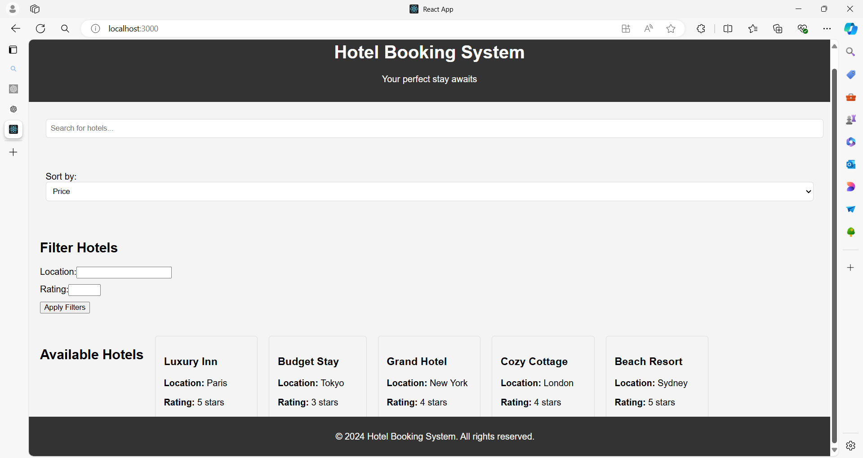

**Project Structure**

/hotel-booking

/components

Header.js

HotelList.js

HotelCard.js

HotelFilter.js

HotelDetails.js

BookingForm.js

Footer.js

SearchBar.js

SortOptions.js

/styles

Header.css

HotelList.css

HotelCard.css

HotelFilter.css

HotelDetails.css

BookingForm.css

Footer.css

SearchBar.css

SortOptions.css

App.js

index.js

**1. App.js**

import React, { useState } from 'react';

import Header from './components/Header';

import HotelList from './components/HotelList';

import HotelFilter from './components/HotelFilter';

import HotelDetails from './components/HotelDetails';

import BookingForm from './components/BookingForm';

import Footer from './components/Footer';

import SearchBar from './components/SearchBar';

import SortOptions from './components/SortOptions';

import './styles/App.css'; // Global styles

// Sample hotel data

const hotels = [

  { id: 1, name: 'Luxury Inn', location: 'Paris', rating: 5, price: 200 },

  { id: 2, name: 'Budget Stay', location: 'Tokyo', rating: 3, price: 50 },

  { id: 3, name: 'Grand Hotel', location: 'New York', rating: 4, price: 150 },

  { id: 4, name: 'Cozy Cottage', location: 'London', rating: 4, price: 120 },

  { id: 5, name: 'Beach Resort', location: 'Sydney', rating: 5, price: 300 },

  { id: 6, name: 'Mountain Lodge', location: 'Zurich', rating: 4, price: 180 },

  { id: 7, name: 'Urban Retreat', location: 'San Francisco', rating: 3, price: 80 },

  { id: 8, name: 'Historic Manor', location: 'Rome', rating: 4, price: 160 },

  { id: 9, name: 'Sea View Hotel', location: 'Barcelona', rating: 5, price: 250 },

  { id: 10, name: 'Desert Oasis', location: 'Dubai', rating: 5, price: 350 }

];

function App() {

const [filteredHotels, setFilteredHotels] = useState(hotels);

const [selectedHotel, setSelectedHotel] = useState(null);

const [searchTerm, setSearchTerm] = useState('');

const [sortOption, setSortOption] = useState('price');

// Filter and sort hotels

const handleFilterChange = (filters) => {

const { location, rating } = filters;

const filtered = hotels.filter(hotel => {

return (

(!location || hotel.location === location) &&

(!rating || hotel.rating === rating)

);

});

setFilteredHotels(filtered);

};

const handleSearchChange = (term) => {

setSearchTerm(term);

const searched = hotels.filter(hotel =>

hotel.name.toLowerCase().includes(term.toLowerCase())

);

setFilteredHotels(searched);

};

const handleSortChange = (option) => {

setSortOption(option);

const sorted = [...filteredHotels].sort((a, b) => a[option] - b[option]);

setFilteredHotels(sorted);

};

return (

<div className="app">

<Header />

<SearchBar searchTerm={searchTerm} onSearchChange={handleSearchChange} />

<SortOptions sortOption={sortOption} onSortChange={handleSortChange} />

<HotelFilter onFilterChange={handleFilterChange} />

<HotelList

hotels={filteredHotels}

onSelectHotel={setSelectedHotel}

/>

{selectedHotel && (

<HotelDetails

hotel={selectedHotel}

onClose={() => setSelectedHotel(null)}

/>

)}

{selectedHotel && (

<BookingForm

hotel={selectedHotel}

onClose={() => setSelectedHotel(null)}

/>

)}

<Footer />

</div>

);

}

export default App;

**2. Header.js**

import React from 'react';

import './styles/Header.css';

function Header() {

return (

<header className="header">

<h1>Hotel Booking System</h1>

<p>Your perfect stay awaits</p>

</header>

);

}

export default Header;

**Header.css**

.header {

background-color: #333;

color: white;

padding: 15px;

text-align: center;

}

**3. HotelList.js**

import React from 'react';

import HotelCard from './HotelCard';

import '../styles/HotelList.css';

function HotelList({ hotels, onSelectHotel }) {

return (

<div className="hotel-list">

<h2>Available Hotels</h2>

<div className="hotel-card-container">

{hotels.map(hotel => (

<HotelCard

key={hotel.id}

hotel={hotel}

onSelect={() => onSelectHotel(hotel)}

/>

))}

</div>

</div>

);

}

export default HotelList;

**HotelList.css**

.hotel-list {

text-align: center; /* Center-aligns the text */

}

.hotel-list h2 {

margin: 20px 0; /* Adds space above and below the title */

font-size: 24px; /* Font size for the title */

font-weight: bold; /* Makes the title bold */

}

.hotel-list .hotel-card-container {

display: flex; /* Aligns items horizontally */

flex-wrap: wrap; /* Allows items to wrap to the next line */

justify-content: center; /* Centers items horizontally */

gap: 20px; /* Space between items */

}

**4. HotelCard.js**

import React from 'react';

import './styles/HotelCard.css';

function HotelCard({ hotel, onSelect }) {

return (

<div className="hotel-card" onClick={onSelect}>

<h3>{hotel.name}</h3>

<p><strong>Location:</strong> {hotel.location}</p>

<p><strong>Rating:</strong> {hotel.rating} stars</p>

<p><strong>Price:</strong> ${hotel.price} per night</p>

</div>

);

}

export default HotelCard;

**HotelCard.css**

.hotel-card {

border: 1px solid #ddd;

border-radius: 5px;

padding: 15px;

cursor: pointer;

transition: background-color 0.3s;

}

.hotel-card:hover {

background-color: #f9f9f9;

}

**5. HotelFilter.js**

import React, { useState } from 'react';

import './styles/HotelFilter.css';

function HotelFilter({ onFilterChange }) {

const [location, setLocation] = useState('');

const [rating, setRating] = useState('');

const handleApplyFilters = () => {

onFilterChange({ location, rating });

};

return (

<div className="hotel-filter">

<h2>Filter Hotels</h2>

<label>

Location:

<input

type="text"

value={location}

onChange={(e) => setLocation(e.target.value)}

/>

</label>

<label>

Rating:

<input

type="number"

min="1"

max="5"

value={rating}

onChange={(e) => setRating(e.target.value)}

/>

</label>

<button onClick={handleApplyFilters}>Apply Filters</button>

</div>

);

}

export default HotelFilter;

**HotelFilter.css**

.hotel-filter {

padding: 20px;

background-color: #f4f4f4;

border-radius: 5px;

}

.hotel-filter label {

display: block;

margin-bottom: 10px;

}

**6. HotelDetails.js**

import React from 'react';

import './styles/HotelDetails.css';

function HotelDetails({ hotel, onClose }) {

return (

<div className="hotel-details">

<button className="close-btn" onClick={onClose}>Close</button>

<h2>{hotel.name}</h2>

<p><strong>Location:</strong> {hotel.location}</p>

<p><strong>Rating:</strong> {hotel.rating} stars</p>

<p><strong>Description:</strong> A wonderful place to stay with top-notch amenities.</p>

<p><strong>Price:</strong> ${hotel.price} per night</p>

</div>

);

}

export default HotelDetails;

**HotelDetails.css**

.hotel-details {

padding: 20px;

background-color: #fff;

border: 1px solid #ddd;

border-radius: 5px;

position: relative;

}

.close-btn {

position: absolute;

top: 10px;

right: 10px;

background: #f44336;

color: white;

border: none;

padding: 5px 10px;

cursor: pointer;

}

**7. BookingForm.js**

import React, { useState } from 'react';

import './styles/BookingForm.css';

function BookingForm({ hotel, onClose }) {

const [name, setName] = useState('');

const [email, setEmail] = useState('');

const handleSubmit = (e) => {

e.preventDefault();

alert(`Booking confirmed for ${name} at ${hotel.name}`);

onClose();

};

return (

<div className="booking-form">

<h2>Book Your Stay at {hotel.name}</h2>

<form onSubmit={handleSubmit}>

<label>

Name:

<input

type="text"

value={name}

onChange={(e) => setName(e.target.value)}

required

/>

</label>

<label>

Email:

<input

type="email"

value={email}

onChange={(e) => setEmail(e.target.value)}

required

/>

</label>

<button type="submit">Book Now</button>

<button type="button" onClick={onClose}>Cancel</button>

</form>

</div>

);

}

export default BookingForm;

**BookingForm.css**

.booking-form {

padding: 20px;

background-color: #fff;

border: 1px solid #ddd;

border-radius: 5px;

}

.booking-form label {

display: block;

margin-bottom: 10px;

}

.booking-form input {

width: 100%;

padding: 8px;

border: 1px solid #ddd;

border-radius: 5px;

}

.booking-form button {

margin-top: 10px;

padding: 10px;

border: none;

border-radius: 5px;

cursor: pointer;

}

.booking-form button[type="submit"] {

background-color: #4CAF50;

color: white;

}

.booking-form button[type="button"] {

background-color: #f44336;

color: white;

}

**8. Footer.js**

import React from 'react';

import './styles/Footer.css';

function Footer() {

return (

<footer className="footer">

<p>&copy; 2024 Hotel Booking System. All rights reserved.</p>

</footer>

);

}

export default Footer;

**Footer.css**

.footer {

background-color: #333;

color: white;

text-align: center;

padding: 10px;

position: fixed;

bottom: 0;

width: 100%;

}

**9. SearchBar.js**

import React from 'react';

import './styles/SearchBar.css';

function SearchBar({ searchTerm, onSearchChange }) {

return (

<div className="search-bar">

<input

type="text"

placeholder="Search for hotels..."

value={searchTerm}

onChange={(e) => onSearchChange(e.target.value)}

/>

</div>

);

}

export default SearchBar;

**SearchBar.css**

.search-bar {

padding: 10px;

background-color: #f4f4f4;

border-radius: 5px;

margin: 20px;

}

.search-bar input {

width: 100%;

padding: 8px;

border: 1px solid #ddd;

border-radius: 5px;

}

**10. SortOptions.js**

import React from 'react';

import './styles/SortOptions.css';

function SortOptions({ sortOption, onSortChange }) {

return (

<div className="sort-options">

<label>

Sort by:

<select

value={sortOption}

onChange={(e) => onSortChange(e.target.value)}

>

<option value="price">Price</option>

<option value="rating">Rating</option>

</select>

</label>

</div>

);

}

export default SortOptions;

**SortOptions.css**

.sort-options {

padding: 10px;

background-color: #f4f4f4;

border-radius: 5px;

margin: 20px;

}

.sort-options label {

display: block;

}

.sort-options select {

width: 100%;

padding: 8px;

border: 1px solid #ddd;

border-radius: 5px;

}

**Summary**

* **App Component**: Manages state and handles the overall logic of filtering, searching, and sorting hotels. It renders all other components and manages their state.
* **Header Component**: Displays a static header.
* **HotelList Component**: Displays a list of HotelCard components using map() and keys.
* **HotelCard Component**: Represents individual hotels with a click event to select the hotel.
* **HotelFilter Component**: Provides input fields to filter hotels by location and rating.
* **HotelDetails Component**: Displays details of a selected hotel.
* **BookingForm Component**: Allows users to book a selected hotel.
* **Footer Component**: Displays footer information.
* **SearchBar Component**: Allows searching for hotels by name.
* **SortOptions Component**: Allows sorting hotels by price or rating.

This example demonstrates how to manage complex state and user interactions in a React application, using lists and keys effectively to render and update components.

**Lifecycle Methods**

In React, lifecycle methods are hooks that allow you to run code at specific points in a component's lifetime.

These methods are particularly useful for managing side effects, performing cleanup, and optimizing performance.

**Class Component Lifecycle Methods**

For class components, lifecycle methods are categorized into **three main phases**: **Mounting**, **Updating**, and **Unmounting**.

**1. Mounting (Component Creation)**

* **constructor(props)**:
  + Called when a component is initialized.
  + Used for setting initial state and binding event handlers.

constructor(props) {

super(props);

this.state = { count: 0 };

}

* **static getDerivedStateFromProps(props, state)**:
  + Called right before rendering when new props are received.
  + Used to update state based on props.
  + Returns an object to update the state or null to do nothing.

static getDerivedStateFromProps(nextProps, prevState) {

if (nextProps.value !== prevState.value) {

return { value: nextProps.value };

}

return null;

}

* **render()**:
  + Required method that returns the JSX to render.
  + Called during the mounting phase and every time the component updates.

render() {

return <div>{this.state.count}</div>;

}

* **componentDidMount()**:
  + Called immediately after the component is mounted.
  + Ideal for initiating network requests, setting up subscriptions, or performing DOM manipulations.

componentDidMount() {

fetch('/api/data')

.then(response => response.json())

.then(data => this.setState({ data }));

}

**2. Updating (Component Updates)**

* **static getDerivedStateFromProps(props, state)**:
  + Also called during the updating phase.
* **shouldComponentUpdate(nextProps, nextState)**:
  + Determines whether the component should re-render.
  + Can optimize performance by returning false if the update is unnecessary.

shouldComponentUpdate(nextProps, nextState) {

return nextProps.value !== this.props.value;

}

* **render()**:
  + Called again if shouldComponentUpdate returns true.
* **getSnapshotBeforeUpdate(prevProps, prevState)**:
  + Called right before the DOM is updated.
  + Useful for capturing information from the DOM (e.g., scroll position) before changes are applied.
  + Returns a value that is passed to componentDidUpdate.

getSnapshotBeforeUpdate(prevProps, prevState) {

if (prevState.items.length < this.state.items.length) {

return this.listRef.scrollHeight;

}

return null;

}

* **componentDidUpdate(prevProps, prevState, snapshot)**:
  + Called immediately after updating occurs.
  + Useful for performing actions after the DOM is updated.
  + snapshot is the value returned from getSnapshotBeforeUpdate.
  + Example:

componentDidUpdate(prevProps, prevState, snapshot) {

if (snapshot !== null) {

this.listRef.scrollTop = this.listRef.scrollHeight - snapshot;

}

}

**3. Unmounting (Component Removal)**

* **componentWillUnmount()**:
  + Called immediately before the component is removed from the DOM.
  + Ideal for cleanup tasks like invalidating timers, canceling network requests, or cleaning up subscriptions.

componentWillUnmount() {

clearInterval(this.timerID);

}

**Functional Components with Hooks**

For functional components, **lifecycle methods are replaced by hooks.**

Here's how you can achieve similar behavior with hooks:

* **useEffect()**:
  + Handles side effects in functional components.
  + You can specify when to run effects (on mount, update, or unmount) by passing dependencies.

import React, { useEffect, useState } from 'react';

function Example() {

const [count, setCount] = useState(0);

useEffect(() => {

// Effect runs after every render

document.title = `You clicked ${count} times`;

// Cleanup function (runs on unmount)

return () => {

console.log('Cleaning up...');

};

}, [count]); // Dependency array, effect runs when 'count' changes

return (

<div>

<p>You clicked {count} times</p>

<button onClick={() => setCount(count + 1)}>Click me</button>

</div>

);

}

export default Example;

**Summary**

* **Mounting**: Initialize and set up resources.
* **Updating**: Respond to changes in props or state and manage re-rendering.
* **Unmounting**: Clean up resources before removal.

Class components use specific lifecycle methods, while functional components use the useEffect hook to manage side effects and lifecycle events.

**Example 01**

Let's create a more comprehensive React application to demonstrate lifecycle methods. We'll build a **User Management Dashboard** with class components, featuring various lifecycle method scenarios.

**User Management Dashboard**

**Features:**

1. **UserList**: Displays a list of users.
2. **UserDetails**: Shows detailed information about a selected user.
3. **AddUserForm**: Form to add a new user.
4. **UpdateUserForm**: Form to update user information.
5. **Header**: Displays the application header.
6. **Footer**: Displays footer information.

**Project Structure**

/user-management

/components

Header.js

UserList.js

UserCard.js

UserDetails.js

AddUserForm.js

UpdateUserForm.js

Footer.js

/styles

Header.css

UserList.css

UserCard.css

UserDetails.css

AddUserForm.css

UpdateUserForm.css

Footer.css

App.js

index.js

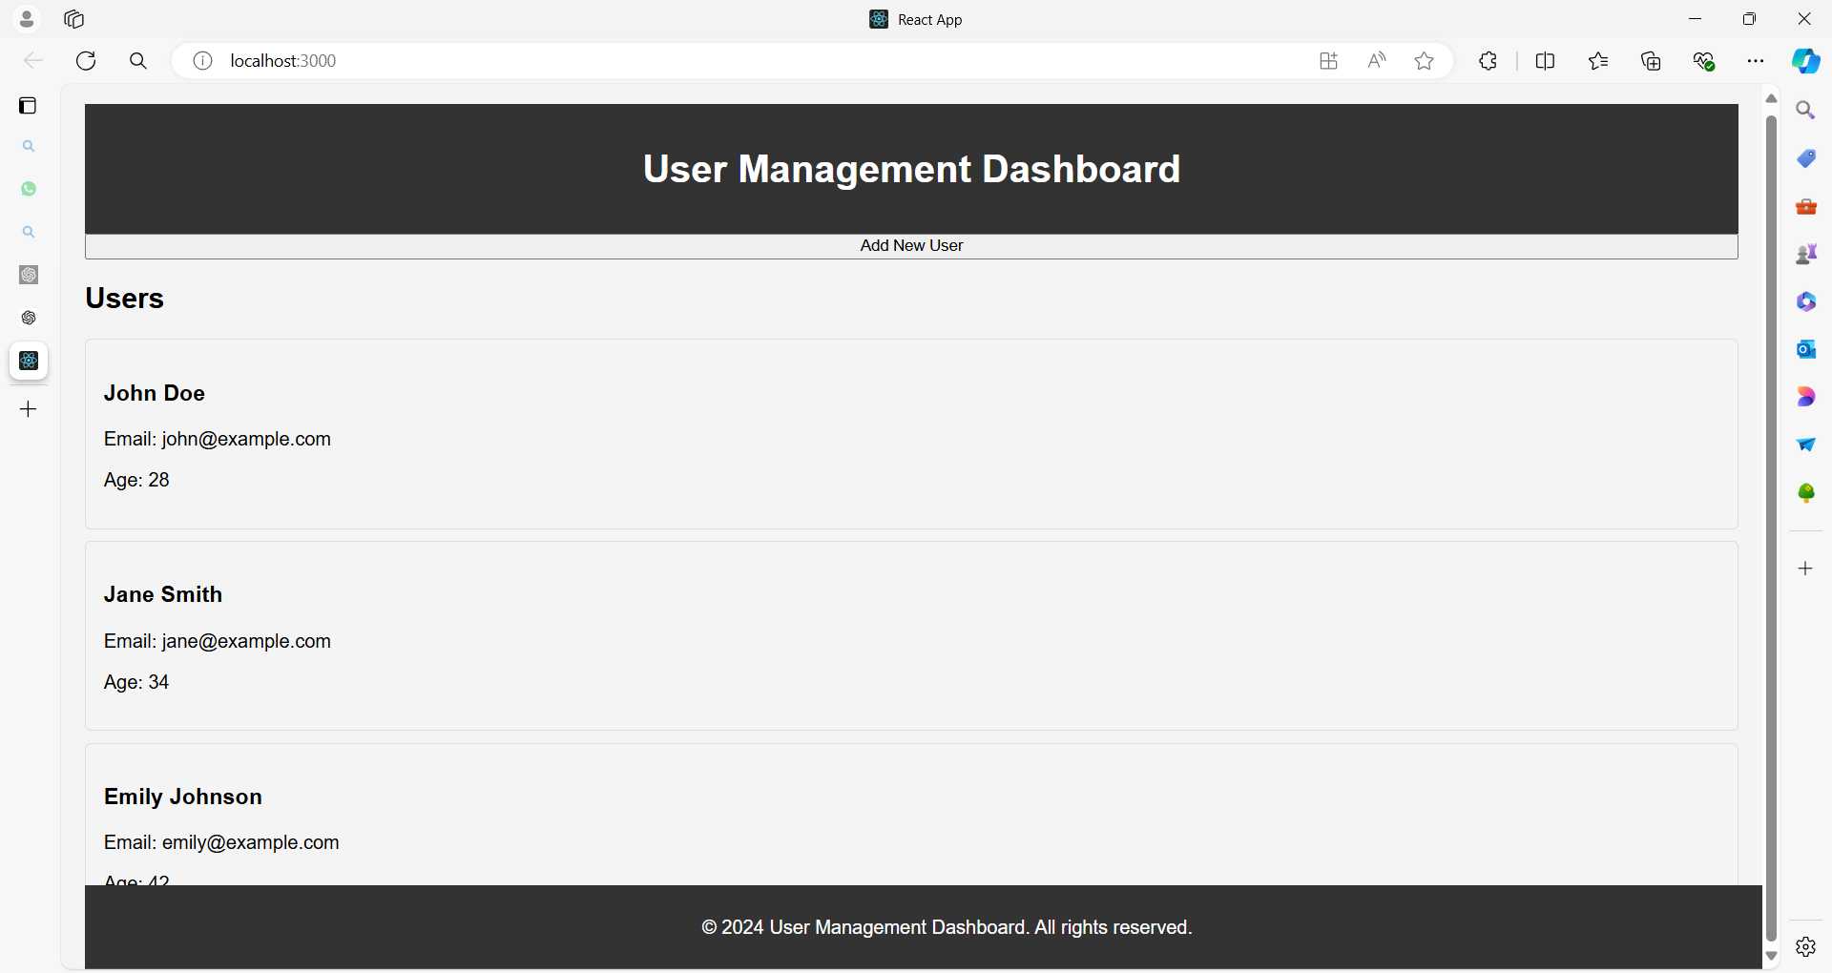

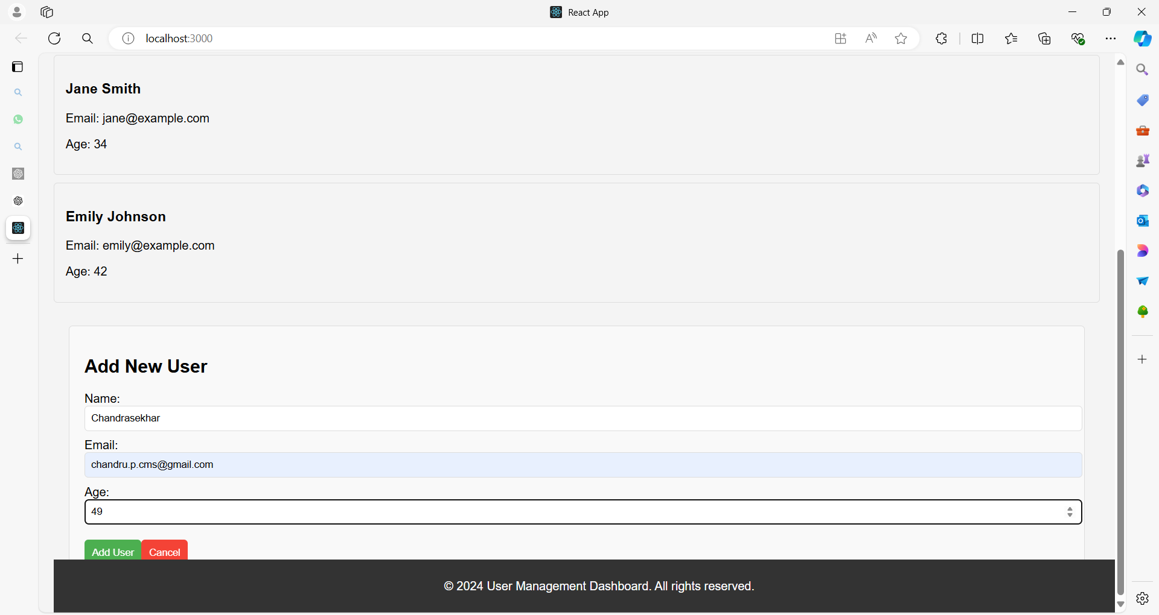

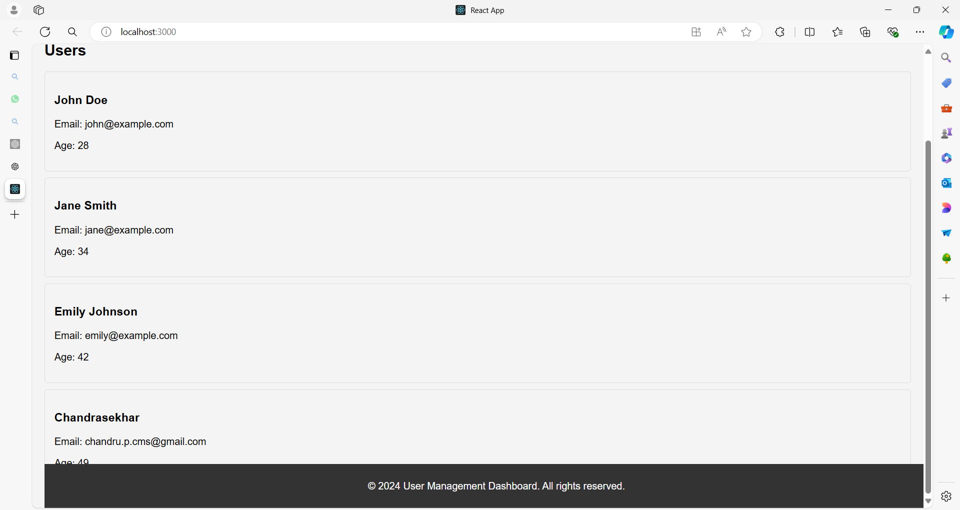

**1. App.js**

import React, { Component } from 'react';

import Header from './components/Header';

import UserList from './components/UserList';

import UserDetails from './components/UserDetails';

import AddUserForm from './components/AddUserForm';

import UpdateUserForm from './components/UpdateUserForm';

import Footer from './components/Footer';

import './styles/App.css'; // Global styles

// Sample user data

const initialUsers = [

{ id: 1, name: 'John Doe', email: 'john@example.com', age: 28 },

{ id: 2, name: 'Jane Smith', email: 'jane@example.com', age: 34 },

{ id: 3, name: 'Emily Johnson', email: 'emily@example.com', age: 42 },

// More users...

];

class App extends Component {

constructor(props) {

super(props);

this.state = {

users: initialUsers,

selectedUser: null,

editingUser: null,

showAddUserForm: false,

showUpdateUserForm: false,

};

}

componentDidMount() {

// Simulate a network request to fetch users

console.log('Component mounted and users fetched');

}

componentDidUpdate(prevProps, prevState) {

// Perform side effects if needed when state changes

if (prevState.users !== this.state.users) {

console.log('User list updated');

}

}

componentWillUnmount() {

// Cleanup before the component is removed

console.log('Component will unmount, perform cleanup');

}

handleUserSelect = (user) => {

this.setState({ selectedUser: user, showUpdateUserForm: false });

};

handleAddUser = (newUser) => {

this.setState((prevState) => ({

users: [...prevState.users, newUser],

showAddUserForm: false,

}));

};

handleUpdateUser = (updatedUser) => {

this.setState((prevState) => ({

users: prevState.users.map(user =>

user.id === updatedUser.id ? updatedUser : user

),

showUpdateUserForm: false,

}));

};

handleShowAddUserForm = () => {

this.setState({ showAddUserForm: true, selectedUser: null });

};

handleShowUpdateUserForm = () => {

this.setState({ showUpdateUserForm: true });

};

handleCloseForms = () => {

this.setState({ showAddUserForm: false, showUpdateUserForm: false });

};

render() {

const { users, selectedUser, showAddUserForm, showUpdateUserForm } = this.state;

return (

<div className="app">

<Header />

<button onClick={this.handleShowAddUserForm}>Add New User</button>

<UserList users={users} onUserSelect={this.handleUserSelect} />

{selectedUser && (

<UserDetails

user={selectedUser}

onEdit={this.handleShowUpdateUserForm}

/>

)}

{showAddUserForm && (

<AddUserForm

onAddUser={this.handleAddUser}

onClose={this.handleCloseForms}

/>

)}

{showUpdateUserForm && selectedUser && (

<UpdateUserForm

user={selectedUser}

onUpdateUser={this.handleUpdateUser}

onClose={this.handleCloseForms}

/>

)}

<Footer />

</div>

);

}

}

export default App;

**2. Header.js**

import React from 'react';

import '../styles/Header.css';

function Header() {

return (

<header className="header">

<h1>User Management Dashboard</h1>

</header>

);

}

export default Header;

**Header.css**

.header {

background-color: #333;

color: white;

padding: 15px;

text-align: center;

}

**3. UserList.js**

import React from 'react';

import UserCard from './UserCard';

import '../styles/UserList.css';

function UserList({ users, onUserSelect }) {

return (

<div className="user-list">

<h2>Users</h2>

{users.map(user => (

<UserCard

key={user.id}

user={user}

onClick={() => onUserSelect(user)}

/>

))}

</div>

);

}

export default UserList;

**UserList.css**

.user-list {

display: flex;

flex-direction: column;

padding: 20px;

}

**4. UserCard.js**

import React from 'react';

import '../styles/UserCard.css';

function UserCard({ user, onClick }) {

return (

<div className="user-card" onClick={onClick}>

<h3>{user.name}</h3>

<p>Email: {user.email}</p>

<p>Age: {user.age}</p>

</div>

);

}

export default UserCard;

**UserCard.css**

.user-card {

border: 1px solid #ddd;

border-radius: 5px;

padding: 15px;

margin: 10px 0;

cursor: pointer;

transition: background-color 0.3s;

}

.user-card:hover {

background-color: #f4f4f4;

}

**5. UserDetails.js**

import React from 'react';

import '../styles/UserDetails.css';

function UserDetails({ user, onEdit }) {

return (

<div className="user-details">

<button className="edit-btn" onClick={onEdit}>Edit</button>

<h2>{user.name}</h2>

<p>Email: {user.email}</p>

<p>Age: {user.age}</p>

</div>

);

}

export default UserDetails;

**UserDetails.css**

.user-details {

padding: 20px;

border: 1px solid #ddd;

border-radius: 5px;

margin: 20px;

}

.edit-btn {

background-color: #4CAF50;

color: white;

border: none;

padding: 10px;

cursor: pointer;

margin-bottom: 15px;

}

**6. AddUserForm.js**

import React, { Component } from 'react';

import '../styles/AddUserForm.css';

class AddUserForm extends Component {

constructor(props) {

super(props);

this.state = {

name: '',

email: '',

age: ''

};

}

handleChange = (e) => {

this.setState({ [e.target.name]: e.target.value });

};

handleSubmit = (e) => {

e.preventDefault();

const newUser = {

id: Date.now(), // Use current timestamp as unique ID

...this.state

};

this.props.onAddUser(newUser);

};

render() {

return (

<div className="add-user-form">

<h2>Add New User</h2>

<form onSubmit={this.handleSubmit}>

<label>

Name:

<input

type="text"

name="name"

value={this.state.name}

onChange={this.handleChange}

required

/>

</label>

<label>

Email:

<input

type="email"

name="email"

value={this.state.email}

onChange={this.handleChange}

required

/>

</label>

<label>

Age:

<input

type="number"

name="age"

value={this.state.age}

onChange={this.handleChange}

required

/>

</label>

<button type="submit">Add User</button>

<button type="button" onClick={this.props.onClose}>Cancel</button>

</form>

</div>

);

}

}

export default AddUserForm;

**AddUserForm.css**

.add-user-form {

padding: 20px;

border: 1px solid #ddd;

border-radius: 5px;

margin: 20px;

background-color: #f9f9f9;

}

.add-user-form label {

display: block;

margin-bottom: 10px;

}

.add-user-form input {

width: 100%;

padding: 8px;

border: 1px solid #ddd;

border-radius: 5px;

}

.add-user-form button {

margin-top: 10px;

padding: 10px;

border: none;

border-radius: 5px;

cursor: pointer;

}

.add-user-form button[type="submit"] {

background-color: #4CAF50;

color: white;

}

.add-user-form button[type="button"] {

background-color: #f44336;

color: white;

}

**7. UpdateUserForm.js**

import React, { Component } from 'react';

import '../styles/UpdateUserForm.css';

class UpdateUserForm extends Component {

constructor(props) {

super(props);

this.state = {

...props.user

};

}

handleChange = (e) => {

this.setState({ [e.target.name]: e.target.value });

};

handleSubmit = (e) => {

e.preventDefault();

this.props.onUpdateUser(this.state);

};

render() {

return (

<div className="update-user-form">

<h2>Update User</h2>

<form onSubmit={this.handleSubmit}>

<label>

Name:

<input

type="text"

name="name"

value={this.state.name}

onChange={this.handleChange}

required

/>

</label>

<label>

Email:

<input

type="email"

name="email"

value={this.state.email}

onChange={this.handleChange}

required

/>

</label>

<label>

Age:

<input

type="number"

name="age"

value={this.state.age}

onChange={this.handleChange}

required

/>

</label>

<button type="submit">Update User</button>

<button type="button" onClick={this.props.onClose}>Cancel</button>

</form>

</div>

);

}

}

export default UpdateUserForm;

**UpdateUserForm.css**

.update-user-form {

padding: 20px;

border: 1px solid #ddd;

border-radius: 5px;

margin: 20px;

background-color: #f9f9f9;

}

.update-user-form label {

display: block;

margin-bottom: 10px;

}

.update-user-form input {

width: 100%;

padding: 8px;

border: 1px solid #ddd;

border-radius: 5px;

}

.update-user-form button {

margin-top: 10px;

padding: 10px;

border: none;

border-radius: 5px;

cursor: pointer;

}

.update-user-form button[type="submit"] {

background-color: #4CAF50;

color: white;

}

.update-user-form button[type="button"] {

background-color: #f44336;

color: white;

}

**8. Footer.js**

import React from 'react';

import '../styles/Footer.css';

function Footer() {

return (

<footer className="footer">

<p>&copy; 2024 User Management Dashboard. All rights reserved.</p>

</footer>

);

}

export default Footer;

**Footer.css**

.footer {

background-color: #333;

color: white;

text-align: center;

padding: 10px;

position: fixed;

bottom: 0;

width: 100%;

}

**9. index.js**

import React from 'react';

import ReactDOM from 'react-dom';

import App from './App';

ReactDOM.render(<App />, document.getElementById('root'));

**Summary**

This example demonstrates:

* **Mounting**: componentDidMount simulates fetching data.
* **Updating**: componentDidUpdate logs updates to the user list.
* **Unmounting**: componentWillUnmount handles cleanup.

Each component illustrates different aspects of lifecycle methods in class components, from initializing and updating state to managing side effects and cleanup.

This setup also demonstrates how to structure a React application with multiple components and CSS styling.

**What is routing in react?**

**Routing** in React refers to the process of managing **navigation** and rendering different components based on the URL or user actions.

In web applications, routing allows users to navigate between different pages or views without reloading the entire page.

React doesn't come with built-in routing capabilities, so developers often use third-party libraries like **React Router** to handle routing in their applications.

React Router is a popular library for handling routing in React applications.

It provides a **<BrowserRouter>** component that wraps your application and enables declarative routing using **<Route>** components.

These **<Route>** components define which component should be rendered based on the current URL path.

**How to install React Router?**

**npm install react@latest react-dom@latest react-router-dom@latest**

**To see which version was installed**

**npm list react-router-dom**

import React from "react";

import { BrowserRouter as Router, Routes, Route, Link } from "react-router-dom";

// Example pages

const Home = () => <h2>Home Page</h2>;

const About = () => <h2>About Page</h2>;

const Contact = () => <h2>Contact Page</h2>;

const App = () => {

return (

<Router>

<div>

<nav>

<ul>

<li><Link to="/">Home</Link></li>

<li><Link to="/about">About</Link></li>

<li><Link to="/contact">Contact</Link></li>

</ul>

</nav>

<Routes>

<Route path="/" element={<Home />} />

<Route path="/about" element={<About />} />

<Route path="/contact" element={<Contact />} />

</Routes>

</div>

</Router>

);

};

export default App;

**Example 01**

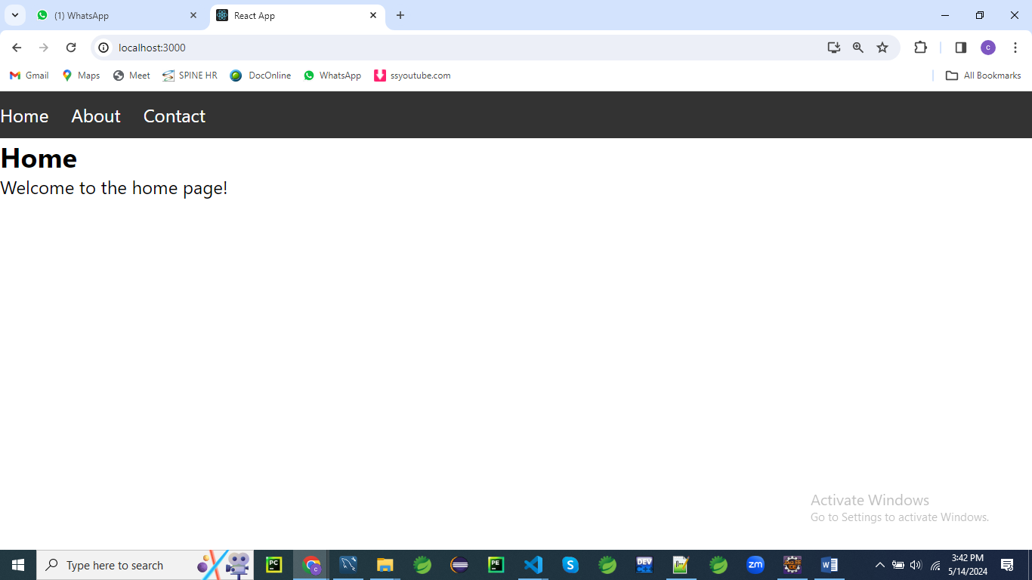

First, make sure you have React and React Router installed in your project as described earlier.

Then, you can create the following file structure:

/src

/components

Home.js

About.js

Contact.js

App.js

Create a folder named **components** under **src** folder

**Home.js**

// components/Home.js

import React from 'react';

const Home = () => {

return (

<div>

<h2>Home</h2>

<p>Welcome to the home page!</p>

</div>

);

};

export default Home;

**About.js**

// components/About.js

import React from 'react';

const About = () => {

return (

<div>

<h2>About</h2>

<p>About us page content goes here...</p>

</div>

);

};

export default About;

**Contact.js**

// components/Contact.js

import React from 'react';

const Contact = () => {

return (

<div>

<h2>Contact</h2>

<p>Contact us page content goes here...</p>

</div>

);

};

export default Contact;

styles.css

/* styles.css */

/* Reset default browser styles */

body, h1, h2, p, ul, li {

margin: 0;

padding: 0;

}

/* Style the navigation bar */

nav {

background-color: #333;

color: #fff;

padding: 10px 0;

}

nav ul {

list-style-type: none;

}

nav ul li {

display: inline;

margin-right: 20px;

}

nav ul li a {

color: #fff;

text-decoration: none;

}

nav ul li a:hover {

text-decoration: underline;

}

/* Style the content container */

.container {

max-width: 800px;

margin: 20px auto;

padding: 0 20px;

}

/* Style the header */

header {

text-align: center;

margin-bottom: 20px;

}

header h1 {

font-size: 2em;

margin-bottom: 10px;

}

/* Style the main content */

.main-content {

background-color: #f9f9f9;

padding: 20px;

border-radius: 5px;

box-shadow: 0 0 10px rgba(0, 0, 0, 0.1);

}

Then, in your **App.js** file, you can set up routing using React Router:

// App.js

import React from 'react';

import { BrowserRouter as Router, Routes, Route, Link } from 'react-router-dom';

import Home from './components/Home';

import About from './components/About';

import Contact from './components/Contact';

import './styles.css'; // Import the CSS file

const App = () => {

  return (

    <Router>

      <div>

        <nav>

          <ul>

            <li>

              <Link to="/">Home</Link>

            </li>

            <li>

              <Link to="/about">About</Link>

            </li>

            <li>

              <Link to="/contact">Contact</Link>

            </li>

          </ul>

        </nav>

        <div className="container">

          <header>

            <h1>My React App</h1>

          </header>

          <div className="main-content">

            <Routes>

            <Route exact path="/" component={Home} />

            <Route path="/about" component={About} />

            <Route path="/contact" component={Contact} />

            </Routes>

          </div>

        </div>

      </div>

    </Router>

  );

};

export default App;

**Explanation:**

**import React from 'react';**

**import { BrowserRouter as Router, Route, Link } from 'react-router-dom';**

**import Home from './components/Home';**

**import About from './components/About';**

**import Contact from './components/Contact';**

**import './styles.css'; // Import the CSS file**

In this section, we're importing necessary modules and components for our React application.

We're importing **React** from the 'react' library and components such as **BrowserRouter**, **Route**, and **Link** from the 'react-router-dom' library.

Additionally, we're importing three custom components (**Home**, **About**, and **Contact**) from their respective files, and we're importing a CSS file named **styles.css** for styling.

**const App = () => {**

**return (**

**<Router>**

**<div>**

**<nav>**

**<ul>**

**<li>**

**<Link to="/">Home</Link>**

**</li>**

**<li>**

**<Link to="/about">About</Link>**

**</li>**

**<li>**

**<Link to="/contact">Contact</Link>**

**</li>**

**</ul>**

**</nav>**

**<div className="container">**

**<header>**

**<h1>My React App</h1>**

**</header>**

**<div className="main-content">**

**<Route exact path="/" component={Home} />**

**<Route path="/about" component={About} />**

**<Route path="/contact" component={Contact} />**

**</div>**

**</div>**

**</div>**

**</Router>**

**);**

**};**

In the **App** component, we're defining the structure of our React application.

* We wrap our entire application with the **<Router>** component to enable routing functionality.
* Inside the router, we have a **<div>** element containing the navigation bar (**<nav>**) and main content area (**<div className="container">**).
* The navigation bar contains an unordered list (**<ul>**) with list items (**<li>**), each containing a **<Link>** component from React Router. These links navigate to different routes specified by the **to** prop.
* The main content area (**<div className="container">**) contains a header (**<header>**) with an **<h1>** element displaying the title of the application.
* Below the header, we have a **<div>** element with the class name **main-content**. This is where the content for each route will be rendered.
* Inside this **<div>**, we have three **<Route>** components. Each **<Route>** component specifies a path and the component to render when that path matches the current URL. The **exact** prop is used for the home route to ensure that it matches exactly the root URL (**/**).

export default App;

Finally, we export the **App** component so it can be imported and used in other parts of our application.

In summary, this code sets up a basic React application with routing functionality using React Router.

It consists of a navigation bar and main content area, with different components rendered based on the current URL path.

The application structure is defined in the **App** component, which is exported as the default component.

**Example 02**

Let's create a React application with multiple routes, navigation, form validation, and CSS styling.

We'll build a simple registration form with the following features:

1. **Home Page**: Displaying a welcome message.
2. **Registration Page**: A form for users to register with validation for email and password fields.
3. **Login Page**: A form for users to login.

Define routes for your application using the **BrowserRouter**, **Route** components provided by React Router.

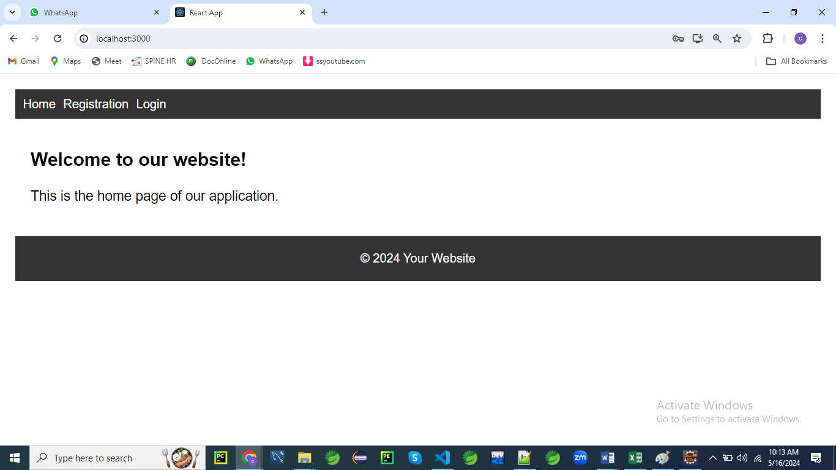

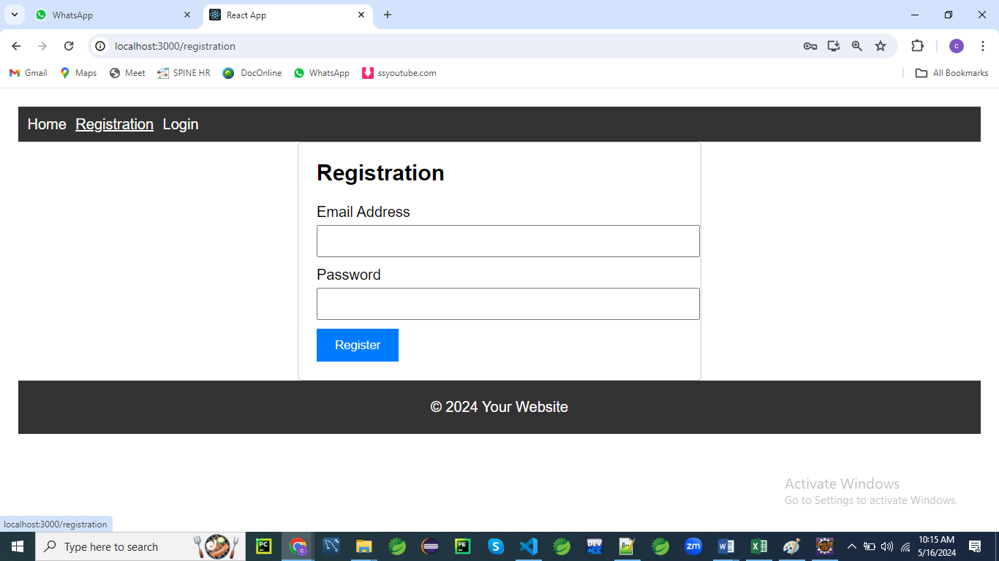

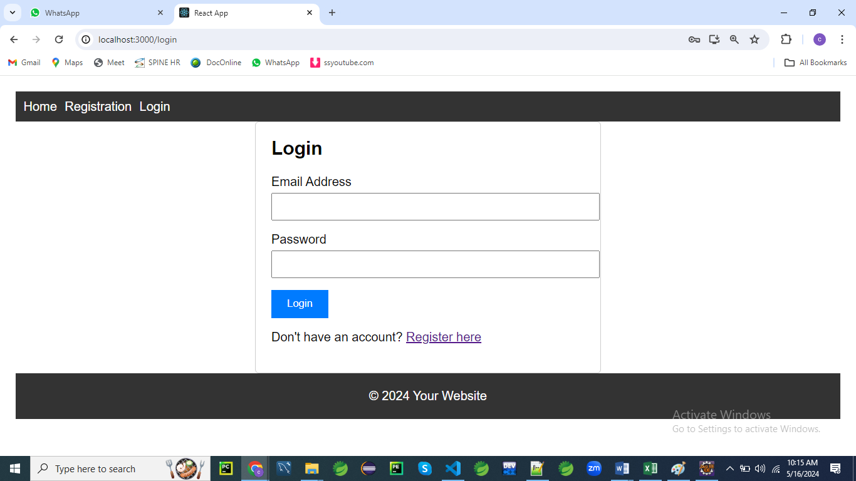

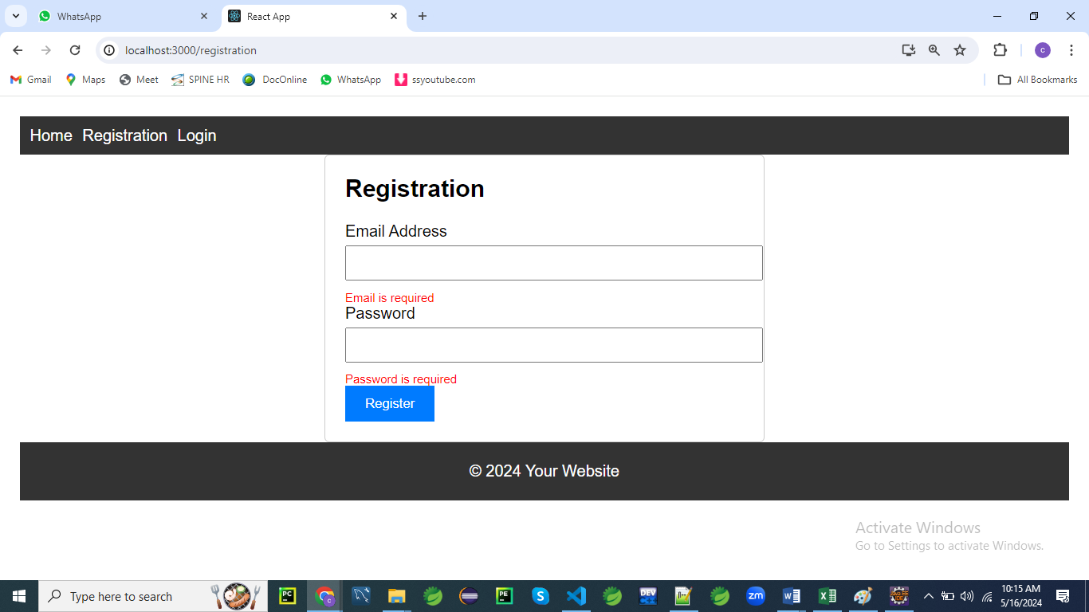

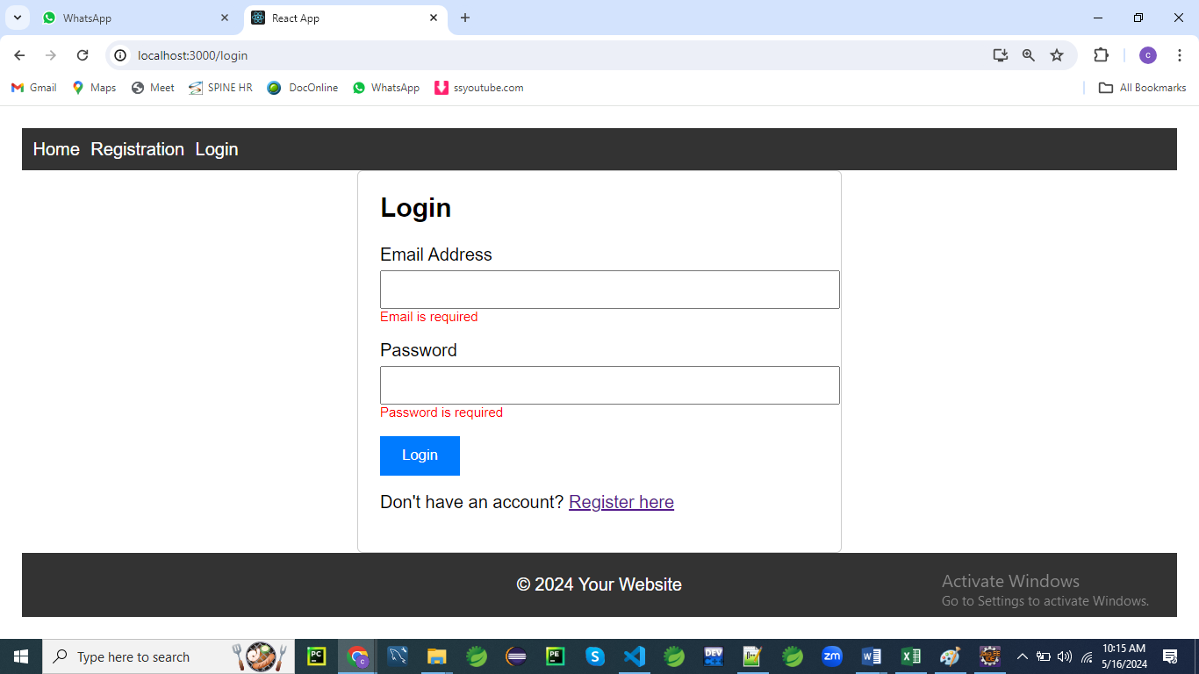

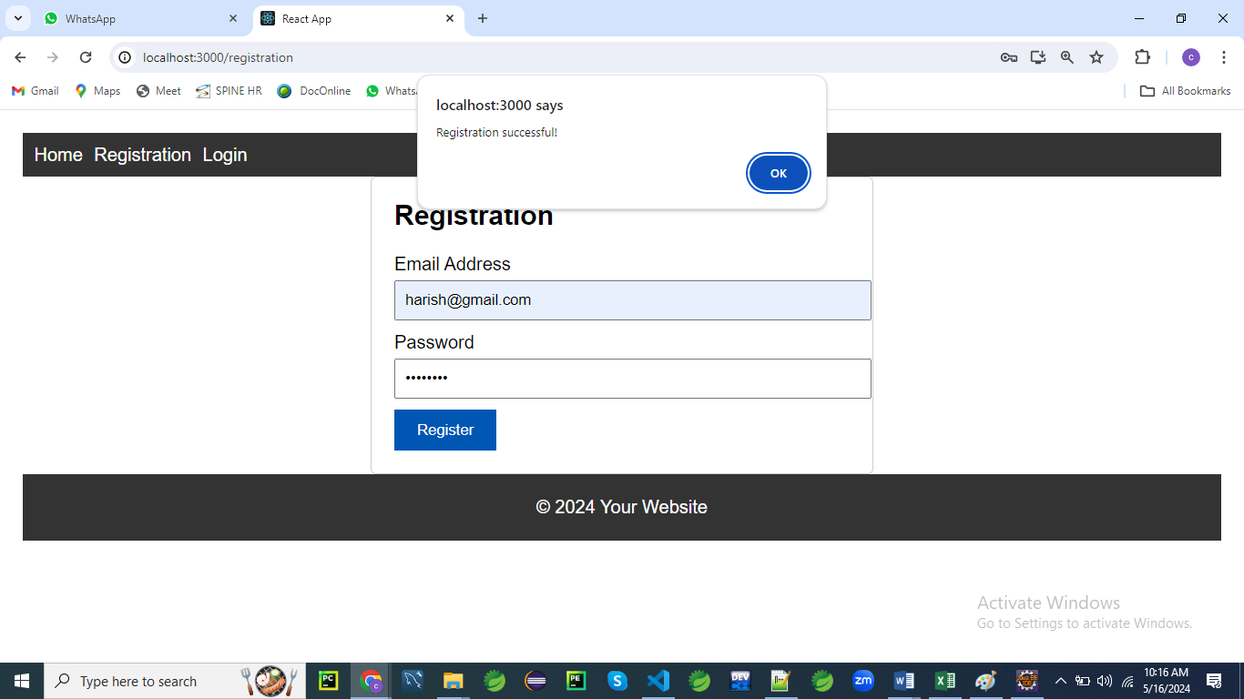

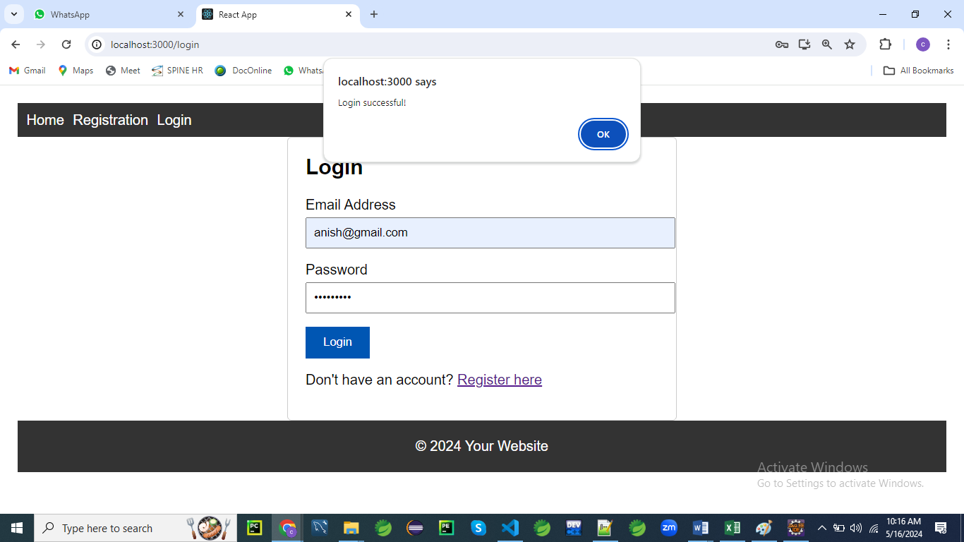

/src

/components

Home.js

Home.css

Registration.js

Registration.css

Login.js

Login.css

Navigation.js

Navigation.css

App.js

App.css

First create Registration.css file

/* Registration.css */

.form-container {

max-width: 400px;

margin: 0 auto;

padding: 20px;

border: 1px solid #ccc;

border-radius: 5px;

}

.form-container h2 {

margin-top: 0;

}

.form-container label {

display: block;

margin-bottom: 5px;

}

.form-container input[type='email'],

.form-container input[type='password'] {

width: 100%;

padding: 8px;

margin-bottom: 10px;

}

.form-container div.error {

color: red;

font-size: 12px;

}

.form-container button {

background-color: #007bff;

color: #fff;

border: none;

padding: 10px 20px;

cursor: pointer;

}

.form-container button:hover {

background-color: #0056b3;

}

You can include the following css file for App.js

/* App.css */

/* Global styles */

body {

font-family: Arial, sans-serif;

margin: 0;

padding: 0;

}

.container {

max-width: 1200px;

margin: 0 auto;

padding: 20px;

}

/* Navigation styles */

nav {

background-color: #333;

color: #fff;

padding: 10px;

}

nav ul {

list-style-type: none;

margin: 0;

padding: 0;

}

nav ul li {

display: inline;

margin-right: 10px;

}

nav ul li a {

color: #fff;

text-decoration: none;

}

/* Footer styles */

footer {

background-color: #333;

color: #fff;

text-align: center;

padding: 20px 0;

}

App.js

// App.js

import React from 'react';

import { BrowserRouter as Router, Routes, Route } from 'react-router-dom';

import Home from './components/Home';

import Registration from './components/Registration';

import Login from './components/Login';

import Navigation from './components/Navigation';

import './App.css'; // Import the global CSS file

const App = () => {

  return (

    <Router>

      <div className="container">

        <Navigation />

        <Routes>

          <Route path="/" element={<Home />} />

          <Route path="/registration" element={<Registration />} />

          <Route path="/Login" element={<Login />} />

        </Routes>

        <footer>

          &copy; 2024 Your Website

        </footer>

      </div>

    </Router>

  );

};

export default App;

Here’s an explanation of the provided code snippet:

1. **Imports**:
   * **import React from 'react';:** Imports the React library, which is necessary for using JSX and creating React components.
   * **import { BrowserRouter as Router, Routes, Route } from 'react-router-dom';:** Imports routing components from react-router-dom for handling navigation within the application.
   * **import Home from './components/Home'**;: Imports the Home component, which will be displayed at the root route.
   * **import Registration from './components/Registration';:** Imports the Registration component, used for the registration route.
   * **import Login from './components/Login';:** Imports the Login component, used for the login route.
   * **import Navigation from './components/Navigation';:** Imports the Navigation component, which provides navigation links or a menu.
   * **import './App.css';:** Imports a CSS file to apply global styles to the application.
2. **Functional Component**: **const App = () => { ... }** defines a functional component named App. This is the main component that sets up the routing and layout for the application.
3. **Router Setup**:
   * **<Router>:** Wraps the entire application to provide routing functionality.
   * Inside <Router>, the **<div className="container">** element acts as a wrapper for layout and styling.
4. **Navigation and Routing**:
   * **<Navigation />:** Renders the navigation component, typically containing links to navigate between different routes.
   * **<Routes>:** Defines the different routes in the application.
     + **<Route path="/" element={<Home />} />:** Maps the root path / to the Home component.
     + **<Route path="/registration" element={<Registration />} />:** Maps the /registration path to the Registration component.
     + **<Route path="/Login" element={<Login />} />:** Maps the /Login path to the Login component. Note that the path should generally be in lowercase (/login) for consistency.
5. **Footer**:
   * **<footer>:** Adds a footer to the bottom of the page with the text “© 2024 Your Website”. This is used for copyright information or other footer content.

This setup provides a basic structure for a React application with routing, a navigation bar, and global styling.

Create components for each page of your application.

// Registration.js

// Registration.js

import React, { useState } from 'react';

import { Navigate, useNavigate  } from 'react-router-dom';

import './Registration.css'; // Import CSS file

const Registration = () => {

  const navigate = useNavigate();

  const [formData, setFormData] = useState({

    email: '',

    password: '',

  });

  const [errors, setErrors] = useState({});

  const handleChange = (e) => {

    const { name, value } = e.target;

    setFormData({ ...formData, [name]: value });

  };

  const handleSubmit = (e) => {

    e.preventDefault();

    const validationErrors = validateForm(formData);

    if (Object.keys(validationErrors).length === 0) {

      // Form is valid, proceed with registration

      alert('Registration successful!');

      navigate('/'); // Redirect to home page

    } else {

      // Form is invalid, display errors

      setErrors(validationErrors);

    }

  };

  const validateForm = (data) => {

    const errors = {};

    // Basic email validation

    if (!data.email) {

      errors.email = 'Email is required';

    } else if (!isValidEmail(data.email)) {

      errors.email = 'Invalid email address';

    }

    // Password validation

    if (!data.password) {

      errors.password = 'Password is required';

    } else if (data.password.length < 8) {

      errors.password = 'Password must be at least 8 characters long';

    }

    return errors;

  };

  const isValidEmail = (email) => {

    // Basic email validation regex

    const regex = /^[^\s@]+@[^\s@]+\.[^\s@]+$/;

    return regex.test(email);

  };

  return (

    <div className="form-container">

      <h2>Registration</h2>

      <form onSubmit={handleSubmit}>

        <div>

          <label htmlFor="email">Email Address</label>

          <input type="email" id="email" name="email" value={formData.email} onChange={handleChange} />

          {errors.email && <div className="error">{errors.email}</div>}

        </div>

        <div>

          <label htmlFor="password">Password</label>

          <input type="password" id="password" name="password" value={formData.password} onChange={handleChange} />

          {errors.password && <div className="error">{errors.password}</div>}

        </div>

        <button type="submit">Register</button>

      </form>

    </div>

  );

};

export default Registration;

Here’s an explanation of the provided Registration component code in 5 points:

1. **Imports**:
   * **import React, { useState } from 'react';:** Imports React and the useState hook to manage component state.
   * **import { Navigate, useNavigate } from 'react-router-dom';:** Imports navigation-related functions for handling routing. useNavigate is used here to programmatically navigate to different routes.
   * **import './Registration.css';:** Imports a CSS file for styling the registration form.
2. **State Management**:
   * **const [formData, setFormData] = useState({ email: '', password: '' });:** Initializes state to store form input values (email and password).
   * **const [errors, setErrors] = useState({});:** Initializes state to store validation error messages.
3. **Event Handlers**:
   * handleChange: Updates the formData state when the user types into form fields. It extracts the name and value from the event target and updates the corresponding field in the formData state.
   * **handleSubmit**: Prevents the default form submission, validates the form data, and either displays errors or shows a success message and redirects to the home page if the form is valid.
4. **Validation Functions**:
   * **validateForm**: Validates the form data and returns an object with error messages if any validation rules are not met. It checks for required fields and validates the email format and password length.
   * **isValidEmail:** Uses a regular expression to validate the email format. Returns true if the email matches the pattern and false otherwise.
5. **JSX Rendering**:
   * The return statement renders the registration form inside a div with the class form-container.
   * Includes <h2>Registration</h2> for the form title.
   * The form fields for email and password are accompanied by labels and conditional error messages.
   * The button with type="submit" triggers the handleSubmit function when clicked, submitting the form.

This component manages form data, validates input, and provides feedback to the user. It also handles navigation using useNavigate to redirect users upon successful registration.

Home.css

/* Home.css */

.container {

max-width: 800px;

margin: 0 auto;

padding: 20px;

}

.title {

font-size: 24px;

margin-bottom: 20px;

}

.content {

font-size: 18px;

line-height: 1.6;

}

Home.js

// Home.js

import React from 'react';

import './Home.css'; // Import the CSS file

const Home = () => {

  return (

    <div className="container">

      <h2 className="title">Welcome to our website!</h2>

      <p className="content">This is the home page of our application.</p>

    </div>

  );

};

export default Home;

Here’s an explanation of the Home component code:

1. **Imports**:
   * import React from 'react';: Imports the React library, which is necessary to create and use React components.
   * import './Home.css';: Imports a CSS file for styling the Home component, ensuring the component's layout and design are defined according to the styles in this file.
2. **Functional Component**:
   * const Home = () => { ... }: Defines a functional component named Home. This is a JavaScript function that returns JSX, which React will render to the screen.
3. **JSX Structure**:
   * <div className="container">: Creates a container div with the CSS class container. This class is used for applying styles defined in the Home.css file.
   * <h2 className="title">Welcome to our website!</h2>: Renders an <h2> heading with the class title, which is styled according to the Home.css file. It provides a welcoming message to users.
   * <p className="content">This is the home page of our application.</p>: Renders a paragraph with the class content, describing the home page of the application. The content is styled with the content class from the CSS file.
4. **Styling**:
   * The classes container, title, and content are defined in the Home.css file. These classes are used to apply specific styles to the div, h2, and p elements respectively, allowing for a consistent look and feel.
5. **Export Statement**:
   * export default Home;: Exports the Home component as the default export from this module. This allows other parts of the application to import and use the Home component, typically in routing or other component compositions.

This component serves as the home page of the application, providing a welcome message and a brief description. It leverages CSS for styling to maintain a clean and organized presentation.

Login.css

/* Login.css */

.login-container {

max-width: 400px;

margin: 0 auto;

padding: 20px;

border: 1px solid #ccc;

border-radius: 5px;

}

.login-container h2 {

margin-top: 0;

}

.form-group {

margin-bottom: 15px;

}

.form-group label {

display: block;

margin-bottom: 5px;

}

.form-group input[type='email'],

.form-group input[type='password'] {

width: 100%;

padding: 8px;

}

.error {

color: red;

font-size: 12px;

}

button {

background-color: #007bff;

color: #fff;

border: none;

padding: 10px 20px;

cursor: pointer;

}

button:hover {

background-color: #0056b3;

}

p {

margin-top: 15px;

}

Login.js

// Login.js

import React, { useState } from 'react';

import { Navigate, useNavigate, Link  } from 'react-router-dom';

import './Login.css'; // Import the CSS file

const Login = () => {

  const [formData, setFormData] = useState({

    email: '',

    password: '',

  });

  const [errors, setErrors] = useState({});

  const navigate = useNavigate();

  const handleChange = (e) => {

    const { name, value } = e.target;

    setFormData({ ...formData, [name]: value });

  };

  const handleSubmit = (e) => {

    e.preventDefault();

    const validationErrors = validateForm(formData);

    if (Object.keys(validationErrors).length === 0) {

      // Form is valid, perform login logic (not implemented in this example)

      alert('Login successful!');

      navigate("/")

    } else {

      // Form is invalid, display errors

      setErrors(validationErrors);

    }

  };

  const validateForm = (data) => {

    const errors = {};

    // Basic email validation

    if (!data.email) {

      errors.email = 'Email is required';

    } else if (!isValidEmail(data.email)) {

      errors.email = 'Invalid email address';

    }

    // Password validation

    if (!data.password) {

      errors.password = 'Password is required';

    } else if (data.password.length < 8) {

      errors.password = 'Password must be at least 8 characters long';

    }

    return errors;

  };

  const isValidEmail = (email) => {

    // Basic email validation regex

    const regex = /^[^\s@]+@[^\s@]+\.[^\s@]+$/;

    return regex.test(email);

  };

  return (

    <div className="login-container">

      <h2>Login</h2>

      <form onSubmit={handleSubmit}>

        <div className="form-group">

          <label htmlFor="email">Email Address</label>

          <input type="email" id="email" name="email" value={formData.email} onChange={handleChange} />

          {errors.email && <div className="error">{errors.email}</div>}

        </div>

        <div className="form-group">

          <label htmlFor="password">Password</label>

          <input type="password" id="password" name="password" value={formData.password} onChange={handleChange} />

          {errors.password && <div className="error">{errors.password}</div>}

        </div>

        <button type="submit">Login</button>

      </form>

      <p>Don't have an account? <Link to="/registration">Register here</Link></p>

    </div>

  );

};

export default Login;

Here’s an explanation of the Login component code:

1. **Imports**:
   * import React, { useState } from 'react';: Imports React and the useState hook for managing component state.
   * import { useNavigate, Link } from 'react-router-dom';: Imports navigation and routing components from react-router-dom. useNavigate is used to programmatically navigate, and Link is used to create navigable links.
   * import './Login.css';: Imports a CSS file for styling the Login component.
2. **State Management**:
   * const [formData, setFormData] = useState({ email: '', password: '' });: Initializes state to store the form input values for email and password.
   * const [errors, setErrors] = useState({});: Initializes state to store validation error messages.
3. **Event Handlers**:
   * handleChange: Updates the formData state when the user types into form fields. It updates the corresponding field in the state based on the input's name attribute.
   * handleSubmit: Prevents the default form submission behavior, validates the form data, and either shows an alert and redirects to the home page if valid, or sets error messages if invalid.
4. **Validation Functions**:
   * validateForm: Validates the form data, returning an object with error messages for invalid fields. It checks for required fields and validates the email format and password length.
   * isValidEmail: Uses a regular expression to validate the email format. Returns true if the email matches the pattern and false otherwise.
5. **JSX Rendering**:
   * The return statement renders the login form within a div with the class login-container.
   * Includes <h2>Login</h2> for the form title.
   * The form fields for email and password are wrapped in divs with the class form-group, each having a label and conditional error messages.
   * The button with type="submit" triggers the handleSubmit function when clicked.
   * A <p> tag with a Link component provides a navigable link to the registration page for users who don’t have an account.

This component manages login functionality, including form data handling, validation, and navigation. It also includes a link to the registration page for users who need to sign up.

Navigation.css

/* Navigation.css */

nav {

    background-color: #333;

    color: #fff;

    padding: 10px;

  }

  nav ul {

    list-style-type: none;

    margin: 0;

    padding: 0;

  }

  nav ul li {

    display: inline;

    margin-right: 10px;

  }

  nav ul li a {

    color: #fff;

    text-decoration: none;

  }

  nav ul li a:hover {

    text-decoration: underline;

  }

Navigation.js

// Navigation.js

import React from 'react';

import { Link } from 'react-router-dom';

import './Navigation.css'; // Import the CSS file

const Navigation = () => {

  return (

    <nav>

      <ul>

        <li><Link to="/">Home</Link></li>

        <li><Link to="/registration">Registration</Link></li>

        <li><Link to="/login">Login</Link></li>

      </ul>

    </nav>

  );

};

export default Navigation;

Here’s an explanation of the Navigation component code:

1. **Imports**:
   * import React from 'react';: Imports the React library, which is necessary for creating and using React components.
   * import { Link } from 'react-router-dom';: Imports the Link component from react-router-dom to create navigable links that enable routing within the application.
   * import './Navigation.css';: Imports a CSS file for styling the Navigation component.
2. **Functional Component**:
   * const Navigation = () => { ... }: Defines a functional component named Navigation. This component returns JSX that represents the navigation menu.
3. **Navigation Structure**:
   * <nav>: The nav element represents a section of a page that contains navigation links. It helps in organizing the navigation menu semantically.
   * <ul>: An unordered list element is used to group the navigation links. It provides a list structure for the links.
   * <li>: Each list item represents an individual navigation link within the list.
4. **Links**:
   * <Link to="/">Home</Link>: Creates a navigable link to the root path (/). Clicking this link will navigate to the Home page.
   * <Link to="/registration">Registration</Link>: Creates a navigable link to the registration page (/registration).
   * <Link to="/login">Login</Link>: Creates a navigable link to the login page (/login).
5. **CSS Styling**:
   * The Navigation component relies on styles defined in Navigation.css to style the navigation menu. This CSS file can include rules for the nav, ul, and li elements to ensure the navigation bar is visually appealing and functional.

This component provides a basic navigation bar with links to the Home, Registration, and Login pages, allowing users to easily navigate through different sections of the application.

**Comments**

We've done a fantastic job setting up the structure for our React application!

It looks like we have everything organized neatly, including separate components for each page, CSS files for styling, and a clear navigation structure.

Here's a summary of what we've achieved:

1. **App.js**: We've set up our main component where we define routes using **BrowserRouter** and **Routes** from React Router.
2. **We**'ve also included the **Navigation** component to provide navigation links throughout the application.
3. **Components**: We have separate components for each page of our application:
   * **Home.js**: Displays a welcome message on the home page.
   * **Registration.js**: Implements a registration form with form validation for email and password fields.
   * **Login.js**: Implements a login form with form validation for email and password fields.
4. **CSS Styling**:
   * We've provided CSS files for styling each component and the global styles for the entire application.
   * Each CSS file contains styles specific to the corresponding component, ensuring modularity and maintainability.
5. **Navigation**:
   * **We**'ve created a **Navigation** component to provide navigation links to different pages of our application.
   * This component is included in the main layout and ensures consistent navigation throughout the app.

Overall, our application structure is well-organized and follows best practices for React development.

We've separated concerns by creating reusable components, applied CSS styling effectively, and implemented navigation using React Router.

**Forms in React**

**What forms are in react?**

In React, forms are used to collect and manage user input.

They allow users to enter data, such as text, numbers, selections, and submit it to the application for processing.

React provides a flexible way to work with forms, allowing developers to handle form data and user interactions efficiently.

Forms in React typically consist of:

1. **Form Elements**:
   1. These include input fields, select boxes, radio buttons, checkboxes, and buttons.
   2. Each form element represents a piece of data that the user can input or select.
2. **State Management**:
   1. React components can maintain internal state to track the values of form elements.
   2. State is updated as the user interacts with the form, and changes are reflected in the UI.
3. **Event Handling**:
   1. React components use event handlers to respond to user interactions with form elements.
   2. For example, onChange event handlers are used to capture changes to input fields in real-time.
4. **Validation**:
   1. Form validation ensures that the data entered by the user meets certain criteria or constraints.
   2. React allows developers to implement custom validation logic and provide feedback to users when input is invalid.
5. **Submission Handling**:
   1. When the user submits the form, React components handle the form submission event.
   2. This typically involves sending the form data to a server or processing it within the application.

Forms are a fundamental part of most web applications, and React provides powerful tools for building interactive and dynamic forms that meet the needs of modern user interfaces.

**Example of programs**

1. **Basic Form with Input Field**:

**BasicForm.js**

import React, { useState } from 'react';

const BasicForm = () => {

const [inputValue, setInputValue] = useState('');

const [value, setValue] = useState('')

const handleChange = (e) => {

setInputValue(e.target.value);

};

const handleSubmit = (e) => {

e.preventDefault();

  e.preventDefault();

    setValue("You have entered: " + inputValue)

console.log('Form submitted with value:', inputValue);

};

return (

<form onSubmit={handleSubmit}>

<label>

Enter your name:

<input type="text" value={inputValue} onChange={handleChange} />

</label>

<button type="submit">Submit</button>

</form>

 <p id="result">{value}</p>

);

};

export default BasicForm;

**App.js**

import React from 'react';

import BasicForm from './BasicForm';

const App = () => {

return (

<div>

<h1>Basic Form Example</h1>

<BasicForm />

</div>

);

};

export default App;

1. **Form with Multiple Input Fields and Submit Handler**:

import React, { useState } from 'react';

const MultiFieldForm = () => {

const [formData, setFormData] = useState({

name: '',

email: '',

password: '',

});

const handleChange = (e) => {

const { name, value } = e.target;

setFormData({ ...formData, [name]: value });

};

const handleSubmit = (e) => {

e.preventDefault();

console.log('Form submitted with data:', formData);

};

return (

<form onSubmit={handleSubmit}>

<label>

Name:

<input type="text" name="name" value={formData.name} onChange={handleChange} />

</label>

<label>

Email:

<input type="email" name="email" value={formData.email} onChange={handleChange} />

</label>

<label>

Password:

<input type="password" name="password" value={formData.password} onChange={handleChange} />

</label>

<button type="submit">Submit</button>

</form>

);

};

export default MultiFieldForm;

import React from 'react';

import MultiFieldForm from './MultiFieldForm';

const App = () => {

return (

<div>

<h1>Multi-field Form Example</h1>

<MultiFieldForm />

</div>

);

};

export default App;

1. **Form with Select Box and Textarea**:

import React, { useState } from 'react';

const SelectForm = () => {

const [selectedOption, setSelectedOption] = useState('');

const [textareaValue, setTextareaValue] = useState('');

const handleSelectChange = (e) => {

setSelectedOption(e.target.value);

};

const handleTextareaChange = (e) => {

setTextareaValue(e.target.value);

};

const handleSubmit = (e) => {

e.preventDefault();

console.log('Form submitted with data:', { selectedOption, textareaValue });

};

return (

<form onSubmit={handleSubmit}>

<label>

Choose an option:

<select value={selectedOption} onChange={handleSelectChange}>

<option value="">Select</option>

<option value="option1">Option 1</option>

<option value="option2">Option 2</option>

<option value="option3">Option 3</option>

</select>

</label>

<label>

Enter your message:

<textarea value={textareaValue} onChange={handleTextareaChange} />

</label>

<button type="submit">Submit</button>

</form>

);

};

export default SelectForm;

import React from 'react';

import SelectForm from './SelectForm';

const App = () => {

return (

<div>

<h1>Select Form Example</h1>

<SelectForm />

</div>

);

};

export default App;

**4. Registration Form**

**App.js**

// App.js

import React from 'react';

import LargeForm from './RegistrationForm';

const App = () => {

return (

<div>

<RegistrationForm />

</div>

);

};

export default App;

**RegistrationForm.js**

// RegistrationForm.js

import React, { useState } from 'react';

import './RegistrationForm.css';

const RegistrationForm = () => {

  const [formData, setFormData] = useState({

    firstName: '',

    lastName: '',

    email: '',

    password: '',

    confirmPassword: '',

    age: '',

    gender: '',

    termsAgreed: false,

  });

  const [errors, setErrors] = useState({});

  const handleChange = (e) => {

    const { name, value, type, checked } = e.target;

    const val = type === 'checkbox' ? checked : value;

    setFormData({ ...formData, [name]: val });

  };

  const handleSubmit = (e) => {

    e.preventDefault();

    const validationErrors = validateForm(formData);

    if (Object.keys(validationErrors).length === 0) {

      // Form is valid, proceed with submission

      console.log('Form submitted with data:', formData);

    } else {

      // Form is invalid, display errors

      setErrors(validationErrors);

    }

  };

  const validateForm = (data) => {

    const errors = {};

    // Validate each field

    if (!data.firstName.trim()) {

      errors.firstName = 'First name is required';

    }

    if (!data.lastName.trim()) {

      errors.lastName = 'Last name is required';

    }

    if (!data.email.trim()) {

      errors.email = 'Email is required';

    } else if (!isValidEmail(data.email)) {

      errors.email = 'Invalid email address';

    }

    if (!data.password.trim()) {

      errors.password = 'Password is required';

    } else if (data.password.length < 8) {

      errors.password = 'Password must be at least 8 characters long';

    }

    if (data.password !== data.confirmPassword) {

      errors.confirmPassword = 'Passwords do not match';

    }

    if (!data.age.trim()) {

      errors.age = 'Age is required';

    } else if (isNaN(data.age) || parseInt(data.age) <= 0) {

      errors.age = 'Invalid age';

    }

    if (!data.gender.trim()) {

      errors.gender = 'Gender is required';

    }

    if (!data.termsAgreed) {

      errors.termsAgreed = 'You must agree to the terms';

    }

    return errors;

  };

  const isValidEmail = (email) => {

    // Check if the email contains an '@' character

    if (email.indexOf('@') === -1) {

      return false;

    }

    // Split the email at the '@' character

    const parts = email.split('@');

    // Check if there are exactly two parts

    if (parts.length !== 2) {

      return false;

    }

    // Check if the local part (before '@') is not empty

    if (parts[0].length === 0) {

      return false;

    }

    // Check if the domain part (after '@') contains a dot

    if (parts[1].indexOf('.') === -1) {

      return false;

    }

    // Check if the domain part is not empty

    if (parts[1].length === 0) {

      return false;

    }

    // If all checks pass, the email is considered valid

    return true;

  };

  return (

    <div className="form-container">

      <h2>Registration Form</h2>

      <form onSubmit={handleSubmit}>

        <div>

          <label>First Name:</label>

          <input type="text" name="firstName" value={formData.firstName} onChange={handleChange} />

          {errors.firstName && <div className="error">{errors.firstName}</div>}

        </div>

        <div>

          <label>Last Name:</label>

          <input type="text" name="lastName" value={formData.lastName} onChange={handleChange} />

          {errors.lastName && <div className="error">{errors.lastName}</div>}

        </div>

        <div>

          <label>Email:</label>

          <input type="email" name="email" value={formData.email} onChange={handleChange} />

          {errors.email && <div className="error">{errors.email}</div>}

        </div>

        <div>

          <label>Password:</label>

          <input type="password" name="password" value={formData.password} onChange={handleChange} />

          {errors.password && <div className="error">{errors.password}</div>}

        </div>

        <div>

          <label>Confirm Password:</label>

          <input type="password" name="confirmPassword" value={formData.confirmPassword} onChange={handleChange} />

          {errors.confirmPassword && <div className="error">{errors.confirmPassword}</div>}

        </div>

        <div>

          <label>Age:</label>

          <input type="number" name="age" value={formData.age} onChange={handleChange} />

          {errors.age && <div className="error">{errors.age}</div>}

        </div>

        <div>

          <label>Gender:</label>

          <select name="gender" value={formData.gender} onChange={handleChange}>

            <option value="">Select</option>

            <option value="male">Male</option>

            <option value="female">Female</option>

            <option value="other">Other</option>

          </select>

          {errors.gender && <div className="error">{errors.gender}</div>}

        </div>

        <div>

          <input type="checkbox" name="termsAgreed" checked={formData.termsAgreed} onChange={handleChange} />

          <label htmlFor="termsAgreed">I agree to the terms</label>

          {errors.termsAgreed && <div className="error">{errors.termsAgreed}</div>}

        </div>

        <button type="submit">Submit</button>

      </form>

    </div>

  );

};

export default RegistrationForm;

**RegistrationForm.css**

/* RegistrationForm.css */

.form-container {

max-width: 600px;

margin: 0 auto;

padding: 20px;

border: 1px solid #ccc;

border-radius: 5px;

}

.form-container h2 {

margin-top: 0;

margin-bottom: 20px;

}

.form-container label {

display: block;

margin-bottom: 5px;

}

.form-container input[type='text'],

.form-container input[type='email'],

.form-container input[type='password'],

.form-container input[type='number'],

.form-container select,

.form-container textarea {

width: 100%;

padding: 8px;

margin-bottom: 10px;

}

.form-container .error {

color: red;

font-size: 12px;

margin-top: 5px;

}

.form-container button {

background-color: #007bff;

color: #fff;

border: none;

padding: 10px 20px;

cursor: pointer;

}

.form-container button:hover {

background-color: #0056b3;

}

.form-container input[type='checkbox'] {

margin-right: 10px;

}

**Explanation**:

1. **Component Definition**: The **RegistrationForm** component is defined using functional components and React hooks to manage state.
2. **State Management**: State variables **formData** and **errors** are initialized using the **useState** hook to manage form data and validation errors, respectively.
3. **Event Handlers**: Event handlers like **handleChange** and **handleSubmit** are defined to handle form input changes and submissions, respectively.
4. **Form Validation**: The **validateForm** function is defined to validate form data based on certain rules.
5. **Render JSX**: The JSX code within the **return** statement renders the form elements, including input fields, error messages, and a submit button.
6. **CSS Styling**: The CSS file **RegistrationForm.css** contains styles for the registration form, including container styling, input fields, labels, buttons, etc.
7. **Component Export**: The **RegistrationForm** component is exported for use in other components.
8. **App Component**: In **App.js**, the **App** component renders the **RegistrationForm** component, which will be displayed in the application.
9. **CSS Import**: The CSS file is imported into the component file to apply styles to the form elements.

**Detailed Explanation of the code:**

**1.**

**import React, { useState } from 'react';**

**import './RegistrationForm.css';**

This lines of code imports the React library and the **useState** hook from React, as well as the CSS file named **RegistrationForm.css**. Let's break it down:

1. **import React from 'react';**: This imports the core React library, which is required for creating React components and using JSX syntax.
2. **{ useState }**: This syntax uses destructuring to import the **useState** hook from the React library. The **useState** hook is a function that allows functional components to manage state.
3. **from 'react';**: This specifies that the **useState** hook is being imported from the 'react' module.
4. **import './RegistrationForm.css';**: This line imports the CSS file named **RegistrationForm.css**. The **./** indicates that the file is located in the same directory as the current component file. The imported CSS styles will be applied to the component's elements when they are rendered.

In summary, this line imports React, the **useState** hook, and a CSS file into the current component file, allowing the component to utilize React functionality and apply CSS styles.

**2.**

**const RegistrationForm = () => {**

This line of code defines a functional component named **RegistrationForm**. Let's break it down:

1. **const**: This keyword is used to declare a constant variable in JavaScript. In this case, it's used to declare a constant variable named **RegistrationForm**.
2. **RegistrationForm**: This is the name of the constant variable and also the name of the functional component.
3. **()**: This set of parentheses indicates that **RegistrationForm** is a function.
4. **=>**: This arrow function syntax is used to define the function body.
5. **{}**: These curly braces contain the function body, which is the code that will be executed when the **RegistrationForm** component is rendered.

In summary, this line defines a functional component named **RegistrationForm** using arrow function syntax, which will be used to render a form for user registration.

**3.**

**const [formData, setFormData] = useState({**

**firstName: '',**

**lastName: '',**

**email: '',**

**password: '',**

**confirmPassword: '',**

**age: '',**

**gender: '',**

**termsAgreed: false,**

**});**

This line of code uses the **useState** hook to declare a state variable named **formData** and a function named **setFormData** to update that state. Let's break it down:

1. **const**: This keyword is used to declare a constant variable in JavaScript.
2. **[formData, setFormData]**: This is array destructuring syntax. It declares two variables **formData** and **setFormData** and assigns them the values returned by the **useState** hook.
3. **useState**: This is a React hook that allows functional components to manage state. It takes one argument, which is the initial state value, and returns an array containing the current state value and a function to update that state.
4. **{}**: This curly braces define the initial state object. It contains properties for each form field (**firstName**, **lastName**, **email**, **password**, **confirmPassword**, **age**, **gender**, **termsAgreed**) initialized with empty strings or **false** for the **termsAgreed** property.

In summary, this line initializes a state variable **formData** with an object representing the initial state of the form fields and a function **setFormData** to update that state.

4.  
**const [errors, setErrors] = useState({});**

This line of code is similar to the previous one, but it declares a state variable **errors** and a function **setErrors** to manage errors that occur during form validation. Let's break it down:

1. **const**: This keyword is used to declare a constant variable in JavaScript.
2. **[errors, setErrors]**: This is array destructuring syntax. It declares two variables **errors** and **setErrors** and assigns them the values returned by the **useState** hook.
3. **useState**: This is a React hook that allows functional components to manage state. It takes one argument, which is the initial state value, and returns an array containing the current state value and a function to update that state.
4. **{}**: This curly braces define the initial state object for errors. Initially, it's an empty object because there are no errors.

In summary, this line initializes a state variable **errors** with an empty object representing the initial state of form validation errors and a function **setErrors** to update that state. As the form is validated, this state will be updated with error messages for each field.

**5.**

**const handleChange = (e) => {**

**const { name, value, type, checked } = e.target;**

**const val = type === 'checkbox' ? checked : value;**

**setFormData({ ...formData, [name]: val });**

**};**

This function **handleChange** is responsible for handling changes in form inputs. Let's break down what it does:

1. **(e) => { ... }**: This is an arrow function syntax in JavaScript, which takes an event **e** as its parameter.
2. **const { name, value, type, checked } = e.target;**: This line uses destructuring assignment to extract properties from the **target** object of the event **e**. The **target** property refers to the element that triggered the event, in this case, an input element.
   * **name**: The **name** attribute of the input element, which identifies the property of the form data being updated.
   * **value**: The current value of the input element.
   * **type**: The type of the input element.
   * **checked**: For checkboxes, it indicates whether the checkbox is checked or not.
3. **const val = type === 'checkbox' ? checked : value;**: This line determines the value to be assigned to the **val** variable based on the type of the input element. If the type is a checkbox, it uses the **checked** property; otherwise, it uses the **value** property.
4. **setFormData({ ...formData, [name]: val });**: This line updates the form data state using the **setFormData** function. It spreads the current form data (**formData**) into a new object and then updates the property specified by **name** with the new value **val**. This effectively updates the corresponding field in the form data.

In summary, this function updates the form data state whenever there is a change in any input field by extracting the field name and value from the event object and then updating the form data state accordingly.

6.

**const handleSubmit = (e) => {**

**e.preventDefault();**

**const validationErrors = validateForm(formData);**

**if (Object.keys(validationErrors).length === 0) {**

**// Form is valid, proceed with submission**

**console.log('Form submitted with data:', formData);**

**} else {**

**// Form is invalid, display errors**

**setErrors(validationErrors);**

**}**

**};**

This **handleSubmit** function is called when the form is submitted. Let's break down its functionality:

1. **(e) => { ... }**: This is an arrow function syntax in JavaScript, which takes an event **e** as its parameter.
2. **e.preventDefault();**: This line prevents the default behavior of form submission, which is to reload the page. By calling **preventDefault()**, the form data is submitted using JavaScript without causing a page refresh.
3. **const validationErrors = validateForm(formData);**: This line calls the **validateForm** function to check if there are any validation errors in the form data. It passes the current form data (**formData**) as an argument to the **validateForm** function.
4. **if (Object.keys(validationErrors).length === 0) { ... }**: This condition checks if there are no validation errors. It uses **Object.keys(validationErrors)** to get an array of all the keys (property names) in the **validationErrors** object. If the length of this array is **0**, it means there are no validation errors.
   * If there are no validation errors, the form is considered valid, and the code inside the **if** block is executed.
     + **console.log('Form submitted with data:', formData);**: This line logs the form data to the console, indicating that the form submission was successful.
   * If there are validation errors, the code inside the **else** block is executed.
     + **setErrors(validationErrors);**: This line updates the **errors** state with the validation errors received from the **validateForm** function. These errors will be displayed to the user to indicate what fields need to be corrected.

In summary, this function handles form submission by first preventing the default behavior, then validating the form data. If there are no validation errors, it proceeds with the submission by logging the form data. Otherwise, it updates the **errors** state with the validation errors to display them to the user.

7.

**const validateForm = (data) => {**

**const errors = {};**

**// Validate each field**

**if (!data.firstName.trim()) {**

**errors.firstName = 'First name is required';**

**}**

**if (!data.lastName.trim()) {**

**errors.lastName = 'Last name is required';**

**}**

**if (!data.email.trim()) {**

**errors.email = 'Email is required';**

**} else if (!isValidEmail(data.email)) {**

**errors.email = 'Invalid email address';**

**}**

**if (!data.password.trim()) {**

**errors.password = 'Password is required';**

**} else if (data.password.length < 8) {**

**errors.password = 'Password must be at least 8 characters long';**

**}**

**if (data.password !== data.confirmPassword) {**

**errors.confirmPassword = 'Passwords do not match';**

**}**

**if (!data.age.trim()) {**

**errors.age = 'Age is required';**

**} else if (isNaN(data.age) || parseInt(data.age) <= 0) {**

**errors.age = 'Invalid age';**

**}**

**if (!data.gender.trim()) {**

**errors.gender = 'Gender is required';**

**}**

**if (!data.termsAgreed) {**

**errors.termsAgreed = 'You must agree to the terms';**

**}**

**return errors;**

**};**

This **validateForm** function is responsible for validating the form data. Let's break down its functionality:

1. **const validateForm = (data) => { ... }**: This defines an arrow function named **validateForm**, which takes the form data (**data**) as its parameter.
2. **const errors = {};**: This initializes an empty object named **errors** to store any validation errors encountered during the validation process.
3. Validation Logic:
   * For each field in the form data, it checks if the value meets the validation criteria.
   * If a field fails validation, it adds an entry to the **errors** object with the field name as the key and the error message as the value.
   * **if (!data.firstName.trim()) { ... }**: This checks if the **firstName** field is empty or contains only whitespace characters. If it is empty, it adds an error message indicating that the first name is required.
   * **if (!data.lastName.trim()) { ... }**: Similar to the previous check, this validates the **lastName** field.
   * **if (!data.email.trim()) { ... }**: This checks if the **email** field is empty or contains only whitespace characters. If it is empty, it adds an error message indicating that the email is required. Otherwise, it validates the email format using the **isValidEmail** function and adds an error message if the email is invalid.
   * **if (!data.password.trim()) { ... }**: This checks if the **password** field is empty or contains only whitespace characters. If it is empty, it adds an error message indicating that the password is required. Otherwise, it checks if the password length is less than 8 characters and adds an error message if it is.
   * **if (data.password !== data.confirmPassword) { ... }**: This checks if the **password** and **confirmPassword** fields match. If they don't match, it adds an error message indicating that the passwords do not match.
   * **if (!data.age.trim()) { ... }**: This checks if the **age** field is empty or contains only whitespace characters. If it is empty, it adds an error message indicating that the age is required. Otherwise, it checks if the age is a valid number and greater than 0.
   * **if (!data.gender.trim()) { ... }**: This checks if the **gender** field is empty or contains only whitespace characters. If it is empty, it adds an error message indicating that the gender is required.
   * **if (!data.termsAgreed) { ... }**: This checks if the **termsAgreed** field is not checked (false). If it is not checked, it adds an error message indicating that the user must agree to the terms.
4. **return errors;**: This returns the **errors** object containing any validation errors encountered during the validation process.

In summary, this function iterates over each field in the form data and validates its value based on specific criteria. If any field fails validation, an entry is added to the **errors** object with the corresponding error message. Finally, it returns the **errors** object containing any validation errors.

8.

**const isValidEmail = (email) => {**

**// Check if the email contains an '@' character**

**if (email.indexOf('@') === -1) {**

**return false;**

**}**

**// Split the email at the '@' character**

**const parts = email.split('@');**

**// Check if there are exactly two parts**

**if (parts.length !== 2) {**

**return false;**

**}**

**// Check if the local part (before '@') is not empty**

**if (parts[0].length === 0) {**

**return false;**

**}**

**// Check if the domain part (after '@') contains a dot**

**if (parts[1].indexOf('.') === -1) {**

**return false;**

**}**

**// Check if the domain part is not empty**

**if (parts[1].length === 0) {**

**return false;**

**}**

**// If all checks pass, the email is considered valid**

**return true;**

**};**

This **isValidEmail** function is used to validate email addresses based on certain criteria. Let's understand how it works:

1. **const isValidEmail = (email) => { ... }**: This defines an arrow function named **isValidEmail**, which takes an email address (**email**) as its parameter.
2. Email Validation Logic:
   * **if (email.indexOf('@') === -1) { ... }**: This checks if the email address contains an '@' character. If not found, it returns **false**, indicating that the email is invalid.
   * **const parts = email.split('@');**: This splits the email address into two parts, before and after the '@' character, creating an array named **parts**.
   * **if (parts.length !== 2) { ... }**: This checks if the email address has exactly two parts after splitting at the '@' character. If not, it returns **false**, indicating that the email is invalid.
   * **if (parts[0].length === 0) { ... }**: This checks if the local part (before the '@' character) is not empty. If it is empty, it returns **false**, indicating that the email is invalid.
   * **if (parts[1].indexOf('.') === -1) { ... }**: This checks if the domain part (after the '@' character) contains a dot ('.'). If not found, it returns **false**, indicating that the email is invalid.
   * **if (parts[1].length === 0) { ... }**: This checks if the domain part is not empty. If it is empty, it returns **false**, indicating that the email is invalid.
   * If all the above checks pass, it means that the email address has passed all validation criteria, and the function returns **true**, indicating that the email is considered valid.

In summary, this function checks various aspects of an email address, including the presence of an '@' character, the structure of the email address (local part and domain part), and the presence of a dot ('.') in the domain part. If all validation checks pass, it returns **true**, indicating that the email address is valid; otherwise, it returns **false**.

9.

**return (**

**<div className="form-container">**

1. **Return Statement**: The return keyword is used in a React functional component to specify what should be rendered to the screen. It indicates that the following JSX will be returned as the component's output.
2. **Opening <div> Element**: The <div> tag creates a generic container element in HTML. It is used to group and style other elements, and in this case, it contains the form and its associated elements.
3. **Class Attribute**: The className="form-container" attribute applies a CSS class named form-container to the <div>. This class can be used to apply specific styling rules to the container element.
4. **Container Purpose**: The <div className="form-container"> is likely used to organize and style the form elements, such as inputs, labels, and buttons, within a distinct section of the page.
5. **JSX Syntax**: The parentheses ( and ) surrounding the <div> tag are used to enclose JSX expressions, allowing for multiline rendering. This syntax is necessary in React components to ensure proper rendering and readability.

**<h2>Registration Form</h2>**

1. **Header Element**: The <h2> tag is an HTML header element. It defines a heading of the second level, which is typically used for sub-sections of a page.
2. **Text Content**: The text "Registration Form" between the opening and closing <h2> tags is the heading content. It provides a title or label for the section of the page where the form is located.
3. **Semantic Meaning**: Using an <h2> tag helps convey the hierarchical structure of the content. It indicates that this is a major heading for a subsection under a larger section, providing context for the form's purpose.
4. **Styling**: By default, headings like <h2> are rendered with a larger font size and bold text compared to normal paragraphs. This visual prominence helps users easily identify important sections of the page.
5. **Accessibility**: <h2> tags improve accessibility for users who rely on screen readers. They help these users navigate the content more effectively by defining the structure and sections of the page.

**<form onSubmit={handleSubmit}>**

1. **Form Element**: The <form> tag defines the start of an HTML form element. It groups together form controls such as input fields, checkboxes, and buttons, which are used to collect user input.
2. **onSubmit Attribute**: The onSubmit={handleSubmit} attribute specifies an event handler function handleSubmit that is triggered when the form is submitted. This function is responsible for processing or validating the form data.
3. **Form Submission**: When the user submits the form (typically by clicking a submit button or pressing Enter in a text field), the handleSubmit function will be called. This allows for custom logic, such as form validation, data handling, or making API calls.
4. **Prevent Default Behavior**: Often, inside the handleSubmit function, event.preventDefault() is used to prevent the default form submission behavior, which would normally cause the page to reload or navigate away. This allows handling the form submission within the client-side JavaScript.
5. **Integration with Form Controls**: All form controls (inputs, selects, buttons) enclosed within the <form> tags are part of this form and will be included in the submission process. The handleSubmit function will process the data from these controls when the form is submitted.

**<div>**

**<label>First Name:</label>**

**<input type="text" name="firstName" value={formData.firstName} onChange={handleChange} />**

**{errors.firstName && <div className="error">{errors.firstName}</div>}**

**</div>**

1. A div container holds the form elements related to the first name.
2. **<label>:** A label for the input field, indicating it's for the first name.
3. **<input type="text">**: An input field for text input with the name attribute set to **firstName**.
4. **value={formData.firstName}:** Binds the input's value to **formData.firstName**, which holds the current state for the first name.
5. **onChange={handleChange}:** Calls **handleChange** when the input value changes to update the state.
6. **{errors.firstName && <div className="error">{errors.firstName}</div>}:** Conditionally renders an error message if **errors**.**firstName** exists.

**<div>**

**<label>Last Name:</label>**

**<input type="text" name="lastName" value={formData.lastName} onChange={handleChange} />**

**{errors.lastName && <div className="error">{errors.lastName}</div>}**

**</div>**

1. **Container div**: The code starts with a <div> element, which acts as a container to group the elements related to the "Last Name" input field.
2. **Label Element**: The <label> tag is used to create a label for the input field. It displays the text "Last Name:" to inform the user what the corresponding input field is for.
3. **Input Field**: The <input type="text"> element is used to create a text input field where users can enter their last name. The name="lastName" attribute links the input field to the form's formData state for easy identification.
4. **State Binding**: The value={formData.lastName} binds the input field's value to the lastName property of the formData state object. This ensures that the input field displays the current value of formData.lastName.
5. **Error Handling**: The expression {errors.lastName && <div className="error">{errors.lastName}</div>} conditionally renders an error message if the errors.lastName property is set. If there is an error, it will be displayed inside a <div> element with the class error.

**<div>**

**<label>Email:</label>**

**<input type="email" name="email" value={formData.email} onChange={handleChange} />**

**{errors.email && <div className="error">{errors.email}</div>}**

**</div>**

1. **Container div**: The <div> element acts as a container that groups the label, input field, and potential error message related to the email input.
2. **Label Element**: The <label> tag provides a label with the text "Email:" for the input field, making it clear that the input is for the user's email address.
3. **Email Input Field**: The <input type="email"> element creates an input field specifically for email addresses. The type="email" ensures that the browser validates the input as a proper email format.
4. **State Binding**: The value={formData.email} attribute binds the input field to the email property of the formData state object. This ensures that the input field reflects the current value stored in formData.email.
5. **Error Handling**: The {errors.email && <div className="error">{errors.email}</div>} conditionally renders an error message if errors.email is set. If an error exists, the message will be displayed in a <div> element with the class error.

**<div>**

**<label>Password:</label>**

**<input type="password" name="password" value={formData.password} onChange={handleChange} />**

**{errors.password && <div className="error">{errors.password}</div>}**

**</div>**

1. **Container div**: The <div> element serves as a container that groups together the label, password input field, and any potential error message related to the password.
2. **Label Element**: The <label> tag provides the text "Password:" next to the input field, indicating that the user should enter their password in this field.
3. **Password Input Field**: The <input type="password"> element creates a password input field. The type="password" attribute ensures that the text entered in the field is masked (shown as dots or asterisks) to keep it hidden for security.
4. **State Binding**: The value={formData.password} attribute binds the input field's value to the password property of the formData state object. This keeps the input field in sync with the current value of formData.password.
5. **Error Handling**: The {errors.password && <div className="error">{errors.password}</div>} conditionally renders an error message if errors.password is set. If there is an error related to the password, it will be displayed in a <div> element with the class error.

**<div>**

**<label>Confirm Password:</label>**

**<input type="password" name="confirmPassword" value={formData.confirmPassword} onChange={handleChange} />**

**{errors.confirmPassword && <div className="error">{errors.confirmPassword}</div>}**

**</div>**

1. **Container div**: The <div> element acts as a container, grouping the label, confirm password input field, and any related error message, keeping the form structure organized.
2. **Label Element**: The <label> tag displays the text "Confirm Password:" next to the input field, instructing the user to re-enter their password to confirm it.
3. **Password Input Field**: The <input type="password"> element creates a password input field. The type="password" attribute ensures that the entered text is hidden (masked with dots or asterisks), suitable for entering sensitive information like a password.
4. **State Binding**: The value={formData.confirmPassword} binds the input field to the confirmPassword property of the formData state object. This ensures that the input field shows the current value of formData.confirmPassword.
5. **Error Handling**: The {errors.confirmPassword && <div className="error">{errors.confirmPassword}</div>} conditionally renders an error message if errors.confirmPassword is set. If there’s an error with the confirm password input, it will be displayed inside a <div> element with the class error.

**<div>**

**<label>Age:</label>**

**<input type="number" name="age" value={formData.age} onChange={handleChange} />**

**{errors.age && <div className="error">{errors.age}</div>}**

**</div>**

1. **Container div**: The <div> element serves as a container to group the label, age input field, and any related error message, keeping the form structure organized.
2. **Label Element**: The <label> tag provides the text "Age:" next to the input field, informing the user that this field is meant for entering their age.
3. **Number Input Field**: The <input type="number"> element creates an input field specifically for numerical input. The type="number" ensures that only numbers can be entered, which is appropriate for capturing the user's age.
4. **State Binding**: The value={formData.age} binds the input field's value to the age property of the formData state object. This keeps the input field in sync with the current value of formData.age.
5. **Error Handling**: The {errors.age && <div className="error">{errors.age}</div>} conditionally renders an error message if errors.age is set. If there is an error related to the age input, the error message will be displayed inside a <div> element with the class error.

**<div>**

**<label>Gender:</label>**

**<select name="gender" value={formData.gender} onChange={handleChange}>**

**<option value="">Select</option>**

**<option value="male">Male</option>**

**<option value="female">Female</option>**

**<option value="other">Other</option>**

**</select>**

**{errors.gender && <div className="error">{errors.gender}</div>}**

**</div>**

1. **Container div**: The <div> element groups the label, dropdown (select), and any related error message, keeping the form elements organized.
2. **Label Element**: The <label> tag displays the text "Gender:" next to the dropdown, indicating that the user should select their gender.
3. **Dropdown (Select) Element**: The <select> element creates a dropdown menu that allows the user to choose their gender. The name="gender" attribute helps identify the field, and value={formData.gender} binds the selected value to the gender property of the formData state object.
4. **Options**: Inside the <select> element, there are three <option> elements. The first option, with value="", serves as a placeholder prompting the user to select a gender. The other two options provide specific values, "Male," "Female," and "Other," as choices.
5. **Error Handling**: The {errors.gender && <div className="error">{errors.gender}</div>} conditionally renders an error message if errors.gender is set. If an error related to the gender selection occurs, the message will be displayed inside a <div> element with the class error.

**<div>**

**<input type="checkbox" name="termsAgreed" checked={formData.termsAgreed} onChange={handleChange} />**

**<label htmlFor="termsAgreed">I agree to the terms</label>**

**{errors.termsAgreed && <div className="error">{errors.termsAgreed}</div>}**

**</div>**

1. **Checkbox Input**: The <input type="checkbox"> element creates a checkbox input field. The name="termsAgreed" attribute identifies this field as the agreement to the terms.
2. **State Binding**: The checked={formData.termsAgreed} attribute binds the checkbox state (checked or unchecked) to the termsAgreed property of the formData state object. If formData.termsAgreed is true, the checkbox will be checked; otherwise, it will be unchecked.
3. **Change Handler**: The onChange={handleChange} attribute calls the handleChange function whenever the user checks or unchecks the checkbox. This updates the formData.termsAgreed state based on the user's interaction.
4. **Label Element**: The <label> tag, associated with the checkbox input, displays the text "I agree to the terms" next to the checkbox. The htmlFor="termsAgreed" attribute links the label to the checkbox input, improving accessibility.
5. **Error Handling**: The {errors.termsAgreed && <div className="error">{errors.termsAgreed}</div>} conditionally renders an error message if errors.termsAgreed is set. If there is an error related to the terms agreement (e.g., the user hasn't checked the box), the error message will be displayed inside a <div> element with the class error.

**<button type="submit">Submit</button>**

1. **Button Element**: The <button> element creates a clickable button on the form. It serves as the action trigger for form submission.
2. **Button Text**: The text "Submit" between the opening and closing <button> tags is displayed on the button, indicating to the user that clicking this button will submit the form.
3. **Type Attribute**: The type="submit" attribute specifies that this button will submit the form data when clicked. This action triggers the form's onSubmit event handler, if defined.
4. **Default Behavior**: When the button is clicked, the browser's default behavior is to submit the form to the action URL or call the form's onSubmit event handler if handled within the component.
5. **Styling**: Although not directly specified here, the button can be styled using CSS classes or inline styles to enhance its appearance, if desired. Without any additional classes or styles, it will render as a default HTML button.

**</form>**

**</div>**

**);**

1. **Closing </form> Tag**: The </form> tag marks the end of the form element. This indicates that all input fields, buttons, and other form-related elements enclosed within the <form> tags are part of the same form.
2. **Form Submission Handling**: Upon form submission (triggered by the Submit button or pressing Enter in an input field), the onSubmit event handler defined in the opening <form> tag will be executed.
3. **Closing </div> Tag**: The </div> tag closes the div container that wraps the entire form. This div was opened with the <div className="form-container"> tag, helping to style and structure the form content within the page layout.
4. **Component Return Statement**: The entire structure, including the div and form elements, is part of the JSX returned by the component. This return statement ensures that the form is rendered on the page as part of the component’s UI.
5. **Component Structure**: This marks the end of the component’s JSX code. After this point, the closing parentheses ()) and curly braces (}) will be used to complete the function or class definition of the component.

This JSX code defines the structure of the registration form component:

* Each input field is associated with its corresponding state variable (**formData**) and onChange event handler (**handleChange**).
* Error messages are displayed conditionally based on the presence of errors in the **errors** state object.
* When the form is submitted, the **handleSubmit** function is called to validate the form data.
* The form is styled using CSS classes defined in the **RegistrationForm.css** file.

**Example 05**

Here's a comprehensive example of a React application that includes routes, form elements, JSON integration, and form validations.

**Project Structure**

product-app/

├── public/

│ └── index.html

├── src/

│ ├── components/

│ │ ├── AddProduct.js

│ │ ├── EditProduct.js

│ │ ├── ProductForm.js

│ │ ├── ProductList.js

│ │ └── ProductDetails.js

│ ├── pages/

│ │ ├── Home.js

│ │ └── NotFound.js

│ ├── styles/

│ │ ├── App.css

│ │ ├── Form.css

│ │ ├── ProductList.css

│ │ ├── ProductDetails.css

│ ├── App.js

│ ├── index.js

│ └── products.json

├── .gitignore

├── package.json

└── README.md

**Step-by-Step Implementation**

**1. Setting Up Routing**

**src/App.js**

import React from 'react';

import { BrowserRouter as Router, Route, Routes } from 'react-router-dom';

import Home from './pages/Home';

import AddProduct from './components/AddProduct';

import EditProduct from './components/EditProduct';

import ProductDetails from './components/ProductDetails';

import NotFound from './pages/NotFound';

function App() {

return (

<Router>

<Routes>

<Route path="/" element={<Home />} />

<Route path="/add-product" element={<AddProduct />} />

<Route path="/edit-product/:id" element={<EditProduct />} />

<Route path="/product/:id" element={<ProductDetails />} />

<Route path="*" element={<NotFound />} />

</Routes>

</Router>

);

}

export default App;

**2. Creating the Product Form Component**

**src/components/ProductForm.js**

import React, { useState } from 'react';

function ProductForm({ product, onSave }) {

const [formData, setFormData] = useState({

name: product?.name || '',

price: product?.price || '',

category: product?.category || 'Electronics',

stock: product?.stock || '',

brand: product?.brand || '',

model: product?.model || '',

weight: product?.weight || '',

color: product?.color || '',

size: product?.size || '',

description: product?.description || ''

});

const [errors, setErrors] = useState({});

const handleChange = (e) => {

setFormData({

...formData,

[e.target.name]: e.target.value

});

};

const validateForm = () => {

const newErrors = {};

if (!formData.name) newErrors.name = 'Product Name is required';

if (!formData.price) {

newErrors.price = 'Price is required';

} else if (isNaN(formData.price) || formData.price <= 0) {

newErrors.price = 'Price must be a positive number';

}

if (!formData.stock) {

newErrors.stock = 'Stock is required';

} else if (isNaN(formData.stock) || formData.stock < 0) {

newErrors.stock = 'Stock must be a non-negative number';

}

if (!formData.brand) newErrors.brand = 'Brand is required';

if (!formData.model) newErrors.model = 'Model is required';

if (!formData.weight) newErrors.weight = 'Weight is required';

if (!formData.color) newErrors.color = 'Color is required';

if (!formData.size) newErrors.size = 'Size is required';

if (!formData.description) newErrors.description = 'Description is required';

setErrors(newErrors);

return Object.keys(newErrors).length === 0;

};

const handleSubmit = (e) => {

e.preventDefault();

if (validateForm()) {

onSave(formData);

}

};

return (

<form onSubmit={handleSubmit}>

<fieldset>

<legend>Product Details</legend>

<div>

<label>Product Name:</label>

<input

type="text"

name="name"

value={formData.name}

onChange={handleChange}

/>

{errors.name && <p style={{ color: 'red' }}>{errors.name}</p>}

</div>

<div>

<label>Price:</label>

<input

type="number"

name="price"

value={formData.price}

onChange={handleChange}

/>

{errors.price && <p style={{ color: 'red' }}>{errors.price}</p>}

</div>

<div>

<label>Category:</label>

<select

name="category"

value={formData.category}

onChange={handleChange}

>

<option value="Electronics">Electronics</option>

<option value="Clothing">Clothing</option>

<option value="Books">Books</option>

<option value="Home Appliances">Home Appliances</option>

</select>

</div>

</fieldset>

<fieldset>

<legend>Product Specifications</legend>

<div>

<label>Stock:</label>

<input

type="number"

name="stock"

value={formData.stock}

onChange={handleChange}

/>

{errors.stock && <p style={{ color: 'red' }}>{errors.stock}</p>}

</div>

<div>

<label>Brand:</label>

<input

type="text"

name="brand"

value={formData.brand}

onChange={handleChange}

/>

{errors.brand && <p style={{ color: 'red' }}>{errors.brand}</p>}

</div>

<div>

<label>Model:</label>

<input

type="text"

name="model"

value={formData.model}

onChange={handleChange}

/>

{errors.model && <p style={{ color: 'red' }}>{errors.model}</p>}

</div>

<div>

<label>Weight:</label>

<input

type="text"

name="weight"

value={formData.weight}

onChange={handleChange}

/>

{errors.weight && <p style={{ color: 'red' }}>{errors.weight}</p>}

</div>

<div>

<label>Color:</label>

<input

type="text"

name="color"

value={formData.color}

onChange={handleChange}

/>

{errors.color && <p style={{ color: 'red' }}>{errors.color}</p>}

</div>

<div>

<label>Size:</label>

<input

type="text"

name="size"

value={formData.size}

onChange={handleChange}

/>

{errors.size && <p style={{ color: 'red' }}>{errors.size}</p>}

</div>

<div>

<label>Description:</label>

<textarea

name="description"

value={formData.description}

onChange={handleChange}

></textarea>

{errors.description && <p style={{ color: 'red' }}>{errors.description}</p>}

</div>

</fieldset>

<button type="submit">Save Product</button>

</form>

);

}

export default ProductForm;

**3. Adding Product Logic**

**src/components/AddProduct.js**

import React from 'react';

import ProductForm from './ProductForm';

import { useNavigate } from 'react-router-dom';

function AddProduct() {

const navigate = useNavigate();

const handleSave = (product) => {

const products = JSON.parse(localStorage.getItem('products')) || [];

product.id = new Date().getTime(); // Assign a unique ID based on timestamp

products.push(product);

localStorage.setItem('products', JSON.stringify(products));

navigate('/');

};

return (

<div>

<h2>Add New Product</h2>

<ProductForm onSave={handleSave} />

</div>

);

}

export default AddProduct;

**4. Editing Product Logic**

**src/components/EditProduct.js**

import React from 'react';

import ProductForm from './ProductForm';

import { useParams, useNavigate } from 'react-router-dom';

function EditProduct() {

const { id } = useParams();

const navigate = useNavigate();

const products = JSON.parse(localStorage.getItem('products')) || [];

const product = products.find((p) => p.id === parseInt(id));

const handleSave = (updatedProduct) => {

const updatedProducts = products.map((p) =>

p.id === parseInt(id) ? { ...updatedProduct, id: parseInt(id) } : p

);

localStorage.setItem('products', JSON.stringify(updatedProducts));

navigate('/');

};

return (

<div>

<h2>Edit Product</h2>

<ProductForm product={product} onSave={handleSave} />

</div>

);

}

export default EditProduct;

**5. Displaying the Product List**

**src/components/ProductList.js**

import React from 'react';

import { Link } from 'react-router-dom';

function ProductList() {

const products = JSON.parse(localStorage.getItem('products')) || [];

return (

<div>

<h2>Product List</h2>

<Link to="/add-product">Add New Product</Link>

<ul>

{products.map((product) => (

<li key={product.id}>

<Link to={`/product/${product.id}`}>{product.name}</Link>

<Link to={`/edit-product/${product.id}`}>Edit</Link>

</li>

))}

</ul>

</div>

);

}

export default ProductList;

**6. Displaying Product Details**

**src/components/ProductDetails.js**

import React from 'react';

import { useParams } from 'react-router-dom';

function ProductDetails() {

const { id } = useParams();

const products = JSON.parse(localStorage.getItem('products')) || [];

const product = products.find((p) => p.id === parseInt(id));

if (!product) {

return <div>Product not found</div>;

}

return (

<div>

<h2>Product Details</h2>

<p><strong>Name:</strong> {product.name}</p>

<p><strong>Price:</strong> ${product.price}</p>

<p><strong>Category:</strong> {product.category}</p>

<p><strong>Stock:</strong> {product.stock}</p>

<p><strong>Brand:</strong> {product.brand}</p>

<p><strong>Model:</strong> {product.model}</p>

<p><strong>Weight:</strong> {product.weight}</p>

<p><strong>Color:</strong> {product.color}</p>

<p><strong>Size:</strong> {product.size}</p>

<p><strong>Description:</strong> {product.description}</p>

</div>

);

}

export default ProductDetails;

**7. Creating the Home and Not Found Pages**

**src/pages/Home.js**

import React from 'react';

import ProductList from '../components/ProductList';

function Home() {

return (

<div>

<h1>Welcome to the Product Management App</h1>

<ProductList />

</div>

);

}

export default Home;

**src/pages/NotFound.js**

import React from 'react';

import { Link } from 'react-router-dom';

function NotFound() {

return (

<div>

<h2>Page Not Found</h2>

<Link to="/">Go to Home</Link>

</div>

);

}

export default NotFound;

**8. Sample JSON Data**

**src/products.json**

[

{

"id": 1,

"name": "Laptop",

"price": 999.99,

"category": "Electronics",

"stock": 5,

"brand": "Dell",

"model": "XPS 15",

"weight": "2 kg",

"color": "Silver",

"size": "15 inches",

"description": "A high-performance laptop for professionals."

},

{

"id": 2,

"name": "Smartphone",

"price": 699.99,

"category": "Electronics",

"stock": 10,

"brand": "Samsung",

"model": "Galaxy S21",

"weight": "200 g",

"color": "Black",

"size": "6 inches",

"description": "A premium smartphone with top-notch features."

}

]

**9. Main Entry Point**

**src/index.js**

import React from 'react';

import ReactDOM from 'react-dom';

import App from './App';

ReactDOM.render(

<React.StrictMode>

<App />

</React.StrictMode>,

document.getElementById('root')

);

**Features Covered**

1. **Routing**: The app uses React Router to navigate between different pages like the home page, add/edit product forms, and product details.
2. **Form Handling**: The ProductForm component handles both adding and editing products.
3. **JSON Integration**: Data is loaded from localStorage, simulating interaction with a JSON-based API. You can extend this to interact with an actual API.
4. **Form Validation**: Form validation ensures that all required fields are filled out correctly before submission.
5. **Dynamic Rendering**: The product list and details pages dynamically render content based on the state.

**Running the Application**

1. **Install Dependencies**: Make sure you have react-router-dom installed.

npm install react-router-dom

1. **Start the Application**:

npm start

Visit http://localhost:3000 to see the application in action.

This example provides a solid foundation for a React application that includes routing, form handling, validation, and JSON data management.

**Services**

**What is a service in React?**

In React, a **service** typically refers to a **module** or a set of functions that are responsible for handling data-related operations.

These operations often involve making HTTP requests to a backend server, interacting with APIs, or performing any other data-fetching and data-manipulating tasks.

By separating these concerns into a service, you promote modularity, reusability, and cleaner code.

**Key Benefits of Using Services in React:**

1. **Separation of Concerns:** Services help keep your components clean and focused on presentation logic, while data-fetching and other business logic are handled separately.
2. **Reusability:** Functions within services can be reused across multiple components, avoiding duplication of code.
3. **Maintainability**: It becomes easier to manage and update your data-fetching logic without affecting the component logic.

**What is axios?**

**Axios** is a popular, promise-based HTTP client for JavaScript that is used to make HTTP requests from the browser and Node.js.

It simplifies the process of making HTTP requests, such as **GET**, **POST**, **PUT**, **DELETE**, and handling the responses, including error handling.

**Key Features of Axios:**

1. **Promise-based**: Axios uses promises, which makes it easy to work with asynchronous requests and handle responses using **.then()** and **.catch()**.
2. **Support for Request and Response Interception**: You can intercept requests or responses before they are handled, allowing for features like logging, modifying requests, or error handling.
3. **Automatic JSON Data Transformation**: Axios automatically transforms JSON data, making it easy to send and receive JSON objects.
4. **Request and Response Data Transformation**: You can transform the data before sending it to the server or after receiving it from the server.
5. **Automatic CSRF Protection**: Axios automatically handles Cross-Site Request Forgery (CSRF) protection by sending the CSRF token as a header.
6. **Node.js Support**: Axios works in both browser environments and Node.js, making it a versatile choice for both client-side and server-side HTTP requests.
7. **Cancellation**: You can cancel requests using the **CancelToken** feature, which is useful for preventing unnecessary network activity.
8. **Wide Browser Compatibility**: Axios works in all modern browsers and is compatible with older ones as well.

**Installation**

To use Axios in a project, you first need to install it via npm or yarn:

**npm install axios@latest**

**What is FetchAPI?**

The **Fetch API** is a modern interface that allows you to make network requests similar to XMLHttpRequest (XHR).

It is more powerful and flexible, providing a better way to make asynchronous requests using promises.

The Fetch API is built into most modern browsers and can be used to request resources such as data, images, or other assets from a server.

Key Features of Fetch API:

1. **Promise**-**based**: Fetch uses promises, which makes it easier to work with asynchronous requests and handle responses using .then() and .catch().
2. **Simplified** **API**: Fetch provides a more straightforward and clean API compared to the older **XMLHttpRequest**.
3. **Streamed** **Response**: Fetch allows you to work with response streams, enabling you to handle large files or process data chunks as they are received.
4. **Better** **Abstraction**: Fetch abstracts away much of the complexity involved in making HTTP requests, like handling different types of responses, setting headers, etc.
5. **More** **Consistent** **Handling** **of** **Errors**: Fetch does not reject HTTP errors (like 404 or 500); instead, it resolves the promise and leaves it up to the user to handle them. This allows for more consistent error handling

**Making HTTP requests in React**

Making HTTP requests in React typically involves using JavaScript libraries like Axios, the Fetch API, or other similar tools.

Below, I will explain how to make HTTP requests using both Axios and the Fetch API.

**Using Axios**

**Installation**

First, you need to install Axios. You can do this using npm

**npm install axios@latest**

**What is useEffect() in React?**

**useEffect** is a hook in React that allows you to perform side effects in function components.

Side effects can include data fetching, subscriptions, or manually changing the DOM in React components.

**useEffect** serves as a combination of **componentDidMount**, **componentDidUpdate**, and **componentWillUnmount** lifecycle methods in class components.

**Basic Syntax**

import React, { useEffect } from 'react';

useEffect(() => {

// Code to run on component mount and update

return () => {

// Code to run on component unmount

};

}, [dependencies]);

**Explanation of Parameters**

* **Effect Function**: The first argument to **useEffect** is a function that contains the code you want to run. This function can optionally return a cleanup function.
* **Dependency Array**: The second argument is an optional array of dependencies. The effect function will only run when one of the dependencies has changed.

**How useEffect Works**

1. **On Mount**: If you provide an empty dependency array (**[]**), the effect function will run only once after the initial render.
2. **On Update**: If you provide a dependency array with values, the effect function will run after every render where any of the dependencies have changed.
3. **Cleanup**: The cleanup function runs before the component is unmounted or before the effect is re-executed due to changes in dependencies.

**Example 01**

Here's an example of how to use **Axios** to make a **GET** request to fetch data and a **POST** request to submit data in a React component.

DataFetcherAxios.js

// Import the necessary libraries

import React, { useState, useEffect } from 'react';

import axios from 'axios';

import './DataFetcherAxios.css';

const DataFetcherAxios = () => {

  const [data, setData] = useState([]);

  const [postData, setPostData] = useState({

    title: '',

    userId: 1,

  });

  // Function to fetch data from an API

  useEffect(() => {

    axios.get('https://jsonplaceholder.typicode.com/posts')

      .then(response => {

        setData(response.data);

      })

      .catch(error => {

        console.error('Error fetching data:', error);

      });

  }, []);

  // Function to submit data to an API

  const handleSubmit = (e) => {

    e.preventDefault();

    axios.post('https://jsonplaceholder.typicode.com/posts', postData)

      .then(response => {

        console.log('Data submitted:', response.data);

        // Append the new post to the existing posts

        setData([response.data, ...data]);

      })

      .catch(error => {

        console.error('Error submitting data:', error);

      });

  };

  // Function to handle input changes

  const handleChange = (e) => {

    const { name, value } = e.target;

    setPostData({ ...postData, [name]: value });

  };

  return (

    <div className="form-container">

      <h2>Submit Data:</h2>

      <form onSubmit={handleSubmit}>

        <div>

          <label>Title:</label>

          <input type="text" name="title" value={postData.title} onChange={handleChange} />

        </div>

        <button type="submit">Submit</button>

      </form>

      <h2>Data from API:</h2>

      <ul className="data-list">

        {data.map(item => (

          <li key={item.id}>{item.title}</li>

        ))}

      </ul>

    </div>

  );

};

export default DataFetcherAxios;

DataFetcherAxios.css

/* DataFetcher.css */

.form-container {

    max-width: 600px;

    margin: 0 auto;

    padding: 20px;

    border: 1px solid #ccc;

    border-radius: 5px;

  }

  .form-container h2 {

    margin-top: 0;

    margin-bottom: 20px;

  }

  .form-container label {

    display: block;

    margin-bottom: 5px;

  }

  .form-container input[type='text'],

  .form-container textarea {

    width: 100%;

    padding: 8px;

    margin-bottom: 10px;

  }

  .form-container button {

    background-color: #007bff;

    color: #fff;

    border: none;

    padding: 10px 20px;

    cursor: pointer;

  }

  .form-container button:hover {

    background-color: #0056b3;

  }

  .data-list {

    list-style: none;

    padding: 0;

  }

  .data-list li {

    padding: 10px;

    border-bottom: 1px solid #ccc;

  }

App.js

import React from 'react';

import DataFetcherAxios from './DataFetcherAxios';

const App = () => {

  return (

    <div>

      <h1>My React App</h1>

      <DataFetcherAxios />

    </div>

  );

};

export default App;

**Using Fetch API**

The Fetch API is built into modern browsers and doesn't require additional installation.

Here's how to use it:

**Example**

Here's an example of how to use the Fetch API to make a GET request to fetch data and a POST request to submit data in a React component.

**DataFetcherFetch.js**

import React, { useState, useEffect } from 'react';

import './DataFetcherFetch.css';

const DataFetcherFetch = () => {

  const [data, setData] = useState([]);

  const [postData, setPostData] = useState({

    title: '',

    userId: 1,

  });

  // Function to fetch data from an API

  useEffect(() => {

    fetch('https://jsonplaceholder.typicode.com/posts')

      .then(response => response.json())

      .then(data => {

        setData(data);

      })

      .catch(error => {

        console.error('Error fetching data:', error);

      });

  }, []);

  // Function to submit data to an API

  const handleSubmit = (e) => {

    e.preventDefault();

    fetch('https://jsonplaceholder.typicode.com/posts', {

      method: 'POST',

      headers: {

        'Content-Type': 'application/json',

      },

      body: JSON.stringify(postData),

    })

      .then(response => response.json())

      .then(newData => {

        console.log('Data submitted:', data);

        // Update the state with the new post

        setData([newData, ...data]);

      })

      .catch(error => {

        console.error('Error submitting data:', error);

      });

  };

  // Function to handle input changes

  const handleChange = (e) => {

    const { name, value } = e.target;

    setPostData({ ...postData, [name]: value });

  };

  return (

    <div className="container">

      <h2>Submit Data:</h2>

      <form onSubmit={handleSubmit} className="form">

        <div className="form-group">

          <label>Title:</label>

          <input

            type="text"

            name="title"

            value={postData.title}

            onChange={handleChange}

            className="form-control"

          />

        </div>

        <button type="submit" className="btn-submit">Submit</button>

      </form>

      <h2>Data from API:</h2>

      <ul className="post-list">

        {data.map(item => (

          <li key={item.id} className="post-item">{item.title}</li>

        ))}

      </ul>

    </div>

  );

};

export default DataFetcherFetch;

**DataFetcherFetch.css**

/* Container styling */

.container {

    width: 80%;

    margin: 0 auto;

    padding: 20px;

    background-color: #f9f9f9;

    border-radius: 8px;

    box-shadow: 0 0 10px rgba(0, 0, 0, 0.1);

  }

  /* Form styling */

  .form {

    margin-bottom: 20px;

  }

  .form-group {

    margin-bottom: 15px;

  }

  .form-group label {

    display: block;

    font-weight: bold;

    margin-bottom: 5px;

  }

  .form-control {

    width: 100%;

    padding: 8px;

    box-sizing: border-box;

    border: 1px solid #ccc;

    border-radius: 4px;

  }

  .btn-submit {

    padding: 10px 20px;

    background-color: #007bff;

    color: #fff;

    border: none;

    border-radius: 4px;

    cursor: pointer;

  }

  .btn-submit:hover {

    background-color: #0056b3;

  }

  /* Post list styling */

  .post-list {

    list-style-type: none;

    padding: 0;

  }

  .post-item {

    padding: 10px;

    border-bottom: 1px solid #ddd;

  }

  .post-item:nth-child(even) {

    background-color: #f1f1f1;

  }

**App.js**

import React from 'react';

import DataFetcherFetch from './DataFetcherFetch';

const App = () => {

  return (

    <div>

      <h1>My React App</h1>

      <DataFetcherFetch />

    </div>

  );

};

export default App;

**Explanation**

1. **State Management:**
   * **useState** is used to manage the state of the data fetched from the API (**data**) and the data to be submitted (**postData**).
2. **Fetching Data (GET Request):**
   * In **useEffect**, a GET request is made to an API endpoint (**https://jsonplaceholder.typicode.com/posts**).
   * The data fetched from the API is then stored in the state variable **data** using **setData**.
3. **Submitting Data (POST Request):**
   * The **handleSubmit** function is called when the form is submitted.
   * This function makes a POST request to an API endpoint with the data stored in **postData**.
   * The response from the API is logged to the console.
4. **Handling Input Changes:**
   * The **handleChange** function updates the **postData** state whenever the input fields are changed.
5. **Rendering the Component:**
   * The component renders a list of items fetched from the API and a form to submit new data.

This structure allows you to handle both fetching and submitting data in a clean and organized way within a React component.

**Example 02**

Let's build a more complex example. In this example, we will create a simple CRUD (Create, Read, Update, Delete) application that interacts with a REST API.

**REST API:**

They allow communication between different applications over the internet.

REST (which stands for **Representational State Transfer**) APIs operate on a stateless client-server architecture, providing a standardized way to create, read, update, and delete resources.

We will use **jsonplaceholder.typicode.com** as our mock API.

The application will have the following features:

1. Display a list of posts.
2. Create a new post.
3. Update an existing post.
4. Delete a post.

Here is how you can set it up:

1. **Create the PostServiceAxios.js file**: This file will contain all the HTTP request functions.

// src/PostServiceAxios.js

import axios from "axios";

const API_URL = 'https://jsonplaceholder.typicode.com/posts';

export const fetchPosts = () => {

    return axios.get(API_URL);

};

export const createPost = (postData) => {

    return axios.post(API_URL, postData);

};

export const updatePost = (id, postData) => {

    return axios.put(`${API_URL}/${id}`, postData);

}

export const deletePost = (id) => {

    return axios.delete(`${API_URL}/${id}`);

}

Let's break down the program into its components and explain each part in detail.

**1. Importing Axios**

**import axios from "axios";**

* **axios**: A promise-based HTTP client for the browser and Node.js. It's used to make HTTP requests to interact with APIs.
* **import axios from "axios";**: This line imports the Axios library into your JavaScript file so you can use it to make HTTP requests.

**2. Defining the API URL**

**const API_URL = 'https://jsonplaceholder.typicode.com/posts';**

* **const API_URL**: A constant variable holding the base URL of the API endpoint. In this case, it points to the posts endpoint of the JSONPlaceholder API, a free fake online REST API for testing and prototyping.

**3. Fetch Posts Function**

**export const fetchPosts = () => {**

**return axios.get(API_URL);**

**};**

* **export const fetchPosts = () => { ... };**: Defines and exports a function named **fetchPosts**.
* **axios.get(API_URL)**: Uses Axios to send a GET request to the **API_URL** to retrieve all posts.
* **return axios.get(API_URL);**: Returns the Axios promise. This allows the caller to handle the asynchronous response (success or failure) using **.then()** and **.catch()** methods.

**4. Create Post Function**

**export const createPost = (postData) => {**

**return axios.post(API_URL, postData);**

**};**

* **export const createPost = (postData) => { ... };**: Defines and exports a function named **createPost**.
* **postData**: A parameter representing the data to be sent in the body of the POST request.
* **axios.post(API_URL, postData)**: Uses Axios to send a POST request to the **API_URL**, with **postData** as the payload. This creates a new post.
* **return axios.post(API_URL, postData);**: Returns the Axios promise. This allows the caller to handle the asynchronous response (success or failure) using **.then()** and **.catch()** methods.

**5. Update Post Function**

**export const updatePost = (id, postData) => {**

**return axios.put(`${API_URL}/${id}`, postData);**

**};**

* **export const updatePost = (id, postData) => { ... };**: Defines and exports a function named **updatePost**.
* **id**: A parameter representing the ID of the post to be updated.
* **postData**: A parameter representing the new data for the post.
* **axios.put(${API_URL}/${id}, postData)**: Uses Axios to send a PUT request to the **API_URL** with the specific **id**, and **postData** as the payload. This updates the existing post.
* **return axios.put(${API_URL}/${id}, postData);**: Returns the Axios promise. This allows the caller to handle the asynchronous response (success or failure) using **.then()** and **.catch()** methods.

**6. Delete Post Function**

**export const deletePost = (id) => {**

**return axios.delete(`${API_URL}/${id}`);**

**};**

* **export const deletePost = (id) => { ... };**: Defines and exports a function named **deletePost**.
* **id**: A parameter representing the ID of the post to be deleted.
* **axios.delete(${API_URL}/${id})**: Uses Axios to send a DELETE request to the **API_URL** with the specific **id**. This deletes the existing post.
* **return axios.delete(${API_URL}/${id});**: Returns the Axios promise. This allows the caller to handle the asynchronous response (success or failure) using **.then()** and **.catch()** methods.

**2. Create the PostsAxios.js file**: This file will be the main component for managing posts.

// src/PostsAxios.js

import React, { useState, useEffect } from 'react';

import {createPost,  fetchPosts, updatePost, deletePost } from './PostServiceAxios';

const PostsAxios = () => {

  const [posts, setPosts] = useState([]);

  const [formData, setFormData] = useState({ title: '', userId: 1 });

  const [editMode, setEditMode] = useState(false);

  const [currentPostId, setCurrentPostId] = useState(null);

  useEffect(() => {

    fetchPosts()

      .then(response => {

        setPosts(response.data);

      })

      .catch(error => {

        console.error('Error fetching posts:', error);

      });

  }, []);

  const handleChange = (e) => {

    const { name, value } = e.target;

    setFormData({ ...formData, [name]: value });

  };

  const handleSubmit = (e) => {

    e.preventDefault();

    if (editMode) {

      updatePost(currentPostId, formData)

        .then(response => {

          setPosts(posts.map(post => (post.id === currentPostId ? response.data : post)));

          setEditMode(false);

          setFormData({ title: '', userId: 1 });

        })

        .catch(error => {

          console.error('Error updating post:', error);

        });

    } else {

      createPost(formData)

        .then(response => {

          setPosts([...posts, response.data]);

          setFormData({ title: '', userId: 1 });

        })

        .catch(error => {

          console.error('Error creating post:', error);

        });

    }

  };

  const handleEdit = (post) => {

    setFormData({ title: post.title, userId: post.userId });

    setCurrentPostId(post.id);

    setEditMode(true);

  };

  const handleDelete = (id) => {

    deletePost(id)

      .then(() => {

        setPosts(posts.filter(post => post.id !== id));

      })

      .catch(error => {

        console.error('Error deleting post:', error);

      });

  };

  return (

    <div>

      <h2>{editMode ? 'Edit Post' : 'Create Post'}</h2>

      <form onSubmit={handleSubmit}>

        <div>

          <label>Title:</label>

          <input type="text" name="title" value={formData.title} onChange={handleChange} />

        </div>

        <button type="submit">{editMode ? 'Update' : 'Create'}</button>

      </form>

      <h2>Posts</h2>

      <ul>

        {posts.map(post => (

          <li key={post.id}>

            <table><tr>

            <td>{post.title}</td>

            <td><button onClick={() => handleEdit(post)}>Edit</button></td>

            <td><button onClick={() => handleDelete(post.id)}>Delete</button></td>

            </tr></table>

          </li>

        ))}

      </ul>

    </div>

  );

};

export default PostsAxios;

Your **PostsAxios** component provides a functional React component that interacts with a REST API using Axios to perform CRUD operations.

Below is a detailed breakdown of each part of the code:

**1. Imports**

**import React, { useState, useEffect } from 'react';**

**import { createPost, fetchPosts, updatePost, deletePost } from './PostServiceAxios';**

* **React, useState, useEffect**: React and its hooks for managing state and side effects.
* **createPost, fetchPosts, updatePost, deletePost**: Functions imported from **PostServiceAxios** for interacting with the API.

**2. Component Definition**

**const PostsAxios = () => {**

* **PostsAxios**: Functional component definition.

**3. State Management**

**const [posts, setPosts] = useState([]);**

**const [formData, setFormData] = useState({ title: '', userId: 1 });**

**const [editMode, setEditMode] = useState(false);**

**const [currentPostId, setCurrentPostId] = useState(null);**

* **posts**: State to store the list of posts.
* **formData**: State to manage form input values.
* **editMode**: State to determine whether the form is in edit mode or create mode.
* **currentPostId**: State to store the ID of the post being edited.

**4. Fetch Posts on Mount**

**useEffect(() => {**

**fetchPosts()**

**.then(response => {**

**setPosts(response.data);**

**})**

**.catch(error => {**

**console.error('Error fetching posts:', error);**

**});**

**}, []);**

* **useEffect**: Hook to perform side effects in functional components. It runs once on component mount to fetch posts.
* **fetchPosts**: Fetches all posts from the API and updates the **posts** state with the response data.

**5. Handle Form Input Changes**

**const handleChange = (e) => {**

**const { name, value } = e.target;**

**setFormData({ ...formData, [name]: value });**

**};**

* **handleChange**: Updates **formData** state when form inputs change.

**6. Handle Form Submission**

**const handleSubmit = (e) => {**

**e.preventDefault();**

**if (editMode) {**

**updatePost(currentPostId, formData)**

**.then(response => {**

**setPosts(posts.map(post => (post.id === currentPostId ? response.data : post)));**

**setEditMode(false);**

**setFormData({ title: '', userId: 1 });**

**})**

**.catch(error => {**

**console.error('Error updating post:', error);**

**});**

**} else {**

**createPost(formData)**

**.then(response => {**

**setPosts([...posts, response.data]);**

**setFormData({ title: '', userId: 1 });**

**})**

**.catch(error => {**

**console.error('Error creating post:', error);**

**});**

**}**

**};**

* **handleSubmit**: Handles form submission. If in edit mode, it updates the post. Otherwise, it creates a new post.
* **e.preventDefault()**: Prevents the default form submission behavior.
* **updatePost**: Updates an existing post and modifies the **posts** state with the updated post.
* **createPost**: Creates a new post and appends it to the **posts** state.

**7. Handle Edit Action**

**const handleEdit = (post) => {**

**setFormData({ title: post.title, userId: post.userId });**

**setCurrentPostId(post.id);**

**setEditMode(true);**

**};**

* **handleEdit**: Populates the form with the post data to be edited and switches to edit mode.

**8. Handle Delete Action**

**const handleDelete = (id) => {**

**deletePost(id)**

**.then(() => {**

**setPosts(posts.filter(post => post.id !== id));**

**})**

**.catch(error => {**

**console.error('Error deleting post:', error);**

**});**

**};**

* **handleDelete**: Deletes a post and updates the **posts** state to remove the deleted post.

**9. JSX Return**

**return (**

**<div>**

**<h2>{editMode ? 'Edit Post' : 'Create Post'}</h2>**

**<form onSubmit={handleSubmit}>**

**<div>**

**<label>Title:</label>**

**<input type="text" name="title" value={formData.title} onChange={handleChange} />**

**</div>**

**<button type="submit">{editMode ? 'Update' : 'Create'}</button>**

**</form>**

**<h2>Posts</h2>**

**<ul>**

**{posts.map(post => (**

**<li key={post.id}>**

**<table>**

**<tr>**

**<td>{post.title}</td>**

**<td><button onClick={() => handleEdit(post)}>Edit</button></td>**

**<td><button onClick={() => handleDelete(post.id)}>Delete</button></td>**

**</tr>**

**</table>**

**</li>**

**))}**

**</ul>**

**</div>**

**);**

* **<h2>{editMode ? 'Edit Post' : 'Create Post'}</h2>**: Dynamic heading based on **editMode**.
* **<form onSubmit={handleSubmit}>**: Form for creating or editing a post.
* **<input type="text" name="title" value={formData.title} onChange={handleChange} />**: Controlled input for the post title.
* **<button type="submit">{editMode ? 'Update' : 'Create'}</button>**: Dynamic button text based on **editMode**.
* **<ul>**: List of posts.
* **{posts.map(post => ( ... ))}**: Maps over the **posts** array to render each post.
* **<button onClick={() => handleEdit(post)}>Edit</button>**: Button to edit a post.
* **<button onClick={() => handleDelete(post.id)}>Delete</button>**: Button to delete a post.

This React component provides a simple interface to manage posts using CRUD operations via the Axios library.

It handles fetching, creating, updating, and deleting posts while maintaining a responsive UI with form inputs and buttons.

**3. Create or update the App.js file**: This file will import and use the **Posts** component.

// src/App.js

// src/App.js

import React from 'react';

import './App.css'; // Import the CSS file

import PostsAxios from './PostsAxios';

const App = () => {

  return (

    <div>

      <h1>CRUD Application</h1>

      <PostsAxios />

    </div>

  );

};

export default App;

**Install Axios**: Make sure Axios is installed in your project. If it's not already installed, you can install it using npm.

**npm install axios@latest**

Here is a CSS file to style the components for the CRUD application. Create a file named **App.css** in your **src** directory and add the following styles:

/* App.css */

/* General Styles */

body {

  font-family: Arial, sans-serif;

  background-color: #f8f9fa;

  margin: 0;

  padding: 0;

}

h1 {

  text-align: center;

  color: #333;

  margin-top: 20px;

}

h2 {

  color: #333;

}

.container {

  max-width: 800px;

  margin: 0 auto;

  padding: 20px;

  background-color: #fff;

  border-radius: 5px;

  box-shadow: 0 0 10px rgba(0, 0, 0, 0.1);

  margin-top: 20px;

}

/* Posts List */

ul {

  list-style: none;

  padding: 0;

}

li {

  display: flex;

  justify-content: space-between;

  align-items: center;

  padding: 10px;

  border-bottom: 1px solid #ddd;

}

li:last-child {

  border-bottom: none;

}

button {

  background-color: #007bff;

  color: white;

  border: none;

  padding: 5px 10px;

  border-radius: 3px;

  cursor: pointer;

  transition: background-color 0.3s ease;

}

button:hover {

  background-color: #0056b3;

}

button + button {

  margin-left: 5px;

}

/* Form Styles */

form {

  margin-top: 20px;

}

form > div {

  margin-bottom: 10px;

}

label {

  display: block;

  margin-bottom: 5px;

}

input[type="text"] {

  width: 100%;

  padding: 8px;

  border: 1px solid #ccc;

  border-radius: 3px;

}

button[type="submit"] {

  background-color: #28a745;

}

button[type="submit"]:hover {

  background-color: #218838;

}

**Example 03**

**Let's rewrite the Example 02 program using the Fetch API instead of Axios.**

**1. Create the PostServiceFetch.js file**

This file will contain all the HTTP request functions using the Fetch API.

// src/PostServiceFetch.js

const API_URL = 'https://jsonplaceholder.typicode.com/posts';

export const fetchPosts = async () => {

const response = await fetch(API_URL);

if (!response.ok) {

throw new Error('Error fetching posts');

}

return response.json();

};

export const createPost = async (postData) => {

const response = await fetch(API_URL, {

method: 'POST',

headers: {

'Content-Type': 'application/json',

},

body: JSON.stringify(postData),

});

if (!response.ok) {

throw new Error('Error creating post');

}

return response.json();

};

export const updatePost = async (id, postData) => {

const response = await fetch(`${API_URL}/${id}`, {

method: 'PUT',

headers: {

'Content-Type': 'application/json',

},

body: JSON.stringify(postData),

});

if (!response.ok) {

throw new Error('Error updating post');

}

return response.json();

};

export const deletePost = async (id) => {

const response = await fetch(`${API_URL}/${id}`, {

method: 'DELETE',

});

if (!response.ok) {

throw new Error('Error deleting post');

}

return response.json();

};

**2. Create the PostsFetch.css file**

/* src/PostsFetch.css */

.container {

max-width: 800px;

margin: 0 auto;

padding: 20px;

font-family: Arial, sans-serif;

background-color: #f9f9f9;

box-shadow: 0 0 10px rgba(0, 0, 0, 0.1);

border-radius: 8px;

}

h1, h2 {

text-align: center;

color: #333;

}

form {

display: flex;

flex-direction: column;

margin-bottom: 20px;

}

label {

margin-bottom: 5px;

font-weight: bold;

}

input[type="text"] {

padding: 10px;

margin-bottom: 10px;

border: 1px solid #ccc;

border-radius: 4px;

font-size: 16px;

}

button {

padding: 10px;

background-color: #007bff;

color: white;

border: none;

border-radius: 4px;

cursor: pointer;

font-size: 16px;

transition: background-color 0.3s;

}

button:hover {

background-color: #0056b3;

}

ul {

list-style: none;

padding: 0;

}

li {

display: flex;

justify-content: space-between;

align-items: center;

padding: 10px;

margin-bottom: 10px;

background-color: #fff;

border: 1px solid #ccc;

border-radius: 4px;

}

table {

width: 100%;

}

td {

padding: 5px;

}

td:first-child {

flex-grow: 1;

}

button.edit-btn {

background-color: #28a745;

margin-right: 5px;

}

button.edit-btn:hover {

background-color: #218838;

}

button.delete-btn {

background-color: #dc3545;

}

button.delete-btn:hover {

background-color: #c82333;

}

**3. Write PostsFetch.js**

Apply the CSS styles to the component by importing the CSS file.

// src/PostsFetch.js

import React, { useState, useEffect } from 'react';

import { createPost, fetchPosts, updatePost, deletePost } from './PostServiceFetch';

import './PostsFetch.css';

const PostsFetch = () => {

const [posts, setPosts] = useState([]);

const [formData, setFormData] = useState({ title: '', userId: 1 });

const [editMode, setEditMode] = useState(false);

const [currentPostId, setCurrentPostId] = useState(null);

useEffect(() => {

const getPosts = async () => {

try {

const data = await fetchPosts();

setPosts(data);

} catch (error) {

console.error('Error fetching posts:', error);

}

};

getPosts();

}, []);

const handleChange = (e) => {

const { name, value } = e.target;

setFormData({ ...formData, [name]: value });

};

const handleSubmit = async (e) => {

e.preventDefault();

try {

if (editMode) {

const updatedPost = await updatePost(currentPostId, formData);

setPosts(posts.map(post => (post.id === currentPostId ? updatedPost : post)));

setEditMode(false);

} else {

const newPost = await createPost(formData);

setPosts([...posts, newPost]);

}

setFormData({ title: '', userId: 1 });

} catch (error) {

console.error(`Error ${editMode ? 'updating' : 'creating'} post:`, error);

}

};

const handleEdit = (post) => {

setFormData({ title: post.title, userId: post.userId });

setCurrentPostId(post.id);

setEditMode(true);

};

const handleDelete = async (id) => {

try {

await deletePost(id);

setPosts(posts.filter(post => post.id !== id));

} catch (error) {

console.error('Error deleting post:', error);

}

};

return (

<div className="container">

<h1>CRUD Application</h1>

<h2>{editMode ? 'Edit Post' : 'Create Post'}</h2>

<form onSubmit={handleSubmit}>

<div>

<label htmlFor="title">Title:</label>

<input

type="text"

id="title"

name="title"

value={formData.title}

onChange={handleChange}

/>

</div>

<button type="submit">{editMode ? 'Update' : 'Create'}</button>

</form>

<h2>Posts</h2>

<ul>

{posts.map(post => (

<li key={post.id}>

<table>

<tr>

<td>{post.title}</td>

<td>

<button className="edit-btn" onClick={() => handleEdit(post)}>Edit</button>

</td>

<td>

<button className="delete-btn" onClick={() => handleDelete(post.id)}>Delete</button>

</td>

</tr>

</table>

</li>

))}

</ul>

</div>

);

};

export default PostsFetch;

**4. Create or update the App.js file**

This file will import and use the **PostsFetch** component.

// src/App.js

import React from 'react';

import './App.css'; // Import the CSS file

import PostsFetch from './PostsFetch';

const App = () => {

return (

<div>

<h1>CRUD Application</h1>

<PostsFetch />

</div>

);

};

export default App;

**Summary**

* **PostServiceFetch.js**: Contains functions for making HTTP requests using the Fetch API.
* **PostsFetch.js**: Main component for managing posts. It fetches posts on mount, handles form submissions for creating/updating posts, and handles edit/delete actions.
* **App.js**: Root component that imports and uses the **PostsFetch** component.

This setup provides a complete CRUD application using the Fetch API to interact with the JSONPlaceholder API.

**Example 04**

**Title:**

**React CRUD Blog App with Routing and JSONPlaceholder API**

**Description:**

This is a simple React-based blog management application demonstrating full **CRUD (Create, Read, Update, Delete)** operations using the JSONPlaceholder API. The app features:

* **Client-side Routing** using react-router-dom v6
* **Data fetching** and manipulation via axios
* A clean UI with components for:
  + Viewing all posts (PostList)
  + Viewing individual post details (PostDetail)
  + Creating and editing posts (PostForm)
* Navigation using a shared Navbar component
* Local state management with useState and useEffect

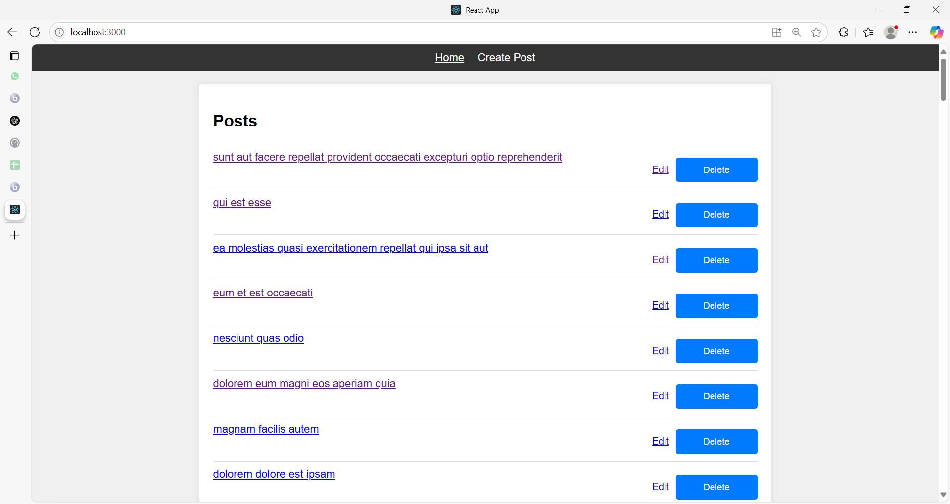

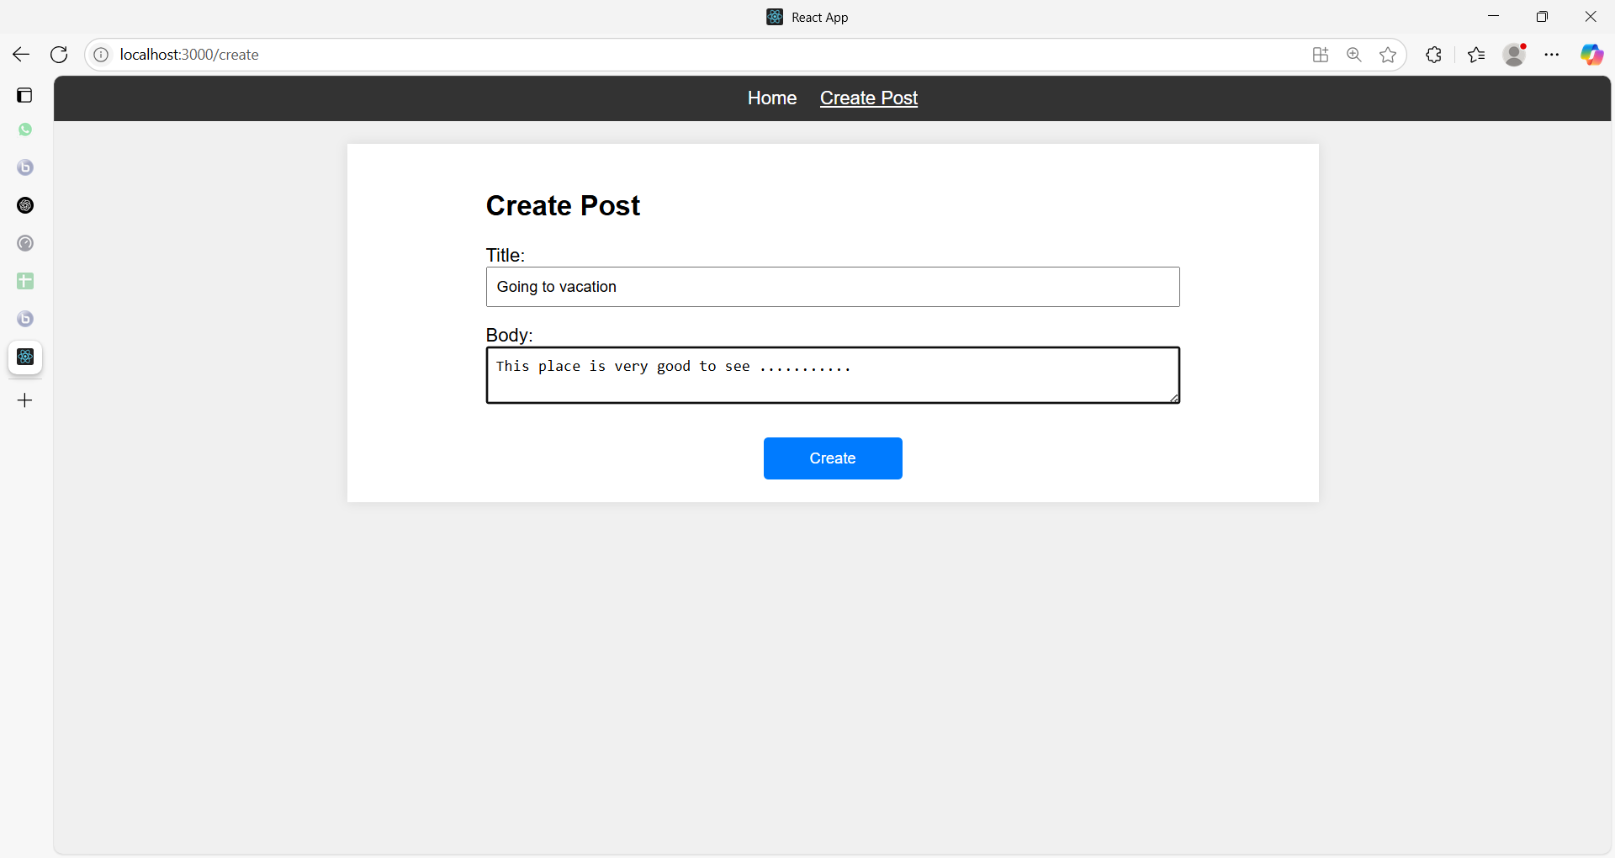

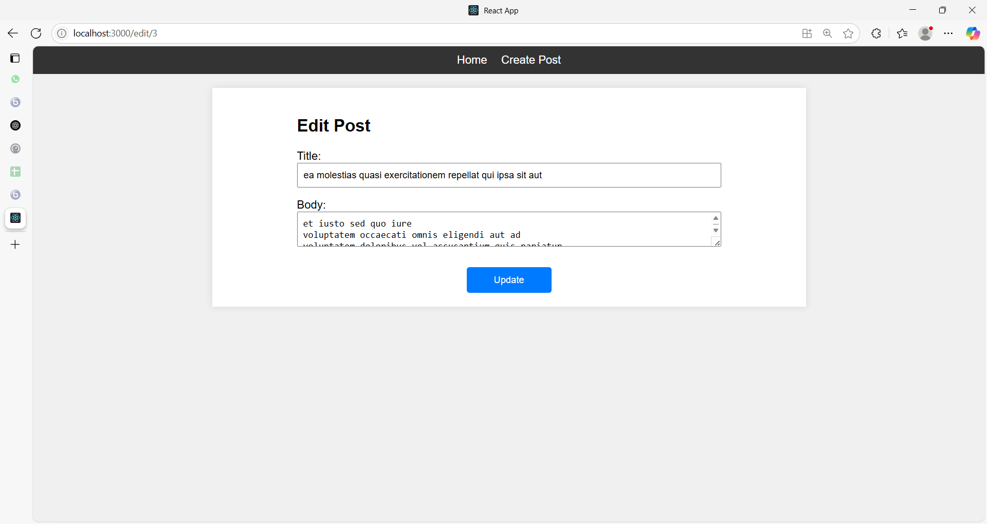

**Project Structure**

/react-app-012

/public

/src

/components

Navbar.js

Navbar.css

PostList.js

PostList.css

PostForm.js

PostForm.css

PostDetail.js

PostDetail.css

/services

PostService.js

App.js

index.js

App.css

**1. PostService.js**

// src/services/PostService.js

import axios from 'axios';

const API_URL = 'https://jsonplaceholder.typicode.com/posts';

export const fetchPosts = () => axios.get(API_URL);

export const fetchPostById = id => axios.get(`${API_URL}/${id}`);

export const createPost = postData => axios.post(API_URL, postData);

export const updatePost = (postId, postData) =>

axios.put(`${API_URL}/${postId}`, postData);

export const deletePost = postId =>

axios.delete(`${API_URL}/${postId}`);

**2. Navbar.js + CSS**

// src/components/Navbar.js

import React from 'react';

import { NavLink } from 'react-router-dom';

import './Navbar.css';

const Navbar = () => (

<nav className="navbar">

<ul>

<li>

<NavLink to="/" className={({ isActive }) => isActive ? 'active' : ''}>

Home

</NavLink>

</li>

<li>

<NavLink to="/create" className={({ isActive }) => isActive ? 'active' : ''}>

Create Post

</NavLink>

</li>

</ul>

</nav>

);

export default Navbar;

Navbar.css

/* src/components/Navbar.css */

.navbar {

background-color: #333;

padding: 10px;

}

.navbar ul {

list-style: none;

display: flex;

justify-content: center;

margin: 0;

padding: 0;

}

.navbar li {

margin: 0 10px;

}

.navbar a {

color: white;

text-decoration: none;

}

.navbar a.active {

text-decoration: underline;

}

**3. PostList.js + CSS**

// src/components/PostList.js

import React, { useState, useEffect } from 'react';

import { Link } from 'react-router-dom';

import { fetchPosts, deletePost } from '../services/PostService';

import './PostList.css';

const PostList = () => {

const [posts, setPosts] = useState([]);

useEffect(() => {

fetchPosts()

.then(res => setPosts(res.data))

.catch(console.error);

}, []);

const handleDelete = id =>

deletePost(id)

.then(() => setPosts(posts.filter(p => p.id !== id)))

.catch(console.error);

return (

<div className="post-list">

<h2>Posts</h2>

<ul>

{posts.map(p => (

<li key={p.id}>

<Link to={`/posts/${p.id}`}>{p.title}</Link>

<div>

<Link to={`/edit/${p.id}`} className="edit-btn">Edit</Link>

<button onClick={() => handleDelete(p.id)}>Delete</button>

</div>

</li>

))}

</ul>

</div>

);

};

export default PostList;

/* src/components/PostList.css */

.post-list ul {

list-style: none;

padding: 0;

}

.post-list li {

display: flex;

justify-content: space-between;

padding: 10px 0;

border-bottom: 1px solid #ddd;

}

.post-list .edit-btn {

margin-right: 10px;

font-size: 0.9em;

}

button {

background-color: #007bff;

color: white;

border: none;

padding: 5px 10px;

border-radius: 4px;

cursor: pointer;

}

button:hover { background-color: #0056b3; }

**4. PostForm.js + CSS**

// src/components/PostForm.js

import React, { useState, useEffect } from 'react';

import { useNavigate, useParams } from 'react-router-dom';

import { createPost, fetchPostById, updatePost } from '../services/PostService';

import './PostForm.css';

const PostForm = () => {

const [data, setData] = useState({ title: '', body: '', userId: 1 });

const [editMode, setEditMode] = useState(false);

const { id } = useParams();

const nav = useNavigate();

useEffect(() => {

if (id) {

setEditMode(true);

fetchPostById(id)

.then(res => setData(res.data))

.catch(console.error);

}

}, [id]);

const handleChange = e => {

setData(prev => ({ ...prev, [e.target.name]: e.target.value }));

};

const handleSubmit = e => {

e.preventDefault();

const action = editMode

? updatePost(id, data)

: createPost(data);

action

.then(() => nav('/'))

.catch(console.error);

};

return (

<div className="post-form">

<h2>{editMode ? 'Edit Post' : 'Create Post'}</h2>

<form onSubmit={handleSubmit}>

<label>Title:

<input name="title" value={data.title} onChange={handleChange} required />

</label>

<label>Body:

<textarea name="body" value={data.body} onChange={handleChange} required />

</label>

<button type="submit">{editMode ? 'Update' : 'Create'}</button>

</form>

</div>

);

};

export default PostForm;

/* src/components/PostForm.css */

.post-form {

max-width: 600px;

margin: 0 auto;

}

.post-form form {

display: flex;

flex-direction: column;

}

.post-form label {

margin-bottom: 15px;

}

.post-form input,

.post-form textarea {

width: 100%;

padding: 8px;

box-sizing: border-box;

}

button {

width: 120px;

padding: 10px;

margin-top: 10px;

align-self: center;

background-color: #007bff;

color: white;

border: none;

border-radius: 4px;

cursor: pointer;

}

button:hover { background-color: #0056b3; }

**5. PostDetail.js + CSS**

// src/components/PostDetail.js

import React, { useState, useEffect } from 'react';

import { useParams } from 'react-router-dom';

import { fetchPostById } from '../services/PostService';

import './PostDetail.css';

const PostDetail = () => {

const [post, setPost] = useState(null);

const { id } = useParams();

useEffect(() => {

fetchPostById(id)

.then(res => setPost(res.data))

.catch(console.error);

}, [id]);

if (!post) return <p>Loading...</p>;

return (

<div className="post-detail">

<h2>{post.title}</h2>

<p>{post.body}</p>

</div>

);

};

export default PostDetail;

/* src/components/PostDetail.css */

.post-detail {

max-width: 600px;

margin: 0 auto;

text-align: left;

}

.post-detail h2 {

margin-bottom: 10px;

}

**6. App.js + App.css**

// src/App.js

import React from 'react';

import { BrowserRouter as Router, Routes, Route } from 'react-router-dom';

import Navbar from './components/Navbar';

import PostList from './components/PostList';

import PostForm from './components/PostForm';

import PostDetail from './components/PostDetail';

import './App.css';

const App = () => (

<Router>

<Navbar />

<div className="container">

<Routes>

<Route path="/" element={<PostList />} />

<Route path="/create" element={<PostForm />} />

<Route path="/posts/:id" element={<PostDetail />} />

<Route path="/edit/:id" element={<PostForm />} />

</Routes>

</div>

</Router>

);

export default App;

/* src/App.css */

body {

margin: 0;

padding: 0;

font-family: Arial, sans-serif;

background-color: #f0f0f0;

}

.container {

max-width: 800px;

margin: 20px auto;

padding: 20px;

background: white;

box-shadow: 0 0 10px rgba(0,0,0,0.1);

}

**Example 05**

Below is a more comprehensive guide for building an e-commerce project in React with routing, services, HTTP operations using Axios, and styled components using CSS.

We'll use React Router v6, which introduces some changes from v5.

**Step 1: Setup React Project**

First, create a new React project using Create React App.

**npx create-react-app ecommerce-app**

**cd ecommerce-app**

**npm start**

**Step 2: Install Dependencies**

Install **react-router-dom** for routing and **axios** for making HTTP requests.

**npm install react-router-dom@6 axios@latest**

**Step 3: Setup Project Structure**

Create a folder structure as follows:

src/

components/

Cart.js

Checkout.js

Home.js

Navbar.js

ProductDetail.js

ProductList.js

Cart.css

Checkout.css

Home.css

Navbar.css

ProductDetail.css

ProductList.css

pages/

HomePage.js

ProductListPage.js

ProductDetailPage.js

CartPage.js

CheckoutPage.js

services/

productService.js

cartService.js

orderService.js

userService.js

paymentService.js

App.js

index.js

App.css

**Step 4: Create Services with HTTP Operations**

**4.1. Product Service**

**src/services/productService.js**:

import axios from 'axios';

const API_URL = 'https://dummyjson.com/products';

export const getProducts = async () => {

const response = await axios.get(API_URL);

return response.data;

};

export const getProductById = async (id) => {

const response = await axios.get(`${API_URL}/${id}`);

return response.data;

};

export const addProduct = async (product) => {

const response = await axios.post(API_URL, product);

return response.data;

};

export const updateProduct = async (id, product) => {

const response = await axios.put(`${API_URL}/${id}`, product);

return response.data;

};

export const deleteProduct = async (id) => {

const response = await axios.delete(`${API_URL}/${id}`);

return response.data;

};

**Explanation:**

This code is a JavaScript module that interacts with a remote API to perform CRUD (Create, Read, Update, Delete) operations on products. The code uses the axios library to send HTTP requests. Below is an explanation of the code line by line:

**import axios from 'axios';**

* This line imports the **axios** library, which is used to make HTTP requests. It allows you to send requests to an API and handle the responses easily.

**const API_URL = 'https://dummyjson.com/products';**

* This line defines a constant variable API_URL that stores the base URL of the API endpoint for the products. The API endpoint provides various operations related to products.

**export const getProducts = async () => {**

**const response = await axios.get(API_URL);**

**return response.data;**

**};**

* **getProducts**: This is an asynchronous function that retrieves a list of all products from the API.
  + **axios.get(API_URL):** Sends a GET request to the API_URL to fetch the products.
  + **response.data:** The response from the API is stored in the response object, and response.data contains the actual data returned by the API.
  + The function returns the data containing the list of products.

**export const getProductById = async (id) => {**

**const response = await axios.get(`${API_URL}/${id}`);**

**return response.data;**

**};**

* **getProductById**: This is an asynchronous function that retrieves a single product by its ID.
  + **axios.get(${API_URL}/${id}):** Sends a GET request to the API URL, appending the id of the product to fetch a specific product.
  + The function returns the data containing the details of the requested product.

**export const addProduct = async (product) => {**

**const response = await axios.post(API_URL, product);**

**return response.data;**

**};**

* **addProduct**: This is an asynchronous function that adds a new product to the API.
  + **axios.post(API_URL, product):** Sends a POST request to the API_URL with the product object as the payload. The product object contains the data of the new product to be added.
  + The function returns the data containing the newly created product.

**export const updateProduct = async (id, product) => {**

**const response = await axios.put(`${API_URL}/${id}`, product);**

**return response.data;**

**};**

* **updateProduct:** This is an asynchronous function that updates an existing product in the API.
  + **axios.put(${API_URL}/${id}, product):** Sends a PUT request to the API URL with the id of the product to be updated and the product object containing the updated data.
  + The function returns the data containing the updated product details.

**export const deleteProduct = async (id) => {**

**const response = await axios.delete(`${API_URL}/${id}`);**

**return response.data;**

**};**

* **deleteProduct**: This is an asynchronous function that deletes a product by its ID from the API.
  + **axios.delete(${API_URL}/${id}):** Sends a DELETE request to the API URL, appending the id of the product to be deleted.
  + The function returns the data containing the result of the deletion operation (often a confirmation message or the deleted product data).

Overall, this module provides functions to interact with a products API, allowing for fetching all products, fetching a product by ID, adding a new product, updating an existing product, and deleting a product.

**4.2. Cart Service**

**src/services/cartService.js**:

let cart = [];

export const addToCart = (product) => {

cart.push(product);

return cart;

};

export const removeFromCart = (productId) => {

cart = cart.filter(product => product.id !== productId);

return cart;

};

export const getCartItems = () => {

return cart;

};

**Explanation:**

This code defines a simple shopping cart module in JavaScript that allows you toadd products to the cart, remove products from the cart, and retrieve the current items in the cart. Here’s a line-by-line explanation:

**let cart = [];**

* This line declares a variable cart as an empty array. The cart array will hold all the products that are added to the cart. Since it is defined outside any function, it serves as the module's shared storage for cart items.

**export const addToCart = (product) => {**

**cart.push(product);**

**return cart;**

**};**

* **addToCart**: This is an exported function that adds a product to the cart array.
  + **(product):** The function takes a product parameter, which is expected to be an object representing the product details.
  + **cart.push(product):** Adds the product to the end of the cart array.
  + **return** **cart**: Returns the updated cart array, now including the newly added product.

**export const removeFromCart = (productId) => {**

**cart = cart.filter(product => product.id !== productId);**

**return cart;**

**};**

* **removeFromCart**: This is an exported function that removes a product from the cart array based on its ID.
  + **(productId):** The function takes a productId parameter, which is the ID of the product to be removed.
  + **cart.filter(product => product.id !== productId):** This filters the cart array, keeping only the products whose id does not match the given productId. The cart variable is then reassigned to this filtered array, effectively removing the product with the matching ID.
  + **return cart**: Returns the updated cart array, now excluding the removed product.

**export const getCartItems = () => {**

**return cart;**

**};**

* **getCartItems**: This is an exported function that retrieves the current items in the cart.
  + return cart: Returns the cart array, which contains all the products currently in the cart.

**Summary**

* **cart** is an array that stores the products added to the cart.
* **addToCart** adds a product to the cart and returns the updated list of cart items.
* **removeFromCart** removes a product from the cart by its ID and returns the updated cart.
* **getCartItems** returns the current list of items in the cart.

This module allows for basic shopping cart functionality, such as adding and removing products and viewing the cart contents.

**4.3. Order Service**

**src/services/orderService.js**:

let orders = [];

export const placeOrder = (order) => {

orders.push(order);

return orders;

};

export const getOrders = () => {

return orders;

};

This code defines a simple module for managing orders in memory using JavaScript. Below is an explanation of the code line by line:

let orders = [];

* This line declares a variable orders as an empty array. The orders array will store all the orders that are placed. Since it is declared outside of any function, it acts as a shared storage for the entire module.

**export const placeOrder = (order) => {**

**orders.push(order);**

**return orders;**

**};**

* **placeOrder:** This is an exported function that adds a new order to the orders array.
  + **(order):** The function takes a parameter order, which is expected to be an object or any data structure representing an order.
  + **orders.push(order):** Adds the order to the end of the orders array.
  + return orders: Returns the updated orders array, now including the newly added order.

**export const getOrders = () => {**

**return orders;**

**};**

* **getOrders**: This is an exported function that retrieves the current list of all orders.
  + return orders: Returns the orders array, which contains all the orders that have been placed.

**Summary**

* orders is an array that stores all the orders.
* placeOrder allows you to add a new order to the orders array and returns the updated list of orders.
* getOrders returns the current list of orders.

This module essentially manages a simple in-memory order list, allowing for the addition and retrieval of orders.

**4.4. User Service**

**src/services/userService.js**:

let user = null;

export const login = (userInfo) => {

user = userInfo;

return user;

};

export const logout = () => {

user = null;

return user;

};

export const getUser = () => {

return user;

};

**4.5. Payment Service**

**src/services/paymentService.js**:

export const processPayment = (paymentInfo) => {

return { status: 'success', transactionId: '12345' };

};

**Step 5: Create Components**

**5.1. Navbar Component**

**src/components/Navbar.js**:

import React from 'react';

import { Link } from 'react-router-dom';

import './Navbar.css';

const Navbar = () => {

return (

<nav className="navbar">

<ul>

<li><Link to="/">Home</Link></li>

<li><Link to="/products">Products</Link></li>

<li><Link to="/cart">Cart</Link></li>

</ul>

</nav>

);

};

export default Navbar;

**src/components/Navbar.css**:

.navbar {

background-color: #333;

padding: 1rem;

}

.navbar ul {

display: flex;

list-style: none;

margin: 0;

padding: 0;

}

.navbar ul li {

margin-right: 20px;

}

.navbar ul li a {

color: white;

text-decoration: none;

}

.navbar ul li a:hover {

text-decoration: underline;

}

**5.2. Home Component**

**src/components/Home.js**:

import React, { useEffect, useState } from 'react';

import { getProducts } from '../services/productService';

import './Home.css';

const Home = () => {

const [products, setProducts] = useState([]);

useEffect(() => {

const fetchProducts = async () => {

const data = await getProducts();

setProducts(data.products || data);

};

fetchProducts();

}, []);

return (

<div className="home">

<h1>Featured Products</h1>

<div className="product-list">

{products.slice(0, 4).map(product => (

<div key={product.id} className="product-item">

<h2>{product.title}</h2>

<p>${product.price}</p>

</div>

))}

</div>

</div>

);

};

export default Home;

**src/components/Home.css**:

.home {

text-align: center;

}

.product-list {

display: flex;

justify-content: center;

flex-wrap: wrap;

}

.product-item {

border: 1px solid #ccc;

margin: 10px;

padding: 20px;

width: 200px;

}

.product-item h2 {

font-size: 18px;

}

.product-item p {

font-size: 16px;

color: #333;

}

**5.3. ProductList Component**

**src/components/ProductList.js**:

import React, { useEffect, useState } from 'react';

import { getProducts } from '../services/productService';

import { Link } from 'react-router-dom';

import './ProductList.css';

const ProductList = () => {

const [products, setProducts] = useState([]);

useEffect(() => {

const fetchProducts = async () => {

const data = await getProducts();

setProducts(data.products || data);

};

fetchProducts();

}, []);

return (

<div className="product-list-page">

<h1>Products</h1>

<div className="product-list">

{products.map(product => (

<div key={product.id} className="product-item">

<h2>{product.title}</h2>

<p>${product.price}</p>

<Link to={`/products/${product.id}`} className="details-link">View Details</Link>

</div>

))}

</div>

</div>

);

};

export default ProductList;

**src/components/ProductList.css**:

.product-list-page {

text-align: center;

}

.product-list {

display: flex;

justify-content: center;

flex-wrap: wrap;

}

.product-item {

border: 1px solid #ccc;

margin: 10px;

padding: 20px;

width: 200px;

}

.product-item h2 {

font-size: 18px;

}

.product-item p {

font-size: 16px;

color: #333;

}

.details-link {

text-decoration: none;

color: #007bff;

}

.details-link:hover {

text-decoration: underline;

}

**5.4. ProductDetail Component**

**src/components/ProductDetail.js**:

import React, { useEffect, useState } from 'react';

import { useParams } from 'react-router-dom';

import { getProductById, deleteProduct, updateProduct } from '../services/productService';

import { addToCart } from '../services/cartService';

import './ProductDetail.css';

const ProductDetail = () => {

const { id } = useParams();

const [product, setProduct] = useState(null);

const [editMode, setEditMode] = useState(false);

const [productData, setProductData] = useState({ title: '', price: '' });

useEffect(() => {

const fetchProduct = async () => {

const data = await getProductById(id);

setProduct(data);

setProductData({ title: data.title, price: data.price });

};

fetchProduct();

}, [id]);

const handleDelete = async () => {

await deleteProduct(id);

alert('Product deleted successfully!');

};

const handleUpdate = async () => {

const updatedProduct = await updateProduct(id, productData);

setProduct(updatedProduct);

setEditMode(false);

alert('Product updated successfully!');

};

if (!product) return <div>Loading...</div>;

return (

<div className="product-detail">

{editMode ? (

<div className="edit-form">

<input

type="text"

value={productData.title}

onChange={(e) => setProductData({ ...productData, title: e.target.value })}

/>

<input

type="text"

value={productData.price}

onChange={(e) => setProductData({ ...productData, price: e.target.value })}

/>

<button onClick={handleUpdate}>Update</button>

</div>

) : (

<div className="product-info">

<h1>{product.title}</h1>

<p>${product.price}</p>

<button onClick={() => addToCart(product)}>Add to Cart</button>

</div>

)}

<button onClick={() => setEditMode(!editMode)}>

{editMode ? 'Cancel' : 'Edit'}

</button>

<button onClick={handleDelete}>Delete</button>

</div>

);

};

export default ProductDetail;

**src/components/ProductDetail.css**:

.product-detail {

text-align: center;

margin: 20px;

}

.product-info {

border: 1px solid #ccc;

padding: 20px;

}

.edit-form input {

margin: 5px;

padding: 5px;

}

button {

margin: 5px;

padding: 10px;

background-color: #007bff;

color: white;

border: none;

cursor: pointer;

}

button:hover {

background-color: #0056b3;

}

**5.5. Cart Component**

**src/components/Cart.js**:

import React, { useState, useEffect } from 'react';

import { getCartItems, removeFromCart } from '../services/cartService';

import { Link } from 'react-router-dom';

import './Cart.css';

const Cart = () => {

const [cartItems, setCartItems] = useState([]);

useEffect(() => {

setCartItems(getCartItems());

}, []);

return (

<div className="cart">

<h1>Cart</h1>

<div className="cart-items">

{cartItems.map(item => (

<div key={item.id} className="cart-item">

<h2>{item.title}</h2>

<p>${item.price}</p>

<button onClick={() => setCartItems(removeFromCart(item.id))}>Remove</button>

</div>

))}

</div>

<Link to="/checkout" className="checkout-link">Proceed to Checkout</Link>

</div>

);

};

export default Cart;

**src/components/Cart.css**:

.cart {

text-align: center;

}

.cart-items {

display: flex;

flex-direction: column;

align-items: center;

}

.cart-item {

border: 1px solid #ccc;

margin: 10px;

padding: 20px;

width: 200px;

}

.cart-item h2 {

font-size: 18px;

}

.cart-item p {

font-size: 16px;

color: #333;

}

.checkout-link {

display: block;

margin-top: 20px;

text-decoration: none;

color: white;

background-color: #007bff;

padding: 10px;

}

.checkout-link:hover {

background-color: #0056b3;

}

**5.6. Checkout Component**

**src/components/Checkout.js**:

import React, { useState } from 'react';

import { getCartItems } from '../services/cartService';

import { placeOrder } from '../services/orderService';

import { processPayment } from '../services/paymentService';

import './Checkout.css';

const Checkout = () => {

const [cartItems] = useState(getCartItems());

const [orderStatus, setOrderStatus] = useState(null);

const handleCheckout = () => {

const order = { items: cartItems, total: cartItems.reduce((sum, item) => sum + item.price, 0) };

placeOrder(order);

const paymentInfo = { amount: order.total };

const paymentResult = processPayment(paymentInfo);

setOrderStatus(paymentResult.status);

};

return (

<div className="checkout">

<h1>Checkout</h1>

{cartItems.map(item => (

<div key={item.id} className="checkout-item">

<h2>{item.title}</h2>

<p>${item.price}</p>

</div>

))}

<button onClick={handleCheckout}>Place Order</button>

{orderStatus && <p>Order Status: {orderStatus}</p>}

</div>

);

};

export default Checkout;

**src/components/Checkout.css**:

.checkout {

text-align: center;

}

.checkout-item {

border: 1px solid #ccc;

margin: 10px;

padding: 20px;

width: 200px;

}

.checkout-item h2 {

font-size: 18px;

}

.checkout-item p {

font-size: 16px;

color: #333;

}

button {

margin: 5px;

padding: 10px;

background-color: #007bff;

color: white;

border: none;

cursor: pointer;

}

button:hover {

background-color: #0056b3;

}

**Step 6: Setup Routing with React Router v6**

**6.1. HomePage Component**

**src/pages/HomePage.js**:

import React from 'react';

import Home from '../components/Home';

const HomePage = () => {

return (

<div>

<Home />

</div>

);

};

export default HomePage;

**6.2. ProductListPage Component**

**src/pages/ProductListPage.js**:

import React from 'react';

import ProductList from '../components/ProductList';

const ProductListPage = () => {

return (

<div>

<ProductList />

</div>

);

};

export default ProductListPage;

**6.3. ProductDetailPage Component**

**src/pages/ProductDetailPage.js**:

import React from 'react';

import ProductDetail from '../components/ProductDetail';

const ProductDetailPage = () => {

return (

<div>

<ProductDetail />

</div>

);

};

export default ProductDetailPage;

**6.4. CartPage Component**

**src/pages/CartPage.js**:

import React from 'react';

import Cart from '../components/Cart';

const CartPage = () => {

return (

<div>

<Cart />

</div>

);

};

export default CartPage;

**6.5. CheckoutPage Component**

**src/pages/CheckoutPage.js**:

import React from 'react';

import Checkout from '../components/Checkout';

const CheckoutPage = () => {

return (

<div>

<Checkout />

</div>

);

};

export default CheckoutPage;

**Step 7: Assemble Everything in App.js**

**src/App.js**:

import React from 'react';

import { BrowserRouter as Router, Routes, Route } from 'react-router-dom';

import HomePage from './pages/HomePage';

import ProductListPage from './pages/ProductListPage';

import ProductDetailPage from './pages/ProductDetailPage';

import CartPage from './pages/CartPage';

import CheckoutPage from './pages/CheckoutPage';

import Navbar from './components/Navbar';

import './App.css';

function App() {

return (

<Router>

<div className="App">

<Navbar />

<Routes>

<Route path="/" element={<HomePage />} />

<Route path="products" element={<ProductListPage />} />

<Route path="products/:id" element={<ProductDetailPage />} />

<Route path="cart" element={<CartPage />} />

<Route path="checkout" element={<CheckoutPage />} />

</Routes>

</div>

</Router>

);

}

export default App;

**Step 8: Add Global Styling**

For global styling, you can add styles in **src/App.css**.

**src/App.css**:

body {

font-family: Arial, sans-serif;

margin: 0;

padding: 0;

background-color: #f8f9fa;

}

.App {

text-align: center;

}

h1 {

color: #333;

}

h2 {

color: #555;

}

button {

cursor: pointer;

}

**Step 9: Run the Project**

Run the project to see your e-commerce application in action.

**npm start**

You should now have a comprehensive e-commerce application with routing, services, HTTP operations using Axios, and styled components.

This application allows users to view products, add them to the cart, and proceed to checkout.

The services handle product data fetching, cart operations, order processing, user management, and payment simulation.

**State management**

State management in React refers to the process of managing the state of a component or application.

The state is an object that holds data that can change over time and affect the rendering of components.

Proper state management ensures that the UI remains in sync with the underlying data.

**Key Concepts in React State Management**

1. **State in Functional Components**: In functional components, state is managed using the **useState** hook.

const [count, setCount] = useState(0);

* + **useState** returns an array with two elements: the current state value and a function to update it.
  + The state can be updated by calling the updater function (**setCount** in this case) with a new value.

1. **State in Class Components**: In class components, state is managed using the **this.state** object and **this.setState** method.

class Counter extends React.Component {

constructor(props) {

super(props);

this.state = { count: 0 };

}

increment = () => {

this.setState({ count: this.state.count + 1 });

};

render() {

return (

<div>

<p>{this.state.count}</p>

<button onClick={this.increment}>Increment</button>

</div>

);

}

}

**3. Global State Management**: For larger applications, managing state across multiple components becomes challenging.

Various state management libraries help in managing global state, including:

* + **Redux**: A predictable state container for JavaScript apps, which helps manage the global state by providing a centralized store.
  + **Context API**: Built into React, it allows for prop drilling-free state sharing across the component tree.
  + **MobX**: A library that makes state management simple and scalable by using observables to manage state.

**4. Context API**: Allows for sharing state without prop drilling (passing props through many levels).

const ThemeContext = React.createContext('light');

function App() {

return (

<ThemeContext.Provider value="dark">

<Toolbar />

</ThemeContext.Provider>

);

}

function Toolbar() {

return (

<div>

<ThemedButton />

</div>

);

}

function ThemedButton() {

const theme = React.useContext(ThemeContext);

return <button theme={theme}>Button</button>;

}

**5. State Management Libraries**:

**Redux**: A widely used library for state management in React.

import { createStore } from 'redux';

const initialState = { count: 0 };

function counterReducer(state = initialState, action) {

switch (action.type) {

case 'INCREMENT':

return { count: state.count + 1 };

case 'DECREMENT':

return { count: state.count - 1 };

default:

return state;

}

}

const store = createStore(counterReducer);

store.dispatch({ type: 'INCREMENT' });

console.log(store.getState()); // { count: 1 }

**MobX**: Uses observables and actions for state management.

import { observable, action } from 'mobx';

class CounterStore {

@observable count = 0;

@action.bound

increment() {

this.count += 1;

}

@action.bound

decrement() {

this.count -= 1;

}

}

const counterStore = new CounterStore();

**Importance of State Management**

* **Consistency**: Ensures that the UI consistently reflects the underlying data.
* **Scalability**: Helps manage complex state logic, making the application scalable and maintainable.
* **Debugging**: Tools like Redux DevTools make it easier to track and debug state changes.

State management in React is a fundamental concept that is essential for building dynamic and interactive applications.

It ranges from simple local state management using hooks to complex global state management using libraries like Redux and MobX.

**State management in React through Redux**

State management in React through Redux involves organizing and managing the state of an application in a centralized and predictable way.

Redux is a state management library for JavaScript applications, and it is commonly used with React.

Here’s a comprehensive guide to understanding how to implement state management using Redux in a React application.

**Key Concepts of Redux**

1. **Store**:
   1. The central place where the application's state is stored.
   2. The state in Redux is read-only, meaning it can only be changed by dispatching actions.
2. **Actions**:
   1. Plain JavaScript objects that describe a type of event.
   2. Actions have a **type** property and can include additional data.
3. **Reducers**:
   1. Functions that determine how the state should change in response to an action.
   2. They take the current state and an action as arguments and return a new state.
4. **Dispatch**:
   1. A function used to send actions to the store.
5. **Selectors**:
   1. Functions to extract specific parts of the state.

**Example 01:**

Let's create a React app that uses Redux for state management. This app will manage a simple list of items with CRUD operations (Create, Read, Update, Delete).

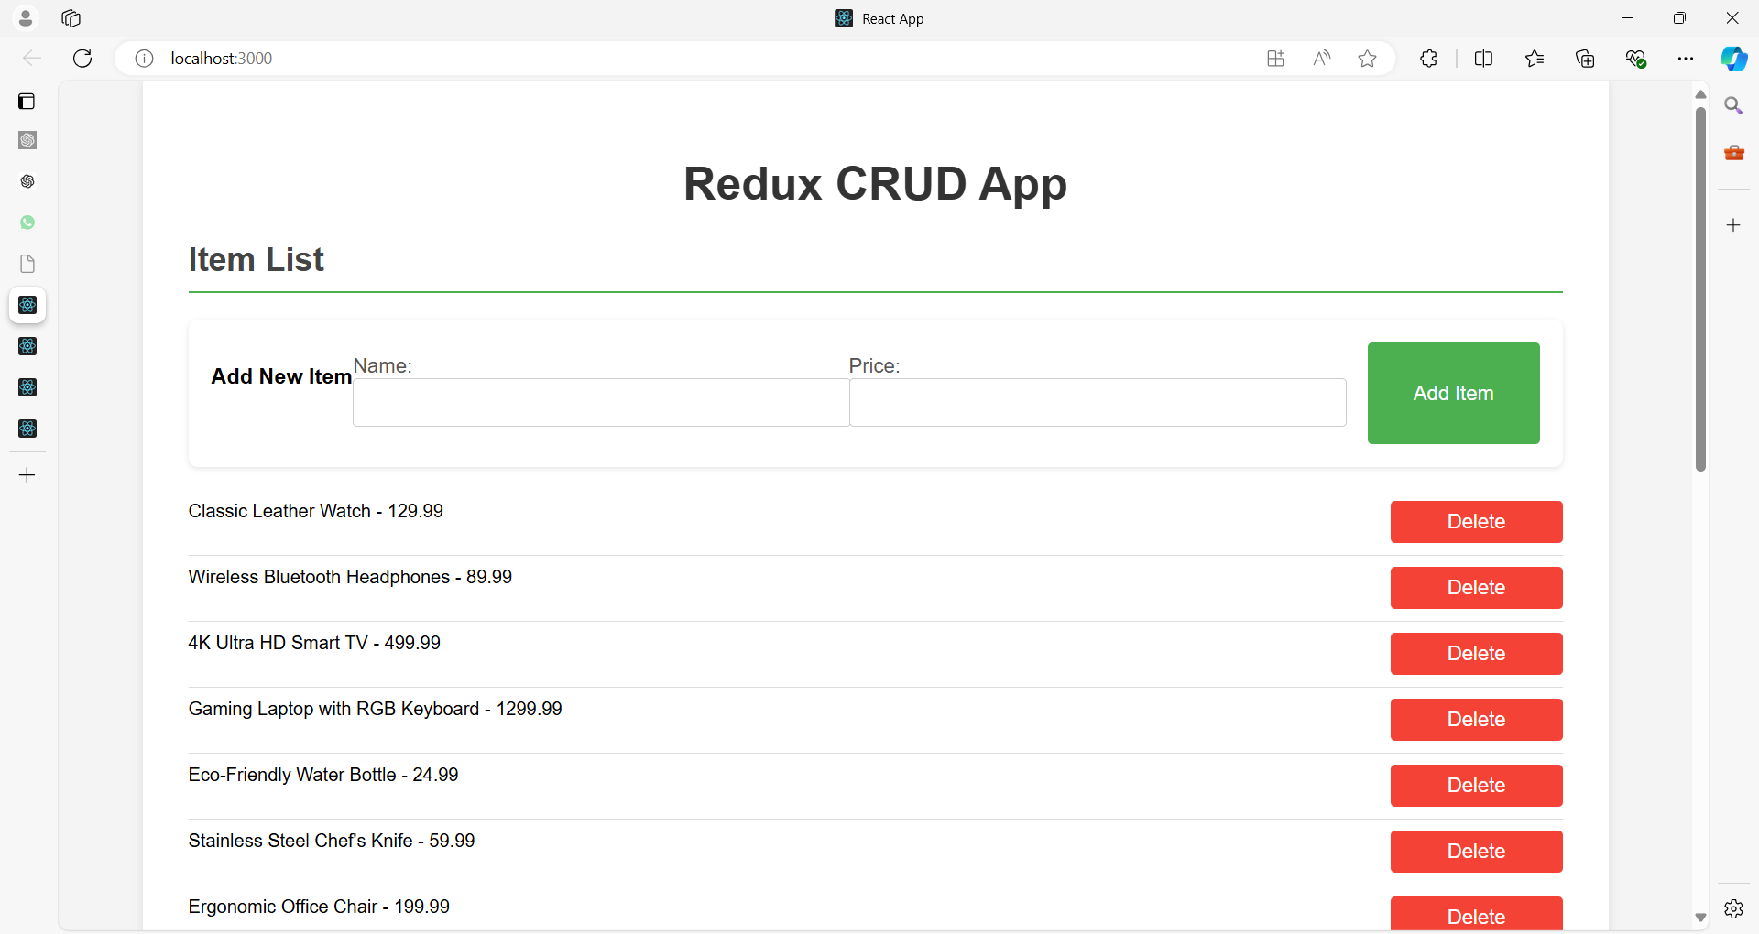

To set up a React app with Redux for managing a list of items with CRUD operations, follow these steps:

**1. Install Dependencies**

Run the following commands to install the necessary libraries:

npm install redux@4.2.1 react-redux@latest --force

npm install redux-thunk@latest --force

npm install redux-devtools-extension@latest --force

npm install axios@latest --force

npm install @reduxjs/toolkit react-redux@latest --force

**2. Project Structure**

Your project structure should look like this:

/state-management-app

db.json

/public

/src

/components

ItemList.js

ItemForm.js

/actions

itemActions.js

/reducers

itemReducer.js

rootReducer.js

/store

store.js

App.js

index.js

package.json

**3. Setup Redux**

**Create a db.json file to mock to use json-server**

**state-management-app/db.json**

{

  "products": [

    {

      "id": 1,

      "title": "Classic Leather Watch",

      "price": 129.99

    },

    {

      "id": 2,

      "title": "Wireless Bluetooth Headphones",

      "price": 89.99

    },

    {

      "id": 3,

      "title": "4K Ultra HD Smart TV",

      "price": 499.99

    },

    {

      "id": 4,

      "title": "Gaming Laptop with RGB Keyboard",

      "price": 1299.99

    },

    {

      "id": 5,

      "title": "Eco-Friendly Water Bottle",

      "price": 24.99

    },

    {

      "id": 6,

      "title": "Stainless Steel Chef's Knife",

      "price": 59.99

    },

    {

      "id": 7,

      "title": "Ergonomic Office Chair",

      "price": 199.99

    },

    {

      "id": 8,

      "title": "Portable Power Bank",

      "price": 34.99

    },

    {

      "id": 9,

      "title": "Digital SLR Camera",

      "price": 749.99

    },

    {

      "id": 10,

      "title": "Bluetooth Fitness Tracker",

      "price": 49.99

    },

    {

      "id": 11,

      "title": "Electric Toothbrush with UV Sanitizer",

      "price": 89.99

    },

    {

      "id": 12,

      "title": "Noise-Canceling Earbuds",

      "price": 69.99

    },

    {

      "id": 13,

      "title": "Smart Home Security Camera",

      "price": 119.99

    },

    {

      "id": 14,

      "title": "High-Speed Blender",

      "price": 89.99

    },

    {

      "id": 15,

      "title": "Adjustable Standing Desk",

      "price": 299.99

    },

    {

      "id": 16,

      "title": "Organic Cotton Bed Sheets",

      "price": 79.99

    },

    {

      "id": 17,

      "title": "Foldable Electric Scooter",

      "price": 399.99

    },

    {

      "id": 18,

      "title": "Compact Air Purifier",

      "price": 59.99

    },

    {

      "id": 19,

      "title": "Cordless Vacuum Cleaner",

      "price": 249.99

    },

    {

      "id": 20,

      "title": "Multifunctional Pressure Cooker",

      "price": 89.99

    },

    {

      "id": "65b3",

      "title": "My Watch",

      "price": "100"

    },

    {

      "id": "5ecd",

      "title": "Your Watch",

      "price": "10"

    }

  ]

}

1. **Install json-server**:

npm install -g json-server

1. **Run json-server**:

json-server --watch db.json --port 5000

1. **Access Endpoints**:
   * **GET all items**: http://localhost:5000/products
   * **GET a single item**: http://localhost:5000/products /:id
   * **POST new item**: http://localhost:5000/products
   * **PUT update item**: http://localhost:5000/products /:id
   * **DELETE item**: http://localhost:5000/products/:id

This setup allows you to interact with your item data through RESTful API endpoints, which can be consumed by your React application

**a. Create Actions**

Create itemActions.js in the /actions directory:

// src/actions/itemActions.js

import axios from 'axios';

export const FETCH_ITEMS_REQUEST = 'FETCH_ITEMS_REQUEST';

export const FETCH_ITEMS_SUCCESS = 'FETCH_ITEMS_SUCCESS';

export const FETCH_ITEMS_FAILURE = 'FETCH_ITEMS_FAILURE';

export const ADD_ITEM = 'ADD_ITEM';

export const UPDATE_ITEM = 'UPDATE_ITEM';

export const DELETE_ITEM = 'DELETE_ITEM';

//const apiUrl = 'https://dummyjson.com/products'; // Replace with your API URL

const apiUrl = 'http://localhost:5000/products'; // Replace with your API URL

export const fetchItems = () => async dispatch => {

  dispatch({ type: FETCH_ITEMS_REQUEST });

  try {

    const response = await axios.get(apiUrl);

    dispatch({ type: FETCH_ITEMS_SUCCESS, payload: response.data });

  } catch (error) {

    dispatch({ type: FETCH_ITEMS_FAILURE, payload: error.message });

  }

};

export const addItem = item => async dispatch => {

  try {

    const response = await axios.post(apiUrl, {

      title: item.title,

      price: item.price

    });

    console.log("Add Item Response:", response.data);

    dispatch({ type: ADD_ITEM, payload: response.data });

  } catch (error) {

    console.error(error.message);

  }

};

export const updateItem = item => async dispatch => {

  try {

    const response = await axios.put(`${apiUrl}/${item.id}`, item);

    dispatch({ type: UPDATE_ITEM, payload: response.data });

  } catch (error) {

    console.error(error.message);

  }

};

export const deleteItem = (id) => async dispatch => {

  try {

    await axios.delete(`${apiUrl}/${id}`);

    dispatch({ type: DELETE_ITEM, payload: id });

  } catch (error) {

    console.error(error.message);

  }

};

Here's an explanation of your code with key points for each section:

**1. Importing Axios**

**import axios from 'axios';**

* **Explanation:** This imports the axios library, which is used to make HTTP requests (GET, POST, PUT, DELETE, etc.). Axios simplifies sending requests and handling responses in promises, making it easier to communicate with external APIs.

**2. Defining Action Types**

**export const FETCH_ITEMS_REQUEST = 'FETCH_ITEMS_REQUEST';**

**export const FETCH_ITEMS_SUCCESS = 'FETCH_ITEMS_SUCCESS';**

**export const FETCH_ITEMS_FAILURE = 'FETCH_ITEMS_FAILURE';**

**export const ADD_ITEM = 'ADD_ITEM';**

**export const UPDATE_ITEM = 'UPDATE_ITEM';**

**export const DELETE_ITEM = 'DELETE_ITEM';**

* **Explanation:** These are constants that define the types of actions. By creating these constants, it reduces the risk of typos when referring to action types in different parts of the code and helps in debugging.
* FETCH_ITEMS_*: Related to fetching data (e.g., items from an API).
* ADD_ITEM, UPDATE_ITEM, DELETE_ITEM: Related to adding, updating, or deleting an item.

**3. Setting the API URL**

**const apiUrl = 'http://localhost:5000/products'; // Replace with your API URL**

* **Explanation:** This variable stores the base URL for the API endpoint. In this case, the json-server is running locally at http://localhost:5000, and it is handling requests to the /products route.
* If the API is deployed on a live server, this URL would change to point to the actual server.

**4. Fetching Items (GET Request)**

**export const fetchItems = () => async dispatch => {**

**dispatch({ type: FETCH_ITEMS_REQUEST });**

**try {**

**const response = await axios.get(apiUrl);**

**dispatch({ type: FETCH_ITEMS_SUCCESS, payload: response.data });**

**} catch (error) {**

**dispatch({ type: FETCH_ITEMS_FAILURE, payload: error.message });**

**}**

**};**

* **Explanation:**
  1. **Dispatching FETCH_ITEMS_REQUEST:** This indicates the process of fetching data has started, usually triggering a loading state in the UI.
  2. **Axios GET Request:** The axios.get(apiUrl) fetches the list of items from the server.
  3. **Dispatching FETCH_ITEMS_SUCCESS:** If the request is successful, the FETCH_ITEMS_SUCCESS action is dispatched, passing the fetched items (response.data) as the payload.
  4. **Error Handling:** If there’s an error during the request, FETCH_ITEMS_FAILURE is dispatched with the error message.

**5. Adding an Item (POST Request)**

**export const addItem = item => async dispatch => {**

**try {**

**const response = await axios.post(apiUrl, {**

**title: item.title,**

**price: item.price**

**});**

**dispatch({ type: ADD_ITEM, payload: response.data });**

**} catch (error) {**

**console.error(error.message);**

**}**

**};**

* **Explanation:**
  1. **Axios POST Request:** The axios.post(apiUrl, {...}) sends a new item (title and price) to the server.
  2. **Dispatching ADD_ITEM:** On success, the ADD_ITEM action is dispatched, passing the added item (response.data) to update the Redux state and the UI.
  3. **Error Handling:** Any errors that occur during the addition of the item are logged to the console.

**6. Updating an Item (PUT Request)**

**export const updateItem = item => async dispatch => {**

**try {**

**const response = await axios.put(`${apiUrl}/${item.id}`, item);**

**dispatch({ type: UPDATE_ITEM, payload: response.data });**

**} catch (error) {**

**console.error(error.message);**

**}**

**};**

* **Explanation:**
  1. **Axios PUT Request:** The axios.put sends an updated version of the item to the server using the item’s id to locate it.
  2. **Dispatching UPDATE_ITEM:** If the update is successful, the UPDATE_ITEM action is dispatched to reflect the updated item in the Redux store.
  3. **Error Handling:** In case of failure, an error message is logged to the console.

**7. Deleting an Item (DELETE Request)**

**export const deleteItem = id => async dispatch => {**

**try {**

**await axios.delete(`${apiUrl}/${id}`);**

**dispatch({ type: DELETE_ITEM, payload: id });**

**} catch (error) {**

**console.error(error.message);**

**}**

**};**

* **Explanation:**
  1. **Axios DELETE Request:** This sends a DELETE request to the API to remove the item identified by id.
  2. **Dispatching DELETE_ITEM:** On success, the DELETE_ITEM action is dispatched, and the Redux store is updated to remove the deleted item.
  3. **Error Handling:** Any error encountered during the deletion process is logged.

This setup helps to manage CRUD operations using Redux in combination with Axios to interact with an external API, handling data and state management seamlessly.

**b. Create Reducers**

Create itemReducer.js in the /reducers directory:

// src/reducers/itemReducer.js

import {

    FETCH_ITEMS_REQUEST,

    FETCH_ITEMS_SUCCESS,

    FETCH_ITEMS_FAILURE,

    ADD_ITEM,

    UPDATE_ITEM,

    DELETE_ITEM

  } from '../actions/itemActions';

  const initialState = {

    items: [],

    loading: false,

    error: null

  };

  const itemReducer = (state = initialState, action) => {

    switch (action.type) {

      case FETCH_ITEMS_REQUEST:

        return { ...state, loading: true };

      case FETCH_ITEMS_SUCCESS:

        return { ...state, loading: false, items: action.payload };

      case FETCH_ITEMS_FAILURE:

        return { ...state, loading: false, error: action.payload };

      case ADD_ITEM:

        return { ...state,

          items: [...state.items,

          action.payload] };

      case UPDATE_ITEM:

        return {

          ...state,

          items: state.items.map(item =>

            item.id === action.payload.id ? action.payload : item

          )

        };

      case DELETE_ITEM:

        return {

          ...state,

          items: state.items.filter(item => item.id !== action.payload)

        };

      default:

        return state;

    }

  };

  export default itemReducer;

Create rootReducer.js in the /reducers directory:

// src/reducers/rootReducer.js

import { combineReducers } from 'redux';

import itemReducer from './itemReducer';

const rootReducer = combineReducers({

  items: itemReducer

});

export default rootReducer;

**c. Create Store**

Create store.js in the /store directory:

// src/store/store.js

import { createStore, applyMiddleware } from 'redux';

import { thunk } from 'redux-thunk';

import { composeWithDevTools } from 'redux-devtools-extension';

import rootReducer from '../reducers/rootReducer';

const store = createStore(

  rootReducer,

  composeWithDevTools(applyMiddleware(thunk))

);

export default store;

**/\***

**applyMiddleware**

Creates a store enhancer that applies middleware to the dispatch method of the Redux store.

This is handy for a variety of tasks, such as expressing asynchronous actions in a concise manner, or logging every action payload.

**\*/**

**d. Connect Redux to React**

In index.js, connect the Redux store to your React application:

// src/index.js

import React from 'react';

import ReactDOM from 'react-dom/client';

import './index.css';

import App from './App';

import reportWebVitals from './reportWebVitals';

import { Provider } from 'react-redux';

import store from './store/store';

const root = ReactDOM.createRoot(document.getElementById('root'));

root.render(

  <React.StrictMode>

    <Provider store={store}>

    <App />

    </Provider>

  </React.StrictMode>

);

reportWebVitals();

**4. Create Components**

**a. ItemList.js**

// src/components/ItemList.js

import React, { useEffect } from 'react';

import { useDispatch, useSelector } from 'react-redux';

import { fetchItems, deleteItem } from '../actions/itemActions';

import ItemForm from './ItemForm';

const ItemList = () => {

  const dispatch = useDispatch();

  const { items, loading, error } = useSelector(state => state.items);

  useEffect(() => {

    dispatch(fetchItems());

  }, [dispatch]);

  const handleDelete = id => {

    dispatch(deleteItem(id));

  };

  if (loading) return <p>Loading...</p>;

  if (error) return <p>Error: {error}</p>;

  return (

    <div>

      <h2>Item List</h2>

      <ItemForm />

      <ul>

        {items.map(item => (

          <li key={item.id}>

            {item.title} - {item.price}

            <button onClick={() => handleDelete(item.id)}>Delete</button>

          </li>

        ))}

      </ul>

    </div>

  );

};

export default ItemList;

**b. ItemForm.js**

// src/components/ItemForm.js

import React, { useState } from 'react';

import { useDispatch } from 'react-redux';

import { addItem, updateItem } from '../actions/itemActions';

const ItemForm = ({ item = null }) => {

  const dispatch = useDispatch();

  const [title, setTitle] = useState(item ? item.title : '');

  const [price, setPrice] = useState(item ? item.price : '');

  const handleSubmit = e => {

    e.preventDefault();

    if (!title || !price) {

      alert('Both title and price are required');

      return;

    }

    if (item) {

      // Update existing item

      dispatch(updateItem({ ...item, title, price }));

    } else {

      // Add new item

      dispatch(addItem({ title, price }));

    }

    // Reset form fields

    setTitle('');

    setPrice('');

  };

  return (

    <form onSubmit={handleSubmit}>

      <h3>{item ? 'Update Item' : 'Add New Item'}</h3>

      <label>

        Name:

        <input

          type="text"

          value={title}

          onChange={e => setTitle(e.target.value)}

          required

        />

      </label>

      <label>

        Price:

        <input

          type="text"

          value={price}

          onChange={e => setPrice(e.target.value)}

          required

        />

      </label>

      <button type="submit">{item ? 'Update' : 'Add'} Item</button>

    </form>

  );

};

export default ItemForm;

**5. App Component**

Update App.js to include the ItemList component:

// src/App.js

import React from 'react';

import ItemList from './components/ItemList';

const App = () => {

  return (

    <div className="app">

      <h1>Redux CRUD App</h1>

      <ItemList />

    </div>

  );

};

export default App;

**6. Basic Styling**

Optionally, you can add some basic styles in index.css to make the app look better:

/* src/index.css */

body {

  font-family: 'Arial', sans-serif;

  margin: 0;

  padding: 0;

  background-color: #f4f4f4;

}

.app {

  max-width: 1200px;

  margin: 0 auto;

  padding: 20px;

  background-color: white;

  box-shadow: 0 2px 8px rgba(0, 0, 0, 0.1);

}

h1 {

  text-align: center;

  color: #333;

  font-size: 2.5em;

}

h2 {

  color: #444;

  font-size: 1.8em;

  border-bottom: 2px solid #4CAF50;

  padding-bottom: 10px;

}

form {

  background-color: #fff;

  padding: 20px;

  margin-bottom: 20px;

  border-radius: 8px;

  box-shadow: 0 2px 5px rgba(0, 0, 0, 0.1);

}

label {

  display: block;

  margin: 10px 0 5px;

  color: #555;

  font-size: 1.1em;

}

input {

  width: 100%;

  padding: 10px;

  margin-bottom: 10px;

  border-radius: 4px;

  border: 1px solid #ccc;

  font-size: 1em;

}

button {

  background-color: #4CAF50;

  color: white;

  padding: 10px 20px;

  border: none;

  border-radius: 4px;

  cursor: pointer;

  font-size: 1.1em;

}

button:hover {

  background-color: #45a049;

}

ul {

  list-style: none;

  padding: 0;

}

li {

  padding: 10px 0;

  border-bottom: 1px solid #ddd;

  display: flex;

  justify-content: space-between;

}

li:last-child {

  border-bottom: none;

}

li button {

  background-color: #f44336;

  border: none;

  padding: 8px 12px;

  color: white;

  cursor: pointer;

  border-radius: 4px;

}

li button:hover {

  background-color: #e53935;

}

@media (min-width: 768px) {

  .app {

    padding: 40px;

  }

  form {

    display: flex;

    justify-content: space-between;

    flex-wrap: wrap;

  }

  label {

    flex: 1;

    margin-right: 20px;

  }

  input {

    flex: 2;

  }

  button {

    flex: 1;

    max-width: 150px;

    margin-left: 20px;

  }

}

This setup includes the basic configuration for Redux with CRUD operations. You can further customize and expand the application based on your needs.

**What is session management in react?**

Session management in React refers to the process of maintaining and managing the state of a user's interaction with an application across different components, routes, and sessions.

This is especially important in web applications that require user authentication, where you need to ensure that a user remains logged in as they navigate through the app, or across different visits.

**Key Aspects of Session Management**

1. **Authentication State:**
   * This involves checking whether a user is logged in or not.
   * The authentication state determines whether the user can access certain parts of the application (like private routes) or whether they need to be redirected to a login page.
2. **Session Persistence:**
   * The session must persist across page reloads and even browser sessions.
   * This is often achieved by storing session data (like tokens or user information) in the browser's local storage, session storage, or cookies.
3. **Session Expiration:**
   * For security reasons, sessions might need to expire after a certain period of inactivity.
   * When a session expires, the user might be logged out automatically, requiring them to log in again.
4. **Session Storage:**
   * The session data is typically stored in the browser using one of the following:
     + **Local Storage:** Persistent storage that lasts even after the browser is closed.
     + **Session Storage:** Temporary storage that is cleared when the session ends (i.e., when the browser or tab is closed).
     + **Cookies:** Small data files stored on the user's device, often used to store session tokens securely.
5. **State Management:**
   * React provides tools like **Context API**, and third-party libraries like **Redux**, to manage the global state of the application.
   * These can be used to store and manage session information across the entire app, ensuring that the user state is consistent regardless of where they are in the application.
6. **Secure Communication:**
   * Session management also involves ensuring that communication between the client (React app) and the server is secure.
   * This often involves using HTTPS, secure tokens (like JWT), and ensuring that sensitive data is not exposed.

**Typical Workflow of Session Management**

1. **User Login:**
   * When a user logs in, the application sends their credentials to the server.
   * If the login is successful, the server returns a session token (e.g., JWT) that is stored in the client’s local storage, session storage, or a cookie.
2. **Maintaining Session State:**
   * The token or session information is used to authenticate the user for subsequent requests to protected resources.
   * The React app checks for the presence of the token to determine if the user is logged in.
3. **Session Expiry and Logout:**
   * The session may expire based on time or when the user logs out.
   * The session data is then cleared from storage, and the user is redirected to the login page.
4. **Refreshing Tokens:**
   * To maintain a session without requiring frequent logins, some applications implement token refresh mechanisms.
   * A refresh token can be used to obtain a new session token without requiring the user to log in again.

**Example**

* **Login:** User logs in, and a JWT token is stored in local storage.
* **Protected Routes:** The React app checks for the token on every route change. If the token is absent or invalid, the user is redirected to the login page.
* **Logout:** When the user logs out, the token is removed from storage, and the session is effectively terminated.

**Conclusion**

Session management in React is about keeping track of the user's state within an application, ensuring that they stay authenticated across different routes and sessions, and securely handling session data.

It's a crucial aspect of building secure and user-friendly web applications.

**What is SessionContext in react?**

In React, SessionContext refers to a pattern where the context API is used to manage session-related data, such as user authentication, session tokens, or any other state that needs to persist across different components of the application.

This is part of React's **Context API**, which is useful for managing global state without the need for prop drilling.

**Prop Drilling** in React refers to the process of **passing data from a parent component to deeply nested child components** via props — even if some intermediate components **don’t need the data themselves** but are just forwarding it.

Here’s how SessionContext works:

1. **Creation of Context:** A SessionContext is created using React.createContext(). This will act as a container to store session-related data like user authentication status, tokens, and user information.
2. **Provider:** The SessionContext.Provider component is used to wrap the parts of your application that need access to the session data. It provides the session state and any methods to modify that state to all the child components.
3. **Consumer:** Components can then consume this session data using either **useContext** hook or the **SessionContext.Consumer** component.

**Example of SessionContext:**

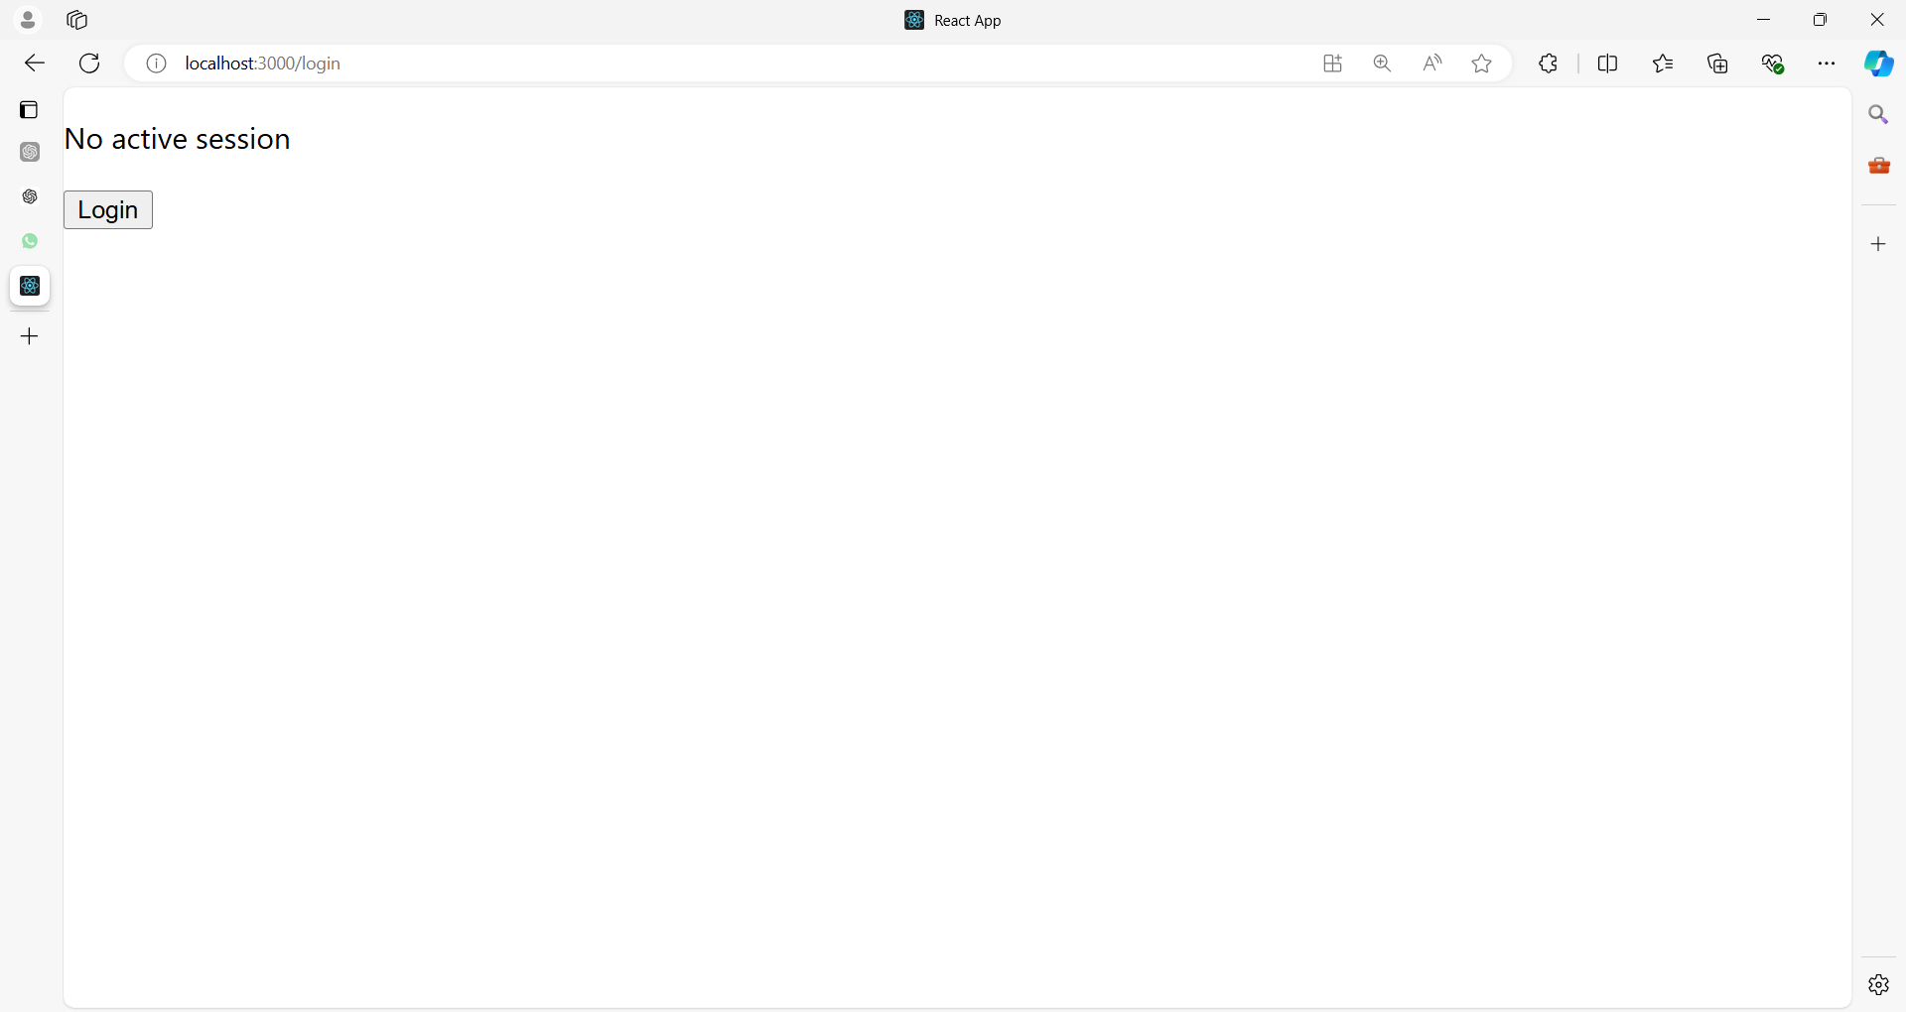

**After clicking on Login button**

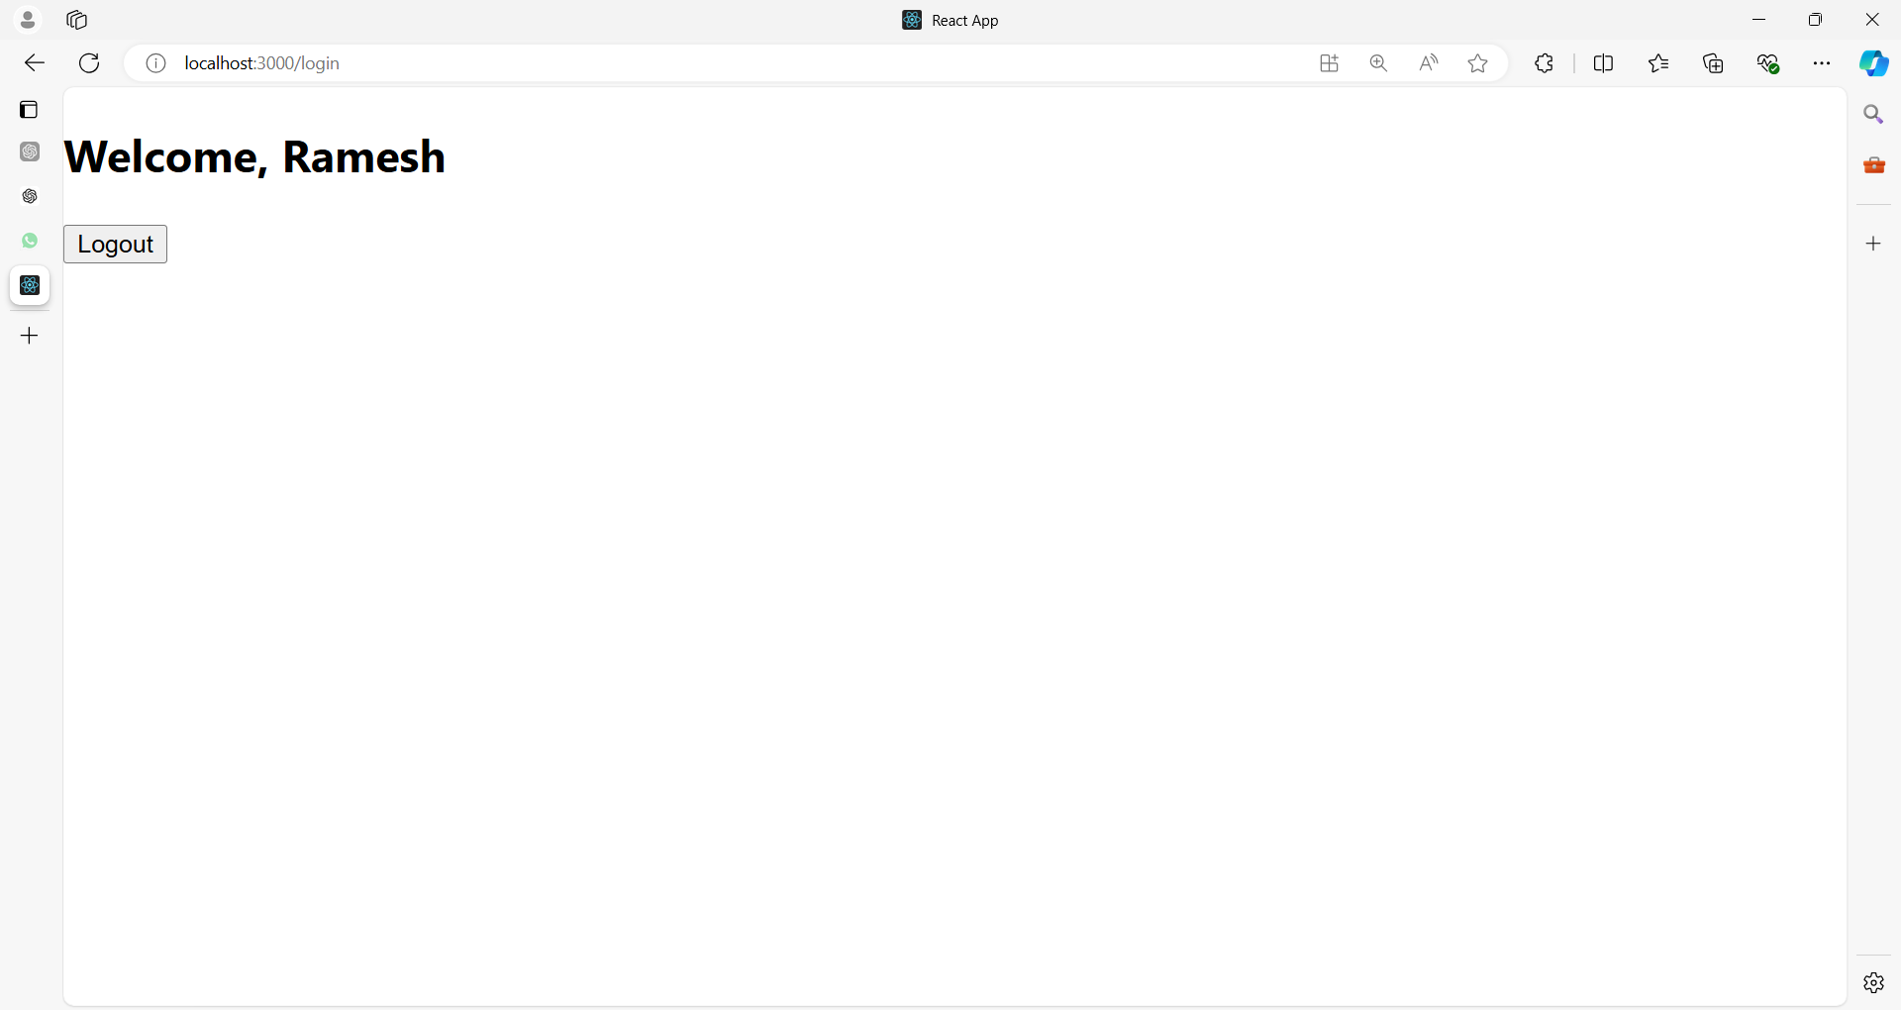

**After clicking on Logout button**

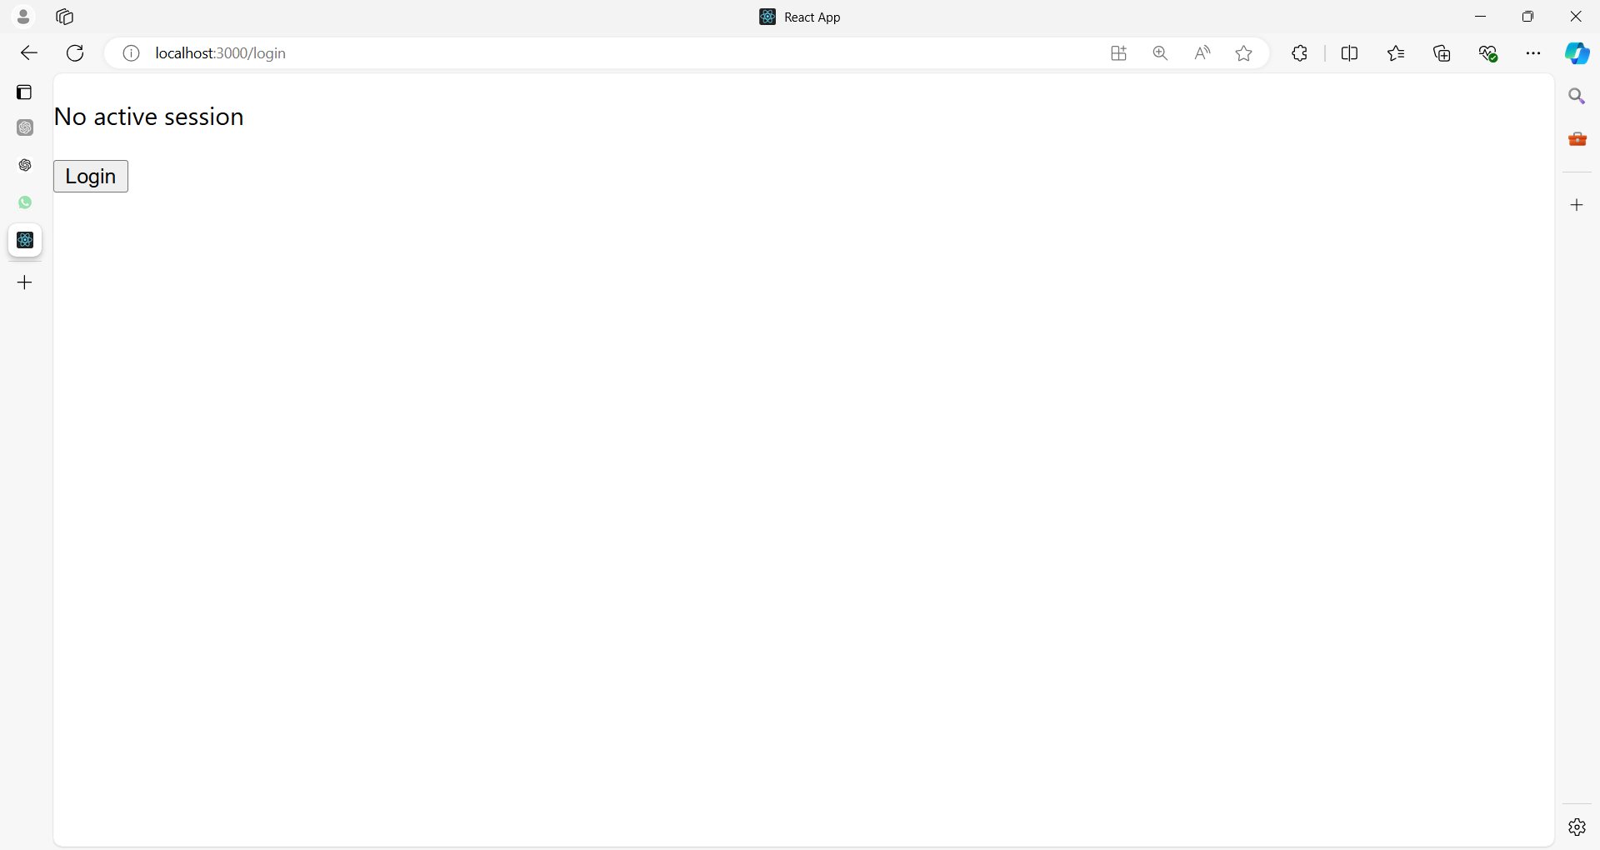

**SessionContext.js**

**// src/contexts/SessionContext.js**

import React, { createContext, useState, useContext } from 'react';

// Create the SessionContext

const SessionContext = createContext();

// SessionProvider component to wrap the app

export const SessionProvider = ({ children }) => {

  const [session, setSession] = useState(null); // null implies no active session

  const login = (userData) => {

    setSession(userData); // Set session with user data

  };

  const logout = () => {

    setSession(null); // Clear session data on logout

  };

  return (

    <SessionContext.Provider value={{ session, login, logout }}>

      {children}

    </SessionContext.Provider>

  );

};

// Custom hook to access the session data

export const useSession = () => useContext(SessionContext);

**UserProfile.js**

// src/components/UserProfile.js

// Example Component that consumes session data

import React from 'react';

import { useSession } from '../contexts/SessionContext';

const UserProfile = () => {

  const { session, login, logout } = useSession();

  if (!session) {

    // Simulate a login with hardcoded user data

    return (

      <div>

        <p>No active session</p>

        <button onClick={() => login({ username: 'Ramesh' })}>Login</button>

      </div>

    );

  }

  return (

    <div>

      <h2>Welcome, {session.username}</h2>

      <button onClick={logout}>Logout</button>

    </div>

  );

};

export default UserProfile;

**App.js**

// src/App.js

// Usage in App

import { SessionProvider } from './contexts/SessionContext';

import UserProfile from './components/UserProfile';

const App = () => (

  <SessionProvider>

    <UserProfile />

  </SessionProvider>

);

export default App;

**Breakdown:**

* **SessionContext:** Holds the session state and provides login and logout functions.
* **SessionProvider:** Wraps the component tree to allow access to session state throughout the app.
* **useSession Hook:** Allows easy access to session data and functions like login and logout in any component.

This pattern is especially useful for managing global session data like user login status and maintaining state across multiple routes or components in a React application.

**Example 01:**

Let's create a simple React application that demonstrates basic session management using the Context API and local storage.

This example will include a login/logout system where the session is maintained across page reloads.

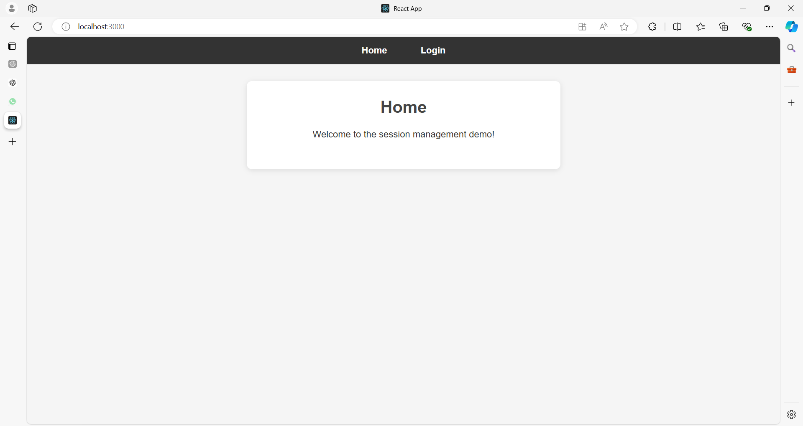

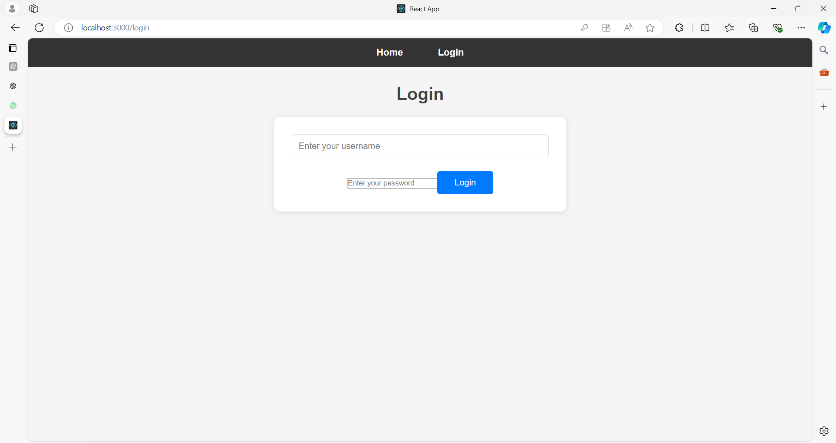

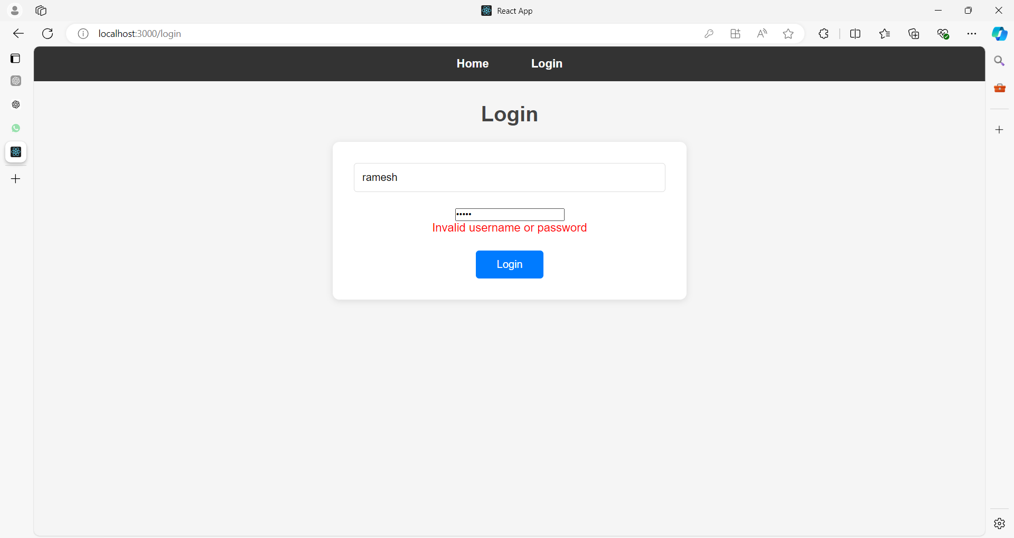

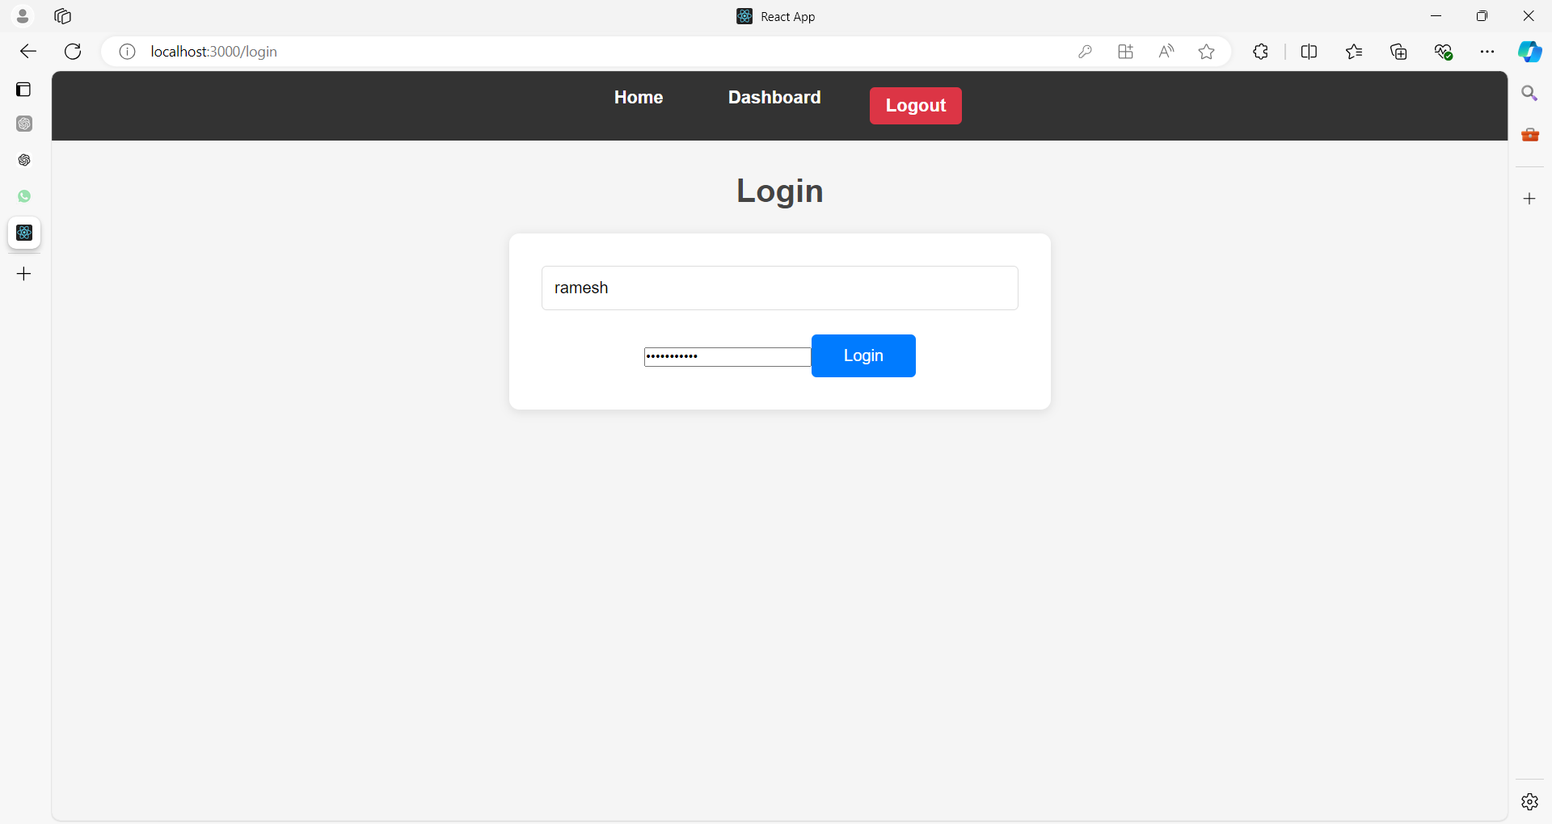

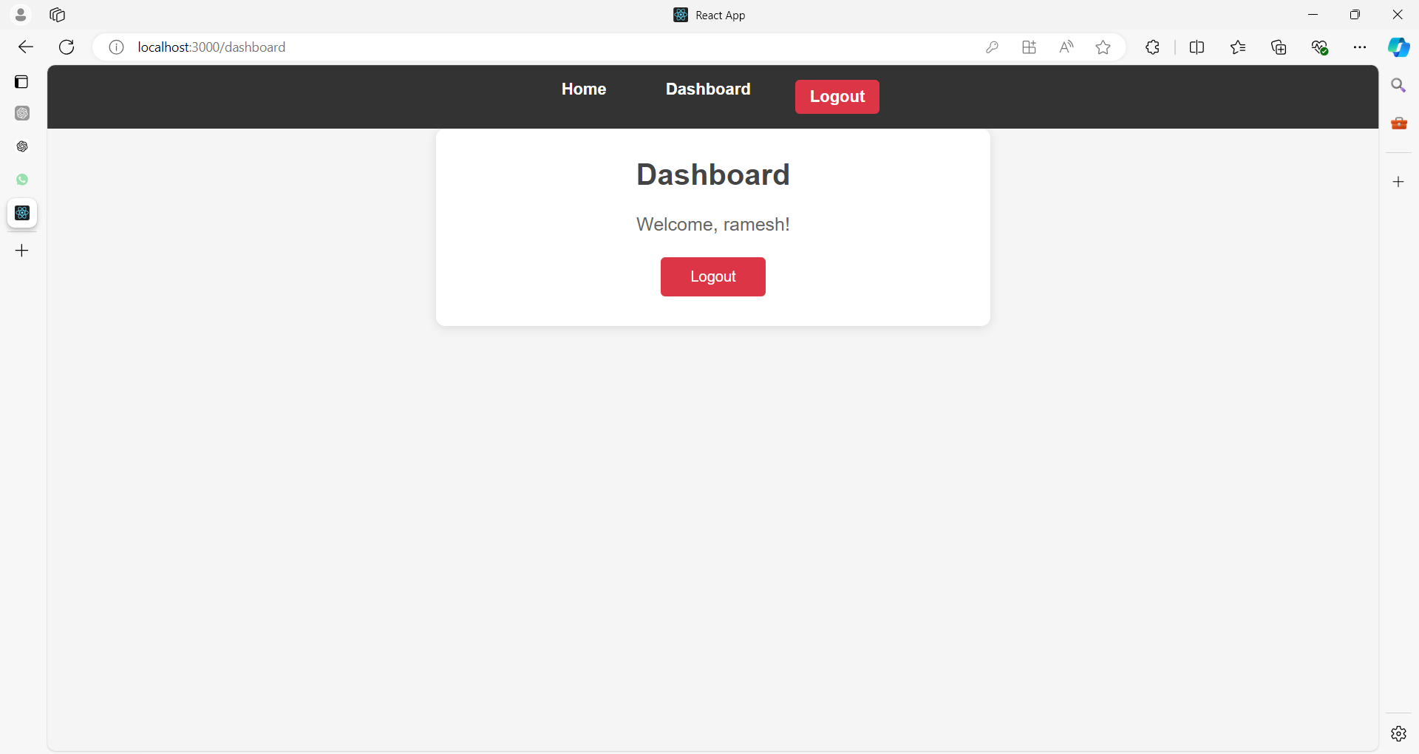

**After clicking on Logout**



**Step 1: Set Up the Project**

Start by creating a new React application if you haven't already.

npx create-react-app react-session-management

cd react-session-management

public/users.json

[

    {

        "username": "ramesh",

        "password": "password123"

    },

    {

        "username": "anish_naik",

        "password": "naik123"

    },

    {

      "username": "john_doe",

      "password": "password123"

    },

    {

      "username": "jane_doe",

      "password": "password456"

    }

  ]

**App.css**

Here’s a simple and clean CSS design that will give your React app a modern look while maintaining good user experience.

Here is the styles for your login form, dashboard, and the overall layout, using a minimalist design with centered content.

You can add the CSS in a App.css file (or another relevant CSS file) and link it to your React components.

**src/App.css**

/* Global Styles */

* {

  margin: 0;

  padding: 0;

  box-sizing: border-box;

  font-family: 'Arial', sans-serif;

}

body {

  background-color: #f5f5f5;

  color: #333;

}

.container {

  max-width: 600px;

  margin: 0 auto;

  padding: 2rem;

  text-align: center;

}

h2 {

  color: #444;

  font-size: 2rem;

  margin-bottom: 1.5rem;

}

p {

  margin-bottom: 1.5rem;

  font-size: 1.1rem;

}

/* Header */

header {

  background-color: #333;

  color: #fff;

  padding: 1rem;

}

header a {

  color: #fff;

  text-decoration: none;

  margin: 0 1rem;

  font-weight: bold;

}

header a:hover {

  text-decoration: underline;

}

/* Form Styles */

form {

  background-color: #fff;

  padding: 2rem;

  border-radius: 10px;

  box-shadow: 0 2px 10px rgba(0, 0, 0, 0.1);

}

input[type="text"] {

  width: 100%;

  padding: 0.75rem;

  margin-bottom: 1.5rem;

  border: 1px solid #ddd;

  border-radius: 5px;

  font-size: 1rem;

}

button {

  padding: 0.75rem 2rem;

  background-color: #007bff;

  color: white;

  border: none;

  border-radius: 5px;

  font-size: 1rem;

  cursor: pointer;

}

button:hover {

  background-color: #0056b3;

}

/* Home Page */

.home {

  background-color: #fff;

  padding: 2rem;

  border-radius: 10px;

  box-shadow: 0 2px 10px rgba(0, 0, 0, 0.1);

  margin-top: 2rem;

}

/* Dashboard */

.dashboard {

  background-color: #fff;

  padding: 2rem;

  border-radius: 10px;

  box-shadow: 0 2px 10px rgba(0, 0, 0, 0.1);

}

.dashboard p {

  font-size: 1.25rem;

  color: #666;

}

button.logout-btn {

  background-color: #dc3545;

}

button.logout-btn:hover {

  background-color: #c82333;

}

nav ul {

  list-style-type: none;

  display: flex;

  justify-content: center;

}

nav ul li {

  margin: 0 1rem;

}

nav ul li a, nav ul li button {

  color: white;

  text-decoration: none;

  font-size: 1.1rem;

  font-weight: bold;

}

nav ul li button {

  background-color: #dc3545;

  border: none;

  padding: 0.5rem 1rem;

  cursor: pointer;

  color: white;

  border-radius: 5px;

}

nav ul li a:hover, nav ul li button:hover {

  text-decoration: underline;

}

**Explanation:**

* **Global Styles:** Basic styles such as resetting margins and padding, setting a global font, and adjusting the overall body color for a clean and minimal design.
* **Container:** Centers the content horizontally with a maximum width and padding. This class can be applied to your main wrapper components like Login, Dashboard, and Home.
* **Form Styles:** Provides styling for the login form, including the input fields and submit button. The button has hover effects to enhance interactivity.
* **Header:** Defines styles for the header, with links having hover effects.
* **Home & Dashboard:** Adds basic styling for both the home and dashboard components, giving them a card-like appearance with shadows and rounded corners for a clean, polished look.
* **Buttons:** The buttons are styled to be modern, with different colors for login and logout buttons.

**Step 2: Create the Session Context**

Create a SessionContext.js file to manage the session state.

// src/SessionContext.js

import React, { createContext, useState, useEffect, useContext } from 'react';

// Create a context

const SessionContext = createContext();

// Session provider component

export const SessionProvider = ({ children }) => {

  const [session, setSession] = useState(null);

  // Load session from local storage if available

  useEffect(() => {

    const storedSession = localStorage.getItem('session');

    if (storedSession) {

      setSession(JSON.parse(storedSession));

    }

  }, []);

  // Save session to local storage

  useEffect(() => {

    if (session) {

      localStorage.setItem('session', JSON.stringify(session));

    } else {

      localStorage.removeItem('session');

    }

  }, [session]);

  const login = (username) => setSession({ username });

  const logout = () => setSession(null);

  return (

    <SessionContext.Provider value={{ session, login, logout }}>

      {children}

    </SessionContext.Provider>

  );

};

// Custom hook to use session context

export const useSession = () => useContext(SessionContext);

Here's a detailed explanation of the SessionContext.js code, breaking it down line by line:

**1. Imports**

**import React, { createContext, useState, useEffect, useContext } from 'react';**

* React: The core library for building user interfaces in React.
* createContext: Used to create a context that can be shared across components without passing props.
* useState: A React hook that allows you to add state to functional components.
* useEffect: A React hook that performs side effects in functional components (e.g., fetching data, saving to local storage).
* useContext: A React hook that allows you to consume context values in any child component.

**2. Creating a Context**

**const SessionContext = createContext();**

* SessionContext: A context object created using createContext(). This object allows us to manage and share the session state across multiple components in the app. Initially, it doesn't have any value.

**3. SessionProvider Component**

**export const SessionProvider = ({ children }) => {**

* SessionProvider: A React component that acts as a wrapper around the entire application or parts of it, providing session data and functions (like login and logout) to its children components.
* It takes children as a prop, which represents the child components inside the SessionProvider.

**const [session, setSession] = useState(null);**

* session: The state variable that holds the session information. Initially, it's set to null (no session).
* setSession: A function that updates the session state.
* useState(null): The useState hook initializes the session state with null to represent that no user is logged in when the app starts.

**4. Load Session from Local Storage (on Component Mount)**

**useEffect(() => {**

**const storedSession = localStorage.getItem('session');**

**if (storedSession) {**

**setSession(JSON.parse(storedSession));**

**}**

**}, []);**

* useEffect: This hook runs after the component mounts (i.e., when the component is first rendered). The [] (empty dependency array) ensures it only runs once.
* localStorage.getItem('session'): Retrieves the stored session data from the browser’s localStorage (if it exists). localStorage is a browser feature that allows data to persist across page reloads.
* if (storedSession): Checks if a session exists in localStorage.
* setSession(JSON.parse(storedSession)): If session data is found, it is parsed from JSON format (because localStorage stores everything as strings) and set as the new session state using setSession.

This ensures that if the user has previously logged in and their session was saved in localStorage, the app restores their session when it is reloaded.

**5. Save Session to Local Storage (when session changes)**

**useEffect(() => {**

**if (session) {**

**localStorage.setItem('session', JSON.stringify(session));**

**} else {**

**localStorage.removeItem('session');**

**}**

**}, [session]);**

* This useEffect watches for changes to the session state, and whenever it changes:
  + If session is **not null** (user has logged in), it stores the session in localStorage using localStorage.setItem(). Since localStorage only supports strings, it converts the session object to a string using JSON.stringify.
  + If session is **null** (user has logged out), it removes the session from localStorage using localStorage.removeItem('session').

This keeps the session state synchronized between the application state and the browser's localStorage.

**6. Login and Logout Functions**

**const login = (username) => setSession({ username });**

* login: This function accepts a username and updates the session state with an object that contains the username.
* setSession({ username }): The session state is updated to include the provided username.

**const logout = () => setSession(null);**

* logout: This function sets the session state to null, effectively logging the user out.
* When the session is set to null, the useEffect that monitors session will remove the session from localStorage.

**7. Providing the Context to Children**

**return (**

**<SessionContext.Provider value={{ session, login, logout }}>**

**{children}**

**</SessionContext.Provider>**

**);**

* SessionContext.Provider: This is a special React component that allows us to share the session state and the login and logout functions with any component that needs it.
* value={{ session, login, logout }}: The value prop provides the data that any component inside the SessionProvider can access. Here, it provides:
  + session: The current session state.
  + login: The function to log in a user.
  + logout: The function to log out a user.
* {children}: Represents the child components wrapped inside SessionProvider. These child components can now access the session data and functions.

**8. Custom Hook for Consuming the Context**

**export const useSession = () => useContext(SessionContext);**

* useSession: A custom hook that uses useContext(SessionContext) to access the SessionContext. This simplifies how components access the session data.
* useContext(SessionContext): This hook allows any component to consume the SessionContext, giving it access to the session state, login, and logout functions.

By using the useSession hook, components can easily get or modify the session without manually dealing with useContext every time.

**Summary:**

1. **SessionContext** provides a global state for managing user session data.
2. **SessionProvider**:
   * Loads session data from localStorage on mount.
   * Saves or removes session data from localStorage when the session state changes.
   * Exposes the session, login, and logout functions to child components via SessionContext.Provider.
3. **useSession Hook** simplifies access to the session data and methods from any component.

**Step 3: Create Login, Dashboard, and Home Components**

Create simple components to demonstrate session management.

**Login Component**

The Login component allows users to "log in" by entering a username.

// src/components/Login.js

import React, { useState, useEffect } from 'react';

import { useSession } from '../SessionContext';

import '../App.css'; // Import the CSS file

const Login = () => {

  const [username, setUsername] = useState('');

  const [password, setPassword] = useState('');

  const [users, setUsers] = useState([]);

  const [error, setError] = useState('');

  const { login } = useSession();

  // Fetch users from the users.json file on component mount

  useEffect(() => {

    fetch('/users.json')

      .then((response) => response.json())

      .then((data) => setUsers(data))

      .catch((err) => console.error('Error fetching users:', err));

  }, []);

  const handleSubmit = (e) => {

    e.preventDefault();

    // Find the user from the users.json file

    const user = users.find((u) => u.username === username && u.password === password);

    if (user) {

      login(username); // If the user is found, log them in

      setError(''); // Clear any previous errors

    } else {

      setError('Invalid username or password'); // Display error if user is not found

    }

  };

  return (

    <div className="container">

      <h2>Login</h2>

      <form onSubmit={handleSubmit}>

        <input

          type="text"

          placeholder="Enter your username"

          value={username}

          onChange={(e) => setUsername(e.target.value)}

        />

        <input

          type="password"

          placeholder="Enter your password"

          value={password}

          onChange={(e) => setPassword(e.target.value)}

        />

        {error && <p style={{ color: 'red' }}>{error}</p>}

        <button type="submit">Login</button>

      </form>

    </div>

  );

};

export default Login;

**Dashboard Component**

The Dashboard component displays the logged-in user's information and provides a logout option.

// src/components/Dashboard.js

import React from 'react';

import { useSession } from '../SessionContext';

import '../App.css'; // Import the CSS file

const Dashboard = () => {

  const { session, logout } = useSession();

  if (!session) {

    return <div className="container">Please log in to access the dashboard.</div>;

  }

  return (

    <div className="container dashboard">

      <h2>Dashboard</h2>

      <p>Welcome, {session.username}!</p>

      <button className="logout-btn" onClick={logout}>Logout</button>

    </div>

  );

};

export default Dashboard;

Here’s a breakdown of the Dashboard.js component:

**1. Imports**

**import React from 'react';**

**import { useSession } from '../SessionContext';**

**import './App.css'; // Import the CSS file**

* **React**: The core library for building user interfaces in React.
* **useSession**: The custom hook from the SessionContext that provides access to the current session and logout functionality.
* **'./App.css'**: Imports the CSS file where styles for the component will be defined.

**2. Component Setup**

**const Dashboard = () => {**

**const { session, logout } = useSession();**

* **session**: Contains the current session data (e.g., username). It is extracted from the SessionContext using the useSession hook.
* **logout**: This function is also provided by SessionContext. It allows the user to log out, which clears the session.

**3. Conditional Rendering**

**if (!session) {**

**return <div className="container">Please log in to access the dashboard.</div>;**

**}**

* **if (!session)**: Checks if there is no active session. If no user is logged in (i.e., session is null or undefined), a message is displayed asking the user to log in.
* **container**: A CSS class for styling the container.

**4. Rendering the Dashboard**

**return (**

**<div className="container dashboard">**

**<h2>Dashboard</h2>**

**<p>Welcome, {session.username}!</p>**

**<button className="logout-btn" onClick={logout}>Logout</button>**

**</div>**

**);**

**};**

* **container**: A general class applied to style the overall container of the dashboard.
* **dashboard**: An additional class that will apply dashboard-specific styles, such as layout, spacing, or typography.
* **{session.username}**: Displays the username of the currently logged-in user, which is stored in the session state.
* **logout-btn**: A CSS class for styling the logout button.
* **onClick={logout}**: Attaches the logout function to the button. When clicked, the user will be logged out and the session cleared.

**5. Exporting the Component**

**export default Dashboard;**

* **Dashboard**: The Dashboard component is exported for use in other parts of the app.

**Summary:**

* The Dashboard component checks if the user is logged in by checking the session state.
  + If no session is found, a message is displayed prompting the user to log in.
  + If a session exists, the username is displayed, and a logout button is provided.
* The logout function allows the user to clear the session and log out.
* The component is styled with the CSS classes container, dashboard, and logout-btn, which are assumed to be defined in the App.css file.

**Home Component**

The Home component will serve as the landing page.

// src/components/Home.js

import React from 'react';

import '../App.css'; // Assuming you're importing your global CSS

const Home = () => (

  <div className='container home'>

    <h2>Home</h2>

    <p>Welcome to the session management demo!</p>

  </div>

);

export default Home;

**Step 4: Set Up Routing**

Update the App.js to handle routing between the Home, Login, and Dashboard components.

// src/App.js

import React from 'react';

import { BrowserRouter as Router, Routes, Route, Link, Navigate } from 'react-router-dom';

import { SessionProvider, useSession } from './SessionContext';

import Home from './components/Home';

import Login from './components/Login';

import Dashboard from './components/Dashboard';

// Private Route component

const PrivateRoute = ({ element, ...rest }) => {

  const { session } = useSession();

  return session ? element : <Navigate to="/login" />;

};

// Header Component for navigation

const Header = () => {

  const { session, logout } = useSession();

  return (

    <header>

      <nav>

        <ul>

          <li>

            <Link to="/">Home</Link>

          </li>

          {!session && (

            <li>

              <Link to="/login">Login</Link>

            </li>

          )}

          {session && (

            <li>

              <Link to="/dashboard">Dashboard</Link>

            </li>

          )}

          {session && (

            <li>

              <button onClick={logout}>Logout</button>

            </li>

          )}

        </ul>

      </nav>

    </header>

  );

};

function App() {

  return (

    <SessionProvider>

      <Router>

        <Header />

        <Routes>

          <Route path="/" element={<Home />} />

          <Route path="/login" element={<Login />} />

          <Route path="/dashboard" element={<PrivateRoute element={<Dashboard />} />} />

        </Routes>

      </Router>

    </SessionProvider>

  );

}

export default App;

Let's go through the App.js file:

**import React from 'react';**

**import { BrowserRouter as Router, Routes, Route, Link, Navigate } from 'react-router-dom';**

**import { SessionProvider, useSession } from './SessionContext';**

**import Home from './components/Home';**

**import Login from './components/Login';**

**import Dashboard from './components/Dashboard';**

* **Imports**:
  + React: Importing the React library to use JSX.
  + Router, Routes, Route, Link, Navigate: Components from react-router-dom for routing and navigation.
  + SessionProvider, useSession: Custom context and hook for session management.
  + Home, Login, Dashboard: Importing the components for different pages in the app.

**const PrivateRoute = ({ element, ...rest }) => {**

**const { session } = useSession();**

**return session ? element : <Navigate to="/login" />;**

**};**

* **PrivateRoute Component**:
  + This component is used to protect routes that require authentication.
  + element: The component to render if the user is authenticated.
  + useSession(): A custom hook to get the current session state.
  + If session exists (i.e., the user is authenticated), it renders the element.
  + If not, it redirects the user to the /login page using the Navigate component.

**const Header = () => {**

**const { session, logout } = useSession();**

**return (**

**<header>**

**<nav>**

**<ul>**

**<li>**

**<Link to="/">Home</Link>**

**</li>**

**{!session && (**

**<li>**

**<Link to="/login">Login</Link>**

**</li>**

**)}**

**{session && (**

**<li>**

**<Link to="/dashboard">Dashboard</Link>**

**</li>**

**)}**

**{session && (**

**<li>**

**<button onClick={logout}>Logout</button>**

**</li>**

**)}**

**</ul>**

**</nav>**

**</header>**

**);**

**};**

* **Header Component**:
  + This component contains navigation links and a logout button.
  + useSession(): Used to get session state and the logout function.
  + nav element includes links to the Home, Login, and Dashboard pages, depending on whether a session exists.
  + If the user is logged in (session exists), the Dashboard link and Logout button are shown.
  + If not logged in, only the Home and Login links are shown.

**function App() {**

**return (**

**<SessionProvider>**

**<Router>**

**<Header />**

**<Routes>**

**<Route path="/" element={<Home />} />**

**<Route path="/login" element={<Login />} />**

**<Route path="/dashboard" element={<PrivateRoute element={<Dashboard />} />} />**

**</Routes>**

**</Router>**

**</SessionProvider>**

**);**

**}**

* **App Component**:
  + **SessionProvider**: Wraps the app to provide session context to its children.
  + **Router**: Manages routing for the application.
  + **Header**: Renders the navigation bar at the top of the page.
  + **Routes**: Defines the routing for different paths:
    - path="/": Renders the Home component for the home page.
    - path="/login": Renders the Login component for the login page.
    - path="/dashboard": Uses PrivateRoute to render Dashboard if the user is authenticated, otherwise redirects to /login.

**export default App;**

* **Export**: Exports the App component as the default export so it can be used in other parts of the application.

This setup ensures that navigation is properly handled and that protected routes are only accessible to authenticated users.

**Step 5: Run the Application**

Start the development server to see the application in action.

npm start

**Summary of Functionality**

* **Home Page:** The landing page of the application.
* **Login Page:** Allows the user to log in by entering a username. After login, the session data is stored in the context and local storage.
* **Dashboard Page:** Displays a welcome message with the username and provides a logout option. Access to the dashboard is restricted to logged-in users (protected route).
* **Session Persistence:** The user remains logged in even after refreshing the page, thanks to session data being stored in local storage.

This is a basic implementation of session management in React using the Context API and local storage. You can expand this by adding more features like session expiration, secure token handling, and integration with a backend authentication service.

**Example 02**

Let's create a more comprehensive eCommerce application using React that includes:

* JSON files to store user data.
* Routing for different pages (e.g., Home, Product Listing, Cart, Profile).
* Session management for login and logout.
* Basic eCommerce functionalities.

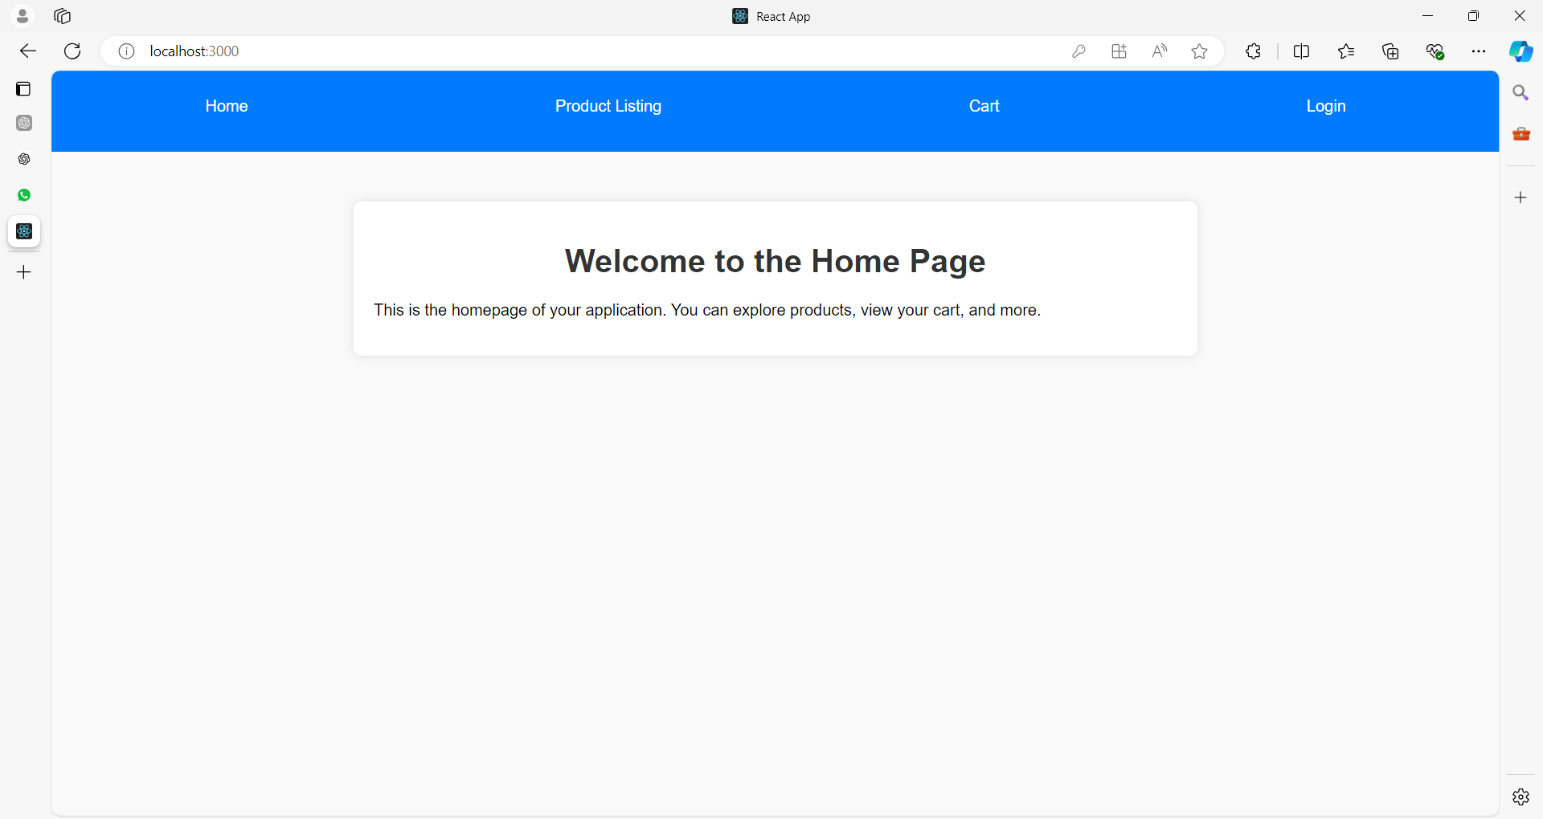

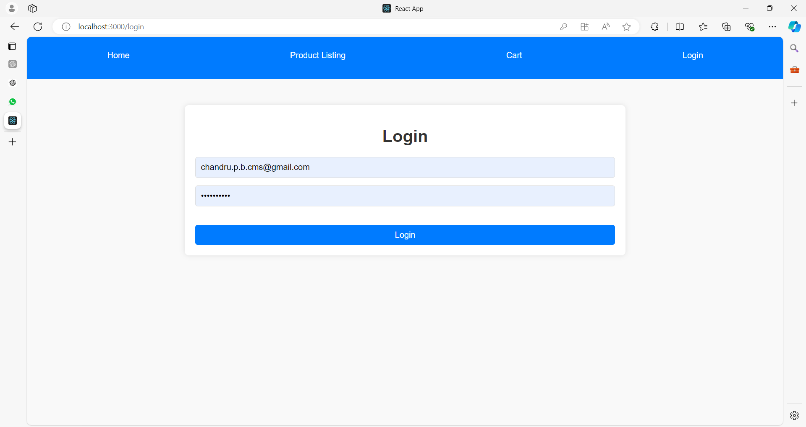

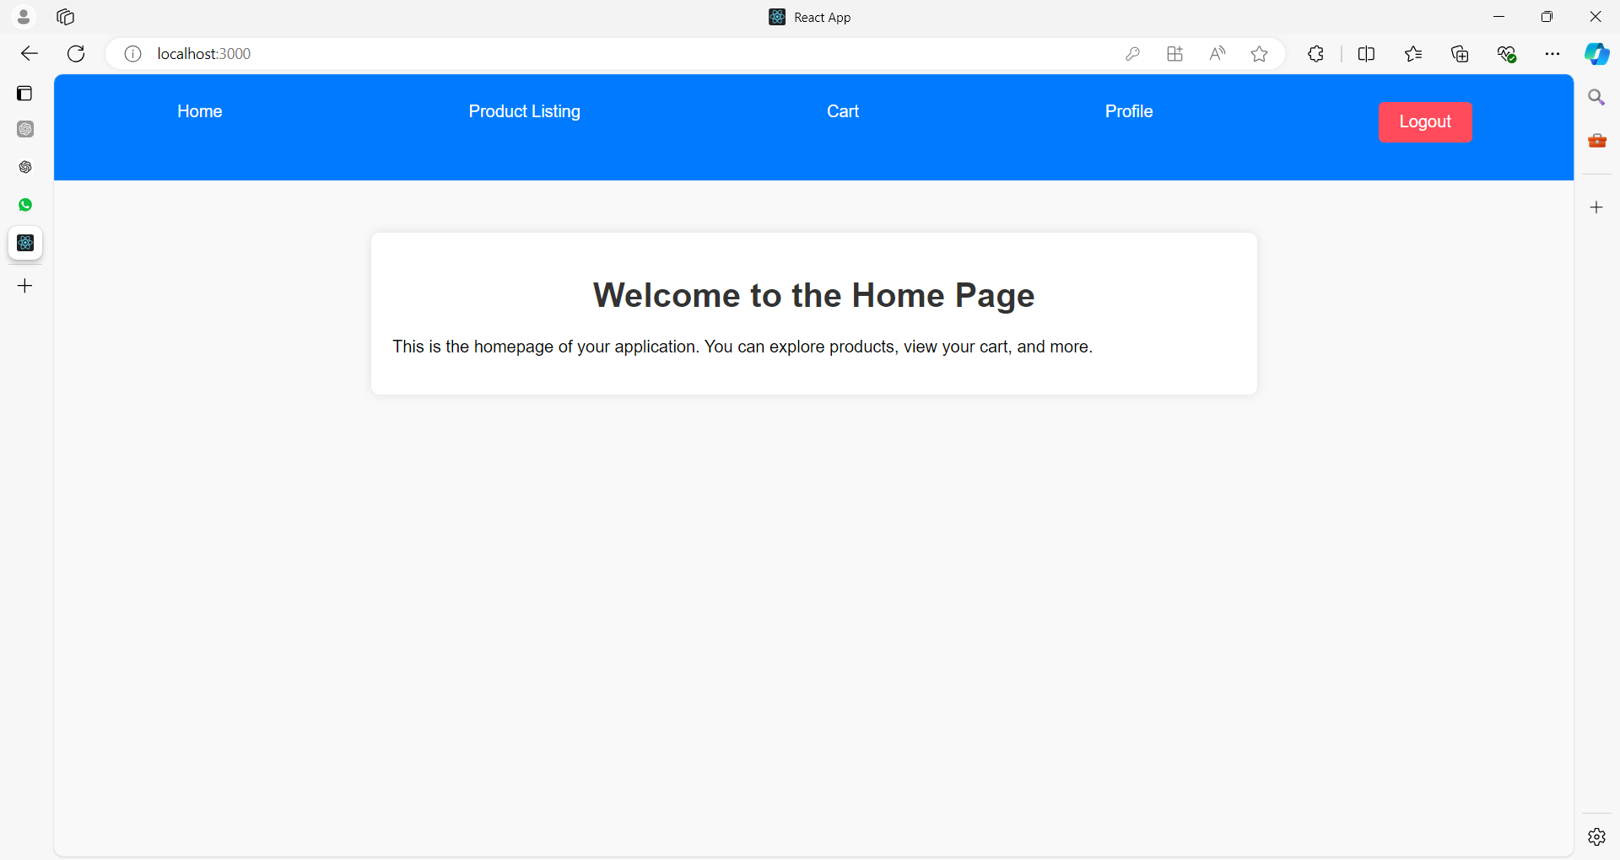

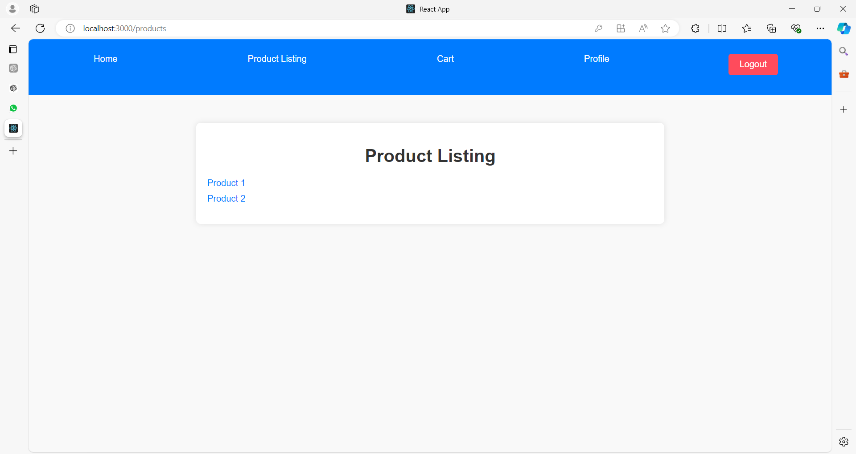

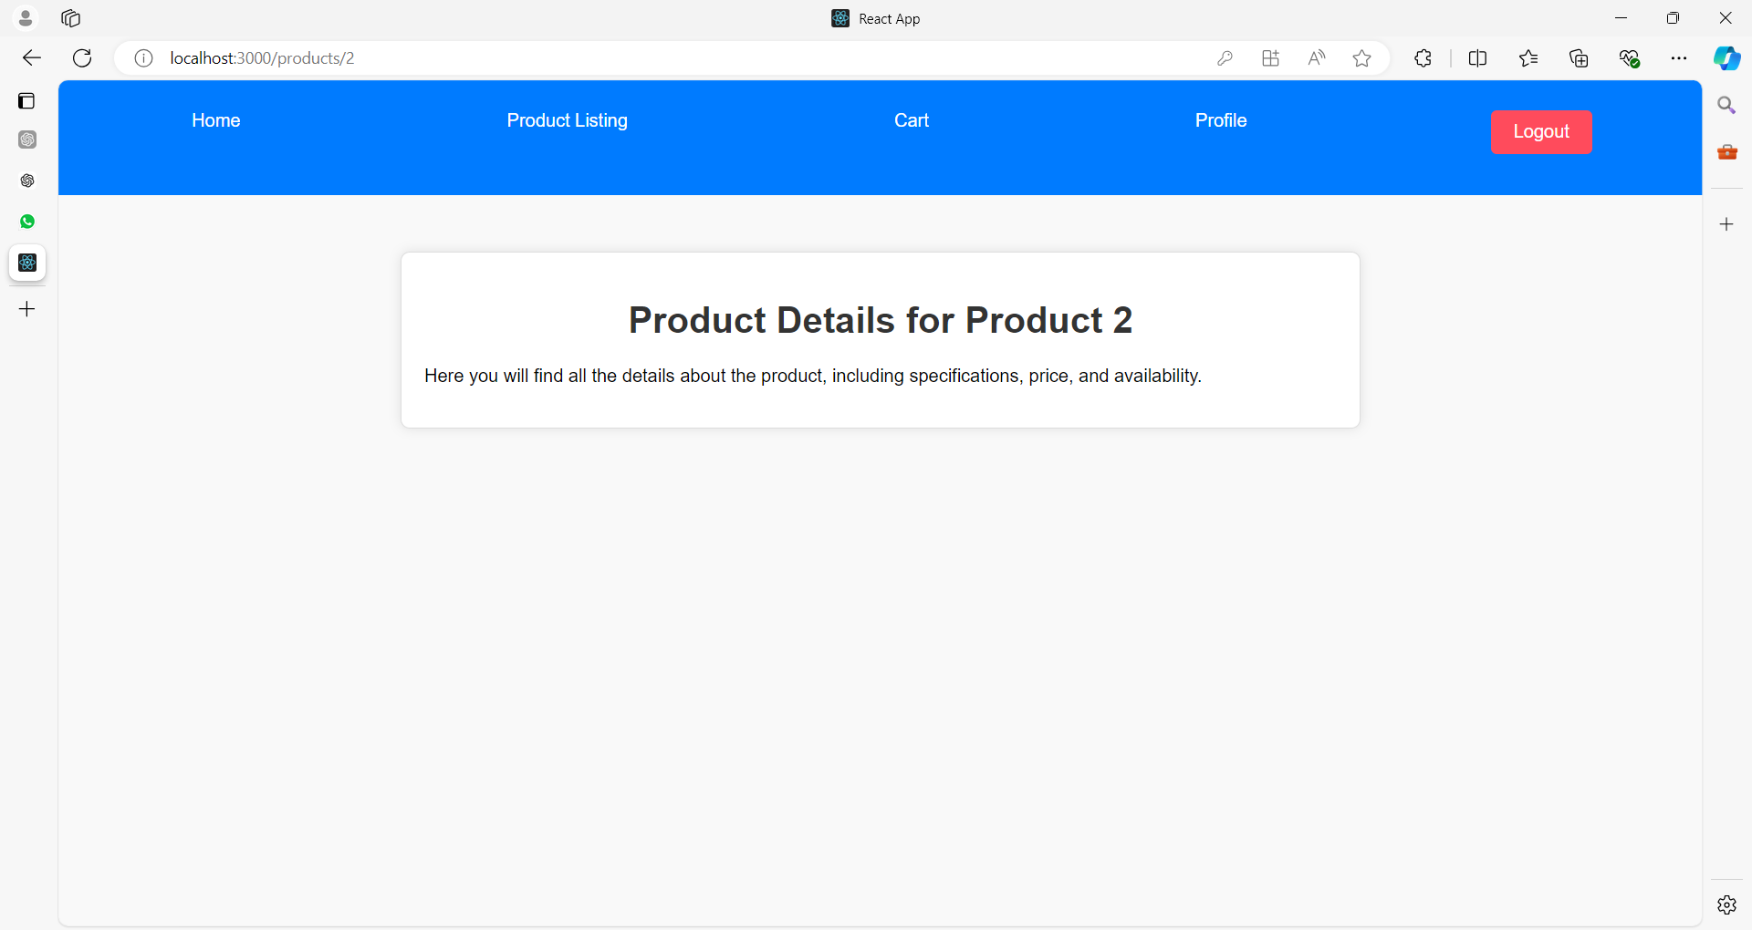

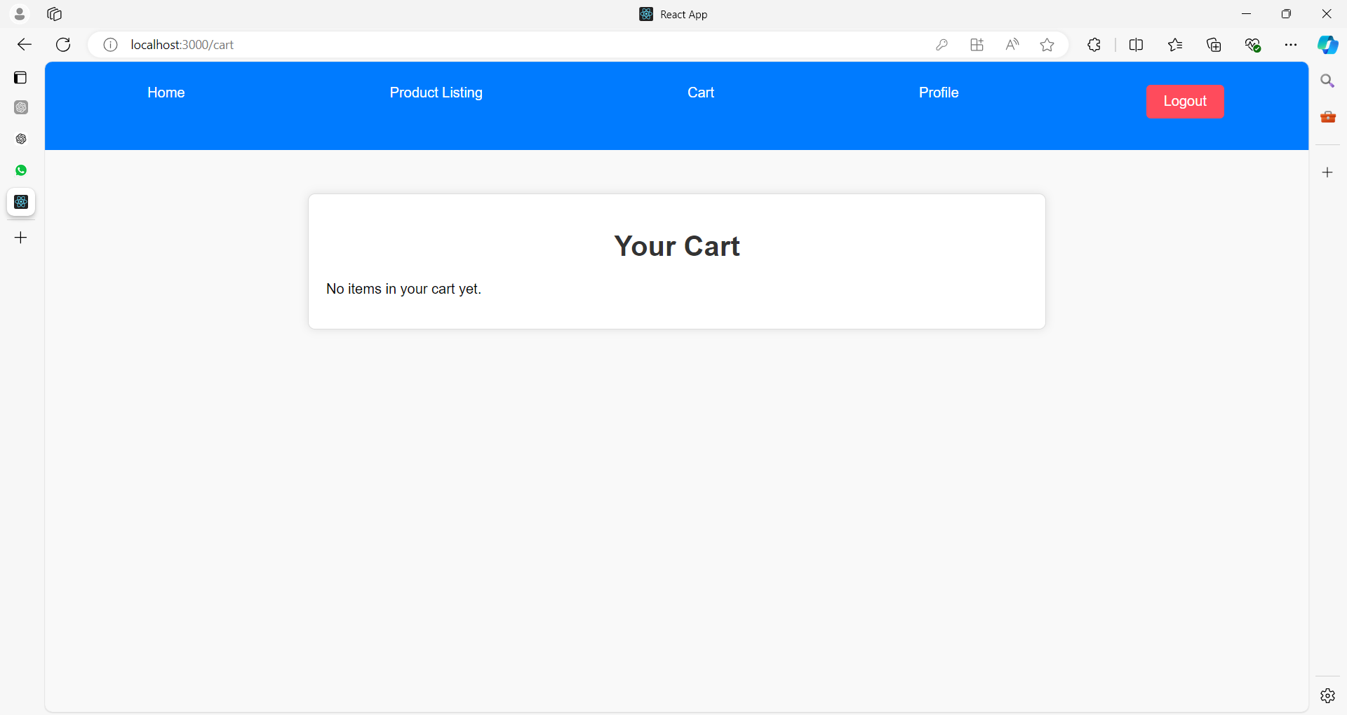

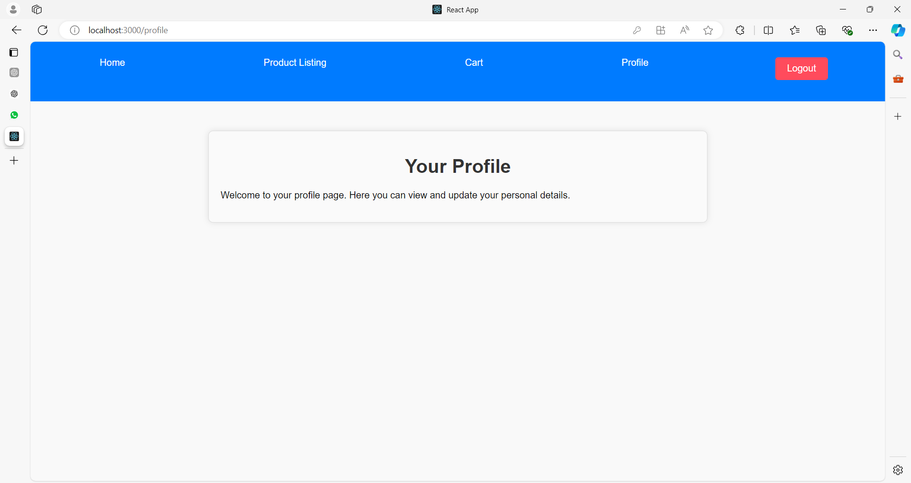

**After clicking on Logout button**



**Project Structure**

Here's a high-level overview of the project structure:

**ecommerce-app/**

**│**

**├── public/**

**│ └── users.json**

**│**

**├── src/**

**│ ├── components/**

**│ │ ├── Home.js**

**│ │ ├── ProductListing.js**

**│ │ ├── ProductDetails.js**

**│ │ ├── Cart.js**

**│ │ ├── Profile.js**

**│ │ ├── Login.js**

**│ │ ├── Logout.js**

**│ │**

**│ ├── css/**

**│ │ ├── Home.css**

**│ │ ├── ProductListing.css**

**│ │ ├── ProductDetails.css**

**│ │ ├── Cart.css**

**│ │ ├── Profile.css**

**│ │ ├── Login.css**

**│ │ └── Logout.css**

**│ │**

**│ ├── context/**

**│ │ └── SessionContext.js**

**│ │**

**│ ├── App.js**

**│ ├── index.js**

**│ └── routes/**

**│ └── PrivateRoute.js**

**│**

**└── package.json**

**Step 1: Set Up the JSON Data**

First, create a **users.json** file in the public/ directory to simulate a database.

// public/users.json

[

{

"id": 1,

"username": "john_doe",

"password": "password123",

"email": "john@example.com",

"cart": []

},

{

"id": 2,

"username": "jane_doe",

"password": "password456",

"email": "jane@example.com",

"cart": []

},

{

"id": 3,

"username": "rohit_sharma",

"password": "rohit789",

"email": "rohit@india.com",

"cart": []

},

{

"id": 4,

"username": "anita_mishra",

"password": "anita321",

"email": "anita@india.com",

"cart": []

},

{

"id": 5,

"username": "emma_james",

"password": "emma456",

"email": "emma@example.com",

"cart": []

},

{

"id": 6,

"username": "liam_smith",

"password": "liam789",

"email": "liam@example.com",

"cart": []

},

{

"id": 7,

"username": "raj_kumar",

"password": "raj1234",

"email": "raj@india.com",

"cart": []

},

{

"id": 8,

"username": "neha_patel",

"password": "neha567",

"email": "neha@india.com",

"cart": []

},

{

"id": 9,

"username": "oliver_brown",

"password": "oliver890",

"email": "oliver@example.com",

"cart": []

},

{

"id": 10,

"username": "sophia_johnson",

"password": "sophia234",

"email": "sophia@example.com",

"cart": []

},

{

"id": 11,

"username": "arjun_singh",

"password": "arjun345",

"email": "arjun@india.com",

"cart": []

},

{

"id": 12,

"username": "priya_sharma",

"password": "priya678",

"email": "priya@india.com",

"cart": []

},

{

"id": 13,

"username": "michael_clark",

"password": "michael901",

"email": "michael@example.com",

"cart": []

},

{

"id": 14,

"username": "ella_davis",

"password": "ella345",

"email": "ella@example.com",

"cart": []

},

{

"id": 15,

"username": "nina_verma",

"password": "nina5678",

"email": "nina@india.com",

"cart": []

},

{

"id": 16,

"username": "ajay_mehta",

"password": "ajay1234",

"email": "ajay@india.com",

"cart": []

},

{

"id": 17,

"username": "madison_lee",

"password": "madison678",

"email": "madison@example.com",

"cart": []

},

{

"id": 18,

"username": "jason_wilson",

"password": "jason7890",

"email": "jason@example.com",

"cart": []

},

{

"id": 19,

"username": "sonia_gupta",

"password": "sonia2345",

"email": "sonia@india.com",

"cart": []

},

{

"id": 20,

"username": "vivek_jain",

"password": "vivek6789",

"email": "vivek@india.com",

"cart": []

}

]

**Step 2: Create the Session Context**

Below is a simplified React application that demonstrates session management.

This example includes basic components for Home, Product Listing, Product Details, Cart, Profile, Login, and Logout functionalities.

The app uses **React Context** to manage user sessions.

**1. src/context/SessionContext.js**

This file provides session context for the entire application.

import React, { createContext, useState, useContext }

from 'react';

// Create a Context for session management

const SessionContext = createContext();

// Create a provider component

export const SessionProvider = ({ children }) => {

  const [session, setSession] = useState(null);

  const login = (user) => {

    setSession(user);

  };

  const logout = () => {

    setSession(null);

  };

  return (

    <SessionContext.Provider value={{ session, login, logout }}>

      {children}

    </SessionContext.Provider>

  );

};

// Custom hook to use session context

export const useSession = () => {

  return useContext(SessionContext);

};

**2. src/routes/PrivateRoute.js**

A route component that only allows access if the user is authenticated.

import React from 'react';

import { Navigate } from 'react-router-dom';

import { useSession } from '../context/SessionContext';

const PrivateRoute = ({ element }) => {

  const { session } = useSession();

  return session ? element : <Navigate to="/login" />;

};

export default PrivateRoute;

**3. src/App.js**

The main app component which includes routing and header.

import React from 'react';

import { BrowserRouter as Router, Routes, Route, Link } from 'react-router-dom';

import { SessionProvider, useSession } from './context/SessionContext';

import Home from './components/Home';

import ProductListing from './components/ProductListing';

import ProductDetails from './components/ProductDetails';

import Cart from './components/Cart';

import Profile from './components/Profile';

import Login from './components/Login';

import Logout from './components/Logout';

import PrivateRoute from './routes/PrivateRoute';

const Header = () => {

  const { session, logout } = useSession();

  return (

    <header>

      <nav>

        <ul>

          <li><Link to="/">Home</Link></li>

          <li><Link to="/products">Product Listing</Link></li>

          <li><Link to="/cart">Cart</Link></li>

{session ? (

            <>

              <li><Link to="/profile">Profile</Link></li>

              <li><button onClick={logout}>Logout</button></li>

            </>

          ) : (

            <li><Link to="/login">Login</Link></li>

          )}

        </ul>

      </nav>

    </header>

  );

};

function App() {

  return (

    <SessionProvider>

      <Router>

        <Header />

        <Routes>

          <Route path="/" element={<Home />} />

          <Route path="/products" element={<ProductListing />} />

          <Route path="/products/:id" element={<ProductDetails />} />

          <Route path="/cart" element={<PrivateRoute element={<Cart />} />} />

          <Route path="/profile" element={<PrivateRoute element={<Profile />} />} />

          <Route path="/login" element={<Login />} />

          <Route path="/logout" element={<Logout />} />

        </Routes>

      </Router>

    </SessionProvider>

  );

}

export default App;

**4. Component Files**

Here’s a brief outline of each component:

**src/components/Home.js**

import React from 'react';

import '../App.css'; // Import the CSS file

const Home = () => {

  return (

    <div className="container">

      <h1 className="text-center">Welcome to the Home Page</h1>

      <p className="mt-20">

        This is the homepage of your application. You can explore products, view your cart, and more.

      </p>

    </div>

  );

};

export default Home;

**src/components/ProductListing.js**

import React from 'react';

import { Link } from 'react-router-dom';

import '../App.css'; // Import the CSS file

const ProductListing = () => {

  return (

    <div className="container">

      <h1 className="text-center">Product Listing</h1>

      <ul className="mt-20">

        {/* Sample product links */}

        <li><Link to="/products/1">Product 1</Link></li>

        <li><Link to="/products/2">Product 2</Link></li>

      </ul>

    </div>

  );

};

export default ProductListing;

**src/components/ProductDetails.js**

import React from 'react';

import { useParams } from 'react-router-dom';

import '../App.css'; // Import the CSS file

const ProductDetails = () => {

  const { id } = useParams();

  return (

    <div className="container product-details">

      <h1 className="text-center">Product Details for Product {id}</h1>

      <p className="mt-20">

        Here you will find all the details about the product, including specifications, price, and availability.

      </p>

      {/* Additional product details would be dynamically displayed here */}

    </div>

  );

};

export default ProductDetails;

**src/components/Cart.js**

import React from 'react';

import '../App.css'; // Ensure you import the CSS file

const Cart = () => {

  return (

    <div className="container cart-section">

      <h1 className="text-center">Your Cart</h1>

      <p className="mt-20">No items in your cart yet.</p>

      {/* Cart items would be dynamically displayed here */}

    </div>

  );

};

export default Cart;

**src/components/Profile.js**

import React from 'react';

import '../App.css'; // Import the CSS file

const Profile = () => {

  return (

    <div className="container profile-section">

      <h1 className="text-center">Your Profile</h1>

      <p className="mt-20">

        Welcome to your profile page. Here you can view and update your personal details.

      </p>

      {/* Profile information would be dynamically displayed here */}

    </div>

  );

};

export default Profile;

**src/components/Login.js**

import React, { useState } from 'react';

import { useNavigate } from 'react-router-dom';

import { useSession } from '../context/SessionContext';

import '../App.css'; // Import the CSS file

const Login = () => {

  const [username, setUsername] = useState('');

  const [password, setPassword] = useState('');

  const { login } = useSession();

  const navigate = useNavigate();

  const handleLogin = () => {

    // Perform authentication (mocked here)

    login({ username });

    navigate('/');

  };

  return (

    <div className="container">

      <h1 className="text-center">Login</h1>

      <form>

        <input

          type="text"

          placeholder="Username"

          value={username}

          onChange={(e) => setUsername(e.target.value)}

        />

        <input

          type="password"

          placeholder="Password"

          value={password}

          onChange={(e) => setPassword(e.target.value)}

        />

        <button type="button" onClick={handleLogin} className="mt-20">Login</button>

      </form>

    </div>

  );

};

export default Login;

**src/components/Logout.js**

import React, { useEffect } from 'react';

import { useNavigate } from 'react-router-dom';

import { useSession } from '../context/SessionContext';

import '../App.css'; // Import the CSS file

const Logout = () => {

  const { logout } = useSession();

  const navigate = useNavigate();

  useEffect(() => {

    logout();

    navigate('/');

  }, [logout, navigate]);

  return (

    <div className="container text-center">

      <h1>Logging out...</h1>

    </div>

  );

};

export default Logout;

**Explanation of the Components and Routing**

* **Home Component:** Displays a welcome message.
* **ProductListing Component:** Lists all products with links to product details.
* **ProductDetails Component:** Shows details of a single product.
* **Cart Component:** A placeholder for the cart functionality (could be expanded later).
* **Profile Component:** Shows user information if logged in.
* **Login Component:** Allows users to log in by matching credentials from users.json.
* **Logout Component:** Logs out the user and redirects them to the home page.
* **PrivateRoute Component:** A route wrapper that ensures users are authenticated before accessing certain routes.

**Step 6: Run Your Application**

Make sure all dependencies are installed and start your development server:

npm install

npm start

Visit http://localhost:3000 in your browser to interact with the application. You can navigate between different pages, log in, and see how session management works.

**Summary**

In this application:

* **Session Management:** Handled by React Context API and local storage to maintain user login state across page reloads.
* **Routing:** Uses React Router for navigation between different pages.
* **JSON Data:** Simulates user data storage and retrieval.

This example provides a solid foundation for an eCommerce application with basic session management. You can further expand this by adding functionalities such as:

* **Cart Management:** Allow users to add products to their cart and view cart details.
* **Product Management:** Fetch product data from an API or a more complex JSON file.
* **User Registration:** Add functionality for new users to register.
* **Order Management:** Allow users to place and view orders.

**Example 03**

Same example with cookies

To integrate cookies for session management in the eCommerce React application, we'll use cookies to store session data (such as authentication tokens). Here’s how you can modify the example to use cookies instead of local storage.

**Step 1: Install Cookie Handling Library**

First, you need a library to handle cookies. js-cookie is a popular choice.

npm install js-cookie

**Step 2: Update the Session Context**

Modify SessionContext.js to use cookies for storing session data.

// src/context/SessionContext.js

import React, { createContext, useState, useEffect, useContext } from 'react';

import Cookies from 'js-cookie';

const SessionContext = createContext();

export const SessionProvider = ({ children }) => {

const [session, setSession] = useState(null);

useEffect(() => {

const storedSession = Cookies.get('session');

if (storedSession) {

setSession(JSON.parse(storedSession));

}

}, []);

useEffect(() => {

if (session) {

Cookies.set('session', JSON.stringify(session), { expires: 1 }); // Cookie expires in 1 day

} else {

Cookies.remove('session');

}

}, [session]);

const login = (user) => setSession(user);

const logout = () => setSession(null);

return (

<SessionContext.Provider value={{ session, login, logout }}>

{children}

</SessionContext.Provider>

);

};

export const useSession = () => useContext(SessionContext);

**Step 3: Update the Login Component**

Make sure the Login component uses the updated session management logic.

// src/components/Login.js

import React, { useState } from 'react';

import { useHistory } from 'react-router-dom';

import { useSession } from '../context/SessionContext';

const Login = () => {

const [username, setUsername] = useState('');

const [password, setPassword] = useState('');

const { login } = useSession();

const history = useHistory();

const handleLogin = async (e) => {

e.preventDefault();

// Fetch users from the JSON file

const response = await fetch('/users.json');

const users = await response.json();

const user = users.find(

(u) => u.username === username && u.password === password

);

if (user) {

login(user);

history.push('/profile');

} else {

alert('Invalid username or password');

}

};

return (

<div>

<h2>Login</h2>

<form onSubmit={handleLogin}>

<input

type="text"

placeholder="Username"

value={username}

onChange={(e) => setUsername(e.target.value)}

/>

<input

type="password"

placeholder="Password"

value={password}

onChange={(e) => setPassword(e.target.value)}

/>

<button type="submit">Login</button>

</form>

</div>

);

};

export default Login;

**Step 4: Update the Logout Component**

Ensure the Logout component clears the session cookie when logging out.

// src/components/Logout.js

import React, { useEffect } from 'react';

import { useSession } from '../context/SessionContext';

import { useHistory } from 'react-router-dom';

const Logout = () => {

const { logout } = useSession();

const history = useHistory();

useEffect(() => {

logout();

history.push('/');

}, [logout, history]);

return <div>You have been logged out.</div>;

};

export default Logout;

**Step 5: Update Routing and Other Components**

The rest of the application remains unchanged. Ensure that your App.js and other components use the updated SessionContext for session management.

Here’s a summary of what you need to check:

* **Home Component:** Remains unchanged.
* **ProductListing Component:** Remains unchanged.
* **ProductDetails Component:** Remains unchanged.
* **Cart Component:** Remains unchanged.
* **Profile Component:** Remains unchanged.
* **Login Component:** Updated to handle cookies.
* **Logout Component:** Updated to handle cookies.

**Step 6: Test the Application**

Make sure all dependencies are installed and start your development server:

npm install

npm start

Visit http://localhost:3000 in your browser. You should be able to log in, log out, and see how session management works with cookies.

**Summary**

In this updated example, we've replaced local storage with cookies for session management:

* **Cookies:** Used for storing session data (authentication tokens) with expiration settings.
* **Session Context:** Updated to use js-cookie for setting and removing cookies.
* **Login/Logout:** Adjusted to handle cookies properly.

This approach helps manage sessions more securely and is suitable for many applications that require persistent sessions across page reloads.

**Example 04**

Same example with redux

Let's refactor the eCommerce application to use Redux for state management instead of the Context API. Redux will handle the session management, product listings, and cart state. Here's how you can structure and implement the application with Redux:

**Project Structure**

The project structure will be similar to the previous setup, with added Redux-specific files:

ecommerce-app/

│

├── public/

│ └── users.json

│

├── src/

│ ├── components/

│ │ ├── Home.js

│ │ ├── ProductListing.js

│ │ ├── ProductDetails.js

│ │ ├── Cart.js

│ │ ├── Profile.js

│ │ ├── Login.js

│ │ └── Logout.js

│ │

│ ├── redux/

│ │ ├── actions/

│ │ │ ├── sessionActions.js

│ │ │ └── cartActions.js

│ │ ├── reducers/

│ │ │ ├── sessionReducer.js

│ │ │ ├── cartReducer.js

│ │ │ └── rootReducer.js

│ │ └── store.js

│ │

│ ├── App.js

│ ├── index.js

│ └── routes/

│ └── PrivateRoute.js

└── package.json

**Step 1: Install Redux and React-Redux**

First, install Redux and React-Redux.

npm install redux react-redux

**Step 2: Set Up Redux**

Create the Redux store, actions, and reducers.

**Store Configuration**

Create store.js to configure the Redux store.

// src/redux/store.js

import { createStore, combineReducers } from 'redux';

import sessionReducer from './reducers/sessionReducer';

import cartReducer from './reducers/cartReducer';

const rootReducer = combineReducers({

session: sessionReducer,

cart: cartReducer,

});

const store = createStore(rootReducer);

export default store;

**Session Actions**

Define actions for managing the session.

// src/redux/actions/sessionActions.js

export const LOGIN = 'LOGIN';

export const LOGOUT = 'LOGOUT';

export const login = (user) => ({

type: LOGIN,

payload: user,

});

export const logout = () => ({

type: LOGOUT,

});

**Cart Actions**

Define actions for managing the cart (for simplicity, we'll add products to the cart).

// src/redux/actions/cartActions.js

export const ADD_TO_CART = 'ADD_TO_CART';

export const REMOVE_FROM_CART = 'REMOVE_FROM_CART';

export const addToCart = (product) => ({

type: ADD_TO_CART,

payload: product,

});

export const removeFromCart = (productId) => ({

type: REMOVE_FROM_CART,

payload: productId,

});

**Session**

**Session Reducer**

Create a reducer to handle session-related actions.

// src/redux/reducers/sessionReducer.js

import { LOGIN, LOGOUT } from '../actions/sessionActions';

const initialState = {

user: null,

};

const sessionReducer = (state = initialState, action) => {

switch (action.type) {

case LOGIN:

return {

...state,

user: action.payload,

};

case LOGOUT:

return {

...state,

user: null,

};

default:

return state;

}

};

export default sessionReducer;

**Cart Reducer**

Create a reducer to handle cart-related actions.

// src/redux/reducers/cartReducer.js

import { ADD_TO_CART, REMOVE_FROM_CART } from '../actions/cartActions';

const initialState = {

items: [],

};

const cartReducer = (state = initialState, action) => {

switch (action.type) {

case ADD_TO_CART:

return {

...state,

items: [...state.items, action.payload],

};

case REMOVE_FROM_CART:

return {

...state,

items: state.items.filter(item => item.id !== action.payload),

};

default:

return state;

}

};

export default cartReducer;

**Root Reducer**

Combine reducers if you have multiple reducers.

// src/redux/reducers/rootReducer.js

import { combineReducers } from 'redux';

import sessionReducer from './sessionReducer';

import cartReducer from './cartReducer';

const rootReducer = combineReducers({

session: sessionReducer,

cart: cartReducer,

});

export default rootReducer;

**Step 3: Update index.js to Provide the Store**

Wrap the application with the Redux Provider.

// src/index.js

import React from 'react';

import ReactDOM from 'react-dom';

import { Provider } from 'react-redux';

import store from './redux/store';

import App from './App';

ReactDOM.render(

<Provider store={store}>

<App />

</Provider>,

document.getElementById('root')

);

**Step 4: Update Components to Use Redux**

**Login Component**

Update the Login component to dispatch login actions.

// src/components/Login.js

import React, { useState } from 'react';

import { useDispatch } from 'react-redux';

import { useHistory } from 'react-router-dom';

import { login } from '../redux/actions/sessionActions';

const Login = () => {

const [username, setUsername] = useState('');

const [password, setPassword] = useState('');

const dispatch = useDispatch();

const history = useHistory();

const handleLogin = async (e) => {

e.preventDefault();

// Fetch users from the JSON file

const response = await fetch('/users.json');

const users = await response.json();

const user = users.find(

(u) => u.username === username && u.password === password

);

if (user) {

dispatch(login(user));

history.push('/profile');

} else {

alert('Invalid username or password');

}

};

return (

<div>

<h2>Login</h2>

<form onSubmit={handleLogin}>

<input

type="text"

placeholder="Username"

value={username}

onChange={(e) => setUsername(e.target.value)}

/>

<input

type="password"

placeholder="Password"

value={password}

onChange={(e) => setPassword(e.target.value)}

/>

<button type="submit">Login</button>

</form>

</div>

);

};

export default Login;

**Logout Component**

Update the Logout component to dispatch logout actions.

// src/components/Logout.js

import React, { useEffect } from 'react';

import { useDispatch } from 'react-redux';

import { useHistory } from 'react-router-dom';

import { logout } from '../redux/actions/sessionActions';

const Logout = () => {

const dispatch = useDispatch();

const history = useHistory();

useEffect(() => {

dispatch(logout());

history.push('/');

}, [dispatch, history]);

return <div>You have been logged out.</div>;

};

export default Logout;

**Profile Component**

Update the Profile component to use Redux state.

// src/components/Profile.js

import React from 'react';

import { useSelector } from 'react-redux';

const Profile = () => {

const user = useSelector((state) => state.session.user);

if (!user) {

return <div>Please log in to view your profile.</div>;

}

return (

<div>

<h2>Profile</h2>

<p>Username: {user.username}</p>

<p>Email: {user.email}</p>

</div>

);

};

export default Profile;

**Cart Component**

Update the Cart component to use Redux state.

// src/components/Cart.js

import React from 'react';

import { useSelector, useDispatch } from 'react-redux';

import { removeFromCart } from '../redux/actions/cartActions';

const Cart = () => {

const cartItems = useSelector((state) => state.cart.items);

const dispatch = useDispatch();

const handleRemove = (id) => {

dispatch(removeFromCart(id));

};

return (

<div>

<h2>Your Cart</h2>

{cartItems.length === 0 ? (

<p>Your cart is currently empty.</p>

) : (

<ul>

{cartItems.map((item) => (

<li key={item.id}>

{item.name} - ${item.price}

<button onClick={() => handleRemove(item.id)}>Remove</button>

</li>

))}

</ul>

)}

</div>

);

};

export default Cart;

**ProductListing Component**

Update the ProductListing component to include add-to-cart functionality.

// src/components/ProductListing.js

import React from 'react';

import { Link } from 'react-router-dom';

import { useDispatch } from 'react-redux';

import { addToCart } from '../redux/actions/cartActions';

const products = [

{ id: 1, name: 'Product 1', price: 50 },

{ id: 2, name: 'Product 2', price: 100 },

{ id: 3, name: 'Product 3', price: 150 },

];

const ProductListing = () => {

const dispatch = useDispatch();

const handleAddToCart = (product) => {

dispatch(addToCart(product));

};

return (

<div>

<h2>Products</h2>

<ul>

{products.map((product) => (

<li key={product.id}>

<Link to={`/product/${product.id}`}>

{product.name} - ${product.price}

</Link>

<button onClick={() => handleAddToCart(product)}>Add to Cart</button>

</li>

))}

</ul>

</div>

);

};

export default ProductListing;

**ProductDetails Component**

Update the ProductDetails component to use Redux state for cart management.

// src/components/ProductDetails.js

import React from 'react';

import { useParams } from 'react-router-dom';

import { useDispatch } from 'react-redux';

import { addToCart } from '../redux/actions/cartActions';

const products = [

{ id: 1, name: 'Product 1', price: 50 },

{ id: 2, name: 'Product 2', price: 100 },

{ id: 3, name: 'Product 3', price: 150 },

];

const ProductDetails = () => {

const { id } = useParams();

const product = products.find((p) => p.id === parseInt(id));

const dispatch = useDispatch();

const handleAddToCart = () => {

dispatch(addToCart(product));

};

return (

<div>

<h2>{product.name}</h2>

<p>Price: ${product.price}</p>

<button onClick={handleAddToCart}>Add to Cart</button>

</div>

);

};

export default ProductDetails;

**Step 5: Update Routing**

Make sure your App.js includes the updated routes.

// src/App.js

import React from 'react';

import { BrowserRouter as Router, Route, Switch } from 'react-router-dom';

import Home from './components/Home';

import ProductListing from './components/ProductListing';

import ProductDetails from './components/ProductDetails';

import Cart from './components/Cart';

import Profile from './components/Profile';

import Login from './components/Login';

import Logout from './components/Logout';

import PrivateRoute from './routes/PrivateRoute';

function App() {

return (

<Router>

<Switch>

<Route path="/" exact component={Home} />

<Route path="/products" exact component={ProductListing} />

<Route path="/product/:id" component={ProductDetails} />

<Route path="/cart" component={Cart} />

<Route path="/login" component={Login} />

<Route path="/logout" component={Logout} />

<PrivateRoute path="/profile" component={Profile} />

</Switch>

</Router>

);

}

export default App;

**Summary**

In this Redux-based example:

* **Redux Store:** Manages state for sessions and the cart.
* **Reducers:** Handle session and cart actions.
* **Actions:** Define login, logout, add-to-cart, and remove-from-cart actions.
* **Components:** Use useDispatch and useSelector to interact with Redux state.

You can expand this basic structure to include more features like product management, user registration, and order management.

**How to create a service in python that can be used in react**

To create a service in Python that can be used in a React application, you'll typically follow these steps:

**1. Create a Python Backend Service**

You can use a web framework like Flask or FastAPI to build a RESTful API that serves as the backend service.

**Example using Flask:**

1. **Install Flask**:

pip install Flask

1. **Create a Flask Application**:

# app.py

from flask import Flask, jsonify, request

app = Flask(__name__)

# Sample data

products = [

{"id": 1, "name": "Product 1", "price": 100},

{"id": 2, "name": "Product 2", "price": 150},

]

@app.route('/products', methods=['GET'])

def get_products():

return jsonify(products)

@app.route('/products', methods=['POST'])

def add_product():

new_product = request.json

new_product['id'] = len(products) + 1

products.append(new_product)

return jsonify(new_product), 201

if __name__ == '__main__':

app.run(debug=True)

1. **Run the Flask Application**:

python app.py

The service will run at http://localhost:5000.

**2. Connect React to the Python Backend**

In your React application, you can use fetch or a library like axios to interact with the Flask API.

**Example using fetch in React:**

1. **Install React and create a project** (if not already done):

npx create-react-app my-app

cd my-app

1. **Create a component to fetch data from the API**:

// src/Products.js

import React, { useEffect, useState } from 'react';

function Products() {

const [products, setProducts] = useState([]);

useEffect(() => {

fetch('http://localhost:5000/products')

.then(response => response.json())

.then(data => setProducts(data));

}, []);

return (

<div>

<h1>Products</h1>

<ul>

{products.map(product => (

<li key={product.id}>{product.name}: ${product.price}</li>

))}

</ul>

</div>

);

}

export default Products;

1. **Add the component to your App**:

// src/App.js

import React from 'react';

import Products from './Products';

function App() {

return (

<div className="App">

<Products />

</div>

);

}

export default App;

1. **Run the React Application**:

npm start

Your React app will now display the products fetched from the Flask API.

**3. Handling CORS**

If you encounter Cross-Origin Resource Sharing (CORS) issues, you may need to install and configure the flask-cors library in your Flask application.

pip install flask-cors

from flask_cors import CORS

app = Flask(__name__)

CORS(app)

**Summary**

* **Backend (Python/Flask):** Create a RESTful API to handle data and business logic.
* **Frontend (React):** Use fetch or axios to consume the API, displaying and interacting with the data in the UI.
* **CORS Handling:** Ensure CORS is correctly configured to allow your React app to communicate with the Flask backend.

**Example 01**

Create a service using flask in python for products and orders using mysql. Also write react components to use the services you have created in python.

**Part 1: Create a Flask Service with MySQL**

**1. Setup MySQL Database**

Create a MySQL database and tables for products and orders.

CREATE DATABASE shopdb;

USE shopdb;

CREATE TABLE products (

id INT AUTO_INCREMENT PRIMARY KEY,

name VARCHAR(255) NOT NULL,

price DECIMAL(10, 2) NOT NULL,

stock INT NOT NULL

);

CREATE TABLE orders (

id INT AUTO_INCREMENT PRIMARY KEY,

product_id INT,

quantity INT NOT NULL,

order_date TIMESTAMP DEFAULT CURRENT_TIMESTAMP,

FOREIGN KEY (product_id) REFERENCES products(id)

);

**2. Install Required Python Packages**

Install Flask and MySQL connector.

pip install Flask flask-mysql-connector

**3. Create Flask Application**

from flask import Flask, jsonify, request

from flask_mysql_connector import MySQL

app = Flask(__name__)

app.config['MYSQL_USER'] = 'yourusername'

app.config['MYSQL_PASSWORD'] = 'yourpassword'

app.config['MYSQL_DATABASE'] = 'shopdb'

app.config['MYSQL_HOST'] = 'localhost'

mysql = MySQL(app)

# Products routes

@app.route('/products', methods=['GET'])

def get_products():

cursor = mysql.connection.cursor(dictionary=True)

cursor.execute("SELECT * FROM products")

products = cursor.fetchall()

cursor.close()

return jsonify(products)

@app.route('/products', methods=['POST'])

def add_product():

data = request.json

cursor = mysql.connection.cursor()

cursor.execute("INSERT INTO products (name, price, stock) VALUES (%s, %s, %s)",

(data['name'], data['price'], data['stock']))

mysql.connection.commit()

cursor.close()

return jsonify({"message": "Product added successfully"}), 201

# Orders routes

@app.route('/orders', methods=['GET'])

def get_orders():

cursor = mysql.connection.cursor(dictionary=True)

cursor.execute("SELECT * FROM orders")

orders = cursor.fetchall()

cursor.close()

return jsonify(orders)

@app.route('/orders', methods=['POST'])

def add_order():

data = request.json

cursor = mysql.connection.cursor()

cursor.execute("INSERT INTO orders (product_id, quantity) VALUES (%s, %s)",

(data['product_id'], data['quantity']))

mysql.connection.commit()

cursor.close()

return jsonify({"message": "Order placed successfully"}), 201

if __name__ == '__main__':

app.run(debug=True)

* **MySQL Configuration**: Replace yourusername and yourpassword with your MySQL credentials.
* **Endpoints**:
  + GET /products: Fetch all products.
  + POST /products: Add a new product.
  + GET /orders: Fetch all orders.
  + POST /orders: Place a new order.

**Part 2: React Components to Use Flask Services**

**1. Create React Project (if not already done)**

npx create-react-app my-app

cd my-app

**2. Install Axios**

npm install axios@latest

**3. Create Products Component**

// src/Products.js

import React, { useEffect, useState } from 'react';

import axios from 'axios';

function Products() {

const [products, setProducts] = useState([]);

const [newProduct, setNewProduct] = useState({ name: '', price: '', stock: '' });

useEffect(() => {

axios.get('http://localhost:5000/products')

.then(response => setProducts(response.data))

.catch(error => console.error('There was an error fetching the products!', error));

}, []);

const addProduct = () => {

axios.post('http://localhost:5000/products', newProduct)

.then(response => {

setProducts([...products, newProduct]);

setNewProduct({ name: '', price: '', stock: '' });

})

.catch(error => console.error('There was an error adding the product!', error));

};

return (

<div>

<h1>Products</h1>

<ul>

{products.map(product => (

<li key={product.id}>{product.name} - ${product.price} (Stock: {product.stock})</li>

))}

</ul>

<div>

<h2>Add New Product</h2>

<input type="text" placeholder="Name" value={newProduct.name} onChange={(e) => setNewProduct({ ...newProduct, name: e.target.value })} />

<input type="number" placeholder="Price" value={newProduct.price} onChange={(e) => setNewProduct({ ...newProduct, price: e.target.value })} />

<input type="number" placeholder="Stock" value={newProduct.stock} onChange={(e) => setNewProduct({ ...newProduct, stock: e.target.value })} />

<button onClick={addProduct}>Add Product</button>

</div>

</div>

);

}

export default Products;

**4. Create Orders Component**

// src/Orders.js

import React, { useEffect, useState } from 'react';

import axios from 'axios';

function Orders() {

const [orders, setOrders] = useState([]);

const [newOrder, setNewOrder] = useState({ product_id: '', quantity: '' });

useEffect(() => {

axios.get('http://localhost:5000/orders')

.then(response => setOrders(response.data))

.catch(error => console.error('There was an error fetching the orders!', error));

}, []);

const addOrder = () => {

axios.post('http://localhost:5000/orders', newOrder)

.then(response => {

setOrders([...orders, newOrder]);

setNewOrder({ product_id: '', quantity: '' });

})

.catch(error => console.error('There was an error placing the order!', error));

};

return (

<div>

<h1>Orders</h1>

<ul>

{orders.map(order => (

<li key={order.id}>Order ID: {order.id}, Product ID: {order.product_id}, Quantity: {order.quantity}</li>

))}

</ul>

<div>

<h2>Place New Order</h2>

<input type="number" placeholder="Product ID" value={newOrder.product_id} onChange={(e) => setNewOrder({ ...newOrder, product_id: e.target.value })} />

<input type="number" placeholder="Quantity" value={newOrder.quantity} onChange={(e) => setNewOrder({ ...newOrder, quantity: e.target.value })} />

<button onClick={addOrder}>Place Order</button>

</div>

</div>

);

}

export default Orders;

**5. Update App.js to Use Components**

// src/App.js

import React from 'react';

import Products from './Products';

import Orders from './Orders';

function App() {

return (

<div className="App">

<Products />

<Orders />

</div>

);

}

export default App;

**6. Run the React Application**

npm start

**Summary**

* **Flask Service**: Created endpoints for products and orders, connected to MySQL.
* **React Components**: Created components to fetch and display products and orders, and to add new products and place new orders.

**Example 02**

Here's another example that extends the previous setup to include full CRUD (Create, Read, Update, Delete) operations for products using Flask as the backend service and React as the frontend.

**Part 1: Extend Flask Service with CRUD Operations**

We'll extend the Flask service to include GET, POST, PUT, and DELETE endpoints.

**1. Update Flask Application (app.py)**

from flask import Flask, jsonify, request

from flask_mysql_connector import MySQL

app = Flask(__name__)

app.config['MYSQL_USER'] = 'yourusername'

app.config['MYSQL_PASSWORD'] = 'yourpassword'

app.config['MYSQL_DATABASE'] = 'shopdb'

app.config['MYSQL_HOST'] = 'localhost'

mysql = MySQL(app)

# CRUD operations for Products

# Read all products

@app.route('/products', methods=['GET'])

def get_products():

cursor = mysql.connection.cursor(dictionary=True)

cursor.execute("SELECT * FROM products")

products = cursor.fetchall()

cursor.close()

return jsonify(products)

# Read single product by ID

@app.route('/products/<int:id>', methods=['GET'])

def get_product(id):

cursor = mysql.connection.cursor(dictionary=True)

cursor.execute("SELECT * FROM products WHERE id = %s", (id,))

product = cursor.fetchone()

cursor.close()

if product:

return jsonify(product)

else:

return jsonify({"message": "Product not found"}), 404

# Create a new product

@app.route('/products', methods=['POST'])

def add_product():

data = request.json

cursor = mysql.connection.cursor()

cursor.execute("INSERT INTO products (name, price, stock) VALUES (%s, %s, %s)",

(data['name'], data['price'], data['stock']))

mysql.connection.commit()

cursor.close()

return jsonify({"message": "Product added successfully"}), 201

# Update an existing product

@app.route('/products/<int:id>', methods=['PUT'])

def update_product(id):

data = request.json

cursor = mysql.connection.cursor()

cursor.execute("UPDATE products SET name=%s, price=%s, stock=%s WHERE id=%s",

(data['name'], data['price'], data['stock'], id))

mysql.connection.commit()

cursor.close()

return jsonify({"message": "Product updated successfully"})

# Delete a product

@app.route('/products/<int:id>', methods=['DELETE'])

def delete_product(id):

cursor = mysql.connection.cursor()

cursor.execute("DELETE FROM products WHERE id=%s", (id,))

mysql.connection.commit()

cursor.close()

return jsonify({"message": "Product deleted successfully"})

if __name__ == '__main__':

app.run(debug=True)

* **Endpoints**:
  + GET /products: Fetch all products.
  + GET /products/<id>: Fetch a single product by its ID.
  + POST /products: Add a new product.
  + PUT /products/<id>: Update an existing product.
  + DELETE /products/<id>: Delete a product.

**Part 2: React Components for CRUD Operations**

Now, let's create React components to interact with these endpoints.

**1. Install Axios**

npm install axios

**2. Update Products Component**

This component will now handle Create, Read, Update, and Delete operations.

// src/Products.js

import React, { useEffect, useState } from 'react';

import axios from 'axios';

function Products() {

const [products, setProducts] = useState([]);

const [newProduct, setNewProduct] = useState({ name: '', price: '', stock: '' });

const [editingProduct, setEditingProduct] = useState(null);

useEffect(() => {

fetchProducts();

}, []);

const fetchProducts = () => {

axios.get('http://localhost:5000/products')

.then(response => setProducts(response.data))

.catch(error => console.error('There was an error fetching the products!', error));

};

const addProduct = () => {

axios.post('http://localhost:5000/products', newProduct)

.then(() => {

fetchProducts();

setNewProduct({ name: '', price: '', stock: '' });

})

.catch(error => console.error('There was an error adding the product!', error));

};

const updateProduct = (id) => {

axios.put(`http://localhost:5000/products/${id}`, editingProduct)

.then(() => {

fetchProducts();

setEditingProduct(null);

})

.catch(error => console.error('There was an error updating the product!', error));

};

const deleteProduct = (id) => {

axios.delete(`http://localhost:5000/products/${id}`)

.then(() => fetchProducts())

.catch(error => console.error('There was an error deleting the product!', error));

};

return (

<div>

<h1>Products</h1>

<ul>

{products.map(product => (

<li key={product.id}>

{product.name} - ${product.price} (Stock: {product.stock})

<button onClick={() => setEditingProduct(product)}>Edit</button>

<button onClick={() => deleteProduct(product.id)}>Delete</button>

</li>

))}

</ul>

<div>

<h2>{editingProduct ? 'Edit Product' : 'Add New Product'}</h2>

<input

type="text"

placeholder="Name"

value={editingProduct ? editingProduct.name : newProduct.name}

onChange={(e) => editingProduct

? setEditingProduct({ ...editingProduct, name: e.target.value })

: setNewProduct({ ...newProduct, name: e.target.value })}

/>

<input

type="number"

placeholder="Price"

value={editingProduct ? editingProduct.price : newProduct.price}

onChange={(e) => editingProduct

? setEditingProduct({ ...editingProduct, price: e.target.value })

: setNewProduct({ ...newProduct, price: e.target.value })}

/>

<input

type="number"

placeholder="Stock"

value={editingProduct ? editingProduct.stock : newProduct.stock}

onChange={(e) => editingProduct

? setEditingProduct({ ...editingProduct, stock: e.target.value })

: setNewProduct({ ...newProduct, stock: e.target.value })}

/>

<button onClick={editingProduct ? () => updateProduct(editingProduct.id) : addProduct}>

{editingProduct ? 'Update Product' : 'Add Product'}

</button>

{editingProduct && <button onClick={() => setEditingProduct(null)}>Cancel</button>}

</div>

</div>

);

}

export default Products;

* **Create**: Add a new product using the POST /products endpoint.
* **Read**: Fetch all products using the GET /products endpoint.
* **Update**: Update an existing product using the PUT /products/<id> endpoint.
* **Delete**: Delete a product using the DELETE /products/<id> endpoint.

**3. Update App.js**

Make sure your App.js is set up to render the Products component.

// src/App.js

import React from 'react';

import Products from './Products';

function App() {

return (

<div className="App">

<Products />

</div>

);

}

export default App;

**4. Run the React Application**

npm start

**Summary**

* **Flask Service**: Added full CRUD operations for products, connected to MySQL.
* **React Component**: Created a Products component that handles Create, Read, Update, and Delete operations with a user-friendly interface.

**Example 03:**

Let's create a full CRUD application for managing posts using SQL, Python (Flask), and React, including CSS for styling.

**Part 1: MySQL Setup**

**1. Create the Database and posts Table**

CREATE DATABASE blogdb;

USE blogdb;

CREATE TABLE posts (

id INT AUTO_INCREMENT PRIMARY KEY,

title VARCHAR(255) NOT NULL,

content TEXT NOT NULL,

created_at TIMESTAMP DEFAULT CURRENT_TIMESTAMP

);

**Part 2: Flask Backend**

**1. Install Required Python Packages**

pip install Flask flask-mysql-connector

**2. Create Flask Application (app.py)**

from flask import Flask, jsonify, request

from flask_mysql_connector import MySQL

app = Flask(__name__)

app.config['MYSQL_USER'] = 'yourusername'

app.config['MYSQL_PASSWORD'] = 'yourpassword'

app.config['MYSQL_DATABASE'] = 'blogdb'

app.config['MYSQL_HOST'] = 'localhost'

mysql = MySQL(app)

# CRUD operations for Posts

# Read all posts

@app.route('/posts', methods=['GET'])

def get_posts():

cursor = mysql.connection.cursor(dictionary=True)

cursor.execute("SELECT * FROM posts ORDER BY created_at DESC")

posts = cursor.fetchall()

cursor.close()

return jsonify(posts)

# Read single post by ID

@app.route('/posts/<int:id>', methods=['GET'])

def get_post(id):

cursor = mysql.connection.cursor(dictionary=True)

cursor.execute("SELECT * FROM posts WHERE id = %s", (id,))

post = cursor.fetchone()

cursor.close()

if post:

return jsonify(post)

else:

return jsonify({"message": "Post not found"}), 404

# Create a new post

@app.route('/posts', methods=['POST'])

def add_post():

data = request.json

cursor = mysql.connection.cursor()

cursor.execute("INSERT INTO posts (title, content) VALUES (%s, %s)",

(data['title'], data['content']))

mysql.connection.commit()

cursor.close()

return jsonify({"message": "Post created successfully"}), 201

# Update an existing post

@app.route('/posts/<int:id>', methods=['PUT'])

def update_post(id):

data = request.json

cursor = mysql.connection.cursor()

cursor.execute("UPDATE posts SET title=%s, content=%s WHERE id=%s",

(data['title'], data['content'], id))

mysql.connection.commit()

cursor.close()

return jsonify({"message": "Post updated successfully"})

# Delete a post

@app.route('/posts/<int:id>', methods=['DELETE'])

def delete_post(id):

cursor = mysql.connection.cursor()

cursor.execute("DELETE FROM posts WHERE id=%s", (id,))

mysql.connection.commit()

cursor.close()

return jsonify({"message": "Post deleted successfully"})

if __name__ == '__main__':

app.run(debug=True)

**Part 3: React Frontend with CSS**

**1. Create React Project**

npx create-react-app blog-app

cd blog-app

**2. Install Axios**

npm install axios

**3. Create CSS for Styling**

Create a CSS file named App.css for basic styling.

/* src/App.css */

body {

font-family: Arial, sans-serif;

background-color: #f9f9f9;

margin: 0;

padding: 0;

}

.container {

max-width: 800px;

margin: 50px auto;

background-color: #fff;

padding: 20px;

box-shadow: 0 0 10px rgba(0, 0, 0, 0.1);

}

h1 {

text-align: center;

color: #333;

}

ul {

list-style: none;

padding: 0;

}

li {

margin: 10px 0;

padding: 10px;

background-color: #f1f1f1;

border: 1px solid #ddd;

}

button {

margin-right: 10px;

padding: 5px 10px;

background-color: #007bff;

color: white;

border: none;

cursor: pointer;

border-radius: 4px;

}

button:hover {

background-color: #0056b3;

}

input[type="text"],

textarea {

width: 100%;

padding: 10px;

margin: 10px 0;

border: 1px solid #ddd;

border-radius: 4px;

}

textarea {

resize: vertical;

}

button.add-btn {

background-color: #28a745;

}

button.add-btn:hover {

background-color: #218838;

}

**4. Create Posts Component**

This component will handle Create, Read, Update, and Delete operations.

// src/Posts.js

import React, { useEffect, useState } from 'react';

import axios from 'axios';

import './App.css';

function Posts() {

const [posts, setPosts] = useState([]);

const [newPost, setNewPost] = useState({ title: '', content: '' });

const [editingPost, setEditingPost] = useState(null);

useEffect(() => {

fetchPosts();

}, []);

const fetchPosts = () => {

axios.get('http://localhost:5000/posts')

.then(response => setPosts(response.data))

.catch(error => console.error('There was an error fetching the posts!', error));

};

const addPost = () => {

axios.post('http://localhost:5000/posts', newPost)

.then(() => {

fetchPosts();

setNewPost({ title: '', content: '' });

})

.catch(error => console.error('There was an error creating the post!', error));

};

const updatePost = (id) => {

axios.put(`http://localhost:5000/posts/${id}`, editingPost)

.then(() => {

fetchPosts();

setEditingPost(null);

})

.catch(error => console.error('There was an error updating the post!', error));

};

const deletePost = (id) => {

axios.delete(`http://localhost:5000/posts/${id}`)

.then(() => fetchPosts())

.catch(error => console.error('There was an error deleting the post!', error));

};

return (

<div className="container">

<h1>Blog Posts</h1>

<ul>

{posts.map(post => (

<li key={post.id}>

<h2>{post.title}</h2>

<p>{post.content}</p>

<button onClick={() => setEditingPost(post)}>Edit</button>

<button onClick={() => deletePost(post.id)}>Delete</button>

</li>

))}

</ul>

<div>

<h2>{editingPost ? 'Edit Post' : 'Add New Post'}</h2>

<input

type="text"

placeholder="Title"

value={editingPost ? editingPost.title : newPost.title}

onChange={(e) => editingPost

? setEditingPost({ ...editingPost, title: e.target.value })

: setNewPost({ ...newPost, title: e.target.value })}

/>

<textarea

placeholder="Content"

value={editingPost ? editingPost.content : newPost.content}

onChange={(e) => editingPost

? setEditingPost({ ...editingPost, content: e.target.value })

: setNewPost({ ...newPost, content: e.target.value })}

/>

<button className="add-btn" onClick={editingPost ? () => updatePost(editingPost.id) : addPost}>

{editingPost ? 'Update Post' : 'Add Post'}

</button>

{editingPost && <button onClick={() => setEditingPost(null)}>Cancel</button>}

</div>

</div>

);

}

export default Posts;

**5. Update App.js**

Make sure your App.js is set up to render the Posts component.

// src/App.js

import React from 'react';

import Posts from './Posts';

function App() {

return (

<div className="App">

<Posts />

</div>

);

}

export default App;

**6. Run the React Application**

npm start

**Summary**

* **MySQL**: Set up a posts table for storing blog posts.
* **Flask**: Created a backend service with full CRUD operations for managing posts.
* **React**: Built a Posts component that handles Create, Read, Update, and Delete operations, with a basic CSS file for styling.

**How to create a service in java (Spring Boot) that can be used in react**

To create a service in Java that can be used in a React application, you typically create a RESTful API using a framework like Spring Boot in Java. The React app can then interact with this service by making HTTP requests (GET, POST, PUT, DELETE, etc.).

Here's a step-by-step guide:

**1. Set Up the Java Service with Spring Boot**

**a. Create a Spring Boot Project**

* Use Spring Initializr (<https://start.spring.io/>) to generate a new Spring Boot project.
* Include dependencies like Spring Web, Spring Data JPA (if you need a database), and H2 or MySQL (depending on your database).

**b. Put prerequisites into the project**

**b. Create a Model Class**

This is a simple Java class representing an entity.

**package** com.spring.boot.demo.model;

**import** jakarta.persistence.Column;

**import** jakarta.persistence.Entity;

**import** jakarta.persistence.GeneratedValue;

**import** jakarta.persistence.GenerationType;

**import** jakarta.persistence.Id;

@Entity

**public** **class** Product {

@Id

@GeneratedValue(strategy = GenerationType.***IDENTITY***)

@Column(name="product_id")

**private** Long id;

@Column(name="product_name")

**private** String name;

@Column(name="price")

**private** Double price;

// Constructors and Getters and Setters

**public** Product() {

**super**();

// **TODO** Auto-generated constructor stub

}

**public** Product(Long id, String name, Double price) {

**super**();

**this**.id = id;

**this**.name = name;

**this**.price = price;

}

**public** Product(String name, Double price) {

**super**();

**this**.name = name;

**this**.price = price;

}

**public** Long getId() {

**return** id;

}

**public** **void** setId(Long id) {

**this**.id = id;

}

**public** String getName() {

**return** name;

}

**public** **void** setName(String name) {

**this**.name = name;

}

**public** Double getPrice() {

**return** price;

}

**public** **void** setPrice(Double price) {

**this**.price = price;

}

}

**c. Create a Repository Interface**

This interface will handle the CRUD operations.

package com.example.demo.repository;

import com.example.demo.model.Product;

import org.springframework.data.jpa.repository.JpaRepository;

public interface ProductRepository extends JpaRepository<Product, Long> {

}

**d. Create a Service Class**

The service class will contain the business logic.

package com.example.demo.service;

import com.example.demo.model.Product;

import com.example.demo.repository.ProductRepository;

import org.springframework.beans.factory.annotation.Autowired;

import org.springframework.stereotype.Service;

import java.util.List;

@Service

public class ProductService {

@Autowired

private ProductRepository productRepository;

public List<Product> getAllProducts() {

return productRepository.findAll();

}

public Product getProductById(Long id) {

return productRepository.findById(id).orElse(null);

}

public Product saveProduct(Product product) {

return productRepository.save(product);

}

public void deleteProduct(Long id) {

productRepository.deleteById(id);

}

}

**e. Create a Controller Class**

This class will handle incoming HTTP requests.

package com.example.demo.controller;

import com.example.demo.model.Product;

import com.example.demo.service.ProductService;

import org.springframework.beans.factory.annotation.Autowired;

import org.springframework.web.bind.annotation.*;

import java.util.List;

@RestController

@RequestMapping("/api/products")

public class ProductController {

@Autowired

private ProductService productService;

@GetMapping

public List<Product> getAllProducts() {

return productService.getAllProducts();

}

@GetMapping("/{id}")

public Product getProductById(@PathVariable Long id) {

return productService.getProductById(id);

}

@PostMapping

public Product createProduct(@RequestBody Product product) {

return productService.saveProduct(product);

}

@PutMapping("/{id}")

public Product updateProduct(@PathVariable Long id, @RequestBody Product product) {

product.setId(id);

return productService.saveProduct(product);

}

@DeleteMapping("/{id}")

public void deleteProduct(@PathVariable Long id) {

productService.deleteProduct(id);

}

}

**2. Run the Spring Boot Application**

* Run the Spring Boot application. By default, it will run on http://localhost:8080.

**3. Connect React with the Java Service**

**a. Make HTTP Requests in React**

You can use fetch or axios to interact with the Java service.

Here’s an example using axios:

import axios from 'axios';

import React, { useEffect, useState } from 'react';

function App() {

const [products, setProducts] = useState([]);

useEffect(() => {

axios.get('http://localhost:8080/api/products')

.then(response => setProducts(response.data))

.catch(error => console.error('Error fetching products:', error));

}, []);

return (

<div>

<h1>Products</h1>

<ul>

{products.map(product => (

<li key={product.id}>

{product.name} - ${product.price}

</li>

))}

</ul>

</div>

);

}

export default App;

**4. Deploy and Test**

* Test your React application by running npm start and ensuring it can communicate with the Java service.
* Deploy the Java service and React application to a production environment (like Heroku, AWS, etc.).

**Summary**

You’ve set up a Spring Boot service in Java that provides a RESTful API, and you’ve connected a React frontend to this service by making HTTP requests. This architecture allows the React application to interact with the backend service to perform CRUD operations.

**Complete React CRUD application** that connects to your **Spring Boot REST API**

(http://localhost:8080/api/products) and uses:

* **React Router DOM** for navigation.
* **Axios** for HTTP requests.
* **CSS** for styling.
* All CRUD operations: Create, Read, Update, Delete.

**React Project Structure**

react-product-crud/

├── public/

├── src/

│ ├── components/

│ │ ├── ProductList.js

│ │ ├── ProductForm.js

│ │ └── ProductDetail.js

│ ├── css/

│ │ ├── App.css

│ │ └── Product.css

│ ├── services/

│ │ └── ProductService.js

│ ├── App.js

│ └── index.js

├── package.json

**1. Install Project & Dependencies**

npx create-react-app react-product-crud

cd react-product-crud

npm install axios react-router-dom@6

**src/services/ProductService.js**

import axios from 'axios';

const BASE_URL = 'http://localhost:8080/api/products';

class ProductService {

getAll() {

return axios.get(BASE_URL);

}

getById(id) {

return axios.get(`${BASE_URL}/${id}`);

}

create(product) {

return axios.post(BASE_URL, product);

}

update(id, product) {

return axios.put(`${BASE_URL}/${id}`, product);

}

delete(id) {

return axios.delete(`${BASE_URL}/${id}`);

}

}

export default new ProductService();

**src/components/ProductList.js**

import React, { useEffect, useState } from 'react';

import ProductService from '../services/ProductService';

import { Link } from 'react-router-dom';

import '../css/Product.css';

function ProductList() {

const [products, setProducts] = useState([]);

const fetchProducts = () => {

ProductService.getAll().then(res => setProducts(res.data));

};

const deleteProduct = (id) => {

ProductService.delete(id).then(fetchProducts);

};

useEffect(() => {

fetchProducts();

}, []);

return (

<div className="product-list">

<h2>Product List</h2>

<Link className="btn" to="/add">Add Product</Link>

<ul>

{products.map(p => (

<li key={p.id}>

<strong>{p.name}</strong> - ${p.price}

<div>

<Link to={`/view/${p.id}`}>View</Link>

<Link to={`/edit/${p.id}`}>Edit</Link>

<button onClick={() => deleteProduct(p.id)}>Delete</button>

</div>

</li>

))}

</ul>

</div>

);

}

export default ProductList;

**src/components/ProductForm.js**

import React, { useEffect, useState } from 'react';

import { useNavigate, useParams } from 'react-router-dom';

import ProductService from '../services/ProductService';

import '../css/Product.css';

function ProductForm() {

const [product, setProduct] = useState({ name: '', price: '' });

const { id } = useParams();

const navigate = useNavigate();

const handleChange = (e) => {

setProduct({ ...product, [e.target.name]: e.target.value });

};

const handleSubmit = (e) => {

e.preventDefault();

if (id) {

ProductService.update(id, product).then(() => navigate('/'));

} else {

ProductService.create(product).then(() => navigate('/'));

}

};

useEffect(() => {

if (id) {

ProductService.getById(id).then(res => setProduct(res.data));

}

}, [id]);

return (

<div className="product-form">

<h2>{id ? 'Edit' : 'Add'} Product</h2>

<form onSubmit={handleSubmit}>

<label>Name:</label>

<input name="name" value={product.name} onChange={handleChange} required />

<label>Price:</label>

<input name="price" value={product.price} onChange={handleChange} type="number" required />

<button type="submit">{id ? 'Update' : 'Create'}</button>

</form>

</div>

);

}

export default ProductForm;

**src/components/ProductDetail.js**

import React, { useEffect, useState } from 'react';

import { useParams, Link } from 'react-router-dom';

import ProductService from '../services/ProductService';

import '../css/Product.css';

function ProductDetail() {

const { id } = useParams();

const [product, setProduct] = useState(null);

useEffect(() => {

ProductService.getById(id).then(res => setProduct(res.data));

}, [id]);

return (

<div className="product-detail">

{product ? (

<>

<h2>Product Detail</h2>

<p><strong>Name:</strong> {product.name}</p>

<p><strong>Price:</strong> ${product.price}</p>

<Link to="/">Back to List</Link>

</>

) : (

<p>Loading...</p>

)}

</div>

);

}

export default ProductDetail;

**src/App.js**

import React from 'react';

import { BrowserRouter as Router, Routes, Route } from 'react-router-dom';

import ProductList from './components/ProductList';

import ProductForm from './components/ProductForm';

import ProductDetail from './components/ProductDetail';

import './css/App.css';

function App() {

return (

<Router>

<div className="app-container">

<h1>React + Spring Boot Product App</h1>

<Routes>

<Route path="/" element={<ProductList />} />

<Route path="/add" element={<ProductForm />} />

<Route path="/edit/:id" element={<ProductForm />} />

<Route path="/view/:id" element={<ProductDetail />} />

</Routes>

</div>

</Router>

);

}

export default App;

**src/css/App.css**

.app-container {

padding: 30px;

font-family: Arial, sans-serif;

max-width: 800px;

margin: auto;

background: #f4f4f4;

border-radius: 8px;

}

**src/css/Product.css**

.product-list ul {

list-style: none;

padding: 0;

}

.product-list li {

background: #fff;

margin: 10px 0;

padding: 15px;

border-radius: 6px;

display: flex;

justify-content: space-between;

align-items: center;

}

.product-list li div a,

.product-list li div button {

margin-left: 10px;

text-decoration: none;

background: #007bff;

color: white;

border: none;

padding: 5px 8px;

border-radius: 4px;

cursor: pointer;

}

.product-list li div button:hover {

background: #dc3545;

}

.btn {

display: inline-block;

margin-bottom: 10px;

padding: 8px 14px;

background: green;

color: white;

border-radius: 5px;

text-decoration: none;

}

.product-form input {

width: 100%;

padding: 8px;

margin: 8px 0 16px;

}

.product-form button {

padding: 8px 14px;

background: #28a745;

color: white;

border: none;

border-radius: 5px;

}

**Final Step**

Run the React app:

npm start

Ensure Spring Boot backend is running at http://localhost:8080.

**Enhance the React CRUD app** to use the **Context API** to manage global state for products. This will help centralize data access and reduce prop drilling.

**What We'll Do:**

* Create a ProductContext to manage product state.
* Use a ProductProvider to wrap the app.
* Fetch and update data globally.
* Components (like list, form, detail) will use useContext instead of useState.

**Step-by-Step Conversion to Context API**

**src/context/ProductContext.js**

import React, { createContext, useState, useEffect } from 'react';

import ProductService from '../services/ProductService';

export const ProductContext = createContext();

export const ProductProvider = ({ children }) => {

const [products, setProducts] = useState([]);

const loadProducts = () => {

ProductService.getAll().then(res => setProducts(res.data));

};

const addProduct = (product) => {

return ProductService.create(product).then(() => loadProducts());

};

const updateProduct = (id, product) => {

return ProductService.update(id, product).then(() => loadProducts());

};

const deleteProduct = (id) => {

return ProductService.delete(id).then(() => loadProducts());

};

const getProductById = (id) => {

return ProductService.getById(id);

};

useEffect(() => {

loadProducts();

}, []);

return (

<ProductContext.Provider value={{

products,

addProduct,

updateProduct,

deleteProduct,

getProductById

}}>

{children}

</ProductContext.Provider>

);

};

**Modify src/components/ProductList.js**

import React, { useContext } from 'react';

import { ProductContext } from '../context/ProductContext';

import { Link } from 'react-router-dom';

import '../css/Product.css';

function ProductList() {

const { products, deleteProduct } = useContext(ProductContext);

return (

<div className="product-list">

<h2>Product List</h2>

<Link className="btn" to="/add">Add Product</Link>

<ul>

{products.map(p => (

<li key={p.id}>

<strong>{p.name}</strong> - ${p.price}

<div>

<Link to={`/view/${p.id}`}>View</Link>

<Link to={`/edit/${p.id}`}>Edit</Link>

<button onClick={() => deleteProduct(p.id)}>Delete</button>

</div>

</li>

))}

</ul>

</div>

);

}

export default ProductList;

**Modify src/components/ProductForm.js**

import React, { useContext, useEffect, useState } from 'react';

import { useNavigate, useParams } from 'react-router-dom';

import { ProductContext } from '../context/ProductContext';

import '../css/Product.css';

function ProductForm() {

const [product, setProduct] = useState({ name: '', price: '' });

const { id } = useParams();

const navigate = useNavigate();

const { addProduct, updateProduct, getProductById } = useContext(ProductContext);

useEffect(() => {

if (id) {

getProductById(id).then(res => setProduct(res.data));

}

}, [id, getProductById]);

const handleChange = (e) => {

setProduct({ ...product, [e.target.name]: e.target.value });

};

const handleSubmit = (e) => {

e.preventDefault();

if (id) {

updateProduct(id, product).then(() => navigate('/'));

} else {

addProduct(product).then(() => navigate('/'));

}

};

return (

<div className="product-form">

<h2>{id ? 'Edit' : 'Add'} Product</h2>

<form onSubmit={handleSubmit}>

<label>Name:</label>

<input name="name" value={product.name} onChange={handleChange} required />

<label>Price:</label>

<input name="price" value={product.price} onChange={handleChange} type="number" required />

<button type="submit">{id ? 'Update' : 'Create'}</button>

</form>

</div>

);

}

export default ProductForm;

**Modify src/components/ProductDetail.js**

import React, { useEffect, useState, useContext } from 'react';

import { useParams, Link } from 'react-router-dom';

import { ProductContext } from '../context/ProductContext';

import '../css/Product.css';

function ProductDetail() {

const { id } = useParams();

const [product, setProduct] = useState(null);

const { getProductById } = useContext(ProductContext);

useEffect(() => {

getProductById(id).then(res => setProduct(res.data));

}, [id, getProductById]);

return (

<div className="product-detail">

{product ? (

<>

<h2>Product Detail</h2>

<p><strong>Name:</strong> {product.name}</p>

<p><strong>Price:</strong> ${product.price}</p>

<Link to="/">Back to List</Link>

</>

) : (

<p>Loading...</p>

)}

</div>

);

}

export default ProductDetail;

**Modify src/App.js**

import React from 'react';

import { BrowserRouter as Router, Routes, Route } from 'react-router-dom';

import ProductList from './components/ProductList';

import ProductForm from './components/ProductForm';

import ProductDetail from './components/ProductDetail';

import { ProductProvider } from './context/ProductContext';

import './css/App.css';

function App() {

return (

<ProductProvider>

<Router>

<div className="app-container">

<h1>React + Spring Boot Product App (with Context)</h1>

<Routes>

<Route path="/" element={<ProductList />} />

<Route path="/add" element={<ProductForm />} />

<Route path="/edit/:id" element={<ProductForm />} />

<Route path="/view/:id" element={<ProductDetail />} />

</Routes>

</div>

</Router>

</ProductProvider>

);

}

export default App;

**Summary**

* ProductContext.js manages state and logic.
* Components are simplified using useContext.
* This approach is scalable and prepares you for larger state management.
* Backend remains the same (Spring Boot API).

**Convert this Context API-based React app into Redux Toolkit** version for global state management. This is ideal for **larger applications** where you want:

* Scalable state management
* DevTools support
* Middleware like logging/thunk
* Advanced structure and separation of concerns

**Step-by-Step: Redux Toolkit Integration for React CRUD App**

**1. Install Redux Toolkit and React-Redux**

npm install @reduxjs/toolkit react-redux

**2. Set Up the Redux Store**

**src/redux/store.js**

import { configureStore } from '@reduxjs/toolkit';

import productReducer from './productSlice';

const store = configureStore({

reducer: {

product: productReducer

}

});

export default store;

**3. Create a Redux Slice**

**src/redux/productSlice.js**

import { createSlice, createAsyncThunk } from '@reduxjs/toolkit';

import ProductService from '../services/ProductService';

export const fetchProducts = createAsyncThunk('product/fetchAll', async () => {

const res = await ProductService.getAll();

return res.data;

});

export const fetchProductById = createAsyncThunk('product/fetchById', async (id) => {

const res = await ProductService.getById(id);

return res.data;

});

export const createProduct = createAsyncThunk('product/create', async (product) => {

await ProductService.create(product);

const res = await ProductService.getAll();

return res.data;

});

export const updateProduct = createAsyncThunk('product/update', async ({ id, product }) => {

await ProductService.update(id, product);

const res = await ProductService.getAll();

return res.data;

});

export const deleteProduct = createAsyncThunk('product/delete', async (id) => {

await ProductService.delete(id);

const res = await ProductService.getAll();

return res.data;

});

const productSlice = createSlice({

name: 'product',

initialState: {

products: [],

selectedProduct: null,

loading: false

},

reducers: {},

extraReducers: builder => {

builder

.addCase(fetchProducts.fulfilled, (state, action) => {

state.products = action.payload;

})

.addCase(fetchProductById.fulfilled, (state, action) => {

state.selectedProduct = action.payload;

})

.addCase(createProduct.fulfilled, (state, action) => {

state.products = action.payload;

})

.addCase(updateProduct.fulfilled, (state, action) => {

state.products = action.payload;

})

.addCase(deleteProduct.fulfilled, (state, action) => {

state.products = action.payload;

});

}

});

export default productSlice.reducer;

**4. Provide the Store**

**src/index.js**

import React from 'react';

import ReactDOM from 'react-dom';

import App from './App';

import { Provider } from 'react-redux';

import store from './redux/store';

ReactDOM.render(

<Provider store={store}>

<App />

</Provider>,

document.getElementById('root')

);

**5. Use Redux in Components**

**Modify ProductList.js**

import React, { useEffect } from 'react';

import { useDispatch, useSelector } from 'react-redux';

import { fetchProducts, deleteProduct } from '../redux/productSlice';

import { Link } from 'react-router-dom';

import '../css/Product.css';

function ProductList() {

const dispatch = useDispatch();

const { products } = useSelector(state => state.product);

useEffect(() => {

dispatch(fetchProducts());

}, [dispatch]);

const handleDelete = (id) => {

dispatch(deleteProduct(id));

};

return (

<div className="product-list">

<h2>Product List</h2>

<Link className="btn" to="/add">Add Product</Link>

<ul>

{products.map(p => (

<li key={p.id}>

<strong>{p.name}</strong> - ${p.price}

<div>

<Link to={`/view/${p.id}`}>View</Link>

<Link to={`/edit/${p.id}`}>Edit</Link>

<button onClick={() => handleDelete(p.id)}>Delete</button>

</div>

</li>

))}

</ul>

</div>

);

}

export default ProductList;

**Modify ProductForm.js**

import React, { useEffect, useState } from 'react';

import { useDispatch, useSelector } from 'react-redux';

import { createProduct, fetchProductById, updateProduct } from '../redux/productSlice';

import { useNavigate, useParams } from 'react-router-dom';

import '../css/Product.css';

function ProductForm() {

const { id } = useParams();

const navigate = useNavigate();

const dispatch = useDispatch();

const { selectedProduct } = useSelector(state => state.product);

const [product, setProduct] = useState({ name: '', price: '' });

useEffect(() => {

if (id) {

dispatch(fetchProductById(id));

}

}, [id, dispatch]);

useEffect(() => {

if (id && selectedProduct) {

setProduct({ name: selectedProduct.name, price: selectedProduct.price });

}

}, [selectedProduct, id]);

const handleChange = e => {

setProduct({ ...product, [e.target.name]: e.target.value });

};

const handleSubmit = e => {

e.preventDefault();

if (id) {

dispatch(updateProduct({ id, product })).then(() => navigate('/'));

} else {

dispatch(createProduct(product)).then(() => navigate('/'));

}

};

return (

<div className="product-form">

<h2>{id ? 'Edit' : 'Add'} Product</h2>

<form onSubmit={handleSubmit}>

<label>Name:</label>

<input name="name" value={product.name} onChange={handleChange} required />

<label>Price:</label>

<input name="price" value={product.price} onChange={handleChange} type="number" required />

<button type="submit">{id ? 'Update' : 'Create'}</button>

</form>

</div>

);

}

export default ProductForm;

**Modify ProductDetail.js**

import React, { useEffect } from 'react';

import { useDispatch, useSelector } from 'react-redux';

import { fetchProductById } from '../redux/productSlice';

import { useParams, Link } from 'react-router-dom';

import '../css/Product.css';

function ProductDetail() {

const { id } = useParams();

const dispatch = useDispatch();

const { selectedProduct } = useSelector(state => state.product);

useEffect(() => {

dispatch(fetchProductById(id));

}, [id, dispatch]);

return (

<div className="product-detail">

{selectedProduct ? (

<>

<h2>Product Detail</h2>

<p><strong>Name:</strong> {selectedProduct.name}</p>

<p><strong>Price:</strong> ${selectedProduct.price}</p>

<Link to="/">Back to List</Link>

</>

) : (

<p>Loading...</p>

)}

</div>

);

}

export default ProductDetail;

**Summary**

| **Feature** | **Context API** | **Redux Toolkit** |
| --- | --- | --- |
| Setup Simplicity | Simple | More boilerplate |
| Debugging Tools | Limited | Excellent DevTools |
| Async Actions | Manual with useEffect | Clean with createAsyncThunk |
| Scalability | Good | Excellent |

Would you like to:

* Add **search**, **pagination**, or **filtering**?
* Convert the backend to support **authentication**?
* Add **toast notifications** (e.g., success/error messages)?

**Enhance your Redux-based React + Spring Boot CRUD application** by adding:

**Search**

**Pagination**

**Filtering**

These are **client-side features**, but I'll also mention how to optimize them for **server-side with Spring Boot** later.

**1. UI Changes — Add Search & Filter Inputs**

**Update ProductList.js**

We’ll add:

* Search bar (searchTerm)
* Filter by price (priceFilter)
* Pagination (prev/next)

import React, { useEffect, useState } from 'react';

import { useDispatch, useSelector } from 'react-redux';

import { fetchProducts, deleteProduct } from '../redux/productSlice';

import { Link } from 'react-router-dom';

import '../css/Product.css';

function ProductList() {

const dispatch = useDispatch();

const { products } = useSelector(state => state.product);

const [searchTerm, setSearchTerm] = useState('');

const [priceFilter, setPriceFilter] = useState('');

const [currentPage, setCurrentPage] = useState(1);

const productsPerPage = 5;

useEffect(() => {

dispatch(fetchProducts());

}, [dispatch]);

const handleDelete = (id) => {

dispatch(deleteProduct(id));

};

// Filtered products based on search + price

const filtered = products.filter(p =>

p.name.toLowerCase().includes(searchTerm.toLowerCase()) &&

(priceFilter === '' || p.price <= parseFloat(priceFilter))

);

// Pagination

const indexOfLast = currentPage * productsPerPage;

const indexOfFirst = indexOfLast - productsPerPage;

const currentProducts = filtered.slice(indexOfFirst, indexOfLast);

const totalPages = Math.ceil(filtered.length / productsPerPage);

return (

<div className="product-list">

<h2>Product List</h2>

<Link className="btn" to="/add">Add Product</Link>

{/*Search & Filter */}

<div className="filter-box">

<input

type="text"

placeholder="Search by name..."

value={searchTerm}

onChange={e => setSearchTerm(e.target.value)}

/>

<input

type="number"

placeholder="Max Price"

value={priceFilter}

onChange={e => setPriceFilter(e.target.value)}

/>

</div>

{/*Product List */}

<ul>

{currentProducts.map(p => (

<li key={p.id}>

<strong>{p.name}</strong> - ${p.price}

<div>

<Link to={`/view/${p.id}`}>View</Link>

<Link to={`/edit/${p.id}`}>Edit</Link>

<button onClick={() => handleDelete(p.id)}>Delete</button>

</div>

</li>

))}

</ul>

{/* Pagination Controls */}

<div className="pagination">

<button disabled={currentPage === 1} onClick={() => setCurrentPage(currentPage - 1)}>

Prev

</button>

<span> Page {currentPage} of {totalPages} </span>

<button disabled={currentPage === totalPages} onClick={() => setCurrentPage(currentPage + 1)}>

Next

</button>

</div>

</div>

);

}

export default ProductList;

**2. CSS Enhancements**

**src/css/Product.css**

Add styles for search/filter & pagination:

.filter-box {

margin: 20px 0;

}

.filter-box input {

margin-right: 10px;

padding: 5px;

font-size: 14px;

}

.pagination {

margin-top: 15px;

text-align: center;

}

.pagination button {

margin: 0 10px;

padding: 6px 12px;

font-size: 14px;

cursor: pointer;

}

**3. (Optional) Server-Side Filtering, Pagination, Search**

Update your **Spring Boot controller** like this:

@GetMapping

public List<Product> getAllProducts(

@RequestParam(required = false) String search,

@RequestParam(required = false) Double maxPrice,

@RequestParam(defaultValue = "0") int page,

@RequestParam(defaultValue = "5") int size) {

Pageable pageable = PageRequest.of(page, size);

if (search != null && maxPrice != null) {

return productRepository.findByNameContainingAndPriceLessThanEqual(search, maxPrice, pageable).getContent();

} else if (search != null) {

return productRepository.findByNameContaining(search, pageable).getContent();

} else if (maxPrice != null) {

return productRepository.findByPriceLessThanEqual(maxPrice, pageable).getContent();

} else {

return productRepository.findAll(pageable).getContent();

}

}

And modify ProductRepository.java:

Page<Product> findByNameContaining(String name, Pageable pageable);

Page<Product> findByPriceLessThanEqual(Double price, Pageable pageable);

Page<Product> findByNameContainingAndPriceLessThanEqual(String name, Double price, Pageable pageable);

Then modify the ProductService.js to send query params for search and pagination.

**Result**

You now have:

Client-side **Search**  
Client-side **Price Filter**  
Client-side **Pagination**  
Easily upgradable to **server-side** using Spring Boot query parameters.

**Let's now enhance your Product List with sorting functionality. Users will be able to sort products by:**

* Name (ascending/descending)
* Price (ascending/descending)

We’ll implement this **entirely client-side**, and I'll also guide you on how to support **server-side sorting** if needed.

**Step-by-Step: Add Sorting to React Redux Product List**

**1. Update State in ProductList.js**

We’ll add:

* sortField: Which field to sort by (name or price)
* sortOrder: Ascending or descending

**src/components/ProductList.js**

import React, { useEffect, useState } from 'react';

import { useDispatch, useSelector } from 'react-redux';

import { fetchProducts, deleteProduct } from '../redux/productSlice';

import { Link } from 'react-router-dom';

import '../css/Product.css';

function ProductList() {

const dispatch = useDispatch();

const { products } = useSelector(state => state.product);

const [searchTerm, setSearchTerm] = useState('');

const [priceFilter, setPriceFilter] = useState('');

const [currentPage, setCurrentPage] = useState(1);

const [sortField, setSortField] = useState('name');

const [sortOrder, setSortOrder] = useState('asc');

const productsPerPage = 5;

useEffect(() => {

dispatch(fetchProducts());

}, [dispatch]);

const handleDelete = (id) => {

dispatch(deleteProduct(id));

};

//Filtering

let filtered = products.filter(p =>

p.name.toLowerCase().includes(searchTerm.toLowerCase()) &&

(priceFilter === '' || p.price <= parseFloat(priceFilter))

);

//Sorting

filtered = filtered.sort((a, b) => {

const valA = sortField === 'name' ? a.name.toLowerCase() : a.price;

const valB = sortField === 'name' ? b.name.toLowerCase() : b.price;

if (valA < valB) return sortOrder === 'asc' ? -1 : 1;

if (valA > valB) return sortOrder === 'asc' ? 1 : -1;

return 0;

});

// Pagination

const indexOfLast = currentPage * productsPerPage;

const indexOfFirst = indexOfLast - productsPerPage;

const currentProducts = filtered.slice(indexOfFirst, indexOfLast);

const totalPages = Math.ceil(filtered.length / productsPerPage);

return (

<div className="product-list">

<h2>Product List</h2>

<Link className="btn" to="/add">Add Product</Link>

{/*Filters */}

<div className="filter-box">

<input

type="text"

placeholder="Search by name..."

value={searchTerm}

onChange={e => setSearchTerm(e.target.value)}

/>

<input

type="number"

placeholder="Max Price"

value={priceFilter}

onChange={e => setPriceFilter(e.target.value)}

/>

<select value={sortField} onChange={e => setSortField(e.target.value)}>

<option value="name">Sort by Name</option>

<option value="price">Sort by Price</option>

</select>

<select value={sortOrder} onChange={e => setSortOrder(e.target.value)}>

<option value="asc">Ascending</option>

<option value="desc">Descending</option>

</select>

</div>

{/*Product List */}

<ul>

{currentProducts.map(p => (

<li key={p.id}>

<strong>{p.name}</strong> - ${p.price}

<div>

<Link to={`/view/${p.id}`}>View</Link>

<Link to={`/edit/${p.id}`}>Edit</Link>

<button onClick={() => handleDelete(p.id)}>Delete</button>

</div>

</li>

))}

</ul>

{/* Pagination */}

<div className="pagination">

<button disabled={currentPage === 1} onClick={() => setCurrentPage(currentPage - 1)}>

Prev

</button>

<span> Page {currentPage} of {totalPages} </span>

<button disabled={currentPage === totalPages} onClick={() => setCurrentPage(currentPage + 1)}>

Next

</button>

</div>

</div>

);

}

export default ProductList;

**2. Update CSS for Sort UI (optional)**

**src/css/Product.css**

Add this to style the sorting dropdowns:

.filter-box select {

margin-right: 10px;

padding: 5px;

font-size: 14px;

}

**Enable Sorting in Spring Boot (Server-Side)**

If your dataset grows large, offloading sorting to the backend is wise.

**Update Controller**

@GetMapping

public Page<Product> getAllProducts(

@RequestParam(defaultValue = "0") int page,

@RequestParam(defaultValue = "5") int size,

@RequestParam(defaultValue = "name") String sort,

@RequestParam(defaultValue = "asc") String direction

) {

Sort sortObj = direction.equalsIgnoreCase("desc") ? Sort.by(sort).descending() : Sort.by(sort).ascending();

Pageable pageable = PageRequest.of(page, size, sortObj);

return productRepository.findAll(pageable);

}

**Update ProductService.js to pass query params**

getAll(params = {}) {

return axios.get(BASE_URL, { params });

}

Call with:

dispatch(fetchProducts({ sort: 'price', direction: 'desc' }));

**Summary**

You now have:

**Client-side sorting by name and price**  
**Toggles for ascending/descending**  
Optional: Ready for server-side sorting when needed

Would you like to:

* Add **toast notifications** (e.g. success messages)?
* Add **modal dialogs** for delete confirmation?
* Add **form validation** using a library like Formik or React Hook Form?

**Let's enhance your React Product List by adding modal dialogs for delete confirmation before removing a product.**

**This prevents accidental deletions and improves the UX.**

**What We’ll Add**

* A **confirmation modal** when clicking “Delete”
* The user can confirm or cancel
* We'll use only **React + CSS** (no external libraries needed)

**Step-by-Step Implementation**

**src/components/ProductList.js**

Update your component to manage modal state:

import React, { useEffect, useState } from 'react';

import { useDispatch, useSelector } from 'react-redux';

import { fetchProducts, deleteProduct } from '../redux/productSlice';

import { Link } from 'react-router-dom';

import '../css/Product.css';

function ProductList() {

const dispatch = useDispatch();

const { products } = useSelector(state => state.product);

const [searchTerm, setSearchTerm] = useState('');

const [priceFilter, setPriceFilter] = useState('');

const [currentPage, setCurrentPage] = useState(1);

const [sortField, setSortField] = useState('name');

const [sortOrder, setSortOrder] = useState('asc');

const [showModal, setShowModal] = useState(false);

const [selectedProductId, setSelectedProductId] = useState(null);

const productsPerPage = 5;

useEffect(() => {

dispatch(fetchProducts());

}, [dispatch]);

// Open modal

const confirmDelete = (id) => {

setSelectedProductId(id);

setShowModal(true);

};

// Confirm deletion

const handleDeleteConfirmed = () => {

dispatch(deleteProduct(selectedProductId));

setShowModal(false);

};

// Cancel modal

const handleCancelDelete = () => {

setSelectedProductId(null);

setShowModal(false);

};

// Filter + Sort

let filtered = products.filter(p =>

p.name.toLowerCase().includes(searchTerm.toLowerCase()) &&

(priceFilter === '' || p.price <= parseFloat(priceFilter))

);

filtered = filtered.sort((a, b) => {

const valA = sortField === 'name' ? a.name.toLowerCase() : a.price;

const valB = sortField === 'name' ? b.name.toLowerCase() : b.price;

return sortOrder === 'asc' ? valA.localeCompare(valB) : valB.localeCompare(valA);

});

// Pagination

const indexOfLast = currentPage * productsPerPage;

const indexOfFirst = indexOfLast - productsPerPage;

const currentProducts = filtered.slice(indexOfFirst, indexOfLast);

const totalPages = Math.ceil(filtered.length / productsPerPage);

return (

<div className="product-list">

<h2>Product List</h2>

<Link className="btn" to="/add">Add Product</Link>

{/* Filters */}

<div className="filter-box">

<input

type="text"

placeholder="Search by name..."

value={searchTerm}

onChange={e => setSearchTerm(e.target.value)}

/>

<input

type="number"

placeholder="Max Price"

value={priceFilter}

onChange={e => setPriceFilter(e.target.value)}

/>

<select value={sortField} onChange={e => setSortField(e.target.value)}>

<option value="name">Sort by Name</option>

<option value="price">Sort by Price</option>

</select>

<select value={sortOrder} onChange={e => setSortOrder(e.target.value)}>

<option value="asc">Ascending</option>

<option value="desc">Descending</option>

</select>

</div>

{/* Product List */}

<ul>

{currentProducts.map(p => (

<li key={p.id}>

<strong>{p.name}</strong> - ${p.price}

<div>

<Link to={`/view/${p.id}`}>View</Link>

<Link to={`/edit/${p.id}`}>Edit</Link>

<button onClick={() => confirmDelete(p.id)}>Delete</button>

</div>

</li>

))}

</ul>

{/* Pagination */}

<div className="pagination">

<button disabled={currentPage === 1} onClick={() => setCurrentPage(currentPage - 1)}>

Prev

</button>

<span> Page {currentPage} of {totalPages} </span>

<button disabled={currentPage === totalPages} onClick={() => setCurrentPage(currentPage + 1)}>

Next

</button>

</div>

{/* Modal */}

{showModal && (

<div className="modal-overlay">

<div className="modal-content">

<h3>Confirm Deletion</h3>

<p>Are you sure you want to delete this product?</p>

<div className="modal-actions">

<button className="confirm" onClick={handleDeleteConfirmed}>Yes, Delete</button>

<button className="cancel" onClick={handleCancelDelete}>Cancel</button>

</div>

</div>

</div>

)}

</div>

);

}

export default ProductList;

**CSS for Modal**

Add the following to src/css/Product.css:

/* Modal styles */

.modal-overlay {

position: fixed;

top: 0;

left: 0;

width: 100%;

height: 100%;

background-color: rgba(0, 0, 0, 0.5);

display: flex;

justify-content: center;

align-items: center;

z-index: 999;

}

.modal-content {

background-color: #fff;

padding: 20px 30px;

border-radius: 8px;

box-shadow: 0 2px 10px rgba(0, 0, 0, 0.3);

width: 300px;

text-align: center;

}

.modal-actions {

margin-top: 20px;

display: flex;

justify-content: space-around;

}

.modal-actions button {

padding: 8px 14px;

font-size: 14px;

border: none;

cursor: pointer;

border-radius: 4px;

}

.modal-actions .confirm {

background-color: #d9534f;

color: white;

}

.modal-actions .cancel {

background-color: #ccc;

color: black;

}

**Output: Result**

* Click “Delete” → confirmation modal appears
* Click “Yes, Delete” → deletes product
* Click “Cancel” → modal closes

**How to create a service in .net that can be used in react**

**Hooks**: Dive into hooks like **useState**, **useEffect**, **useContext**, and **useReducer** for state management and lifecycle control.

1. **Component Composition and Reusability**:
   * **Higher-Order Components (HOCs)**: Learn about this older pattern for reusing component logic (though less commonly used with modern hooks).
   * **Custom Hooks**: Create your own reusable hooks to encapsulate logic.
   * **Context API**: Explore how React's context system allows you to share data across components without prop drilling.
2. **State Management**:
   * **Local State Management**: Understand how state is managed within individual components.
   * **Global State Management**: Learn about solutions like Redux, MobX, or the Context API for managing state across an application.
   * **Reducers**: Learn how to use reducers for complex state management with **useReducer** or Redux.
3. **Routing and Navigation**:
   * **React Router**: Learn how to navigate between pages and manage complex routing.
   * **Dynamic Routing**: Explore how to create routes with parameters and nested routes.
4. **Styling and UI Components**:
   * **Styling Approaches**: Learn about CSS, CSS-in-JS, Styled Components, and other styling methods in React.
   * **UI Component Libraries**: Explore libraries like Material-UI, Ant Design, or Tailwind CSS for building consistent UIs.
5. **Advanced React Techniques**:
   * **Performance Optimization**: Learn about memoization with **React.memo** and **useMemo**, as well as **useCallback**.
   * **Server-Side Rendering (SSR) and Static Site Generation (SSG)**: Explore frameworks like Next.js for server-side rendering and static site generation.
   * **Code Splitting and Lazy Loading**: Understand how to improve performance by splitting code and loading components asynchronously.
6. **Testing and Debugging**:
   * **Testing Frameworks**: Learn about testing libraries like Jest and React Testing Library.
   * **Debugging Tools**: Explore tools like React DevTools and how to debug React applications.
7. **Deployment and Production**:
   * **Build Tools**: Understand tools like Webpack, Babel, and Create React App.
   * **Deployment**: Learn how to deploy React applications to platforms like Netlify, Vercel, or AWS.
   * **Continuous Integration/Continuous Deployment (CI/CD)**: Explore automated deployment and integration workflows.